Ethics and Religious Culture

Learning and Evaluation Situation

Supernatural Beings

Secondary Cycle One

Competency 2
Demonstrates an understanding of the phenomenon of religion

Competency 3
Engages in Dialogue

WORKING DOCUMENT
June 2011
TABLE OF CONTENTS
Presentation of the Situation p. 3
Overview of Tasks p. 5
Suggested Procedure p. 6
Rubric p. 9
Reproducible documents
Teacher Tool 1- Background Notes on Supernatural Beings pp. 10-12
Teacher Tool 2- Stories Associated with Supernatural Beings p. 13
Teacher Tool 3- Examples of Supernatural Beings p. 14
Student Tool 1- Question Bank p.15
Worksheet 1- What I Know p. 16
Student Tool 2- The Nativity Story pp. 17-18
Worksheet 2- Preparation for Supernatural Beings Study p. 19
Teacher Tool 4- Worksheet 2 -answer key p. 20
Worksheet 3- Research Organizer p. 21
Worksheet 4- Synthesis of Findings p. 22
Worksheet 5- Peer Evaluation of Dialogue p. 23
Student Tool 3- Presentation Checklist p. 24
Worksheet 6- Self-Evaluation of Learning p. 25
Knowledge Verification Exercise- Supernatural Beings p. 26
Knowledge Verification Exercise- possible answers p. 27
Assessment Guidelines p. 28
Suggested Resources pp. 29-30

PRESENTATION OF THE SITUATION

In this learning and evaluation situation students are encouraged to become aware that different cultures and traditions have numerous ways of representing supernatural beings. Students will draw on various forms of religious expression, such as symbols, writings and objects associated with a given religion in order to understand the diversity of representations of supernatural beings, found in society and in the religions from which such representations are derived.

WHAT IS EXPECTED OF STUDENTS

A group presentation explaining different ways of representing supernatural beings within a religious tradition or culture.

The following can be taken into consideration when evaluating students’ work:

In religious culture and dialogue
Criterion 1- Appropriate treatment of forms of religious expression
- Description of forms of religious expression
- Accurate explanation of the meaning and role of forms of religious expression
- Association of forms of religious expression and elements of the social and cultural environment
Criterion 2- Appropriate consideration of diversity
- Presentation of different ways of thinking and acting in society
Criterion 3- Appropriate practice of dialogue
- Questioning of points of view

Note:
These indicators can be found in the rubric on page 9. These are the most easily observable indicators in order to determine the success of the requested task. The teacher could target other criteria and indicators, depending on his/her adaptation of the LES.
CONNECTIONS WITH THE QUÉBEC EDUCATION PROGRAM

Broad Areas of Learning | Citizenship and Community Life
Cross-Curricular Competencies | Exercise Critical Judgment
Subject-Specific Competencies Evaluated | - Demonstrates an understanding of the phenomenon of religion  - Engages in dialogue
Targeted Program Content
Theme and related content in religious culture:
Representations of the divine and of mythical and supernatural beings
- Mythical and supernatural beings

Subject-specific knowledge targeted in the Progression of Learning:
- Names mythical and supernatural beings associated with different cultures and religious traditions
- Describes attributes of mythical or supernatural beings according to different cultures and religious traditions: physical characteristics, feelings, qualities, etc.

* The teacher may choose to target other subject-specific knowledge as outlined in the Progression of Learning in Secondary School.
Content related to dialogue :
- Forms of dialogue: discussion, interview
- Means for developing a point of view: description, explanation, synthesis
- Means for examining a point of view: recognize and examine judgments that form the basis for developing a point of view

SUGGESTED LEARNING CONTEXT

Many religious traditions have examples of supernatural beings that mediate between the divine and the earthly realms. These beings appear in sacred texts, stories and cultural manifestations such as artwork, literature, pop culture, etc. Often there are rituals or celebrations associated with the stories. For example, the angels in the story of the nativity, taken from the Christian tradition, are familiar cultural symbols of peace and joy during the Christmas season. There are many other representations of supernatural beings in culture and society. In this LES, you will be asked to explain the meaning and role of some of these supernatural beings within their particular religious traditions. You will also have an opportunity to explore some of the manifestations of these supernatural beings in the social and cultural environment.
OVERVIEW OF TASKS

Duration: About 4 hours 30 minutes
PREPARATION–about 60 minutes
As a class
Become familiar with the subject of dialogue, the tasks to be completed and the rubric for evaluating Religious Culture and Dialogue found on page 9.

Become familiar with the situation by reading and discussing the learning context. Consider representations of supernatural beings in culture and society.
(Student Tool 1- Question Bank)
(Worksheet 1- What I Know)

Consider the role, meaning and representations of the supernatural beings in the Christian Nativity story.
(Student Tool 2- The Nativity Story)
(Worksheet 2- Preparation for Supernatural Beings Study)
PERFORMANCE –195 minutes
TASK 1
In groups or pairs
Research the role, meaning and different representations of supernatural beings within one religious tradition or culture, using a variety of resources. Find cultural manifestations of the supernatural being.
(Worksheet 3 – Research Organizer )
(Worksheet 4- Synthesis of Findings)

TASK 2
In groups or pairs
Interview a peer about his/her findings on supernatural beings from a different religious tradition or culture.
(Worksheet 5 – Peer Evaluation of Dialogue)

TASK 3
In groups or pairs
Create a presentation that describes the different representations of supernatural beings within the religious tradition or culture studied.
(Student Tool 3- Presentation Checklist)

As a class
Present to the class (time permitting).
TASK 4
Individually
Describe two different ways of representing supernatural beings from different religious traditions or cultures.

INTEGRATION – 15 minutes
Individually
Review process and take stock of reflections.
(Worksheet 6- Self-Evaluation of Learning)

SUGGESTED PROCEDURE

PREPARATION
Consider representations of supernatural beings in culture and society.

30 minutes
As a class
- Give students an overview of the learning and evaluation situation: the competencies that will be worked on and evaluated, the evaluation criteria, the themes that will be addressed, the procedure, and the work methods.
- Explain to students that they will be asked to create a presentation explaining the different ways of representing supernatural beings within a religious tradition or culture.
- Discuss the learning context by asking students to reflect on what they know about supernatural beings, specifically angels or demons within a religious or cultural context.

Individually (may be done in pairs or groups)
- Ask students to read over the guiding questions provided in Student Tool 1- Question Bank.
- Inform them that the questions are provided as a guide to structure their reflection.
- Direct students to complete Worksheet 1- What I Know.
Notes:
- This sheet should be retained for use in the Integration Phase.
- If students are having difficulties coming up with any supernatural beings Teacher Tool 1- Background Information on Supernatural Beings, Teacher Tool 2- Stories Associated with Supernatural beings and Teacher Tool 3- Examples of Supernatural Beings from Different Traditions, may be used to guide reflection. These three tools may also be handed out to students and used to initiate the discussion.
Consider the role and representations of the supernatural beings in the Christian Nativity story.

30 minutes
Individually or in pairs
- Inform students that the following exercise will help them to understand the requirements of the next task and to prepare for the research they will undertake.
- Ask students to read the Nativity Story in Student Tool 2.
- Using information from the class discussion, as well as their own knowledge, ask students to complete Worksheet 2- Preparation for Supernatural Beings Study.

As a class
- Invite students to share their answers with the whole class.
- Guide students by validating their answers.
- Give students the information provided in Teacher Tool 3- Example of Possible Answers.

PERFORMANCE (3 hours 15 minutes)

Research the role, meaning and different representations of supernatural beings within one religious tradition, and the writings, symbols and objects associated with them. Find cultural manifestations of the supernatural being.

TASK 1 75 minutes
In groups (may be done individually or in pairs)
- Ensure that students have access to a variety of resources for research. (See Suggested Resources section).
- Remind students that their resources should be valid and reliable; when possible the actual sacred text or scripture should be consulted to ensure authenticity.
- Each student should research a different supernatural being within the religious tradition or culture studied. This means that each group will have 3-4 supernatural beings to choose from for their presentation.
- Remind them to make use of Student Tool 1 –Question Bank, as it will help them organize their research.
- Direct them to record their findings on Worksheet 3- Research Organizer.
- Give students time to conduct their research and record their findings.
Note: Teachers may wish to assign different religious traditions or currents of thoughts to groups, in order to have a variety of supernatural beings and to avoid duplication.

In groups or pairs
- Invite students to discuss within their research groups or pairs, the role, meaning and representations of the different supernatural beings they researched.
- Ask the groups or pairs to construct a table that synthesizes the role, meaning and different representations of the supernatural beings they researched. A sample may be found in Worksheet 4- Synthesis of Findings.

Interview a peer about his/her findings on supernatural beings from a different religious tradition or culture.

TASK 2 30 minutes
In groups or pairs
- Invite students to find another group or pair who has researched supernatural beings from a religious tradition or culture that is different from the ones they have researched.
- Review means for developing and examining a point of view, and types of judgments, in order to help students organize their discussions.
- Remind students to be aware of conditions favourable to dialogue and to use strategies to overcome obstacles to dialogue during their discussion.
- Direct students to interview each other on the supernatural beings they have researched.
- Encourage students to consider and discuss some of the similarities and differences of the different supernatural beings researched in order to understand the “diversity of representations of supernatural beings found in society and in religions from which such representations are derived.”
- Inform students that at the end of the LES they will be asked to use this information to write a short text describing some differences and similarities of the supernatural beings they researched and those from another religious tradition or culture, so they should take notes on a separate sheet of paper to be kept for later use.
- Ask students to use Student Tool 1-Question Bank to ask pertinent questions to his/her peer(s).
- Invite students to complete Worksheet 5- Peer Evaluation on Dialogue.

PERFORMANCE (continued)
Create a presentation that describes the different representations of supernatural beings within the religious tradition or culture studied.

TASK 3 60 minutes
In groups or pairs
- Inform students that they will create a presentation using the research they have conducted and the discussions within their groups or pairs, as well as the interviews and discussions with other groups or pairs. They should use their research notes, concept maps, and any notes they made during their discussions.
- Inform them that they may choose any mode of communication. Ex. PPT, video (if equipment is available), text, diagrams, posters, etc.
- The presentation should include:
  - A description of at least two supernatural beings within the religious tradition or culture studied.
  - An explanation of the role, meaning and different representations of the supernatural beings.
  - An explanation of the symbols, writings (stories) and objects associated with the representations of the supernatural beings.
  - An example (if applicable) of a cultural manifestation of the supernatural beings.
- Invite students to use Student Tool 3- Presentation Checklist to help them organize their presentation.
Note:
- If time is limited, you may have students draw up a plan for the presentation, making sure they include all the required elements, rather than create the actual presentation.
Describe two different ways of representing supernatural beings from different religious traditions or cultures.
Task 4 30 minutes
(If time is limited, this activity may be optional; it may also be used to evaluate acquisition of knowledge).
Individually

- Invite students to review their research and interview notes (Worksheets 3, and 4) as well as the notes they took during the presentations.
- Ask them to think about how the supernatural beings they have information on from different religious traditions or cultures are different and similar.
- Direct them to write a short text describing two different beings from two different religious traditions. (ex. Angels from Christianity with angels from Islam; demons from Christianity with demons from Judaism; guardian angels from Christianity with guardian spirits from Native Spirituality, etc.)
- Students may choose to address the roles, meanings, representations, cultural manifestations, etc. of these beings.
  - Note: The purpose of this exercise is to assess student knowledge of at least two different supernatural beings from different religious traditions or cultures in order for the teacher to assess whether the student has grasped that there are a variety of ways to represent supernatural beings according to the theme.

Review process and take stock of reflections.
15 minutes
Individually
- Encourage the students to reflect on their learning by reviewing Worksheet 1and thinking about new knowledge they have acquired.
- Invite students to think about their process and as well as their interactions with their peers during discussions and research (Complete Worksheet 6- Self-Evaluation of Learning).
INTEGRATION

Ethics and Religious Culture Secondary Cycle One
Rubric C2-C3 RELIGIOUS CULTURE AND DIALOGUE

Name: ________________________________________ Group: _____________

Title of the task or LES: ______________________________________ Date: ________________
Criteria | The elements evaluated in this task are checked off below. | Observable Elements | Performance Requirement |  | Meets the requirements to an outstanding degree.  Meets the requirements in a satisfactory manner.  Meets a minimum number of requirements.  Meets few of the requirements.  Meets none of the requirements.
Appropriate treatment of forms of religious expression |  | The student describes forms of religious expression in an appropriate manner. | An appropriate description includes:  - the main characteristics of the form of religious expression studied  (who, what, when, how, where)  - the use of accurate vocabulary to describe these main characteristics  - references to reliable and valid sources | 5 | 4 | 3 | 2 | 1
Appropriate treatment of forms of religious expression |  | The student makes appropriate connections between forms of religious expression and their respective traditions. | Appropriate connections involve:  - associating the forms of religious expression studied with their respective traditions  - associating the forms of religious expression studied with other forms of religious expression from the same tradition | 5 | 4 | 3 | 2 | 1
Appropriate treatment of forms of religious expression |  | The student accurately explains the meaning and role of forms of religious expression. | An accurate explanation includes:  - the origins of the forms of religious expression studied  - the meaning and role that these forms of religious expression have according to their religious tradition of origin | 5 | 4 | 3 | 2 | 1
Appropriate treatment of forms of religious expression |  | The student makes relevant connections between forms of religious expression and elements of the environment. | Relevant connections involve:  - identifying forms of religious expression (signs, symbols, heritage elements, etc.) found in the environment  - relating these forms of religious expression to aspects of culture and society | 5 | 4 | 3 | 2 | 1
Appropriate consideration of diversity |  | The student describes various religious or secular ways of thinking and acting in society. | An appropriate description features:  - a variety of religious and secular ways of thinking (concepts, ideas) and acting evident in society  e.g. Presents different ways of highlighting the transition to adult life from within the same religious tradition  e.g. Presents various explanations for the creation of the world and human beings  - the influence of culture on various forms of religious expression | 5 | 4 | 3 | 2 | 1
Appropriate consideration of diversity |  | The student describes some effects of various ways of thinking and acting in society. | An appropriate description features:  - coherent links between a religious or secular vision of the world and human beings, and its impact on life in society (beliefs, norms, behaviours, etc.)  e.g. Presents connections between the urban organization of society in the 1950s and the Catholic vision of the world in this period. | 5 | 4 | 3 | 2 | 1
Appropriate practice of dialogue |  | The student interacts in a way that fosters dialogue. | Appropriate interaction, orally or in writing, can be observed in one or more of the following actions:  - correctly using means for developing a point of view (p. 509)  - correctly using forms of dialogue (p. 508)  - creating and complying with conditions that foster dialogue (p. 508) | 5 | 4 | 3 | 2 | 1
Appropriate practice of dialogue |  | The student examines points of view in an appropriate manner. | Appropriate questioning, orally or in writing, can be observed in one or more of the following actions:  - selecting and using relevant resources (related to the subject of dialogue)  - distinguishing between essential and secondary elements  - identifying and questioning processes likely to hinder dialogue (p. 512)  - identifying and questioning judgments expressed in a point of view (p. 511 )  - anticipating and formulating clarifying questions | 5 | 4 | 3 | 2 | 1
Result:
Teacher’s comments:
Student’s reflections:

Background Notes on Supernatural Beings Teacher Tool 1

Overview
The Merriam-Webster Dictionary defines supernatural as
- of, pertaining to, or being above or beyond what is natural; unexplainable by natural laws or phenomena. 2. of, pertaining to, or characteristic of God or a deity.
Being is defined as 1. the fact of existing; 3. something that exists.

These definitions would suggest that beings that are classified as supernatural are difficult to describe, yet occupy a definite place in the religious traditions or cultures that have representations of supernatural beings. In many of the religious traditions and cultures, supernatural beings often mediate between the divine and the earthly realm. Some of the most prevalent supernatural beings in the major religious traditions are angels and their counterpart demons. The sacred texts depict angels as spiritual intermediaries between humanity and god(s). Angels appear in the three major monotheistic religions, Christianity, Judaism and Islam, which share the belief that mediators are needed to bridge the gap between the spiritual and physical worlds. The term “angel” derives from the Greek “angelos” meaning “messenger”; the Hebrew equivalent is “mal’akh”. Depending on the text, the role of angels may be to bring a message, carry out a task or guard and help people on earth.

Angels are less prevalent in polytheistic religions, as the gods themselves take human forms. In Hinduism, avatars are an example of incarnations of gods; devas are spiritual messengers. In Buddhism, bodhisattvas are people who have attained enlightenment but choose to stay and help others to attain it. While Native Spirituality does not use the term “angels,” spirit messengers often appear in dreams.

History of Angels
The concept of angels and demons has its origin in the ancient religion of Zoroastrianism. Around 1000 BCE, the prophet Zoroaster, founded the religion Zoroastrianism in ancient Persia (modern-day Iran). Zoroastrianism holds a belief in “holy or bounteous immortals” called Amesha Spentas. One of these, named Vohu Manah, revealed the word of God to Iranian prophet Zoroaster in the 6th century BCE. Zoroaster asked many questions of Vohu Manah and the five other Holy Immortals; the answers he was given formed the basis of the Zoroastrian religion.

The six Amesha Spentas are often associated with Archangels found in other monotheistic religions, although they are actually considered divine attributes of God. Each is associated with a specific attribute, and has domain over a specific element of creation, which is often used to represent them:
Vohu Manah - Good mind and good purpose (cattle and animals) ●Asha Vahishta - Truth and righteousness (fire and light) ●Spenta Ameraiti - Holy devotion, serenity and loving kindness (earth) ● Khashathra Vairya - Power and just rule (metal and minerals) ● Hauravatat - Wholeness and health (water) ● Ameretat - Long life and immortality (plants).

Zoroastrianism also identifies at least 40 lesser angels, called Adorable Ones. Some are described as male, others are female. On a still lower level, there are Guardian Angels, assigned to single human beings. Chapter 26 of the text Sad Dar explains that when a man is fifteen years old, he takes one of the angels for his own protection, so that he can beg favors of his angel in times of hardship. These angels, known as Fravashis, are said to fly like winged birds, and are often represented with a winged disk and a person inside

In Zoroastrianism, God (known as Ahura Mazda) is perfect and lives in Heaven, his twin brother Ahriman lives in Hell. The angels form an army to combat the forces of evil, led by Ahriman and his band of daevas (demons). Each Amesha Spenta has a specific daeva as an eternal enemy. When a person dies he or she goes to Heaven or Hell depending on his or her deeds during their lifetime.

Background Notes on Supernatural Beings continued

Angels in Judaism
Angels play an important role in many of the Hebrew texts. They are referred to as mal’akh which means messenger. One of the first mentions of angels are the cherubim that are placed on guard at the gate of the Garden of Eden after Adam and Eve are banished (Genesis 3:23-24). In Genesis 18:2 three strangers appear to Abraham by the oaks of Mamre and he offers them hospitality. The angels are not described and have no particular features, but in later scriptures it is assumed they are angelic figures. They announce to Abraham that after many years of barrenness, his wife Sarah will bear a son. When Abraham is preparing to sacrifice his son Isaac, it is an angel that calls to stop him (Genesis 22:11). Jacob, the son of Isaac, dreams of a ladder that ascends to heaven with angels moving up and down its steps (Genesis 28:12). When Moses climbs Mount Horeb, it is believed that it is an angel that he sees in the burning bush (Exodus 3:2).

There are many references to angels in the Hebrew Scriptures, and they are represented in a variety of ways. They take many shapes and forms and act in ways that are similar to humans. Their functions are varied and include, acting as messengers, praising God, guarding people and places, and transmitting revelations to prophets. Angels are not always named, except in the Apocryphal Book of Enoch (not officially recognized as part of the Hebrew texts) where one finds the names of the seven archangels: Michael, Gabriel, Uriel, Raphael, Remiel, Raguel, and Saragael. Cherubim are cited in Genesis 3:24 and Seraphim in Isaiah 6:2.

Angels in Christianity

Many of the concepts of angels were brought to Christianity from Judaism. Some distinguishing characteristics can be found in the Gospels of the New Testament where reference is made to the fact that people may hope to become angels after the Resurrection (Luke 20:36; Matthew 22:30; Mark 12:25; Psalms 91:11-12). In 325 AD, the Council of Nicaea added faith in angels as part of Church dogma. This decision was later reversed at the Synod of Laodicea in 343 AD that declared angel cults idolatry. Finally in 787 AD faith in angels was reestablished during the 7th Ecumenical Synod. The representations of angels that are commonly recognizable today were established in the Middle Ages. The characteristic wings, white robes, halos and musicality, were evident in many works of art and writings of this period. In 1259 St. Thomas Aquinas gave lectures on angels at the University of Paris that became the basis for much of the ideology of angels in the Christian Church. However, St. Augustine cautioned that angels may be invoked and honored with prayer but not served or worshiped.

In the New Testament angels play a pivotal role in many of the major stories and events. The angel Gabriel visits Mary to announce to her that she will give birth to Jesus (Luke 1:26-28). Angels announce the birth of Jesus to shepherds (Luke 2:8-11). Angels also appear throughout the Book of Revelations.

The hierarchy of angels is not mentioned explicitly in the Bible, but in about 400 AD the Syrian writer and philosopher Dionysius wrote a book entitled The Celestial Hierarchy. In it he postulated that there were nine choirs of angels divided into three triads: seraphim, cherubim, thrones; dominions, virtues, powers; principalities, archangels and angels.
The archangels Michael, Gabriel and Raphael, all have feast days assigned to them in Catholicism, while guardian angels are generally accepted by many (not all) Christians as protectors in their daily lives.

Background Notes on Supernatural Beings continued

Angels in Islam
Angels are mentioned throughout the Qur’an. The term for angels in Islam is Mala’ika, meaning messengers. One of the primary functions of angels in the Qur’an is to carry messages between Allah and humans. Angels in the Qur’an, whose role is to carry out the orders of Allah, are represented as being formed of light or fire. According to the Hadith (the collection of texts and narrations of the Traditions of the Prophet Muhammad and his companions), angels may appear to humans. One of the more important angels in the Qur’an is Djibril (Gabriel) who is said to be the angel that revealed the Holy Qur’an to Muhammad on the “Night of Power and Glory” (2:97). Djibril also accompanied Muhammad to heaven on the “Night Journey.” In Sura 3:45 he is also the angel who appears to Mary to tell her that she has been chosen to be the mother of Jesus. Other angels in the Qur’an are Mikhail (Michael) who is called the Angel of Providence; Azara’il, the Angel of Death; and Israfil the Angel who signals the Day of Judgment. The lesser angels are called hafaza and act as protectors of humans. The Qur’an also mentions Harut and Marut , two angels who were sent to test peoples’ faith (2:102).

An important role of angels in Islam is to follow people throughout their lives recording their deeds. One angel sits to the right and one to the left. On the day a person dies, two angels, Munkir and Nakir appear to question the dead person and tell of either the glory that will await him in heaven or the flames of hell, depending on the person’s actions throughout his life. On the Day of Judgment it is angels who lead the good to heaven and the sinners to hell. There are also angels who roam the world checking on people who are praying, reading the Qur’an or lecturing; they are also present around the Holy Pilgrimage site in Mecca, the Ka’aba.

Supernatural Beings in Hinduism
Hinduism does not have angels per say. According to the Vedic tradition (the Rig Veda in particular) there are supernatural beings that are lesser gods called devas. They are also sometimes referred to as suras, “shining ones.” These beings sometimes act as messengers for the higher gods. Avatars are the embodiment or manifestations of the higher deities on earth. The god Vishnu is associated with a variety of avatars.

Supernatural Beings in Buddhism
Buddhism, like Hinduism has no reference to angels. The writings tell of an encounter between Buddha and an evil being called Mara. When the struggle was over Buddha became enlightened. In Mahayana Buddhism there are people who achieve the status of bodhisattva or “being of wisdom” whose role in life is to help ordinary lay people attain Nirvana. These people are on their last path to enlightenment (or the release from the cycle of birth and rebirth), but opt to delay their enlightenment in order to help others achieve theirs.

Supernatural Beings in Native Spirituality
Native American peoples have a strong belief in spirit or animal guides. These guardian spirits often appear in dreams or visions and during the initiation rite known as the “vision quest.” These guides may take the form of an ancestor or dead relative or sometimes an animal or force of nature with which the person has a personal connection.

Fallen Angels and Demons
Demons are viewed in Christianity, Judaism and Islam as rebellious angels who try to pervert the divine message. The Book of Enoch, (part of the Dead Sea Scrolls) describes the fall of Satan and other angels. The monotheistic religions share a belief in a supreme evil being or Devil, the adversary of God, who tempts believers to turn away from God. Demons, as tempters and other incarnations of evil, also appear in Hinduism, Native spirituality, and Chinese and Japanese spirituality. Although in Buddhism there are no divine revelations or divine messengers, there is a story of Mara (Evil One) that tempts the Buddha.

Sources: (Lewis, 1994; Jones, 2010; Bamberger, 1952; Isaacs, 1998; Riddell, 2007)
See Suggested Resources for full citations.
Stories Associated with Supernatural Beings Teacher Tool 2

To teachers: This list is a suggestion only and not exhaustive as there are many stories of supernatural beings from different cultures worldwide. Please refer to Suggested Resources section.

STORIES ASSOCIATED WITH SUPERNATURAL BEINGS
Christianity & Judaism | Genesis 3:1-24 Serpent in the Garden of Eden  Genesis 18:1-16 Angels visit Abraham  Genesis 19: 1-24 Angels visit Lot  Genesis 22:11 The Binding of Isaac  Genesis 28:12 Jacob’s Ladder  Genesis.32:24 Jacob wrestles with an angel  Daniel 6:22 Daniel in the Lion’s Den  Book of Job Story of Job  *Many of these stories appear in Islamic tradition as well
Christianity | Luke 1:28 The Annunciation  Luke 2:8 Christmas  Luke 4:8 Jesus tempted by the devil  Matthew 8:28 Jesus casts out demon  Luke 22:43 Angel comforts Jesus  Mark 16:5 Easter  Luke 24 :4 Easter  Acts 12:6-11 Angel frees Peter from Herod’s prison  *Some of these stories appear in Islamic tradition as well
Judaism | Balaam and the Angels  Book of Enoch Fallen angels  Lilith – Adam’s first wife
Native Spirituality | Iroquois legends: Right-Handed and Left-Handed Twins  Three Sisters (corn, beans, squash)  Legend of Dreamcatchers
Islam | Isra xvii:70 The angels bow down to Adam; Diabolis disobeys  Sura 11:69 Angels visit Abraham  Al-Alaq, 96:1-5: Jibriel delivers the Qur’an to Prophet Mohammed  Death of Prophet Mohammed  Day of Judgment
Hinduism | Bhagavata Purana: Krishna the Demon Slayer
Buddhism | Padhaana Sutta in the Sutta-nipaata (vv. 425 ff.) The Buddha is tempted by Mara (Evil One)

Sources:
http://www.britannica.com (see references)
http://www.mythencyclopedia.com (see references)

Examples of Supernatural Beings Teacher Tool 3

Note: This is not meant as a comprehensive list, merely a starting point for research.

Tradition | Supernatural beings
 | TYPES | NAMES
Christianity | Angels, archangels, cherubim, seraphim  Fallen angels – demons | Gabriel, Michael, Raphael,  Satan, Lucifer, Beelzebub
Judaism | Angels, archangels, cherubim, seraphim  Grigori (fallen angels) | Michael, Gabriel, Raphael, Uriel  Metatron  Satan, Belial, Mastema  Lilith, Asmodeus, Azezel, Rahab, Samael
Islam | Angels, archangels  Hafaza  Jinn  Fallen angels, demons, shaitans | Jibriel, Mikha’il, Izrail, Israfil  Munkar and Nakir  Iblis (Devil)
Native Spirituality (Iroquois) | Dream messengers  Otgont (demon possession) | Sky Woman and Right-handed and Left-Handed Twins
Hinduism (Vedas) | Devas (angels; nature spirits)  Asuras (demons)  Nagas (serpent demons)  Rakshasas (demon followers of Ravana) | Kallsa  Putana, Agha (Putana’s brother)  Trinavarta  Ravana (demon king)
Chinese spirituality  Japanese spirituality  Buddhism | Gui  Oni  Mara (Evil One) and Mara’s daughters

Question Bank Student Tool 1

Use these questions to guide your reflection and research.

General background information:
- What are these supernatural beings called? Do any have specific names?
- What form(s) do they take?
- What powers do they have?
- What is their role within the tradition studied? What is their message?
- Where are they found?
- What objects (if any) are associated with them?
- What sacred texts mention them?
- How do they represent the values of the religious tradition?
- How are they related to supernatural beings from other traditions?
Story information:
- What happens in this story?
- What form do the supernatural beings take?
- How do they interact with humans?
- How do the humans react?
- What objects (if any) are associated with the supernatural beings?
- Is there a message in the story? Are there any values present?
- How does it relate to stories of supernatural beings from other traditions?
- What rituals (if any) are performed because of this story?
Cultural manifestations:
- How are the supernatural beings manifested in the social/cultural environment? (Art, books, movies, etc.)
- How well do these manifestations represent the descriptions from the sacred texts?
- How do these manifestations relate to supernatural beings from other traditions?
What I Know-Supernatural Beings From Different Traditions Worksheet 1

Name __________________________________________ Date ___________________ Group ___________

- Use your prior knowledge as well as the class discussions and any tools your teacher may have provided.
- Use the Question Bank to guide your reflection.
- Note in point form the knowledge that the members of your group have about the three subcategories for as many traditions as you can (use reverse if necessary).
- Keep this page for review during Integration Phase.

Tradition | General Information  Names ,forms, behaviour, places found | Stories  specific story associated with tradition  (record the Sacred text if possible) | Cultural Manifestations  art, literature, symbols, rituals, pop culture, etc.

The Nativity Story Student Tool 2

And there were in the same country shepherds abiding in the field, keeping watch over their flock by night.
And, lo, the angel of the Lord came upon them, and the glory of the Lord shone round about them; and they were sore afraid.
And the angel said unto them, Fear not: for, behold, I bring you good tidings of great joy, which shall be to all people
For unto you is born this day in the city of David a Savior,
which is Christ the Lord.
And this shall be a sign unto you; ye shall find the babe
wrapped in swaddling clothes, lying in a manger.
And suddenly there was with the angel a multitude of the heavenly host praising God, and saying
Glory to God in the highest, and on earth peace, good will toward men.
From Luke 2:8-14 KJV

Nativity Story -Examples of Cultural Manifestations Student Tool 2 (continued)

Art based on Luke 2: 8-14

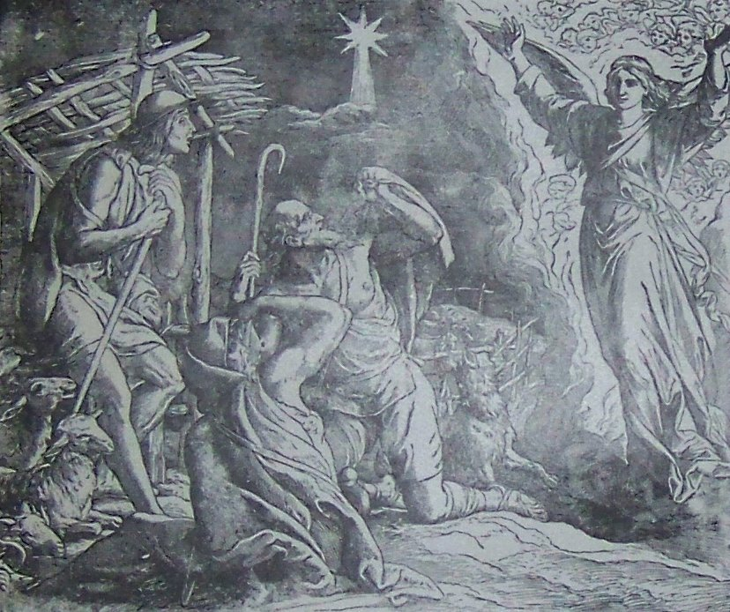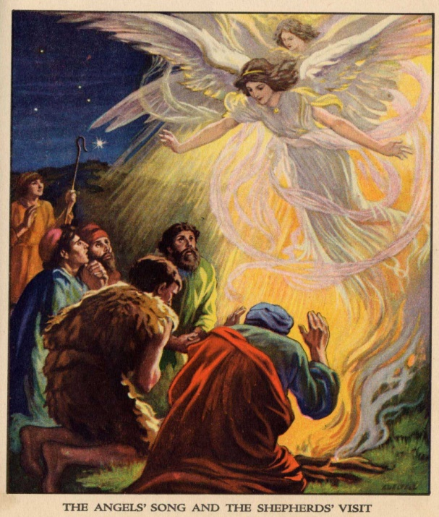

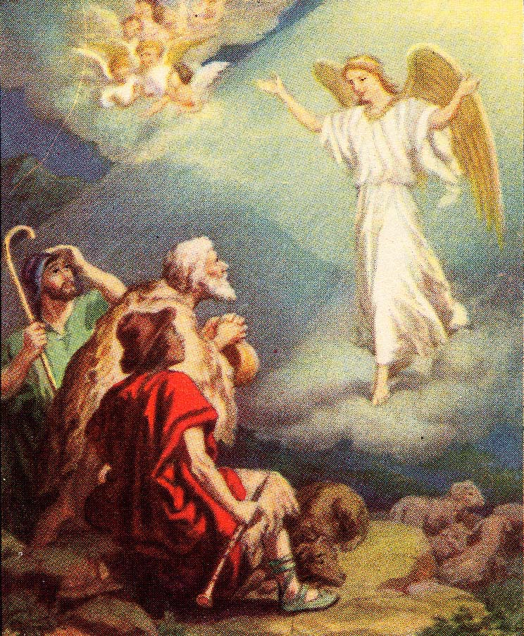

Preparation for Supernatural Beings Study Worksheet 2

Name __________________________________________ Date ___________________ Group ___________

- Read Luke 2: 8-14 and look at the examples of artwork.
- Answer as many Question Bank questions as you can. Use your prior knowledge, the text and the artwork.

Tradition: Christian Sacred Text: Bible
General background information:
Specific story information: Luke 2:8-14
Cultural manifestations:

Preparation for Supernatural Beings Study Teacher Tool 4

Possible Answers

- The following is an example of what a student’s answers might consist of.

Tradition: Christian Sacred Text: Bible
General background information:

Any information about angels offered by students, e.g. white robes, halos, wings, live in heaven, harps, singing, etc. Found in Jewish, Muslim and Zoroastrian traditions as well.
Specific story information: Luke 2:8-14

What happens: The angels appear to shepherds at night, to tell of Jesus’ birth.

Form taken: The shepherds can see them and hear them. The angels are shining with the glory of God. First one appears, then a multitude.

Human reaction: The shepherds are terrified; (but go to Bethlehem)

The point of the story: Heavenly intervention to convey the message of the birth of Jesus
Values present: worship, peace, good will

A ritual associated with this story: Carolling

Relationship to other traditions: Angels are depicted as heavenly messengers in Jewish and Islamic traditions, as in the story of the three angels who visit Abraham.
Cultural manifestations and representations: (see examples)

Paintings, sculptures, decorations, Christmas cards, Christmas songs, etc.
Christmas angels are often depicted as female, with wings, flying in the sky, although none of this is mentioned in Luke 2.
White robes, glowing light and halos are often used to show the glory of God shining around them.
Although the text does not refer to them singing, they are often shown holding musical instruments such as harps and trumpets.
Wings are mentioned in the Islamic traditions; trumpeting angels are associated with announcing the Day of Judgment.

Research Organizer 1- Supernatural Beings Worksheet 3

Names__________________________________________ Date_________________ Group _____________

- Use the organizer below to record your findings on supernatural beings. Use the Question Bank to guide your research.
General Information  names, forms, behaviour, places found | Stories  specific story associated with tradition  (record the Sacred text if possible) | Associated Objects or Symbols  (ex. In Christianity angels are often associated with wings, halos, trumpets, etc.) | Cultural Manifestations  art, literature, symbols, rituals, pop culture, etc.

Religious Tradition Researched: _____________________________________________

Synthesis of Findings- Supernatural Beings Worksheet 4

Names__________________________________________ Date_________________ Group _____________

- Use the organizer below to synthesize the information you found on supernatural beings. This should include:
  - The role: What role does the supernatural being have in the story or text? - Messenger, guardian, tempter, etc.?
  - The meaning: What does this particular being mean or represent for the people in the story and believers of the religious tradition? Is it a good or evil being, etc?
Religious tradition:  _____________________________  Name or type of being | Role | Meaning | Representations
  - The representations: How is this being represented (described) physically or spiritually?
Peer Evaluation of Dialogue Worksheet 5

Name __________________________________________ Date ___________________ Group ___________

- Use this sheet to evaluate your interaction with a peer after the interview on supernatural beings.

Criteria | Me |  | My Peer
Criteria | Yes (explain how) | No (explain why) | Yes (explain how) | No (explain why)
We referred to the resources from our research about supernatural beings to develop our point of view.

We tried to distinguish between the essential and secondary elements in the information we gathered.

If we didn’t understand something we asked for clarification

We created conditions that fostered dialogue.

One thing I learned from our discussion is:

Presentation Checklist Student Tool 3

- Use this checklist to plan your group presentation.

We have included:
- A description of at least two supernatural beings within the religious tradition or culture studied.
- An explanation of the role, meaning and different representations of the supernatural beings.
- An explanation of the symbols, writings (stories) and objects associated with the representations of the supernatural beings.
- An example (if applicable) of a cultural manifestation of the supernatural beings.

We have used:

- Visual aids such as illustrations, graphics, pictures, etc. to make it easy to see the representations of supernatural beings.
- Valid and reliable resources
- When possible the actual texts and scriptures from the religious traditions

- ****We have ensured that our explanations and descriptions are respectful and take into consideration any restrictions or prohibitions with respect to representations within the tradition and culture researched. **** (i.e. some traditions such as Islam and some branches of Judaism may have a restriction on physical representations of divine or supernatural beings. Check the source.)
Other things I may want to consider:

Self-Evaluation of Learning Worksheet 6
Name: _________________________________ Date: _____________________ Group: _____________

Supernatural Beings

- What is your concept of a supernatural being?

- Name one supernatural being you are now familiar with and name its tradition of origin.

- Name one cultural manifestation of this supernatural being.

Dialogue

- What are some of the strategies that you used to ensure that conditions were favourable to dialogue?

- What were some of the means that you used to better understand the subject of dialogue (supernatural beings) during your interactions with your peers or during your research?

Proficiency of knowledge in religious culture:
The student describes the characteristics of mythical or supernatural beings in religious or
cultural traditions (physical characteristics, qualities, etc.).
Successful
More or less successful
Needs improvement

Supernatural Beings Knowledge Verification Exercise
Name: _________________________________ Date: _____________________ Group: _____________

- Read the following story and then answer the questions that follow on a separate sheet.
The Binding of Isaac
Tradition: Judaism Text: Genesis 22
9 And they came to the place which G-d had told him of; and Abraham built the altar there, and laid the wood in order, and bound Isaac his son, and laid him on the altar, upon the wood.
10 And Abraham stretched forth his hand, and took the knife to slay his son.
11 And the angel of HaShem called unto him out of heaven, and said: 'Abraham, Abraham.' And he said: 'Here am I.'
12 And he said: 'Lay not thy hand upon the lad, neither do thou any thing unto him; for now I know that thou art a G-d-fearing man, seeing thou hast not withheld thy son, thine only son, from Me.'
13 And Abraham lifted up his eyes, and looked, and behold behind him a ram caught in the thicket by his horns. And Abraham went and took the ram, and offered him up for a burnt-offering in the stead of his son.
14 And Abraham called the name of that place Adonai-jireh; as it is said to this day: 'In the mount where HaShem is seen.'
15 And the angel of HaShem called unto Abraham a second time out of heaven,
16 and said: 'By Myself have I sworn, saith HaShem, because thou hast done this thing, and hast not withheld thy son, thine only son,
17 that in blessing I will bless thee, and in multiplying I will multiply thy seed as the stars of the heaven, and as the sand which is upon the seashore; and thy seed shall possess the gate of his enemies;
18 and in thy seed shall all the nations of the earth be blessed; because thou hast hearkened to My voice.'
Questions:
- What type of supernatural being is represented in this story and how is it represented?
- What role does the supernatural being play in the story?
- What meaning does the being have for the people in the story?
- Are any characteristics of this being given in the story (i.e. physical appearance, spiritual qualities, etc.)?
- Are there any objects or symbols associated with this being that are evident in the story?

Supernatural Beings –Possible Answers Knowledge Verification Exercise
Name: _________________________________ Date: _____________________ Group: _____________

*The following answers are provided as suggestions only and are not exhaustive. They contain the main elements that should be part of the student answers.

- What type of supernatural being is represented?
The supernatural being is an angel of the Lord. This is evident because in verse 11 it states “the angel of HaShem” called out to Abraham.
- What role does the supernatural being play in the story?
At first glance it is not clear whether it is an angel or God Himself calling out to Abraham. Assuming that there are two distinct beings in the story then, the angel’s role in the story is to stop Abraham from sacrificing his son Isaac as God had commanded him to do. At first glance it may seem that the angel is rebellious and is going against God’s decree but in verse 12 the angel is merely attracting Abraham’s attention so that HaShem, God, may speak to Abraham directly. When Abraham answers and then looks up, his attention is caught by a ram in the bushes that he may sacrifice in Isaac’s place. The angel calls Abraham a second time to attract his attention so that God may speak again and tell Abraham that because he has followed the will of God he will be blessed and be a father of many and patriarch of a nation. So the angel’s role is protector and messenger: 1. To get Abraham’s attention and in doing so protect Isaac 2. To get Abraham’s attention and in doing so allow Abraham to receive God’s message.
- What meaning does the being have for the people in the story?
For Abraham the angel means salvation for his son because he intercedes and saves Isaac’s life. So grateful is he that he calls the place ‘where God is seen.” For Abraham it also means that he becomes an important patriarch, blessed and revered for his compliance to God’s command.
- Are any characteristics of this being given in the story (i.e. physical appearance, spiritual qualities, etc.)?
It is not clear whether the angel is male or female, as it merely calls out to Abraham. The angel must have some supernatural qualities because he resides in heaven with God.
- Are there any objects or symbols associated with this being that are evident in the story?
The angel’s residence is heaven, as he calls out from there in verse 11 and 15; heavenly residence is usually symbolic of a supernatural existence.

Assessment Guidelines

These guidelines are provided as suggestions only and should not constitute the whole of the evaluation process. The guidelines are by no means exhaustive; it is up to teachers to judge the relevancy of a student’s responses.
In religious culture | Evaluation
- Appropriate treatment of forms of religious expression
- The student describes forms of religious expression in an appropriate manner. | - Worksheet 2- Preparation for Supernatural Being Study  - Worksheet 3- Research Organizer  - Worksheet 4- Synthesis of Findings  - Task 3- Presentation  - Knowledge Verification Tool
- The student accurately explains the meaning and role of forms of religious expression. | - Worksheet 3- Research Organizer  - Worksheet 4- Synthesis of Findings  - Task 2-Interview  - Task 3- Presentation  - Task 4-Short Text
- The student makes relevant connections between forms of religious expression and elements of the environment. | - Worksheet 3- Research Organizer  - Worksheet 4- Synthesis of Findings  - Task 3- Presentation  - Task 4-Short Text  - During class/group discussions
- Appropriate consideration of diversity
- The student describes various religious or secular ways of thinking and acting in society. | - Task 3- Presentation  - Task 4-Short Text  - During class/group discussions
- Proficiency of subject-specific knowledge targeted in the Progression of Learning | - Knowledge Verification Tool
In dialogue
- Appropriate practice of dialogue
- Questions points of view | - Task 2- Interview  - During class/group discussions

SUGGESTED RESOURCES

BOOKS

Bamberger, Bernard. J. Fallen Angels. Philadelphia: Jewish Publication Society, 1952.

Guiley, Rosemary. The Encyclopedia of Angels. New York: Facts on File, 2004.

Isaacs, Ronald, H. Ascending Jacob’s Ladder. Northvale NJ: Jason Aronson Inc, 1998.

Jones, David Albert. Angels. Oxford: Oxford University Press, 2010.

Lewis, James R. and Oliver, Evelyn Dorothy. Angels A to Z. New York: Gale Research Inc., 1996.

Riddell, Peter G. and Riddell, Beverly Smith. Angels and Demons. Nottingham, ENG: Apollos, 2007.

SUGGESTED WEBSITES FOR STUDENT RESEARCH

GENERAL
From Encyclopedia Britannica Online:
http://www.britannica.com/EBchecked/topic/24463/angel#tab=active~checked%2Citems~checked&title=angel%20and%20demon%20--%20Britannica%20Online%20Encyclopedia Angels and demons (last accessed April 7, 2011)

Varieties of angels and demons in religions worldwide
http://www.mythencyclopedia.com/Am-Ar/Angels.html (last accessed April 7, 2011)
http://www.mythencyclopedia.com/Cr-Dr/Devils-and-Demons.html (last accessed April 7, 2011)
http://www.aril.org Scroll down to Hot Sites: Links to all major religions (last accessed April 7, 2011)
http://www.crystalinks.com/genie.html Jinn in different traditions (last accessed April 7, 2011)
http://www.bbc.co.uk/religion/religions/ All religions (last accessed April 7, 2011)
http://www.wordiq.com/definition/Gabriel Gabriel in different traditions (last accessed April 7, 2011)

CHRISTIANITY
http://www.newadvent.org/cathen/01476d.htm, See also “Early Christian Representations of Angels”, ”Cherubim”,
“Seraphim” , “Devil”, “Demons”, “Demonology” (last accessed April 7, 2011)
http://www.clarifyingchristianity.com/angel.shtml Easy to read (last accessed April 7, 2011)
http://www.crystalinks.com/angels.html Christian and Jewish angels (last accessed April 7, 2011)
http://scriptures.lds.org/en/bd/a/84 (last accessed April 7, 2011)
http://www.teacherhelp.org/chris.htm Christmas story from Luke 2: 8-14 (KJV) (last accessed April 7, 2011)
http://www.christiananswers.net/dictionary/angel.html With biblical references (last accessed April 7, 2011)
http://www.christiananswers.net/q-acb/acb-t005.html (last accessed April 7, 2011)
http://www.christiananswers.net/dictionary/demon.html (last accessed April 7, 2011)
http://www.biblegateway.com/topical/topical_searchresults.php?resultsapp=25&source=1&search=angel&searchtype=all Bible references to stories with angels (last accessed April 7, 2011)

Christian art:
http://thebiblerevival.com/clipart.htm Bible clipart #1,#11,#18, #19, #26, #41, #46 (last accessed April 7, 2011)
http://www.faithclipart.com/category/angel-clipart.html Images of angels, with objects (last accessed April 7, 2011)

JUDAISM
http://thebiblerevival.com/clipart.htm Bible clipart #1, #11, #26 (last accessed April 7, 2011)
http://www.jewishencyclopedia.com/view.jsp?artid=1521&letter=A&search=Angelology (last accessed April 7, 2011)
http://www.chabad.org/library/article_cdo/aid/692875/jewish/What-Are-Angels.htm (last accessed April 7, 2011)
http://www.torah.org/learning/ramchal/classes/fundamental-2part5.html (last accessed April 7, 2011)

NATIVE SPIRITUALITY
http://www.webwinds.com/yupanqui/iroquoisdreams3.htm Legend of Sky Woman and Right and Left-handed Twins (last accessed April 7, 2011)
http://www.collectionscanada.gc.ca/settlement/kids/021013-2111.12-e.html Huron Wendat
(last accessed April 7, 2011)
http://www.cmp-cpm.forces.gc.ca/pub/rc/rel/ns-sa-eng.asp (general Native Spirituality) (last accessed April 7, 2011)

ISLAM
http://www.hotconflict.com/blog/2008/01/belief-in-angel.html (last accessed April 7, 2011)
http://westwing.bewarne.com/third/koran.html (last accessed April 7, 2011)
http://collectionsonline.lacma.org/mwebcgi/Searchall.exe?keyword=angels+in+islamic+art Angels adoring Adam; The Mi’raj of Muhammad, Angel with bird, Angel with crown (last accessed April 7, 2011)
www.cabula6.com/angelBIOS.htm (last accessed April 7, 2011)
http://islam.about.com/gi/dynamic/offsite.htm?zi=1/XJ/Ya&sdn=islam&zu=http%3A%2F%2Fwww.harunyahya.com%2Findexa.php Passages from the Qur’an: Angels, Diabolis, Jinn (last accessed April 7, 2011)

HINDUISM
http://www.crystalinks.com/nature_spirits.html Devas: Nature Spirits (last accessed April 7, 2011)
http://hinduism.iskcon.com/practice/305.htm Avatars of Vishnu (last accessed April 7, 2011)
http://www.sanatansociety.com/indian_art_galleries/hgs_durga_paintings.htm (last accessed April 7, 2011)

BUDDHISM
http://www.accesstoinsight.org/lib/authors/guruge/wheel419.html#ch-4 Buddha’s encounter with Mara
(last accessed April 7, 2011)
http://www.shunyata.net/mara2.htm Mara and Satan (last accessed April 7, 2011)

