Ethics and Religious Culture

Learning and Evaluation Situation

Writings Related to Religious Traditions
Elementary Cycle Two
Religious Culture and Dialogue

Student Booklet

Table of Contents

Student Evidence and Tools
- Research Findings p. 3
- Team Contribution Plan p. 4
- Page Planner p. 6
- What I Learned p.7
- Definition of Sacred p.8

Evaluation Tools
- Self-Evaluation of Dialogue p. 5
Criterion of dialogue: Relevance of how students show they have organized their thinking
Criterion of religious culture: Contextualized knowledge of forms of religious expression
Research Findings

Name: _______________________________ Date: __________

- Read the information given by your teacher.
- Use the information provided to answer the questions in the spaces below. Use another piece of paper if needed.
- Try to answer in full sentences.
Tradition: ___________________________ Name of Text: _______________________
Who reads this text?

Who are some of the stories about?
What language was it written in?

Where is it kept?
When is it used?

How is it treated?
Other interesting facts:

Team Contribution Plan

- Decide with your team which information you will contribute to the book.
- Write your sentence as it will appear in the class book.
- Write your name next to the sentence you will contribute.
- Make sure every member of the team has at least one sentence.

Tradition: _____________________ Name of text: __________________

Sentence: Student’s Name:

Sentence: Student’s Name:

Sentence: Student’s Name:

Sentence: Student’s Name:

Self-Evaluation of Dialogue
Name: _______________________________________________ Date: ____________
- Evaluate the dialogue you had with your team, giving examples.

 | Yes  How? | No  Why?
I expressed my ideas

I listened attentively to others’ ideas
I showed concern for others

I helped overcome obstacles if any came up

My team worked well because:
_____________________________________________________________________________
_____________________________________________________________________________
A strategy I would use next time is:
________________________________________________________________________________
________________________________________________________________________________
Criterion of dialogue: Relevance of how students show they have organized their thinking
Criterion of religious culture: Contextualized knowledge of forms of religious expression

Page Planner
Name: _______________________________________________ Date: ____________

Tradition: ______________________ Text: _________________________
Use this page to do a rough copy of your page contribution. Be sure to include all the writing and any illustrations you want to add. Show this page to your teacher before you start the final copy.
Picture(s): (optional)
Border design:
(optional)

Sentence(s):

What I Learned
Criterion of religious culture: Contextualized knowledge of forms of religious expression
- Choose a tradition and find statements in the class reference book that correspond to the words on the hand below.
- Write the statements in the spaces.
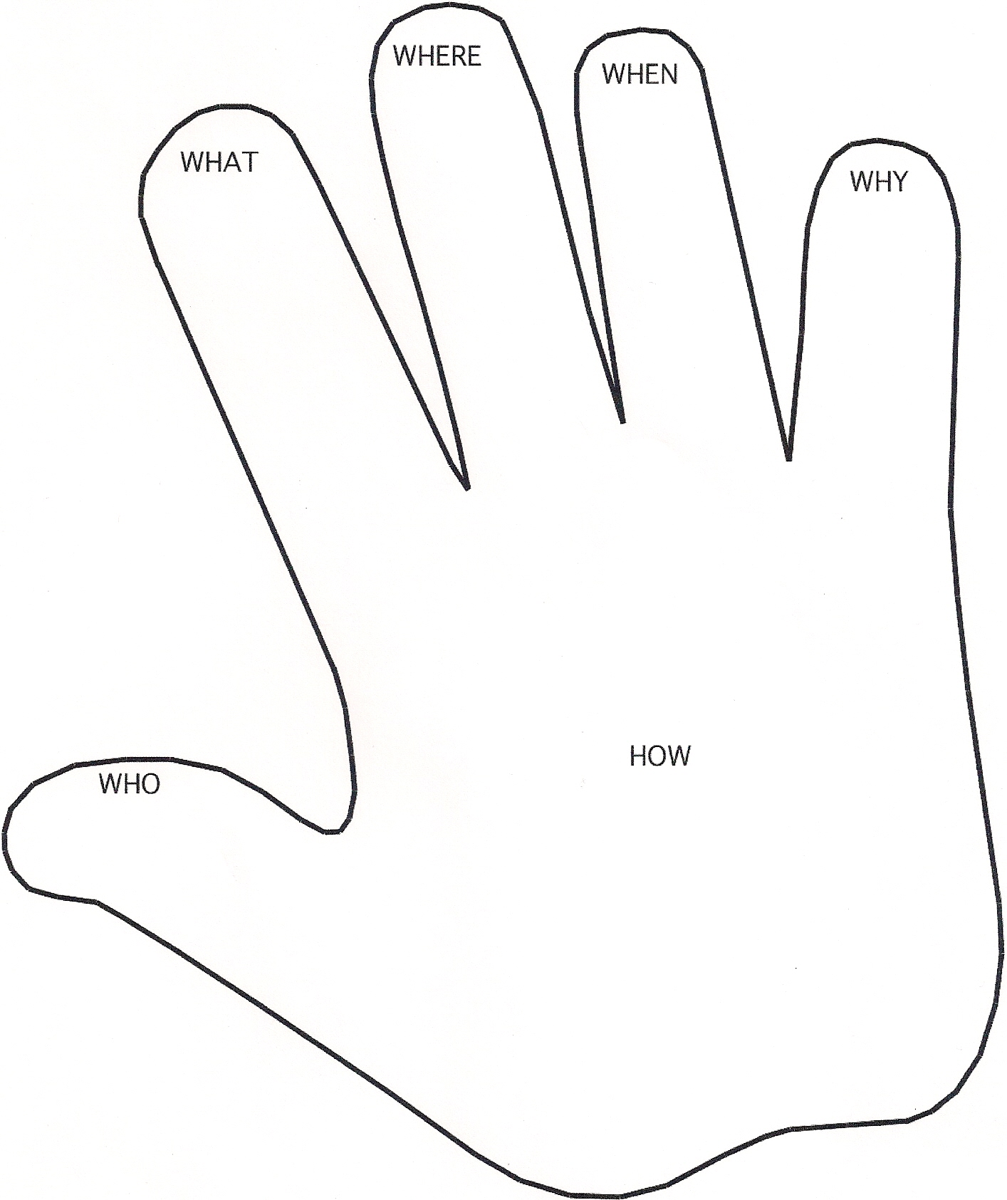
Definition of Sacred
Names: _______________________________________ Date: ____________________

Sacred means: 1. Set apart; special
2. Holy
3. Religious
4. Deserving respect or honour

Example: The Bible is sacred to Christians.

An example of an object that could be considered sacred: ____________________________________________________________________________________________________________________________________

An example of a place that could be considered sacred: ____________________
____________________________________________________________________________________________________________________________________

An example of something else that could be considered sacred:
____________________________________________________________________________________________________________________________________

Name some appropriate behaviours related to things that are considered sacred:

Do | Don’t

