Ethics and Religious Culture

Learning and Evaluation Situation
Continuum of Learning and Evaluation Situations

Learning This LES Evaluation

Forms of Religious Expression:
Symbols and Objects

Elementary Cycle Two
Religious Culture and Dialogue

Teacher Guide

NOTE

This learning and evaluation situation is a working document, which is therefore subject to change. It may be adapted as needed depending on the student’s social environment, the planning of teaching and learning activities, the integration of the Ethics and Religious Culture program and the Québec Education Program, etc.

Table of Contents

Section 1: Presentation of the situation p. 3

- Time and Overview p.4
- Program Content p.4
Section 2: Suggested Procedure p. 5

Section 3: Suggested References
for the Students and the Teacher p. 8

Section 4: Content and Evaluation Tools p. 9

Section 5: Table of Program Content p. 24

Section 1: Presentation of the Situation
Aim

This learning and evaluation situation is intended to evaluate the level of competency developed in religious culture. The student should be able to identify certain characteristics of religious observances in the community, using the vocabulary appropriate to the religious traditions. The student should be able to give a brief description of the forms of religious expression associated with practices of prayer and meditation, as well as the meaning of such forms of expression within the larger context of the religious tradition.

Context
Recently in the Native community, a powwow took place. Participants gathered at the edge of a forest and formed a large circle around a dancer, who wore traditional clothing and danced and sang to the rhythm of the drum. Many objects and actions with symbolic meaning were used in the ceremony, such as the burning of sweetgrass and the beating of the drum. These objects and the actions that go with them are ways of practicing a religion or spiritual tradition, known as “forms of religious expression” in this LES. Forms can be objects used in ceremonies, objects used for individual prayer and meditation, and symbols, among many others. What do you know about forms of religious expression in Native spirituality? In other traditions? Do you think forms of religious expression are different or similar in different traditions?

Description of the situation

Introductory Activity: The student will become familiar with the learning context and share previous knowledge of Native spirituality. As a class, they will identify the main elements and meaning of the use of a form of religious expression within the context of this tradition. Discuss the questions raised in the learning context.

Part One of the Evaluation Situation: View pictures of forms of religious expression and choose two from two different traditions to study. Associate the form with the appropriate tradition.

Part Two of the Evaluation Situation: Research and record information on the given form of religious expression (object or symbol). Repeat process for a second religious expression from a different tradition.

Part Three of the Evaluation Situation: Using the recorded information, draw a comparison between the two forms of religious expression studied, using a Venn diagram or other comparison organizer. Summarize and draw conclusions from the comparison.

Integration activity: Present some of the final productions to the class, and answer questions of clarification.
Reflect on questions from learning context, as well as work process.

Resources to be mobilized
- Student Booklet
- Pictures
- Information Pages
It is recommended that the LES “A Time and Place to Celebrate” and/or “Writings Related to Religious Traditions” be completed before working with this LES.

Time and Overview
Preparation Phase | Performance Phase |  | Integration Phase
(20 minutes) | (40 minutes) | (1 hour ) | (25 minutes)
Introductory Activity  - Part 1  (15 minutes)  Present LES and learning context  - Part 2  (5 minutes)  View pictures and choose 2 forms of religious expression from different traditions | Task 1  - Part 1  (20 minutes)  Record information  Form of Religious Expression #1  - Part 2  (20 minutes)  Record information  Form of Religious Expression #2 | Task 2  - Part 1  (30 minutes)  Venn diagram  - Part 2  (30 minutes)  Summary of comparisons and conclusions drawn | Task 4  - Part 1  (15 minutes)  Present some summaries and conclusions / listen to others  - Part 2  (10 minutes)  Self-evaluation

Note: The times for each activity may vary depending upon the class.
Program Content
Broad Area of Learning | Citizenship and Community Life  •To ensure that students take part in the democratic life of the classroom or the school and develop a spirit of openness to the world and respect for diversity.
Cross-Curricular Competency | To use information  •To gather information
Subject-Specific Competencies | Demonstrates an Understanding of the Phenomenon of  Religion  Engages in Dialogue
Themes and Related Content for Religious Culture | Religious practices in the community  • A time for celebrations  ● Places of worship, religious objects and symbols  ● Practices of prayer and meditation

Section 2: Suggested Procedure Duration: 2 hours 25 minutes
Preparation Phase (20 minutes)

Tasks for the students:
- Listen to the learning context.
- As a class, identify the key elements and meaning of a form of religious expression presented by the teacher.
- View pictures of forms of religious expression and choose two forms from two different traditions to study.

Key features of religious culture: Explores forms of religious expression;
Makes connections between forms of religious expression
and the social and cultural environment
Key feature of dialogue: Organizes his/her thinking
Tasks for the teacher:  - Present the learning situation and pictures of powwow objects, and ask students to share previous knowledge of powwows and/or Native Spirituality in general.  - With the class, identify the key elements of one or more of the objects used in powwows (see Teacher Guide p. 17 for information). Together, associate the meaning of these objects within the larger context of Native spirituality. Record answers in a visual display.  - Share further information regarding powwows and record information in the display.  - Present pictures of forms of religious expression related to religious traditions. Allow time for students to choose two forms of religious expression for their focus of study (see note to teacher below).  - Invite students to complete Focus of Study in their Student Booklet. | Required materials:  Powwow information (Teacher Guide, p. 9)  Chart or visual display of class work  Suggested Images (Teacher Guide, pp.10-15)  Focus of Study (Student Booklet, p.3)
Notes to teacher
- Many traditions and objects are provided in this ES; the teacher may choose to use as many or as few as desired. Objects related to holiday celebrations (e.g. Christmas, Hannukah, etc.) may also be used. Pictures may be assigned to students rather than chosen, to ensure more interesting comparisons. Students must use either two symbols or two objects from different traditions for their focus of study.
- It is important to present the object within the context of the rites and the actions surrounding its use; the object on its own does not represent the form of religious expression.

Record keeping: Focus of Study

Performance Phase (1 hour 40 minutes)

Tasks for the students:
- Research and record information on a given form of religious expression.
- Repeat process for a second form of religious expression from a different tradition

Key features of religious culture: Explores forms of religious expression;
Makes connections between forms of religious expression and
the social and cultural environment; Considers various ways of thinking, being and acting
Key feature of dialogue: Organizes his/her thinking
Criterion of religious culture: Contextualized knowledge of forms of religious expression
Tasks for the teacher:  - Remind students of the tradition studied as a class during the preparation phase. Make the visual display of answers available to serve as a model for their work.  - Provide students with Information Pages and any other available resources (see note to teacher below).  - Ask students to complete Form of Religious Expression #1 for one object or symbol related to a religious tradition.  - Ask students to complete Form of Religious Expression #2 for another object or symbol related to a different religious tradition. | Required material:  Visual display of class work from learning context  Information Pages (Teacher Guide, pp.17-22) and/or other resources (Resources, Teacher Guide, p.8)  Form of Religious Expression #1 (Student Booklet, pp.4-7)  Form of Religious Expression #2 (Student Booklet, pp.4-7)
Notes to teacher:
- Information Pages may be given to students prior to beginning the LES.
- This activity may be done individually, in pairs or in small groups.
Record keeping: Forms of Religious Expression #1 and #2

Tasks for the students:
- Compare the two forms of religious expression studied, using the recorded information and a Venn diagram or other comparison organizer.
- Summarize and draw conclusions from the comparison.
Key features of religious culture: Explores forms of religious expression;
Considers various ways of thinking, being and acting
Key feature of dialogue: Organizes his/her thinking
Criterion of religious culture: Consideration of various ways of thinking, being or acting that are relevant to the context
Tasks for the teacher:  - Ensure that students have completed copies of the Forms of Religious Expression #1 and #2 from the previous activity.  - Invite the students to use the work from the previous activity to compare the roles and meanings of the symbols or objects using a Venn diagram (Student Booklet, p.6) or other type of comparison organizer.  - Invite students to reflect on their comparison and complete Comparison Summary and Conclusions (Student Booklet, p.7). | Required materials:  Forms of Religious Expression #1 and #2 from previous activity  Comparing Forms of Religious Expression Student Booklet, p.6)  Comparison Summary and Conclusions (Student Booklet, p.7)
Record keeping: Comparing Forms of Religious Expression; Comparison Summary and Conclusions

Integration Phase (25 minutes)

Tasks for the students:
- Present some of the final productions to the class, and answer questions for clarification.
- Reflect on questions from the learning context as well as work process.
Key features of religious culture: Explores forms of religious expression;
Considers various ways of thinking, being and acting
Key feature of dialogue: Organizes his/her thinking
Criterion of religious culture: Contextualized knowledge of forms of religious expression
Tasks for the teacher:  - Invite several students to present their comparisons or summaries and conclusions to the class, ensuring that a variety of traditions is represented.  - Ensure that conditions favourable to dialogue are respected as students discuss and ask questions of work presented.  - Invite students to share their responses to questions from the learning context in light of work done.  - Invite students to reflect on their process using the Self-Evaluation worksheet. | Required materials:  Self-Evaluation (Student Booklet, p.10)
Record keeping: Self-evaluation

Section 3: Suggested References the Students and the Teacher
BOOKS:
Barron’s Educational Series This Is My Faith. London: Ticktock Entertainment, 2006.
Osborne, Mary Pope. One World, Many Religions. New York: Knopf Books for Young Readers, 1996.
Glossop, Jennifer. The Kids Book of World Religions. Toronto: Kids Can Press, Ltd., 2003.
Buller, Laura. A Faith Like Mine. New York: Dorling Kindersley, 2005.
Wilkinson, Philip. Illustrated Dictionary of Religions. New York: Dorling Kindersley, 2006.
Langley, Myrtle. Religion. New York: Dorling Kindersley Eyewitness Books, 2005.
Dorling Kindersley Eyewitness Series on Religions: Judaism/Christianity/Islam/Buddhism. New York: Eyewitness Books, 2003-2005.
Quinlan, et al. Exploring World Religions: The Canadian Perspective. Toronto: Oxford University Press, 2001.
SUGGESTED BOOKS FOR TEACHERS:
Department of National Defence Canada. Religions in Canada. Directorate of Human Rights and Diversity, 2003 (includes extensive bibliography with Web sites)
Bowker, John. World Religions. New York: Dorling Kindersley, 2006.
Schade, Johannes P., ed. Encyclopedia of World Religions. Amsterdam: Foreign Media Books, 2006.

WEB SITES:
http://www.strath.ac.uk/curricularstudies/re/db/reartefacts/ info /pictures of artefacts
http://wri.leaderu.com/ table index of many world religions
http://www.educhurch.org.uk/pupils/combs/communion_objects.html
http://www.mrdowling.com/zip/605westr.pdf (a downloadable study file on Western Religions)
http://www.uri.org/kids/world.htm
http://www.bbc.co.uk/religion/religions/
http://www.woodlands-junior.kent.sch.uk/homework/religion/
http://atschool.eduweb.co.uk/carolrb/index1.htm
http://www.teachnet.ie/clane/2006/worldreligions.htm
http://www.elements.nb.ca/Theme/ethics/pow/wow.htm (powwow)
http://www.rcmp-grc.gc.ca/aboriginal-autochtone/pub/spirit-spiritualite-eng.htm Meaning of rituals and symbols in powwow
http://library.thinkquest.org/3081/drum.htm Information about and picture of a powwow drum http://www.tpt.org/powwow/drum.html

WEB VIDEOS:
http://www.pbs.org/wnet/religionandethics/lessons/religion-culture-and-diversity/procedures-for-teachers/525/ excellent videos of religious ceremonies
http://pow.reonline.org.uk/videos.htm videos of worship services
http://www.cleo.net.uk/resources/index.php?ks=2&cur=15 videos of various celebrations
http://tv.powwows.com/ videos of powwows
http://www.learnquebec.ca/en/index.html Log in and click on Religious Culture themes, cycle 2.
Section 4: Content and Evaluation Tools
Example:
Form of Religious Expression
(Note to teacher: It is important to present the object within the context of the rites and the actions surrounding its use; the object on its own does not represent the form of religious expression.)

Name of the form of religious expression:  Powwow drum | Tradition:  Native spirituality
Name of celebration, ceremony or ritual in which it is used: Powwow

Other forms associated with this celebration, ceremony or ritual: Eagle bone whistle, herbs/incense

Description of the religious expression: The drum is a wooden shell covered with cow or buffalo hide. It is large enough to seat eight people around it. Drumsticks often have leather handles and a padded leather head.
Where it is found/used:  Often outdoors, in nature | When it is used: (day, season, time of day, etc.) Special occasions. Powwows can be held to welcome a new member, honour a community member, pay respects to someone who has died, etc.
How it is used: Eight to ten people sit around the drum, and beat in unison in time to the songs. Drummers must know many songs because they are not to be repeated during a powwow, which can last up to eight hours or more.

Words spoken during use:
Drummers sing specific songs while playing the drum. Examples are: Flag songs, memorial songs, honour songs, intertribal songs, and contest songs.

How this form relates to other things I know about this tradition:
Many objects have their own spirit in the Native tradition. The drum has its own spirit, and so must be treated with respect and care. The drum sounds like a heartbeat, and the Earth has a heartbeat in Native tradition, so the drum is like the Earth’s heart beating. Native spirituality focuses on nature, so the drum is made of natural materials like wood and animal skins.

Sources:
http://library.thinkquest.org/3081/drum.htm
http://www.tpt.org/powwow/drum.html
http://www.rcmp-grc.gc.ca/aboriginal-autochtone/pub/spirit-spiritualite-eng.htm

Suggested Images

(Note: All images from http://www.strath.ac.uk/curricularstudies/re/db/reartefacts/ or Microsoft ClipArt. Images can be enlarged for student use. Colour pictures, videos and other objects available at the sites listed on page 8, Suggested References.)

Christianity

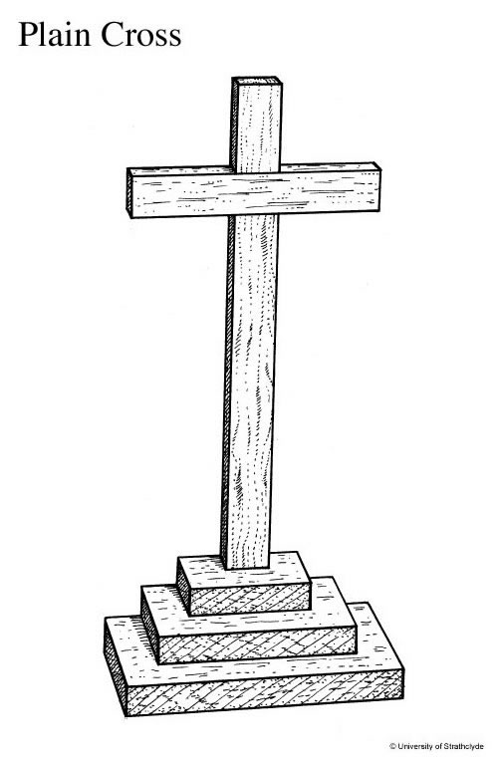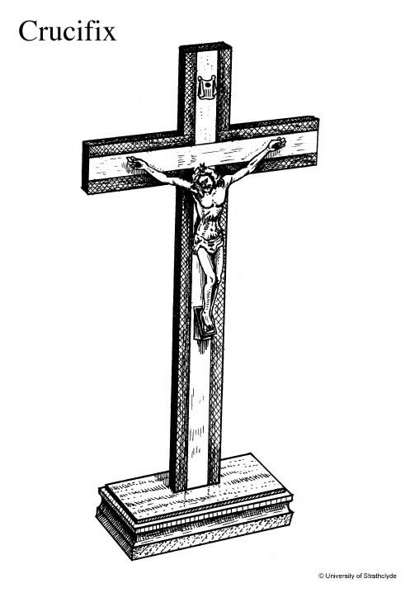

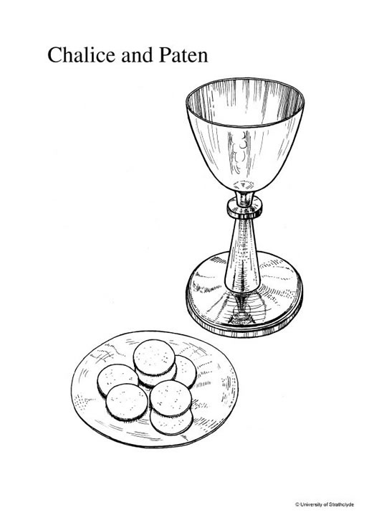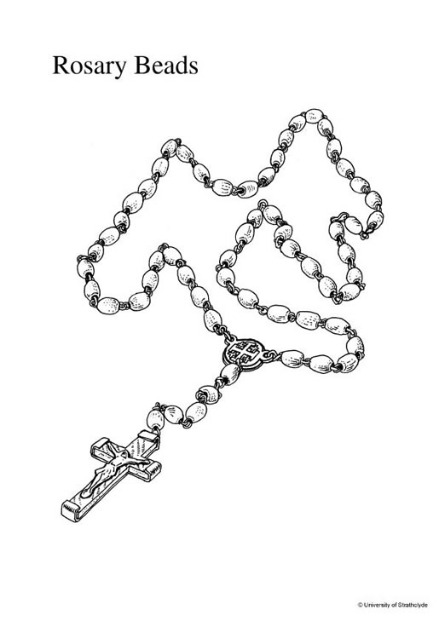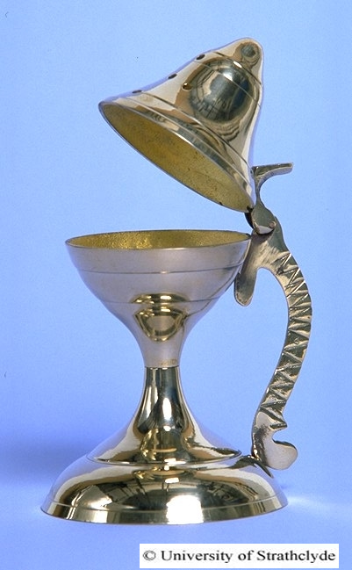
Censer

Judaism
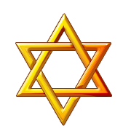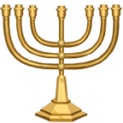

Star of David Menorah

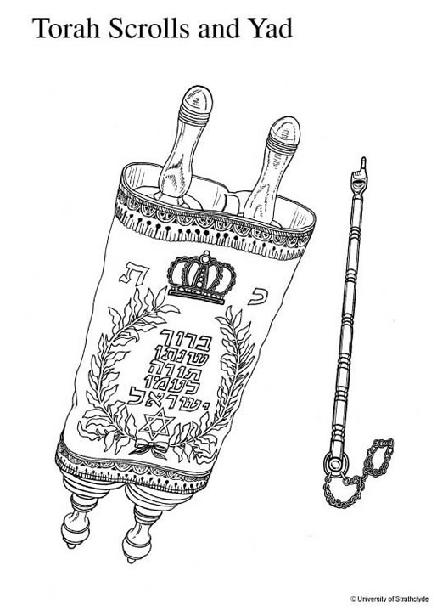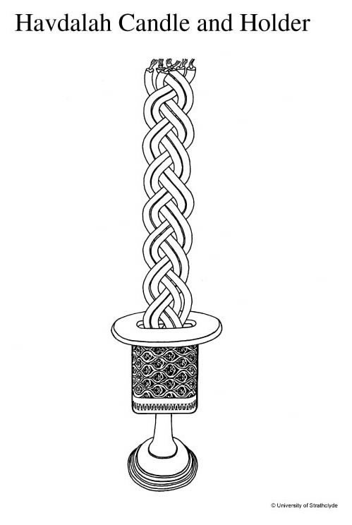

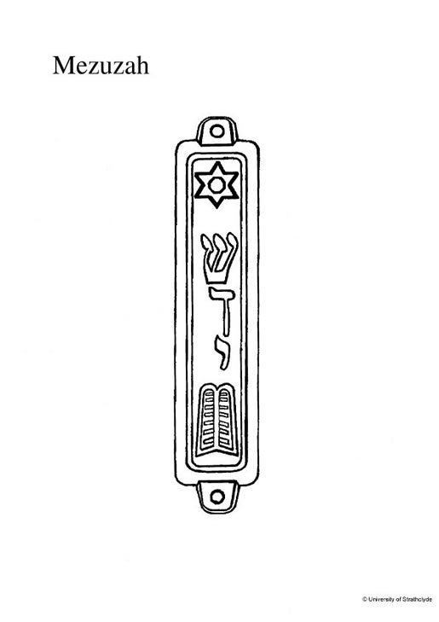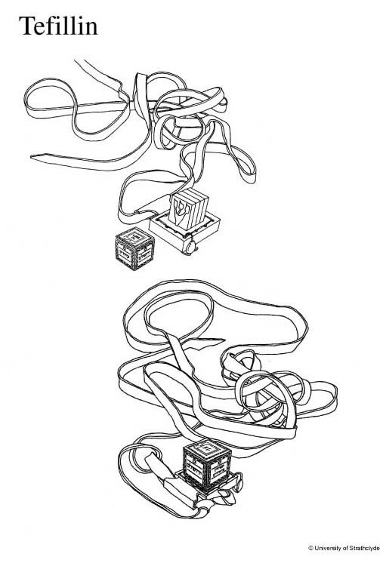

Islam

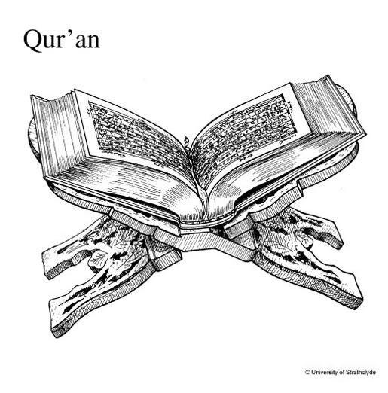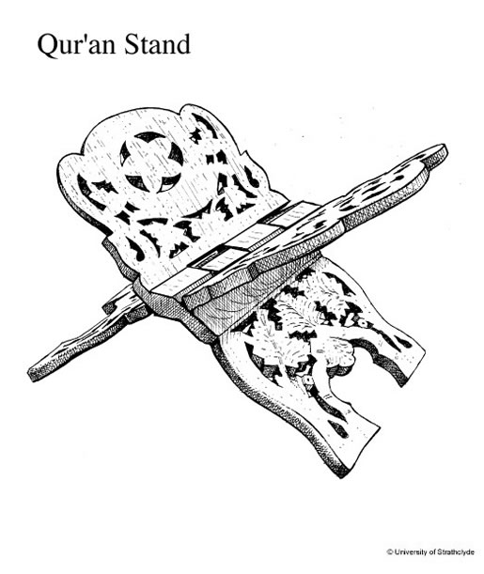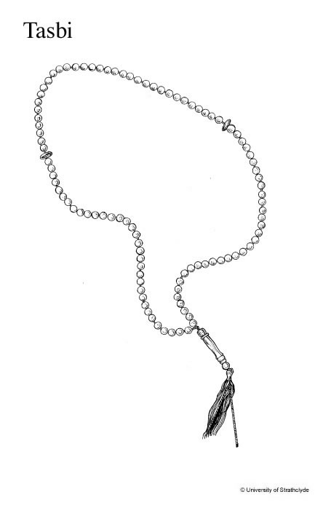

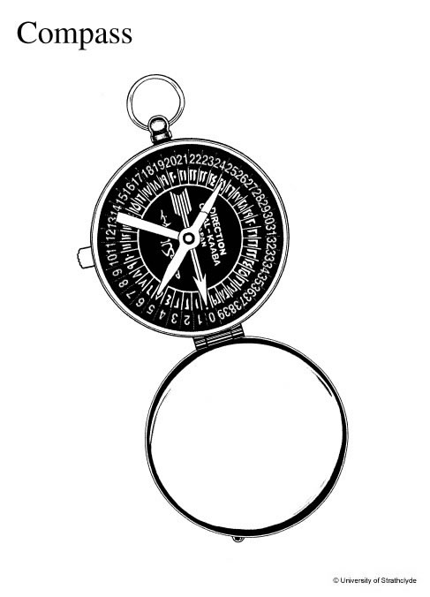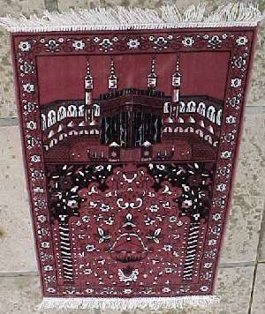
Prayer Rug

Hindu

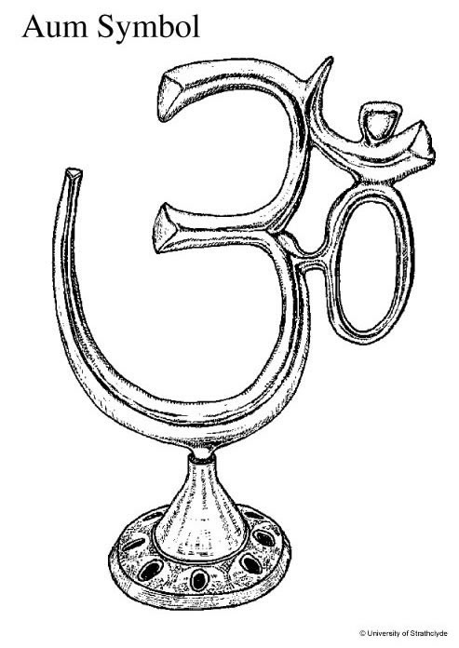

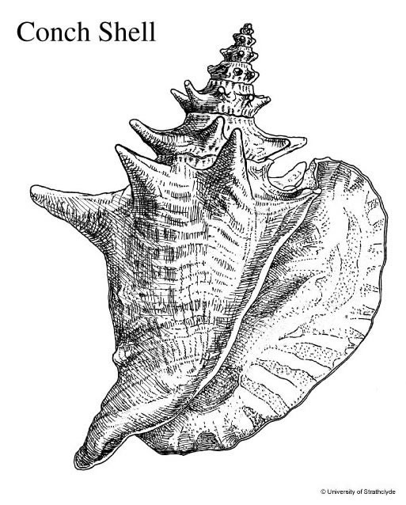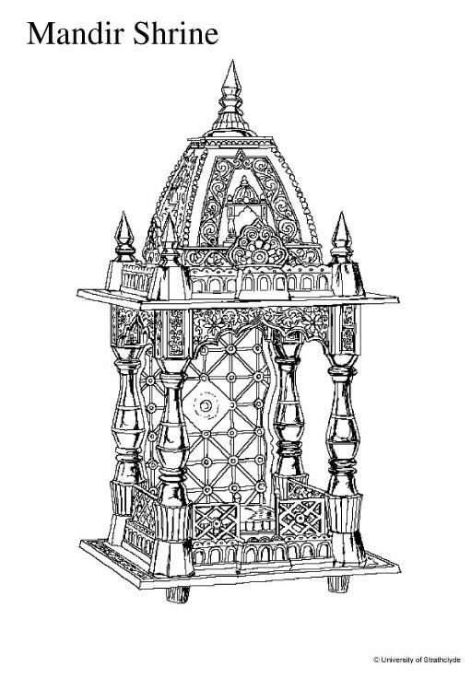

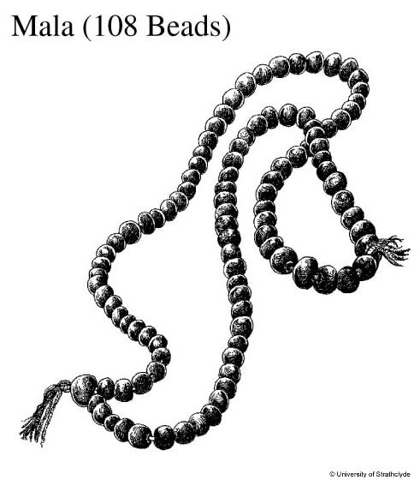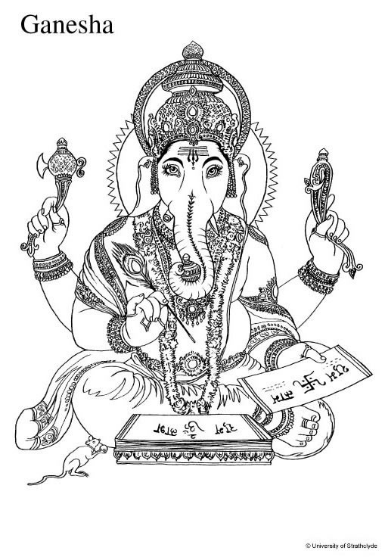
Image of a deity

Buddhism

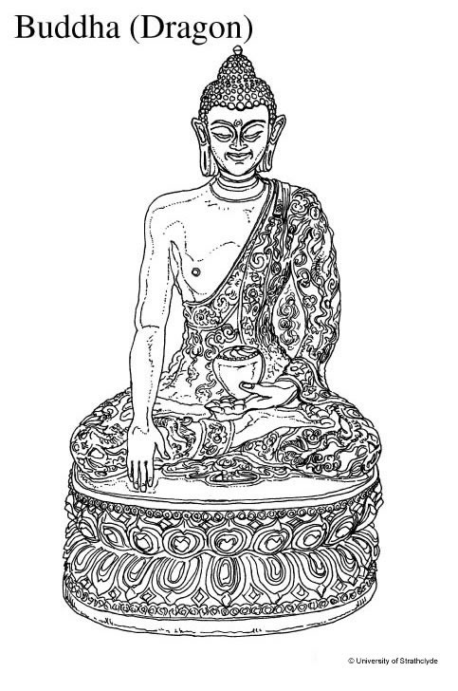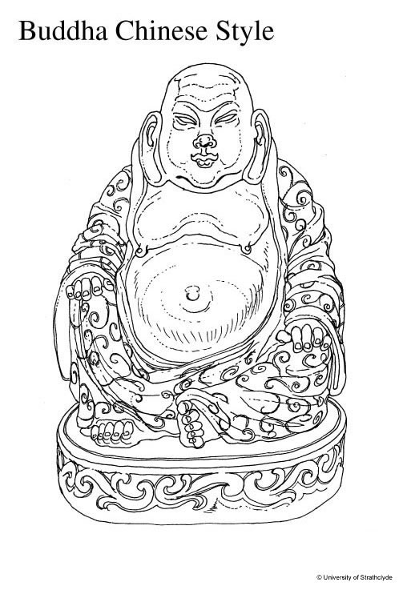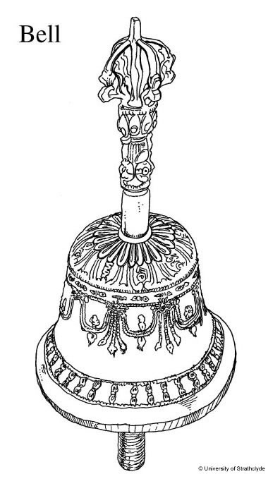
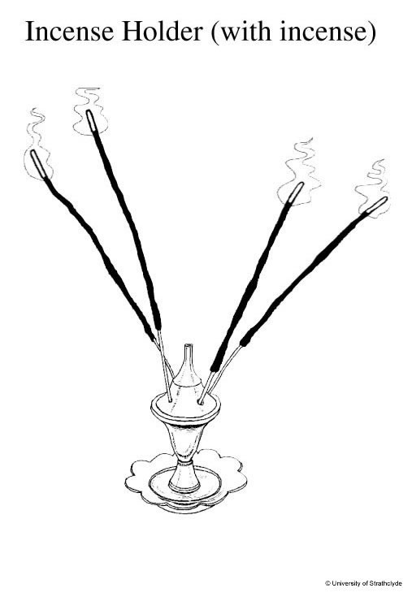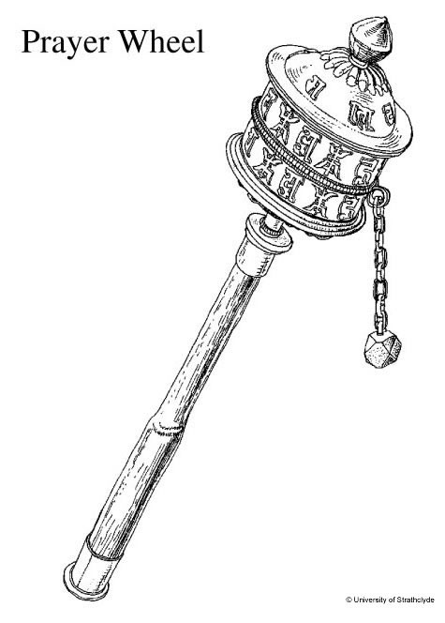
Lotus flower

Sikhism

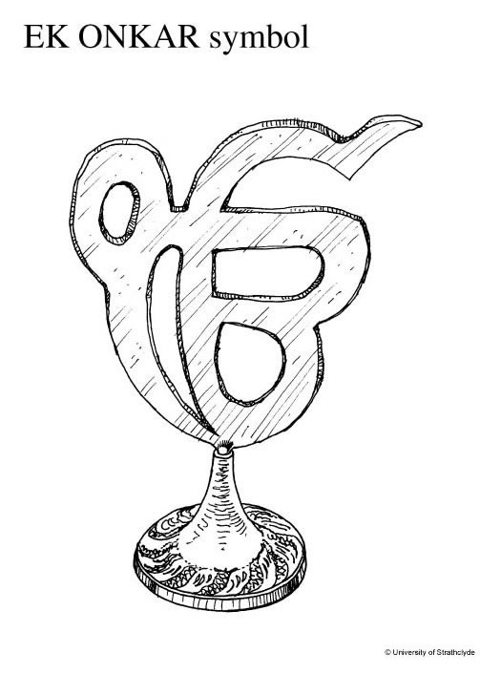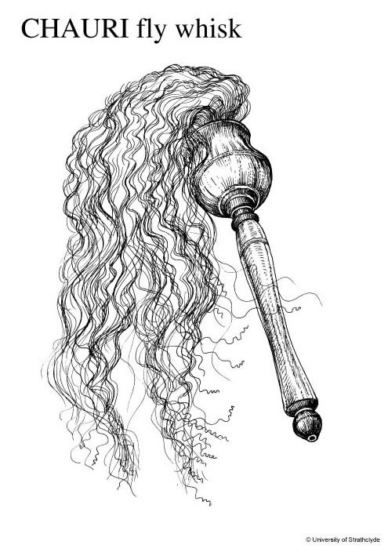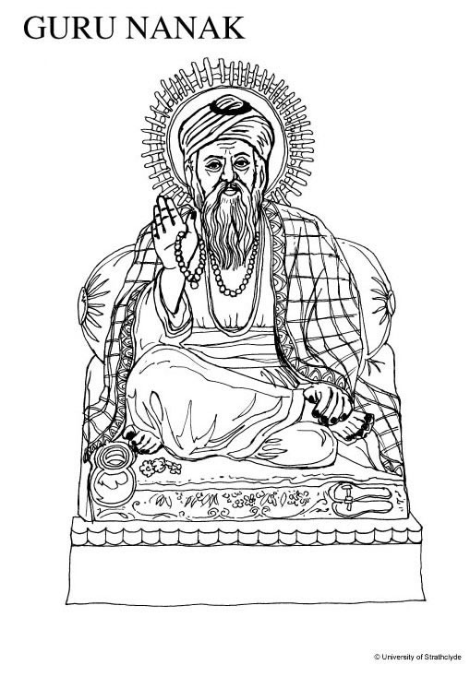

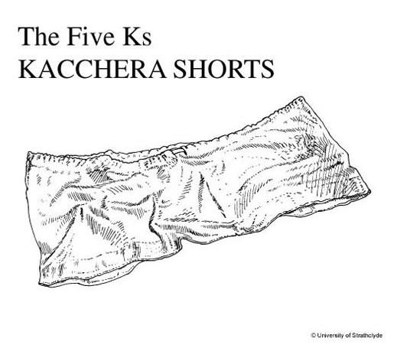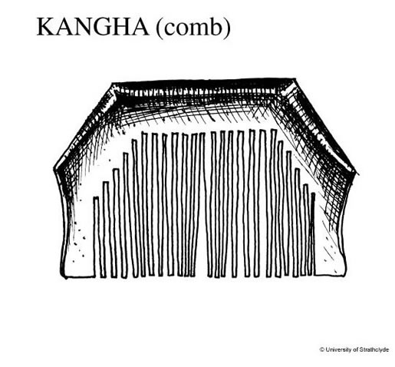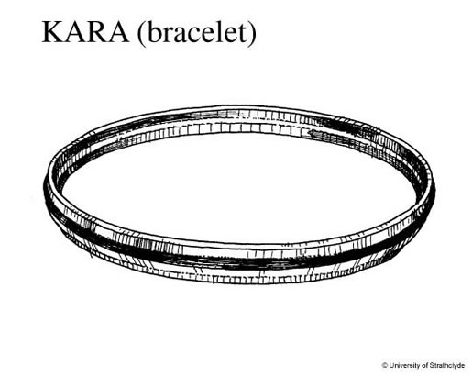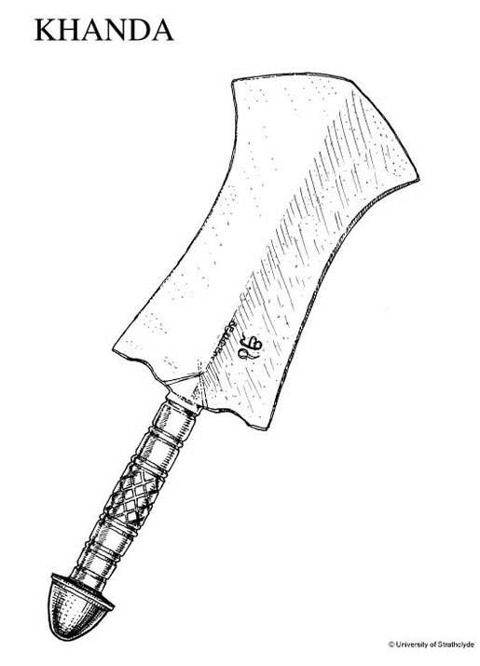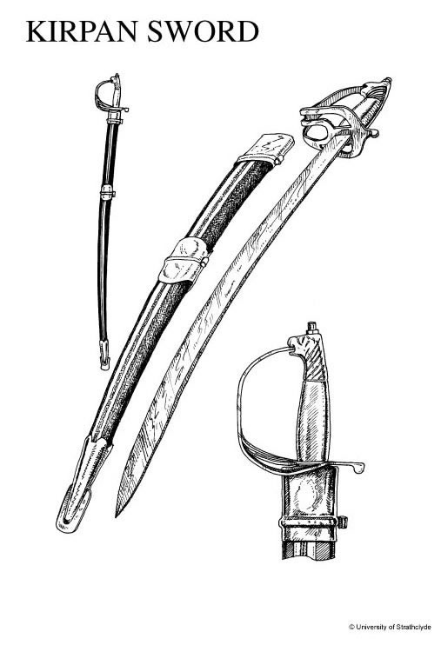

Traditions, Symbols and Objects
(Students should focus on two forms of religious expression from the same column in order to compare them.)

Tradition | Symbols | Ceremonial Objects | Prayer Objects
Christianity | Cross, Crucifix | Chalice and Paten, Censer | Rosary
Judaism | Star of David, Menorah | Yad, Havdalah candle, Mezuzah | Tefellin
Islam | Crescent moon and star, badges | Qur’an stand | Prayer mats, compass, subha
Hinduism | Aum | Puja tray, conch shell, mandir | Malas
Buddhism | Eight-spoked wheel, lotus flower | Buddha statues, bell, incense | Malas
Sikhism | Sikh symbol, Ik Onkar | Five Ks, Chauri | Malas

Information Pages
Forms of Religious Expression: Symbols and Objects
(Sources: see Suggested References and Resources, Web sites, p. 8)

Christianity

Cross/Crucifix
- Central Christian symbol
- Represents Jesus’ death and resurrection
- Crucifix has an image of Jesus on it, used in Roman Catholic and Anglican traditions

Chalice and Paten
- Made of silver or gold
- Holds the wine and bread used in Holy Communion (Eucharist, Mass)
- Means cup and plate

Censer
- Used for burning incense during services
- Used in the Roman Catholic and Orthodox traditions
- The rising smoke is like prayers rising to God

Rosary
- The name of the set of prayers as well as the string of beads
- Five sets of ten beads (decades) with a crucifix at the end
- Prayers start at the crucifix and are recited in order: “Our Father,” “Hail Mary,” “Glory Be,” etc.

Judaism

Star of David
- Made of six points
- Worn on King David’s battle shield (Magen David)
- Appears on flag of Israel

Menorah
- Hebrew for candle-holder with many branches
- Has seven branches
- Found in synagogues and homes
- Given to Moses by God

Yad
- Hebrew for hand
- Rod shaped like a hand with pointing finger
- Used for reading Torah scrolls
- Protects the parchment from smudging

Havdalah candle
- Braided candle set out with wine and spices
- Marks the end of Sabbath on Saturdays at sundown
- Lit by the woman of the home; extinguished with the wine

Mezuzah
- Hebrew for door post
- Hung at an angle on the right side of the door
- Contains a handwritten scroll with Jewish text called Shema
- Often touched when entering a house or room

Tefellin
- Small black leather boxes with leather straps
- Contain handwritten Jewish texts
- Tied to the forehead and left arm during morning prayer
- Reminds people to love God with their hearts and minds

Islam
Crescent moon and star
- Found on the flag of most Muslim countries
- The moon stands for progress, the stars for knowledge and light
- Traditionally green or gold

Badges
- Worn or displayed to associate with Islam
- Show images of people or animals are forbidden in Islamic art
- Use patterns based on calligraphy or texts from the Qur’an

Qur’an Stand
- Qur’an is the Islamic holy book and must never touch the floor
- Foldable carved wooden stand used to hold the Qur’an during worship
- Arabic word for the stand means “throne”

Prayer Rugs
- Used to provide a clean place to pray
- One meter long, decorated with patterns
- Often have an arch in the pattern to show the direction of Mecca
- Used five times a day for daily prayers

Compass
- Used to find the direction in which to pray facing the Ka’ba in the city of Mecca
- Prayer rugs often have compass pockets on the back
- Often given as gifts

Prayer Beads
- Called subha or tasbi
- Three sets of 33 beads and one large one
- Used while saying the 99 beautiful names for God

Hinduism

Aum
- Central symbol for Hindus
- Represents God and the sound that began the universe
- Chanted before prayers to prepare for worship
- Made of three parts representing birth, life and death

Puja Tray
- Holds symbolic items on the family shrine during worship called puja
- Made of stainless steel to represent purity
- Holds a bell, pot of water, incense burner, arti lamp, and dish of paste to mark the forehead
- Food and fruit are also offered
- Puja takes place three times a day

Mandir
- Model of a Hindu temple found on the home shrine
- Contains an image of a Hindu deity under a canopy or roof
- Tall dome represents reaching for the sky

Conch Shell
- Blowing into it makes a sound like the Aum
- Used at the family shrine to mark the beginning of special ceremonies or prayers
- Represents space and the universe

Malas
- String of beads used for prayer
- Contains 108 beads
- Used while repeating the sacred sound Aum or the name of a deity

Buddhism

Eight-Spoked Wheel
- Represents the cycle of birth, life, death
- Reminds people of the eight paths to eliminate suffering taught by the Buddha
- Circular shape shows that the order of the paths is not important

Buddha Statue
- Found in all Buddhist temples and most homes
- Used to focus during meditation
- Bump on head, mark on forehead, curly hair, long earlobes have symbolic meaning
- Chinese Laughing Buddha represents friendship and joy
- Often shown holding prayer beads

Lotus Flower
- Has many symbolic meanings, such as: purity, potential, impermanence
- Offered during worship called puja
- Buddha often shown seated on a lotus blossom

Bell
- Used to mark the beginning and end of meditation sessions
- Sometimes rung in the temple while worshippers chant
- Ringing the bell represents sending the message of enlightenment all around the world

Incense
- Offered during worship called puja
- Smoke spreading everywhere represents good deeds affecting everyone
- Sweet fragrance represents the sweetness of a good life

Prayer Wheels
- Cylinders holding scrolls with messages of love, compassion and energy written on them called mantras
- Wheel is turned while chanting the mantra, representing sending the message around the world
- Wheels can be small enough to hold in the hand or large monuments

Sikhism

Sikh Symbol
- Called the Khanda
- Made of three Sikh images: double-edged sword (Khanda), circle (Kara) and two crossed ceremonial daggers (Kirpan)
- Represents power, unity, balance
- Found on gurdwaras (house of worship) and the Sikh flag

Ek Onkar
- Means “one”
- Represents God as one being
- Found at the beginning of the Sikh text called the Mul Mantra

Chauri
- Ceremonial fan used to show respect for authority
- Made of tail hair from a white horse or yak
- Waved over the pages of the Sikh holy book called the Guru Granth Sahib while it is being read

The Five Ks
- Symbolic clothing worn by baptized (named) Sikh men: Kesh, Kangha, Kara, Kirpan, Kachhera
- Identifies them as members of the brotherhood (Khalsa)
- Never removed, as a reminder to always be faithful

Malas
- String of knotted wool used for meditation
- Contains 108 knots
- Used while meditating on two common names for God: Waheguru and Nam.

Evaluation Grid for the Competency
Demonstrates an Understanding of the Phenomenon of Religion
Forms of Religious Expression: Symbols and Objects
Elementary Cycle Two

Evaluation Criteria: | Manifestations | Observable elements | 4 | 3 | 2 | 1
Evaluation Criteria: | Manifestations | Observable elements | Thorough development | Acceptable development | Partial development | Minimal development with assistance
Contextualized knowledge of forms of religious expression | Describes and puts into context forms of religious expression  Looks for the meaning of forms of religious expression  Makes connections between these forms of expression and their tradition of origin | Describes the key elements of a form of religious expression  Identifies the meaning of the forms of religious expression within the context of worship  Associates the form of religious expression with a tradition of origin
Consideration of various ways of thinking, being or acting | Explores various ways of thinking, being or acting in the context of several religious traditions | Compares the form of religious expression to one of a different tradition
Note to teachers: When scoring student work, teachers should use ALL the student’s worksheets from the Student Booklet. This will provide an overall general impression of the student’s performance.
Section 5: Table of Program Content

Targeted Subject-Specific Competencies

Demonstrates an Understanding of the Phenomenon of Religion
Key features | Evaluation criteria
Explores forms of religious expression | Contextualized knowledge of forms of religious expression
Makes connections between forms of religious expression and the social and cultural environment | X
Considers various ways of thinking, being and acting | Consideration of various ways of thinking, being or acting that are relevant to the context
Themes and related content: ● Religious practices in the community
- Places of worship, religious objects and symbols
- Practices of prayer and meditation
Engages in dialogue
Content regarding the practice of dialogue:
Key features | Evaluation criteria
Organizes his/her thinking | X
Interacts with others | X
Develops a point of view | X
Form of dialogue: conversation, discussion
Means for developing a point of view: description, comparison
Means for examining a point of view: recognize and examine judgments and processes that may hinder dialogue

Cross-curricular competency

To use information

Broad Area of Learning

Citizenship and community life

