Continuum of Learning and Evaluation Situations
Ethics and Religious Culture

Learning and Evaluation Situation

NOTE

This learning and evaluation situation is a working document, which is therefore subject to change. It may be adapted as needed depending on the student’s social environment, the planning of teaching and learning activities, the integration of the Ethics and Religious Culture program and the Québec Education Program, etc.

Learning This LES Evaluation

Forms of Religious Expression:
Symbols & Objects
Elementary Cycle Two
Religious Culture and Dialogue

Student Booklet

Table of Contents

Student Worksheets

- 1. Forms of Religious Expression Focus of Study p. 3
- 2. a) Form of Religious Expression #1 p. 4
b) Form of Religious Expression #2 p. 5
- 3. Comparing Forms of Religious Expression p. 6
- 4. Comparison Summary and Conclusions p. 7

Evaluation Tools
- Self-Evaluation p. 8

Forms of Religious Expression
Focus of Study

Name: _______________________________________ Date: ___________

#1

Religious tradition:

Name of symbol or object:

I have seen this symbol or object before: yes no

If so, where?

══════════════════════════════════════════════════

#2

Religious tradition:

Name of symbol or object:

I have seen this symbol or object before: yes no

If so, where?

Form of Religious Expression #1
Criterion of religious culture: Contextualized knowledge of forms of religious expression
Name: _______________________________________ Date: ___________

Name of the form of religious expression: | Tradition:
Name of celebration, ceremony or ritual in which it is used:

Other forms associated with this celebration, ceremony or ritual:

Description of the religious expression:

Where it is found/used: | When it is used: (day, season, time of day, etc.)
How it is used:

Words spoken during use:

How this form relates to other things I know about this tradition:

Form of Religious Expression #2
Criterion of religious culture: Contextualized knowledge of forms of religious expression
Name: _______________________________________ Date: ___________

Name of the form of religious expression: | Tradition:
Name of celebration, ceremony or ritual in which it is used:

Other forms associated with this celebration, ceremony or ritual:

Description of the religious expression:

Where it is found/used: | When it is used: (day, season, time of day, etc.)
How it is used:

Words spoken during use:

How this form relates to other things I know about this tradition:

Criterion of religious culture: Contextualized knowledge of forms of religious expression
Criterion of religious culture: Consideration of various ways of thinking, being or acting that are relevant to the context
Comparing Forms of Religious Expression
Name: _______________________________________________ Date: ___________

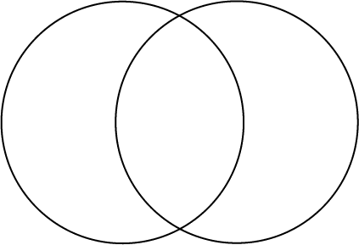
Use your Form of Religious Expression information pages to compare the forms used in two traditions in the Venn diagram below:
Tradition:

Form of religious expression:

Tradition:

Form of religious expression:
What they have in common
Criterion of religious culture: Contextualized knowledge of forms of religious expression
Criterion of religious culture: Consideration of various ways of thinking, being or acting that are relevant to the context
Comparison Summary and Conclusions
Name: _______________________________________ Date: ___________
- Use the information on your Venn diagram to summarize your comparison and draw one or more conclusions from your findings.

Similarities between the forms of religious expression:

Differences between the forms of religious expression:

Conclusions:

Self-Evaluation
Name: _______________________________________ Date: ___________

For each statement, check the appropriate box and give an example if possible.
A lot Somewhat Not at all
1. I worked independently.

Example:

2. I used valid resources and tried to make sure my information was correct.

Example:
3. I found similarities and differences between two forms of religious expression.

Example:
4. I drew some conclusions from my comparison.

Example:
5. My work demonstrates my understanding of the phenomenon of religion.

Example:

