Ethics and Religious Culture

Learning and Evaluation Situation

Celebrations of Light
Elementary Cycle One
Religious Culture and Dialogue

Teacher tools

NOTE
This learning and evaluation situation is a working document, which is therefore subject to change. It may be adapted as needed depending on the student’s social environment, the planning of teaching and learning activities, the integration of the Ethics and Religious Culture program and the Québec Education Program, etc.
Table of Contents

Section 1: Presentation of the Learning and
Evaluation Situation p. 3

Section 2: Suggested Procedure p. 4

Section 3: References for the Students and the Teacher p. 11

Section 4: Teacher Tools p. 14

Section 5: Table of Program Content p. 30

Please note that all graphics are from Microsoft Word and Microsoft Office Online and are intended for classroom use only.
Section 1: Presentation of the Learning and Evaluation Situation
Demonstrates an understanding of the phenomenon of religion
Celebrations of Light
Engages in dialogue

Aim
To help students discover family celebrations, rites and rituals, and make them aware of the fact that families celebrate key events in a variety of ways. To help students explore forms of celebration in their own families and in those of others.
Forms of dialogue: conversation, discussion, narration

Learning Context

Sam has just come from his town’s annual Winter Carnival. There was a special event after dark called “Lighting Up the Night,” a parade with coloured lights, sparklers and even a fireworks display. Sam loved the bright colours lighting up the night sky, and although he is sometimes afraid of the dark, he felt safe and happy with his family nearby. In winter the nights are long because it gets dark very early. Many celebrations that take place in winter involve bringing light to the dark, or “Lighting Up the Night.” In this LES we will look at two different ones.
Work Expected of Students

Classroom display of elements of celebrations involving light from two different traditions
Theme:
Celebrations

Possible Student Tasks

Present and discuss the learning context. Have a conversation about celebrations involving light.
Key feature: Explores forms of religious expression
Criterion 1

Read about a traditional winter celebration involving light. As a class, identify the key elements and discuss the use of light in the celebration.
Key feature:
Interacts with others

Criterion 2

Explore a different celebration involving light from another tradition. Identify the key elements and discuss the use of light in this celebration.
Key feature:
Considers various ways of thinking, being and acting

Review the key elements from the two traditions. As a class, brainstorm the elements to be included in the display; have students create an element of one of the traditions to add to the display.

Reflect on their learning about different celebrations involving light and make connections with other celebrations and with the students’ immediate environment.
Key feature:
Makes connections between forms of religious expression and the social and cultural environment

Cross-curricular competency:
Uses information

Section 2: Suggested Procedure Duration: 3 hours 15 minutes
Preparation Phase (30 MINUTES)

Present and discuss the learning context. Have a conversation about celebrations involving light.

Key feature of religious culture: Makes connections between forms of religious expression and the social and cultural environment
Key features of dialogue: Organizes his/her thinking; Interacts with others
Criterion of dialogue: Adequate use of related content involving interaction with others
The teacher: | The students:
- presents the learning context  - helps students identify the key elements of the story (see Visual Cues, Teacher Tools, p. 15)  - displays answers in visual format (board or chart paper)  - leads discussion of light/dark: what can happen in the dark, of different kinds of light, of the importance of light and what light means to us, with special emphasis on feelings aroused by dark/light  - explains that for these reasons lights are often part of celebrations -discuss and brainstorm examples (e.g. birthday candles, sparklers, fireworks, outdoor Christmas lights, etc.)  (Teacher can use pictures as a visual aid –see Teacher Tools, p. 16)  - invites students to draw an example of a celebration that involves a form of light (ideally from their own experience) using My Drawing of A Celebration (Student Booklet, p. 3)  - reminds students of rules for fostering dialogue, such as waiting one’s turn to speak, listening, eye contact, etc.  - pairs or groups students and invites them to converse about their drawings  - observes students as they interact using Observation Grid for Student Interaction (Teacher Tools, p. 27) | - listen to the learning context and access prior knowledge of winter celebrations  - offer suggestions of key elements (who, what, where, when, why, how)  - reflect on the feelings associated with dark/light and participate in discussion  - brainstorm examples of celebrations involving light  - draw a picture of a celebration involving light  - with a partner, display and converse about their drawings  - respect rules for fostering dialogue by listening to one another and asking questions for clarification
Required materials: Visual Cues for Key Elements (Teacher Tools, p. 15)● Blackboard or chart paper for recording key elements● Examples of Secular Celebrations Involving Light (Teacher Tools, p. 16)● My Drawing of a Celebration (Student Booklet, p. 3) Observation Grid for Student Interaction (Teacher Tools, p. 27)
Record keeping: Collective answers of key elements of the learning context ● My Drawing of a Celebration

Performance Phase (2.5 hours)

Read about a traditional winter celebration involving light. As a class, identify the key elements and discuss the use of light in the celebration. (45 minutes)
Key feature of religious culture: Explores forms of religious expression
Key features of dialogue: Organizes his/her thinking; Interacts with others
Criterion of religious culture: Contextualized knowledge of forms of religion expression
The teacher: | The students:
- reminds students of conversation about celebrations, emphasizing elements of light/darkness  - introduces the idea of religious and spiritual celebrations using forms of light  - reads provided text (or book from classroom if available) about a traditional celebration that incorporates a ritual involving light, including pictures (Provided Texts, Provided Pictures, Teacher Tools, pp. 17-24)  - invites students to share with the class any previous knowledge or experience of that celebration  - aids students in identifying the key elements of the celebration (using Visual Cues if needed)  - displays answers in a visual format (board or chart paper)  - leads discussion of how light is used in this celebration  - allows time for students to consolidate new knowledge and to draw the ritual involving light using Celebrations of Light, Part 1 (Student Booklet, p. 4) | - reflect on elements of light and darkness in celebrations  - listen to the text  - access prior knowledge or experience with this celebration  - share with the class and listen to others  - offer suggestions of the key elements of the celebration (who, what, where, when, why, how)  - reflect on the use of light in this celebration  - consolidate learning by drawing the ritual involving light using Celebrations of Light, Part 1
Note to teacher #1: There are 4 traditions offered in this LES. It is recommended that the teacher choose 2 to explore. In order to respect the program’s preponderance regarding religious traditions, one of the choices must involve a Christian or Jewish celebration.
Note to teacher #2: Students must keep Celebrations of Light for the next activity
Required materials: Provided texts and pictures (Teacher Tools, pp. 17-24)● Visual Cues for Key Elements (Teacher Tools, p. 15)● Board or chart paper for recording key elements ● Celebrations of Light –Part 1 (Student Booklet, p. 4)
Record keeping: Celebrations of Light – Part 1

Explore a different celebration involving light from another tradition. Identify the key elements and discuss the use of light in this celebration. (45 minutes)
Key features of religious culture: Explores forms of religious expression;
Considers various ways of thinking, being and acting
Key feature of dialogue: Organizes his/her thinking
Criterion of religious culture: Contextualized knowledge of forms of religion expression
The teacher: | The students:
- reads provided text or classroom book about a different traditional celebration that incorporates a ritual involving light  - invites students to share with the class any previous knowledge or experience of that celebration  - aids students in identifying the key elements of the celebration  - leads discussion of how light is used in that celebration (see Note to teacher below)  - allows time for students to consolidate new knowledge and to draw the ritual involving light using Celebrations of Light, Part 2 (Student Booklet, p. 4) | - listen to the text  - access prior knowledge or experience with this celebration  - share with the class and listen to others  - offer suggestions of the key elements of the celebration (who, what, where, when, why, how)  - reflect on the use of light in the celebration  - complete Celebrations of Light – Part 2
Note to teacher: Discussion may touch on the symbolic dimension of light (see Objects, Symbols, Signs and Rituals, Teacher Tools, p. 25 and Objects, Symbols, Words and Rituals in Some Celebrations Involving Light, Teacher Tools, p. 26)
Required materials : Provided texts and pictures (Teacher Tools, pp. 17-24)● Visual Cues for Key Elements (Teacher Tools, p. 15)● Celebrations of Light – Part 2 (Student Booklet, p. 4)
Record keeping: Celebrations of Light – Part 2
Performance Phase (cont.)

Review the key elements from the two traditions. Brainstorm as a class the elements to be included in the display; students create an element of one of the traditions to add to the display.
(I hour)
Key feature of religious culture: Considers various ways of thinking, being and acting.
Key features of dialogue: Organizes his/her thinking; Interacts with others
Criterion of religious culture: Contextualized knowledge of forms of religion expression
Criterion of dialogue: Adequate use of related content involving interaction with others
The teacher: | The students:
- reviews the key elements of the celebrations covered in class  - invites students to suggest elements (pictures) to be displayed for each celebration (Example: Hanukkah – playing dreidel, lighting the hanukiah, eating latkes, etc. Use provided pictures for inspiration if necessary.)  - writes the suggested elements on cards or slips of paper  - pairs or groups students and distributes cards to the groups, explaining the element that they will create  - allows time for students to discuss procedure and determine who will draw and who will write the labels or text  - provides art materials and allows time for students to create their element to display  - ensures that the name of the celebration and the tradition of origin appear on the display  - displays finished elements and labels on wall or table  - invites students to complete Peer Evaluation of Process (Student Booklet, p. 5) | - reflect on the key elements of the celebrations  - offer suggestions as to what should be included in the display, based on key elements  - with a partner, ensure understanding of element to be created and decide who will do what (draw picture or write label)  - with partner, create contribution to display  - reflect on work with partner using Peer Evaluation of Process
Note to teacher #1: The students with stronger writing skills may be designated the ‘scribe’, to copy the text for labels for the artist’s drawings.
Note to teacher #2: Students can simply draw or paint their contribution, but with adequate time and materials there are easy 3D crafts that can be made – see References, Teacher Tools, p. 13).
Required materials: Cards or slips of paper on which to write elements to be displayed ● Art materials● Peer Evaluation of Process (Student Booklet, p. 5)
Record keeping: Student production for the display● Peer Evaluation of Process

Integration Phase (45 minutes)

Reflect on their learning about different winter celebrations involving light and make connections with other celebrations and with the students’ immediate environment.
Key features of religious culture: Explores forms of religious expression;
Makes connections between various forms of religious expression and the social and cultural environment;
Considers various ways of thinking, being and acting.
Key feature of dialogue: Organizes his/her thinking; interacts with others
Criterion of religious culture: Consideration of various ways of thinking, being or acting that are relevant to the context
Criterion of dialogue: Adequate use of related content involving interaction with others
The teacher: | The students:
- pairs students who worked on different traditions, asks them to explain to each other their production in the context of the celebration  - observes students’ interaction using Observation Grid for Student Interaction (Teacher Tools, p. 27)  - explains that light is used in many other celebrations than the ones studied – (pictures of the two traditions not covered can be introduced here); invites discussion of students’ previous knowledge and experience with these or other celebrations involving light (see Provided pictures, Teacher Tools, pp. 17-24)  - invites students to share with the class any evidence of these or other celebrations involving light that they have observed in their immediate environment (ongoing throughout the LES)  - allows time for students to complete Reflection on Learning (Student Booklet, p. 6) | - meet with a partner that worked on the other tradition  - explain their contribution to the display and remembered elements of the celebration  - listen to their partner’s explanation of their contribution and the elements of the celebration  - ask questions if necessary  - reflect on prior knowledge or experience with other celebrations involving light, including secular ones  - share with the class any observed evidence of these celebrations (ongoing)  - complete Reflection on Learning
Required materials: Provided pictures (Teacher Tools, pp. 17-24)● Reflection on Learning (Student Booklet, p. 6)
Record keeping: Reflection on Learning

Paths for progressing within a group of learning and evaluation situations:

- Winter solstice celebrations in Native Spirituality and other traditions
- Stories related to religious celebrations
Section 3: References for the Students and the Teacher

Suggested books:

Conrad, Heather. Lights of Winter: Winter Celebrations Around the World. Lafayette: Lightport Books, 2001.
Heiberg, Jeanne. Advent Arts and Christmas Crafts. Mahwah, NJ: Paulist Press, 1995.
Holub, Joan. Light the Candles: A Hanukkah Lift-the-Flap Book. London: Puffin, 2002.
Katz, Karen. My First Chinese New Year. New York: Henry Holt Co., 2004.
Mackall, Dandi Daley. Who’ll Light the Chanukah Candles? New York: Little Simon, 2003.
Prezler & Jane. Diwali: Hindu Festival of Lights. Mankato, MN: Capstone Press, 2006.
Roberts, Cindy. Chinese New Year For Kids. New York: Chinasprout Inc., 2002.
Rosen, Michael J. Chanukah Lights Everywhere. Orlando: Harcourt Books, 2001.
Silverman, Maida. Festival of Lights: The Story of Hanukkah. New York: Aladdin Paperbacks, 1999.
Stockman, Jack. The Advent Book.. Wheaton, IL: Crossway Books, 2008.
Trueit, Trudi Strain. Diwali. Toronto: Scholastic, 2007.
Zucker, Jonny. Lanterns and Firecrackers: A Chinese New Year Story. Hauppauge, NY: Barron’s Educational Series, 2003.
Zucker, Jonny. Lighting a Lamp: A Diwali Story. Hauppauge, NY: Barron’s Educational Series, 2004.

General Web Sites:
http://teachers.teach-nology.com/index.html Links to sites for teachers
http://minnesota.publicradio.org/display/web/2006/12/11/loopculture/ Interesting facts on light in celebrations
http://ezinearticles.com/?The-Religious-Significance-of-Candles&id=825657 Candles in various religious traditions
http://www.ladysmithfol.com/pictures.html Secular lights display
http://www.history.com/genericContent.do?id=53343 Excellent videos on major holidays

Advent:
http://www.cptryon.org/prayer/child/adv.html Advent candles
http://holidays.net/christmas/advent_wreaths.htm
http://www.edhelper.com/ReadingComprehension_38_77.html Advent & Hannukah

Hanukkah:
http://www.holidays.net/chanukah/menorah.html
http://www.holidays.net/chanukah/menorah_light.htm
http://www.holidays.net/chanukah/didyouknow.htm
http://www.ort.org/ort/edu/festivals/hanukkah/index.html
http://www.history.com/minisites/hanukkah/
http://www.bl.uk/learning/cult/sacred/stories/ Hanukkah, Diwali (Rama & Sita)

Diwali:
http://www.diwalifestival.org/
http://www.diwalifestival.org/know-diwali.html Teacher info
http://www.diwalifestival.org/the-tradition-of-lights.html
http://www.balagokulam.org/ppt/deepawaliutsav.ppt PowerPoint
http://www.fathertimes.net/diwaliannewyear.htm
http://hindunet.com/festivals/deevali/

Chinese New Year:
http://www.educ.uvic.ca/faculty/mroth/438/CHINA/chinese_new_year.html
http://www.history.com/minisite.do?content_type=Minisite_Generic&content_type_id=53326&display_order=2&mini_id=53324 video of Chinese New Year

Crafts:
http://www.first-school.ws/activities/bible/advent1.htm Advent craft
http://www.first-school.ws/activities/crafts/holiday/christmas-candle.htm Candle craft
http://crafts.holidays.net/categories.php?id=14 Hanukkah crafts
http://www.first-school.ws/activities/crafts/holiday/hanukkah-candle.htm candle craft
http://www.holidays.net/chanukah/dreidel.html Make your own dreidel
http://www.pitara.com/activities/colouring/14.htm Diyas
http://www.pitara.com/activities/colouring/20.htm Houses decorated for Diwali
http://www.enchantedlearning.com/crafts/chinesenewyear/lantern/ Making a paper lantern
http://www.enchantedlearning.com/crafts/fireworks/ Fireworks craft

Section 4: Teacher Tools
Content Tools

- Visual Cues for Key Elements p. 15
- Examples of Secular Celebrations Involving Light p. 16
- Provided Texts and Pictures pp. 17-24
- Symbols, Objects, Signs and Rituals p. 25
- Objects, Symbols, Words and Rituals in Some Celebrations Involving Light p. 26

Evaluation Tools
- Observation Grid for Interaction p. 27
- Rubric for the Dialogue Competency p. 28
- Rubric for the Religious Culture Competency p. 29

Please note that all rubrics may be used as guidelines for evaluation purposes but they have not yet been validated. They are included in this LES as a working document.

Visual Cues for Key Elements
About a Story or Situation
(May be put onto flash cards)
Who?  (characters) | What?  (action)
Where?  (setting)  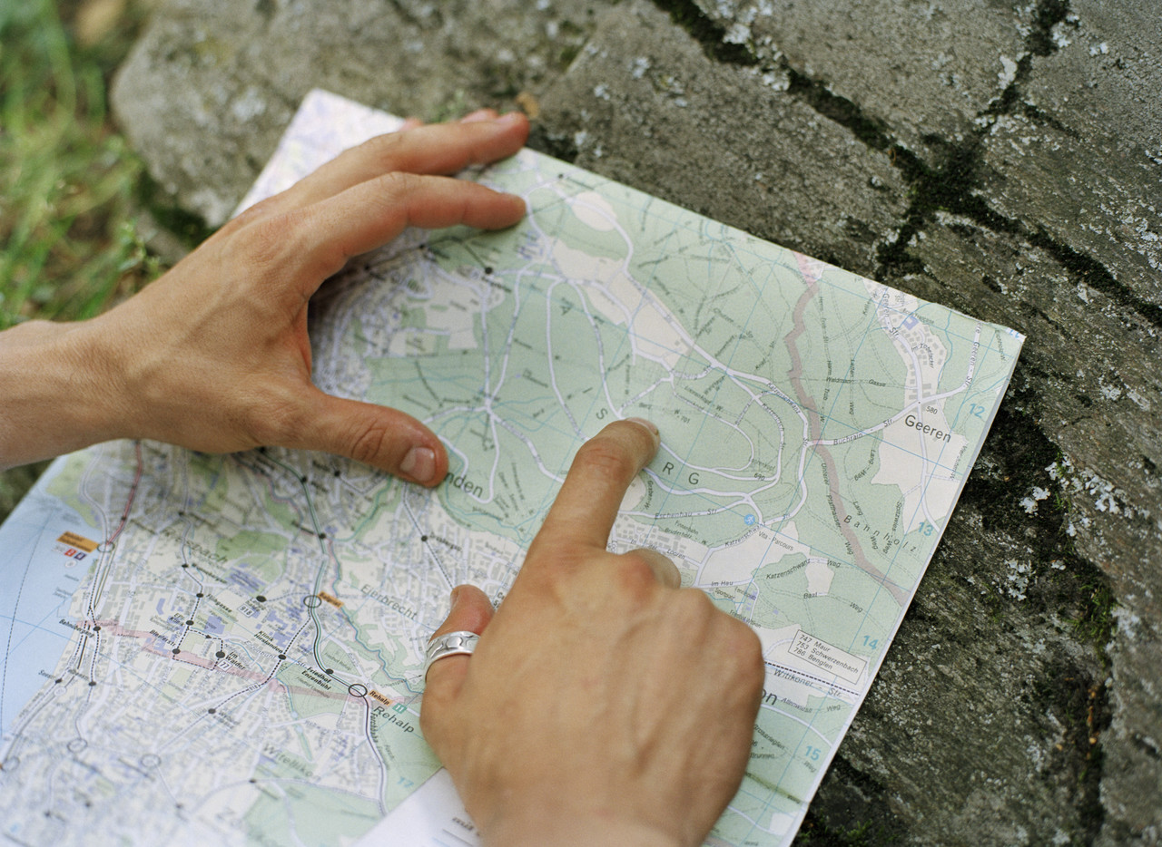 | When?  (time)  
Why?  (theme) | How?  (methods)
Examples of Secular Celebrations Involving Light


Birthday candles Sparklers Special dinners

Fireworks Olympics
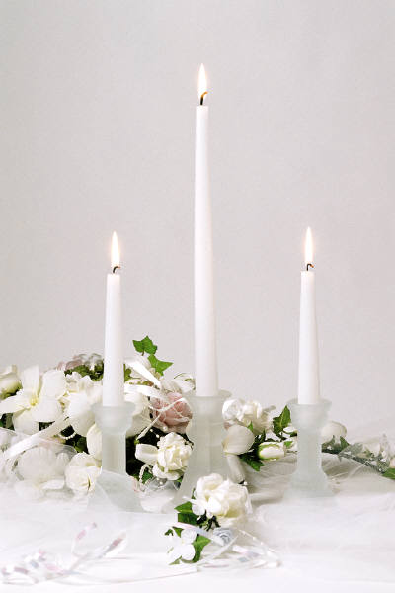
Weddings Bonfires

(Provided Texts)
 Advent / Christmas

Advent means “arrival.” Many Christians celebrate Advent in the weeks leading up to Christmas, the arrival of Jesus. Advent starts on the Sunday closest to November 30, and continues for four Sundays until Christmas day.

A wreath made out of pine tree branches is set out with four candles in it, and a white one in the middle.

Every week for four weeks, leading up to Christmas, another candle is lit, prayers are said, verses are read from the Bible, and special hymns are sung. On the first Sunday, one candle is lit: this is the candle of hope. The next Sunday, the candle of hope is relit, and a second candle is also lit, the candle of peace. The third Sunday, the third candle represents joy. The last Sunday in Advent represents love, when all four candles are lit.
Finally on Christmas Eve or Christmas Day, the white Christ candle in the middle is lit, to represent Jesus’ birth. Sometimes all the other candles are replaced by white ones too.

The Advent wreath is usually lit in church, but sometimes people have them in their homes. In some places, the wreath is worn like a crown, or candles are put on the Christmas tree; this is rarely done here anymore as it is considered too dangerous.

Even though it is not part of the religious celebration of Advent, many people use Advent calendars, with little doors that open for every day of December leading up to Christmas. Many people also decorate their homes, inside and outside, with colourful lights during Advent.

Advent / Christmas

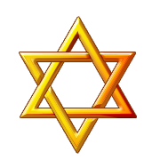 Hanukkah

Hanukkah is the Jewish Festival of Lights, which lasts eight days. Hanukkah begins four days before the new moon, which is the darkest night of the month.

Every night during Hanukkah another candle is lit in the hanukiah, a special candle-holder with nine branches. The extra candle in the center is the helper candle, which is used to light the others. The candles are lit from right to left, and burn for at least 30 minutes after the stars appear in the night sky. This is done at home, and the hanukiah is usually displayed in a window for all to see. Special prayers are said for each night.

The story of Hanukkah takes place long ago, when King Antiochus tried to stop the Jews from worshipping and placed a statue of Zeus in the Jewish temple. The Jews, led by Judah Maccabee, defeated the king and destroyed the statue of Zeus. They cleaned up the temple and wanted to make it holy again. To do this they lit a special lamp that was meant to burn forever, but they only had enough oil to light the lamp for one night. It took eight days to go and get more oil, which is when a miracle happened: the lamp stayed lit for all eight days, even without oil. Hanukkah is a remembering of the Jewish victory in taking back their temple, and of the miracle of the oil, which is why the celebration lasts eight nights.

Traditional Hanukkah foods are usually fried in oil, because of the miracle of the oil. Potato pancakes called latkes and fried donuts called sufganiyot are usually served.

During Hanukkah children play with a dreidel, a four-sided top with Hebrew letters on the sides. The children play for chocolate gold coins called gelt.



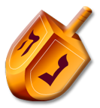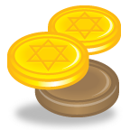

Diwali

Diwali is an ancient Hindu festival of joy and happiness, a celebration of good winning over evil. Diwali is a five day festival that comes in October or November. The third day is called the Festival of Lights, and takes place on the darkest night, when there is no moon.

Diwali comes from a Sanskrit word meaning “a row of lights”. People light little clay lamps filled with oil called diyas all around the inside and outside of their homes. Bottles of coloured water are sometimes placed in front of the lights to give them colour. New clothes are worn, special prayers are said, songs are sung and gifts and cards are exchanged. Fireworks are set off in the streets.

Different stories are celebrated at Diwali in different parts of India. In the north, the festival celebrates the homecoming of Lord Rama, after being sent to live in the forest for fourteen years. He defeated the demon Ravana and returned to become the king; people joyfully lit candles and lights to welcome him back.

In the south, the festival celebrates the Goddess Durga’s victory over an evil demon named Narakasura. Elsewhere the festival honors Lakshmi, Goddess of wealth, or the Goddess Kali. All of the festivals celebrate the power of goodness, truth, and knowledge over darkness and evil.

Diwali

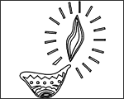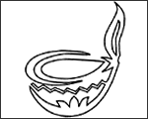

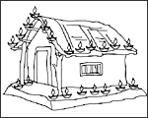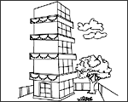
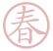Chinese New Year

Chinese New Year (or Spring Festival) is a two week festival that takes place in late January or early February. The celebration starts with the new moon, and ends with the full moon 15 days later.

The last day of the celebration is called the Festival of Lanterns; that night lanterns are lit in all the streets in a large parade. Firecrackers are set off and paper lanterns on wheels in the shape of the animal of the year are paraded down the street.

Sometimes the lanterns are shaped like rabbits, to remember the legend of the Goddess Chang E, who jumped to the moon with her rabbit. It is said that people with good, pure hearts can see the Goddess and her rabbit on the moon on this special night.

Dragon dances are also performed, as the dragon represents good luck. The colour red also means good luck and happiness; most people wear red and put up red decorations. Children are given money in special red envelopes called hong bao.

Walls and doors are decorated with poetic messages written on red paper. Flowers, oranges and candies are set out to bring good luck, happiness and a sweet new year.

Families share special meals with many courses. Fish and chicken are served with the head and tail on the plate, to mean a good beginning and end of the year. Offerings and prayers are sometimes offered to household gods and family ancestors.
Chinese New Year

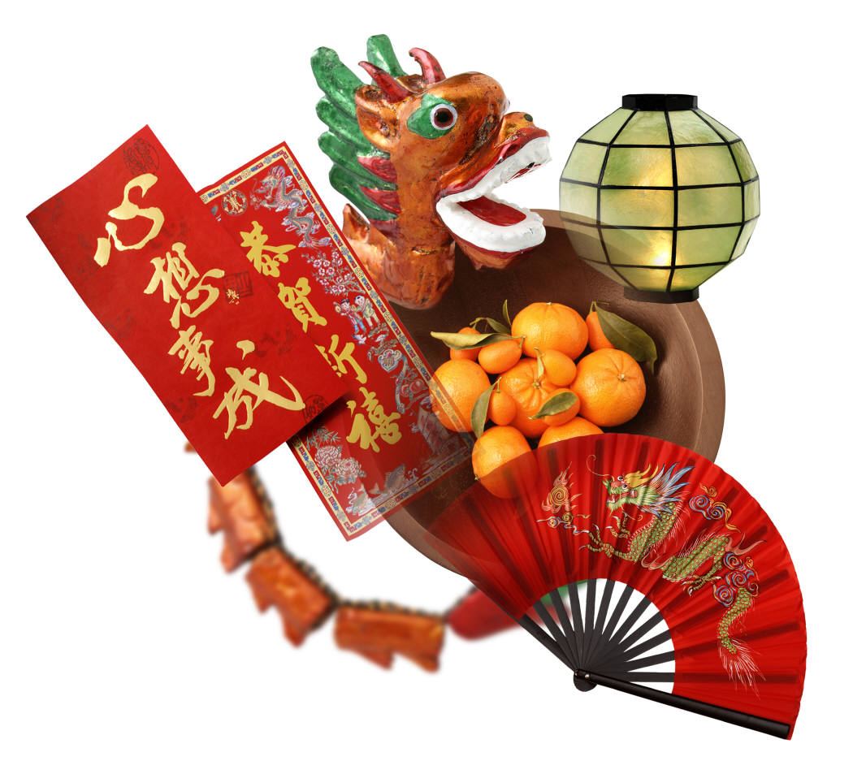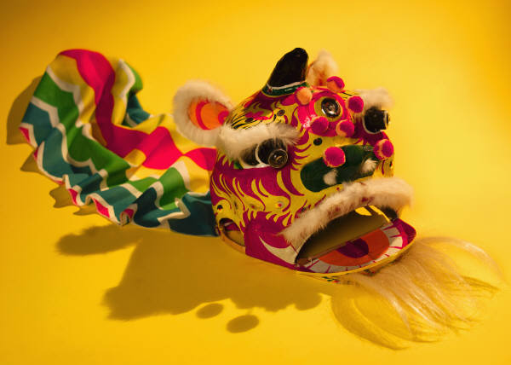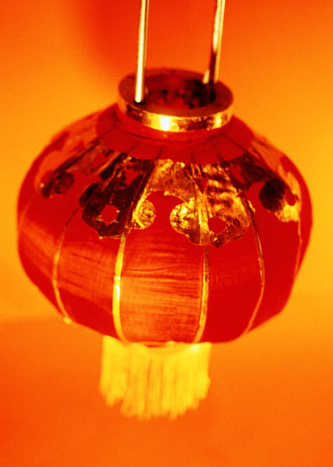

Symbols, Objects, Signs and Rituals

What is an object?
1: something that can be perceived by the senses: “I see an object in the distance.”
Objects can become symbolic if a religious, cultural or social group agrees upon it and it becomes accepted over time.

What is a sign?
1: something having a generally understood meaning and used in place of words.
For example: A stop sign means STOP.

What is a symbol?
1: something concrete (an object or a picture) that stands for or suggests another thing that cannot in itself be pictured or shown.
For example: The Star of David is a symbol of Judaism. The cross is a symbol of Christianity.
A symbol is usually something that has been agreed upon by members of a cultural, religious or social group.

What is a ritual?
1: an established form for a ceremony
2: a: a system of rites b: a ceremonial act or action c: a formal and customarily repeated act or series of acts

References from the Merriam-Webster’s Word Central Web site
<http://www.wordcentral.com/home.html>
Objects, Symbols, Words and Rituals
in Some Celebrations Involving Light
N.B. The following are simple examples to help students understand the symbolic use of light through objects and accompanying rituals.
Objects | Symbols of | Words | Rituals  (the action)
Hanukiah  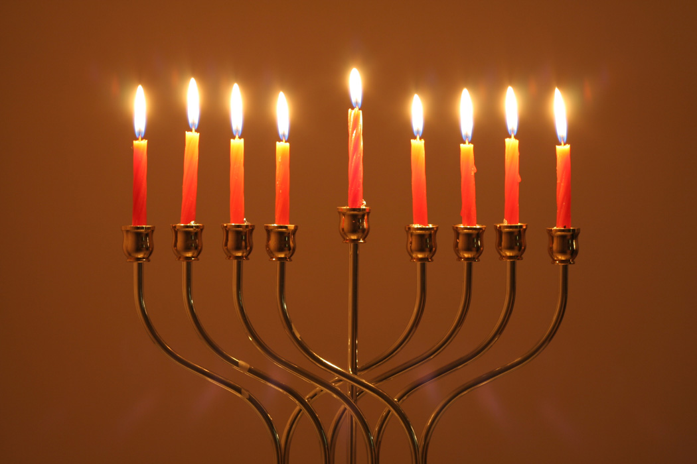 | Victory  The power of the divine | Prayers | Lighting one candle per night for eight nights
Advent Wreath | Hope, joy, peace, love | Bible readings | Lighting one candle per week for four weeks until Christmas
Diyas | Goodness, knowledge, truth | Prayers | Rows of lights set out inside and outside
Lanterns | Good luck | Auspicious greetings | Parade in the streets at night
Observation Grid for Student Interaction in Dialogue During Discussion or Conversation with a Peer or Within a Group

Student’s Name  - = exceeds expectations  - = meets expectations  - = does not meet expectations | Expresses his/her preferences, feelings or ideas | Listens attentively to others | Asks questions for clarification | Explores ways to overcome obstacles to dialogue

Descriptive Rubric for the Evaluation of the Competency Demonstrates an understanding of the phenomenon of religion

Celebrations of Light – Elementary Cycle 1

 | Name: Date:
 | A | B | C | D | E
Evaluation criterion: Contextualized knowledge of forms of religious expression
Can the student name the key elements of a celebration studied in class? | Names most of the elements | Names several of the elements | Names some of the elements | Names a few of the elements | Names one or none of the elements
Can the student identify the form of religious expression studied in the context of a tradition? | Accurately and clearly identifies expression within context | Identifies the expression within the context | Minimally identifies the expression out of context | Partially identifies the expression | With help, can identify the expression
Evaluation criterion: Consideration of various ways of thinking, being or acting that are relevant to the context
Can the student name elements from several celebrations involving light? | Names most or all of the elements | Names several of the elements | Names some of the elements | Names a few of the elements | Names one or none of the elements
Teacher’s comments:

Descriptive Rubric for the Evaluation of the Competency Engages in dialogue

Celebrations of Light – Elementary Cycle 1

 | Name: Date:
 | A | B | C | D | E
Evaluation criterion: Adequate use of related content involving interaction with others
Does the student listen attentively to others? | Consistently listens to others and offers encouragement | Listens to others, indicates listening through non-verbal cues | Usually listens to others | Occasionally listens to others | Needs guidance in order to listen to others
Does the student express his/her ideas? | Clearly expresses his/her ideas | Expresses his/her ideas | Expresses his/her ideas in an unclear manner | Has difficulty expressing his/her ideas | Needs guidance to express his/her ideas
Does the student ask for clarification if he/she doesn’t understand? | Consistently | Usually | Often | Sometimes | Rarely
Is the student able to overcome obstacles to dialogue? | Consistently | Usually | Often | Sometimes | Rarely
Teacher’s comments:

Section 5: Table of Program Content

Targeted Subject-Specific Competencies
Demonstrates an understanding of the phenomenon of religion
Key features | Criteria
Explores forms of religious expression | Contextualized knowledge of forms of religion expression
Makes connections between forms of religious expression and the social and cultural environment | X
Considers various ways of thinking, being and acting | Consideration of various ways of thinking, being or acting that are relevant to the context
Theme and related content:
Family celebrations (Celebrations)
Engages in dialogue
Key features | Criteria
Organizes his/her thinking | X
Interacts with others | Adequate use of related content involving interaction with others
Develops a point of view | X
Content regarding the practice of dialogue:
Forms of dialogue: Discussion, narration
Means for developing a point of view: Description
Means for examining a point of view: recognize and examine judgments and processes that may hinder dialogue
Targeted Cross-Curricular Competency
Uses information

Broad Area of Learning

Citizenship and Community Life

