TEACHER’S DOCUMENT

ELEMENTARY CYCLE THREE
2nd YEAR OF THE CYCLE

TO INTERACT
WITH OTHERS IN DIFFERENT
PHYSICAL ACTIVITY SETTINGS

LEARNING AND EVALUATION SITUATION

My Kinball Team

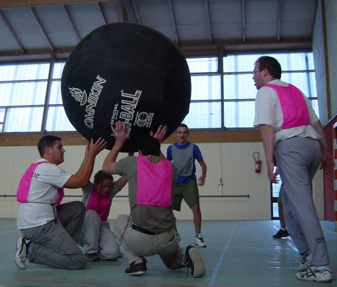

SEPTEMBER 2006

Titre of activity: My Kinball Team
Elementary Cycle Three  1st year of the cycle | Number of periods:  7 sixty-minute periods
Author: Pierre Gagnon, physical education teacher | Subject-specific competency:  To interact with others in different physical activity settings
Summary of the learning and evaluation situation

The teacher divides the students into mixed teams. Each team plans offence and defence strategies and applies them in a group activity in a common space. They apply the rules of ethics that have been agreed upon. They communicate effectively about the game in a way that is adapted to their team. They adjust their movements and actions after discussing them with their teammates. During games, they apply the strategies they planned. They do a self-evaluation after the teacher makes his or her observations.

Evaluation criteria | Observable aspects
Active participation in developing the plan of action | Suggests ideas for preparing strategies (the plan).  Listens to others’ ideas with a view to developing strategies.
Adaptation of movements or actions to the situation | Applies the strategies developed by the team.  Implements the adjustments made to the plan.
Adaptation of verbal or nonverbal communication to the situation | Communicates effectively during games.
Behaviour consistent with ethical rules | Applies the rules of ethics.
Identification of desirable improvements | With his/her teammates, identifies the strengths and weaknesses of the plan.  With his/her teammates identifies ways of adjusting the plan.

Essential knowledge
- Principles of communication: being understood by the person with whom one is interacting, being receptive to others’ messages
- Methods of communication
- Principles of synchronization
- Roles
- Action rules in group activities in a common space
- Behaviour: ethics-related aspects

Period 1

Presentation of the challenge

Explain that the students will be working in teams to develop kinball strategies as follows: “You will be placed in mixed teams of four and will stay in the same team for the entire learning situation, which will last at least seven periods. Using the team document, you will identify offence and defence strategies. Your method of communication with your teammates is extremely important in applying your strategies. You will apply the rules of ethics chosen by the class. At different times, you will evaluate your teammates’ ability to help plan strategies. As a team, you will identify the strengths and weaknesses of your plan and determine how to adjust it in order to improve your strategies, based on those of your opponents.”

APPENDIX 1

STUDENT’S PROCESS
(What you will be evaluated on)

COLLABORATE (active participation in the development of the plan of action)

- I suggest ideas for preparing my team’s offence and defence strategies.

- I listen to others’ ideas.

PERFORM (participation in the application of the plan of action)

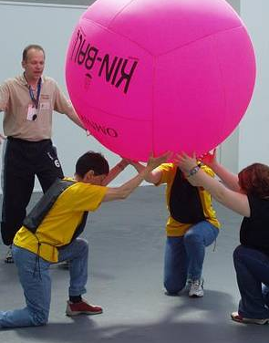
- During games, I apply the plan prepared by my team.

- I follow the rules of ethics in all situations.

- I communicate effectively with my teammates during games.

- With my teammates, I implement the adjustments made to our plan.

EVALUATE (the implementation of the plan of action)


- With my teammates, I identify the strengths and weaknesses of the plan.

- With my teammates, I identify desirable improvements.

APPENDIX 2
RULES OF ETHICS

Rules | My responsibility
  Respect for my teammates | - I give each player an opportunity to perform movements or actions  - I encourage my teammates  - I accept my teammates’ mistakes  - I shake hands with my teammates after the game
Respect for my opponents   | - I am not physically or verbally violent  - I shake hands after the game  - I use appropriate language on the court
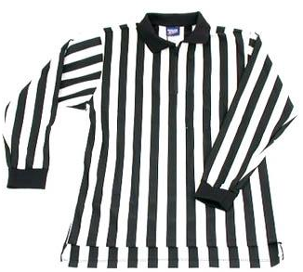  Respect for the  referee | - I accept his or her decisions without arguing
Friendly atmosphere   | - I follow the rules of the game  - I remain calm on the bench  - I drink water during breaks
Students’ suggestions:

APPENDIX 3

COMMUNICATE WITH YOUR TEAMMATES DURING GAMES

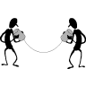
- Call the player’s number.
- Call the player’s name.
- Use a code.
- If you are the captain, use hand signals to identify a strategy.
- Direct the player using signs.
- Talk to the others on the court.
- Look the player in the eye.

To pass the ball
To prepare for a strategy
To take position

APPENDIX 4

OFFENCE STRATEGIES DEVELOPED BY STUDENTS

- Use misleading messages.
- Hit the ball into free areas.
- Fake a hit.
- Fake a double hit.
- Move under the ball.
- Quickly re-serve the ball.
- Other:
___________________________________________________________________________________________________________________________________________________________________________________________________________________________________________

APPENDIX 5

DEFENCE STRATEGIES DEVELOPED BY STUDENTS

- Surround the ball.
- Form a square.
- Form a half-circle.
- Form a diamond along a wall.
- Other:
__________________________________________________________________________________________________________________________________________________________________________________________________________________

APPENDIX 6

ACCEPTABLE CALLS

- OMNIKIN RED – OMNIKIN RED
- RED – OMNIKIN – RED
- OMNIKIN YELLOW – YELLOW
- RED – OMNIKIN – YELLOW
- OMNI – OMNIKIN YELLOW

UNACCEPTABLE CALLS

- OMNIKIN RED – OMNIKIN BLUE
- OMNIKIN – OMNIKIN RED
- OMNIKIN YELLOW – BLUE
- OMNIKIN RICHARD (PLAYER’S NAME) – RED
- OMNIKIN – (A COLOUR THAT IS NOT BEING USED)

APPENDIX 7

EVALUATION RUBRIC FOR THE TEACHER

++  SUCCEEDS EASILY  (without help) | +  SUCCEEDS  (with occasional help) | ±  SOMETIMES SUCCEEDS  (with constant help) | -  DOES NOT SUCCEED  (despite constant help)

Observable aspects  My Kinball Team  Class:  Date: | Suggests ideas for preparing strategies. | Listens to others’ ideas with a view to developing strategies. | Plans strategies based on the weaknesses of his/her teammates and opponents. | Applies the strategies developed to the plan. | Implements the adjustments made by the team. | Applies the rules of ethics. | Communicates effectively during games. | With his/her teammates, identifies the strengths and weaknesses of the plan. | Rating

