A Friendly Match
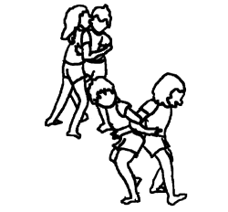

USING INFORMATION GATHERED ON THREE STUDENTS:

- interpret their results
- make a judgment on their level of competency development

SEPTEMBER 2006

EVALUATION RUBRIC FOR THE TEACHER
Competency: To interact with others in different physical activity settings

A Friendly Match – Elementary Cycle Three

Legend for the observable aspects:
++  SUCCEEDS EASILY  (without help) | +  SUCCEEDS  (with occasional help) | ±  SOMETIMES SUCCEEDS  (with constant help) | -  DOES NOT SUCCEED  (despite constant help)

Observable aspects  A Friendly Match  Class:  Date: November 2005 | Chooses at least two forms of combat. | Takes the instructions into account during teamwork. | Takes offensive and defensive action during the tournament. | Applies the rules of ethics. | Performs his/her movements or movement sequences effectively. | In teams of three, identifies possible improvements after the tournament. | Identifies what worked well and what could be used in other situations. | Rating
EDDY | ++ | ++ | ++ | + | ++ | ++ | ++
EDDY | Occasionally criticizes teammates during a match. Participates in the preparation of strategies. Demonstrates leadership during matches. Communicates with his teammates and helps them position themselves and perform different movements or actions.
JULIE | ++ | + | ± | + | ± | ++ | -
JULIE | Has some difficulty listening to others’ ideas. Has difficulty applying the strategies and communicating during a match. Helps her teammates identify the strengths and weaknesses of the plan but cannot identify desirable improvements or elements worth keeping in her process.
FRANK | + | ++ | + | ++ | ++ | ++ | ++
FRANK | Has some difficulty collaborating with teammates. Is sometimes confused with respect to the strategies to be applied (transition from offence to defence).

A: The student succeeds easily.

B: The student succeeds with or without occasional help.

C: The student needs help to succeed.

D: The student has difficulty despite the help given.

NE: Not evaluated

Self-evaluation
A Friendly Match

Student’s name: Julie___________________ Student no.: 11_____

Identify the forms of combat you chose:

1 Japanese wrestling__2 African wrestling_________

Legend:
O: Often S: Sometimes R: Rarely N: Never
OFFENCE
How do you use movements and actions that could help you throw your opponent off balance?
Pushing |  | Pulling |  | Twisting and  reverse twisting
1 | 2 | 1 | 2 | 1 | 2
R | R | R | R | N | N

DEFENCE
How do you use movements or actions that could help you keep your balance?
Adequate distance between support points |  | Low centre of gravity
1 | 2 | 1 | 2
R | R | N | N

What has improved the most since the beginning of the activity?
__________My defence_____________________________________________________

What have you learned since the beginning of the activity that you could use in another context?
_Make more of an effort________________________________________________________
Peer evaluation
A Friendly Match

In teams of three, observe and evaluate three of your classmates.
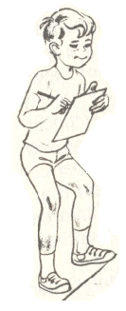
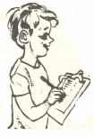
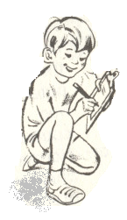
Observers:

- _______________Eric______________________
- _______________Sergei_____________________
- _______________Patrick__________________

Legend:

O: Often S: Sometimes R: Rarely N: Never

Student’s name | Observance of rules of ethics | In his/her defensive actions |  | In his/her offensive actions
Student’s name | Observance of rules of ethics | Keeps his/her centre of gravity low | Keeps a good distance between his/her support points | Pushes | Pulls | Twists and reverse twists
Julie | S | R | R | N | N | N

Self-evaluation

A Friendly Match

Student’s name: ___________________________ Student no.:___

Identify the forms of combat you chose.

1 _____________________________ 2 ________________________

Legend:
O: Often S: Sometimes R: Rarely N: Never
OFFENCE
How do you use movements and actions that could help you throw your opponent off balance?
Pushing |  | Pulling |  | Twisting and  reverse twisting
1 | 2 | 1 | 2 | 1 | 2

DEFENCE
How do you use movements or actions that could help you keep your balance?
Adequate distance between support points |  | Low centre of gravity
1 | 2 | 1 | 2

What has improved the most since the beginning of the activity?
__________________________________________________________________________________

What have you learned since the beginning of the activity that you could use in another context?
__________________________________________________________________________________
Peer evaluation
A Friendly Match

In teams of three, observe and evaluate three of your classmates.
Observers:

- __________________________________________

- __________________________________________

- __________________________________________

Legend:

O: Often S: Sometimes R: Rarely N: Never

Student’s name | Observance of rules of ethics | In his/her defensive actions |  | In his/her offensive actions
Student’s name | Observance of rules of ethics | Keeps his/her centre of gravity low | Keeps a good distance between his/her support points | Pushes | Pulls | Twists and reverse twists

