TEACHER’S DOCUMENT

ELEMENTARY CYCLE THREE
1st YEAR OF THE CYCLE

TO INTERACT
WITH OTHERS IN DIFFERENT
PHYSICAL ACTIVITY SETTINGS

LEARNING AND EVALUATION SITUATION

A Friendly Match

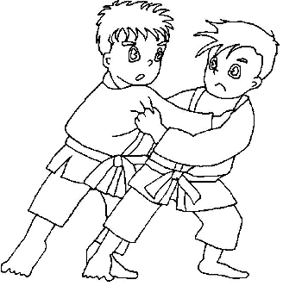

SEPTEMBER 2006

LEARNING AND EVALUATION SITUATION

Title of activity: A Friendly Match
Elementary Cycle Three  1st year of Cycle Three | Number of periods:  6 sixty-minute periods
Authors: Véronique Houde, France Meilleur, Diane Massé | Subject-specific competency:  To interact in different physical activity settings
Summary of the learning and evaluation situation
The students experiment with the following types of wrestling: Japanese, African, Belgian, Swiss, Danish and Canadian. In teams of three, referring to the principles of action rules in combat activities, the students help each other adapt their movements and actions to unforeseeable events in hand-to-hand combat. In order to learn offence strategies, they can choose among the following actions: pushing, pulling and reverse twisting. Defence strategies are based on the following actions: sufficient distance between supports and lowering of the body’s centre of gravity. The students receive feedback from their classmates in order to adjust their strategy. They can evaluate their process throughout the activity.

Evaluation criteria | Observable aspects
Active participation in developing the plan of action | Chooses two forms of combat.  Takes the instructions into account during teamwork.
Adaptation of movements or actions to the situation | Takes offensive and defensive action during the tournament.  Effectively performs his/her movements or sequence of movements.
Behaviour consistent with ethical rules | Applies the rules of ethics.
Identification of desirable improvements | In teams of three, identifies possible improvements after the tournament.
Identification of strategies that are transferable to other situations | Identifies what worked well and what could be used in other situations.

Challenge
“You will choose at least two forms of combat (e.g. African and Danish wrestling) you feel comfortable with. You will then participate in a round robin tournament. During the matches, you will identify movements or actions that could help you throw your opponent off balance, and the movements or actions that could help you keep your balance. You will follow safety rules and the rules of ethics at all times. After every match, you will discuss what worked well and what you could improve in similar activities in the future.”

APPENDIX 1

STUDENT’S PROCESS
(What you will be evaluated on)

COLLABORATE (active participation in the development of the plan of action)


- I prepare my offence and defence strategies, taking my opponents into account.

- I listen to others’ comments.

PERFORM (participation in the implementation of the plan of action)

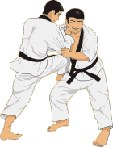

- I perform offensive and defensive actions.

- I perform offensive and defensive actions effectively.

- I follow the rules of ethics in all situations.

EVALUATE (the implementation of the plan of action)


- With my teammates, I identify the strengths and weaknesses of the plan.

- I identify what actions worked well and other situations in which I could use these actions.

APPENDIX 2

SAFETY RULES

Rules |  | My responsibility
1 | Respect for my opponent  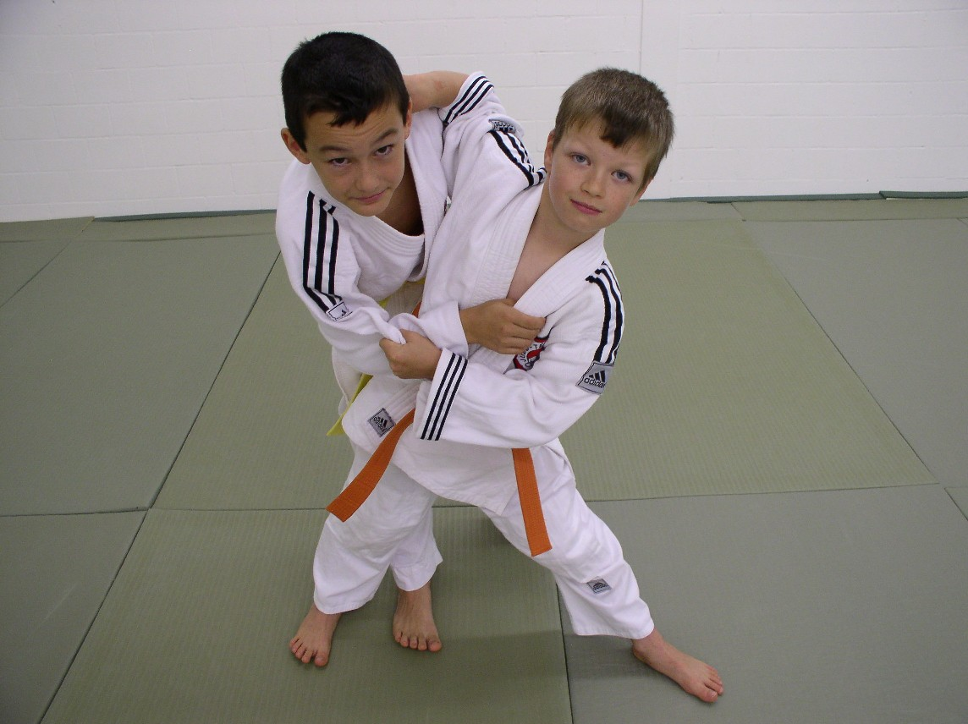 | - Do not hold onto my opponent’s clothes  - Do not grab my opponent by the head or neck  - Remove my shoes  - When I throw my opponent off balance, I keep constant contact with him or her to prevent him or her from getting hurt  - Trim my fingernails to prevent injury  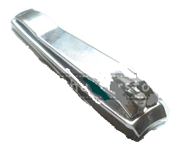
2 | Students’ suggestions:

APPENDIX 3

CODE OF ETHICS

Rules | My responsibility
Self-respect | - I enjoy the friendly competition.
Respect for my opponent | - Bow at the beginning and end of the match  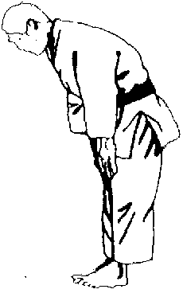  (This means that our intentions are pure and respectful.)
Respect for officials | - Accept his/her decisions without arguing  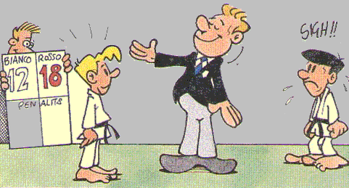
Students’ suggestions:

APPENDIX 4

OFFENSIVE ACTIONS

Legend: TORI = attacker UKE = collaborator

PUSHING
Two participants
- Starting position on all fours
- Tori and Uke do not stand up
- Tori pushes Uke outside the circle

Three participants
- The observer checks whether Tori PUSHES Uke effectively
- He/she keeps score (referee)

PULLING
Two participants
- Starting position on all fours
- Tori and Uke do not stand up
- Tori PULLS Uke outside the circle

Three participants
- The observer checks whether Tori PULLS Uke effectively.
- He/she keeps score (referee)
TWISTING AND REVERSE TWISTING

TWISTING:
Rotating action caused by pushing on one side and pulling on the other, while facing the opponent

REVERSE TWISTING:
Same as twisting, but while trying to get the opponent in front of you
APPENDIX 5

JAPANESE WRESTLING
The opponents stand facing each other, arms extended, hands on each other’s arms. You must throw your opponent off the mat by pushing, pulling, twisting or reverse twisting.

APPENDIX 6

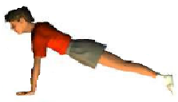
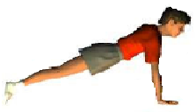
AFRICAN WRESTLING
In push-up position, use your hands to try to throw your opponent off balance. You can move, but you must keep your balance. You must always have three support points on the mat. The match ends when part of your body other than your hands or feet touches the mat.
APPENDIX 7

BELGIAN WRESTLING

One wrestler is face down spread-eagle on the mat while the other tries to turn him or her over.

APPENDIX 8

DANISH WRESTLING

The opponents stand foot to foot. With legs spread, place the outside of a foot in contact with the outside of your opponent’s foot while holding his or her wrist. For example: right foot to right foot, right hand holding right wrist.
The match ends when one support point leaves the mat.

APPENDIX 9

SWISS WRESTLING

The opponents kneel facing each other. You must bring your opponent to the mat, either in a sitting position or on his or her back.

APPENDIX 10

CANADIAN WRESTLING

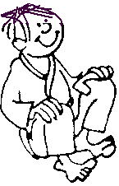

The opponents sit facing each other. You must pin your opponent’s shoulders to the mat for a two-count.

APPENDIX 11

EVALUATION RUBRIC FOR THE TEACHER

++  SUCCEEDS EASILY  (without help) | +  SUCCEEDS  (with occasional help) | ±  SOMETIMES SUCCEEDS  (with constant help) | -  DOES NOT SUCCEED  (despite constant help)

Observable aspects  A Friendly Match  Class:  Date: | Chooses at least two forms of combat. | Takes the instructions into account during teamwork. | Takes offensive and defensive action during the tournament. | Applies the rules of ethics. | Effectively performs his/her movements or sequence of movements. | In teams of three, identifies possible improvements after the tournament. | Identifies what worked well and what could be used in other situations. | Rating

APPENDIX 12

EVALUATION RUBRIC FOR THE TEACHER

++  SUCCEEDS EASILY  (without help) | +  SUCCEEDS  (with occasional help) | ±  SOMETIMES SUCCEEDS  (with constant help) | -  DOES NOT SUCCEED  (despite constant help)

Observable aspects  A Friendly Match  Class:  Date: | Chooses at least two forms of combat. | Takes the instructions into account during teamwork. | Takes offensive and defensive action during the tournament. | Applies the rules of ethics. | Performs his/her movements or movement sequences effectively. | In teams of three, identifies possible improvements after the tournament. | Identifies what worked well and what could be used in other situations. | Rating

1. Here, the key feature “collaborates in developing the plan of action” could be interpreted in a combat activity in which the student interacts as “develops a plan of action, taking his/her opponents into account.”

