TEACHER’S DOCUMENT

ELEMENTARY CYCLE THREE
1st YEAR OF THE CYCLE

TO INTERACT
WITH OTHERS IN DIFFERENT
PHYSICAL ACTIVITY SETTINGS

LEARNING AND EVALUATION SITUATION

My Tchoukball Team

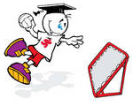

SEPTEMBER 2006

Title of the activity: My Tchoukball Team
Elementary Cycle Three  1st year of Cycle Three | Number of periods:  7 sixty-minute periods
Author: Pierre Gagnon, physical education teacher | Subject-specific competency:  To interact with others in different physical activity settings
Summary of the learning and evaluation situation

The teacher divides the students into mixed teams. Each team plans strategies and applies them in a group activity in a common space. They apply the rules of ethics agreed upon. They communicate effectively about the game in a way that is adapted to their team. At different times they form small groups to reflect on certain aspects of their process. During games, they apply the strategies they planned. They do a self-evaluation after the teacher makes his or her observations.

Evaluation criteria | Observable aspects 
Active participation in developing the plan of action | Suggests ideas for preparing strategies (the plan).  Listens to others’ ideas with a view to developing strategies.
Adaptation of movements or actions to the situation | Applies the strategies developed by the team.
Adaptation of verbal or nonverbal communication to the situation | Communicates effectively during games.
Behaviour consistent with ethical rules | Applies the rules of ethics.
Identification of desirable improvements | With his/her teammates, identifies the strengths and weaknesses of the plan.  Makes a judgment on his/her process based on his/her achievements and difficulties.

Essential knowledge
- Principles of communication: being understood by the person with whom one is interacting, being receptive to others’ messages
- Methods of communication
- Principles of synchronization
- Roles
- Action rules in group activities in a common space
- Behaviour: ethics-related aspects

Period 1

Presentation of the challenge

You will be placed in a mixed team in order to develop strategies to beat the other tchoukball team, while maintaining a healthy opposition. You will apply the rules of ethics approved by the class. You will find effective means of communicating with your teammates. You will adapt your actions as part of the team after having discussed the matter with your teammates. During games, you will do your best to apply the strategies your team planned and, afterwards, you will take the time to evaluate your process.

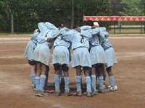
APPENDIX 1

STUDENT’S PROCESS
(What you will be evaluated on)

COLLABORATE (in developing a plan of action)

- I suggest ideas for preparing my team’s offence and defence strategies.

- I listen to others’ ideas.

PERFORM (participation in the application of the plan of action)

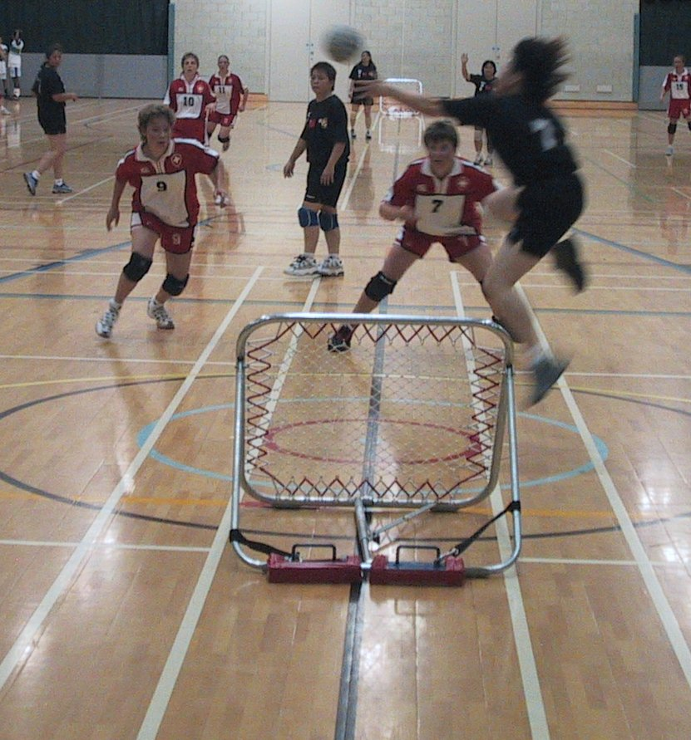
- During games, I apply the plan prepared by my team.

- I follow the rules of ethics in all situations.

- I communicate effectively with my teammates during games.

EVALUATE (the implementation of the plan of action)


- With my teammates, I identify the strengths and weaknesses of the plan.

- I evaluate my process (collaborate, perform, evaluate) based on my achievements and difficulties.
APPENDIX 2
RULES OF ETHICS
[Win or lose, let’s stay friends]

- NO PHYSICAL OR VERBAL VIOLENCE


- ENCOURAGE YOUR TEAM

- RESPECT YOUR OPPONENTS

- GIVE EVERY PLAYER THE CHANCE TO RECEIVE A PASS

- AVOID CRITICIZING THE REFEREE’S DECISIONS
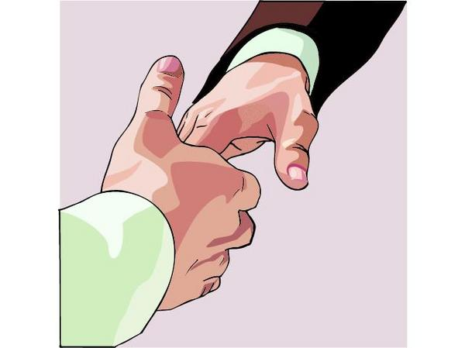
- SHOW GOOD SPORTSMANSHIP WHETHER YOU WIN OR LOSE

- RESPECT THE RULES OF THE GAME


- REMAIN CALM ON THE BENCH

APPENDIX 3

COMMUNICATE WITH YOUR TEAMMATES DURING GAMES

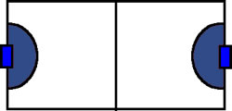

- Call the player’s number.
- Call the player’s name.
- Use a code.
- Ask for the ball, making a target with your hands to receive a pass.
- Clap your hands.
- Direct the player using signs.
- Talk to the others on the court.
- Look the other players in the eye.

To pass the ball
To ask for the ball
To take position
To perform a movement or an action

APPENDIX 4

Offence strategies developed by students

- Zigzag
- Bounce the ball off the rebound surface on your side of the court
- Quickly bounce the ball off the rebound surface on the other side of the court
- Single-pass attack
- Double-pass attack
- Triple-pass attack
- L position
- + position
- Powerful throw
- Short throw
- 2-1-2 position
- 1-2-2 position
- 1-3-1 position
- Move quickly
- Throw quick, short passes
- Throw diagonally
- Throw based on the position of your opponent’s defence
- Throw long passes
- Other
_____________________________________________________________________________________________________________________________________________

APPENDIX 5

Defence strategies developed by students

- 2-1-2 position
- 1-2-2 position
- 1-3-1 position
- Crossbow position
- Eiffel tower position
- Half-moon around the rebound surface
- Other
_____________________________________________________________________________________________________________________________________________________________________________________________________________

APPENDIX 6

EVALUATION RUBRIC FOR THE TEACHER

++  SUCCEEDS EASILY  (without help) | +  SUCCEEDS  (with occasional help) | ±  SOMETIMES SUCCEEDS  (with constant help) | -  DOES NOT SUCCEED  (despite constant help)

Observable aspects   My Tchoukball Team  Class:  Date: | Suggests ideas for preparing strategies. | Listens to others’ ideas with a view to developing strategies. | Applies the strategies developed by the team. | Communicates effectively during games. | Applies the rules of ethics. | With his/her teammates, identifies the strengths and weaknesses of the plan. | Makes a judgment on his/her process based on his/her achievements and difficulties. | Rating

APPENDIX 7

EVALUATION RUBRIC FOR THE TEACHER
++  SUCCEEDS EASILY  (without help) | +  SUCCEEDS  (with occasional help) | ±  SOMETIMES SUCCEEDS  (with constant help) | -  DOES NOT SUCCEED  (despite constant help)

Observable aspects  My Tchoukball Team  Class:  Date: | Suggests ideas for preparing strategies. | Listens to others’ ideas with a view to developing strategies. | Applies the strategies developed by the team. | Communicates effectively during games. | Applies the rules of ethics. | With his/her teammates, identifies the strengths and weaknesses of the plan. | Makes a judgment on his/her process based on his/her achievements and difficulties. | Rating

