TEACHER’S DOCUMENT

ELEMENTARY CYCLE THREE
2nd YEAR OF THE CYCLE

TO PERFORM
MOVEMENT SKILLS IN DIFFERENT
PHYSICAL ACTIVITY SETTINGS

LEARNING AND EVALUATION SITUATION
My Movement Skills

SEPTEMBER 2006
Title of the activity: My Movement Skills
Elementary Cycle Three  2nd year of Cycle Three | Number of periods:  7 sixty-minute periods
Author: Pierre Gagnon, physical education teacher | Subject-specific competency:  To perform movement skills in different physical activity settings
Summary of the learning and evaluation situation

The students must create a sequence of locomotor, nonlocomotor and manipulation skills, using two of the following types of activities: rhythmic activities, skill activities and technical/artistic activities. Posters illustrating different movement skills should be posted on the gym walls to help students make a choice. The students can also consult other resources (e.g. the Internet, peer experts, parent experts). The sequence must contain three movement skills from each category, several directions and several levels (height). It must involve the use of a tool or object. During the planning stage, the students present their performance to a classmate to obtain assistance and make improvements. They have access to several manipulation objects (e.g. balls, hoops) and a restricted work space. During the last two periods, they present their performance to the teacher, who will evaluate and discuss their process.

Evaluation criteria | Observable aspects 
Justification of own choice of movement skills | Plans the sequence, taking into account:  - the goal pursued  - the constraints of the physical environment  - his/her abilities  Justifies the movement skills based on his/her abilities, the goal and the constraints.
Performance of sequence of movement skills  Performance of simultaneous movement skills | Coordinates the performance of his/her movement skills.  Performs the sequence as planned (number and sequence of elements).  Applies safety rules.
Identification of desirable improvements or elements that are worth keeping  Identification of possible opportunities for the transfer of learning | Notes improvements to be made to his/her sequence.  Notes the strengths and weaknesses of his/her process.  Lists activities in which he/she could apply his/her learning.

Essential knowledge
- Principles of balance
- Principles of coordination
- Linking of movements
- Flow in the performance of movement skills
- Locomotor skills
- Nonlocomotor skills
- Manipulation skills
- Technical/artistic activities
- Rhythmic and expressive activities
- Skill activities

Period 1

Presentation of the challenge

Tell the students that they must use the knowledge they acquired in the past two years to create a sequence as follows: “Plan a sequence of locomotor skills (e.g. cartwheel), nonlocomotor skills (e.g. arabesque) and manipulation skills (e.g. juggling three objects). You can use gymnastics equipment (e.g. balance beam, trampoline, parallel bars) or perform your sequence on the floor. You must perform three different movement skills in each category, combined with two types of activity; these movement skills must be synchronized. You must move in several different directions and at several different levels (high, low or medium heights). You must handle a tool or object (e.g. small ball, hoop, devil sticks) and integrate the movement skills into your sequence. You can use music to establish a regular rhythm. You must apply the appropriate safety rules. You have five periods to plan your sequence, practise it and fill out the student’s document. The final two periods will be devoted to the presentation of performances to a panel of judges.”

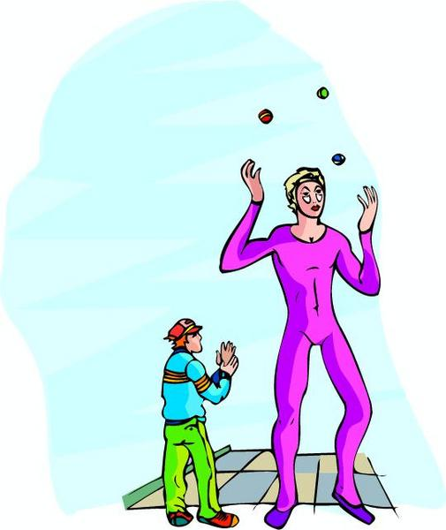

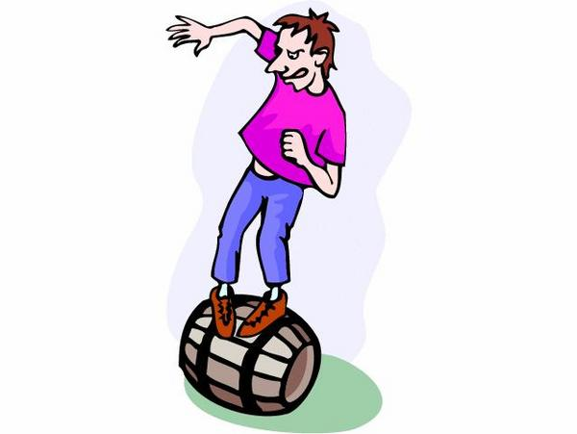

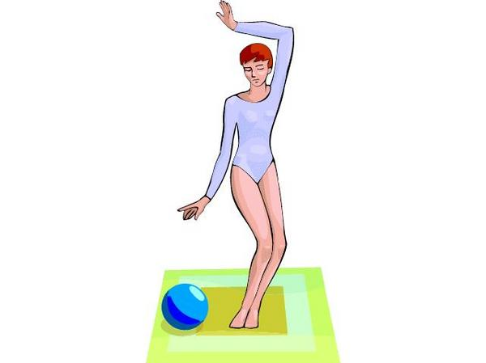

APPENDIX 1

STUDENT’S PROCESS
(What you will be evaluated on)
ANALYZE (the situation based on the requirements of the context) AND CHOOSE (appropriate movement skills)

- I choose what I am going to do and in what order (first, second, third, etc.).


- I choose my movement skills based on the instructions posted in the gym.

- I choose my movement skills based on my abilities (not too hard, not too easy).

- I can say why I chose the movement skills in my sequence.

PERFORM (movement skills based on the requirements of the situation)

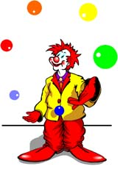
- I perform my movement skills without hesitation and without stopping.

- I perform all the movement skills chosen in the order indicated.

- I perform my movement skills in
accordance with the instructions.
See posters in the gym
- I apply safety rules.

EVALUATE (your process and results)
- I identify my achievements and my difficulties in the preparation and presentation of my sequence.

- I note improvements to be made to my sequence.

- I list activities in which I could apply my learning.

APPENDIX 2

PROCESSES

- I try different locomotor, nonlocomotor and manipulation skills on the floor or using gymnastics equipment.

- I plan my sequence using the student’s document.

- I present my sequence to a classmate.

- I present my sequence to a panel of judges.

- I have five periods to prepare.

- I fill out the self-evaluation sheet in the student’s document.

- I meet with the teacher to discuss my process.

INSTRUCTIONS (production)

- I choose and perform locomotor skills (e.g. cartwheel), nonlocomotor skills (e.g. arabesque) and manipulation skills (e.g. juggling three objects).

- I choose and perform movement skills based on my abilities.

- I choose and perform three movement skills in each category.

- My sequence contains two types of activity (e.g. skill and expression).

- I move in several different directions.

- I perform at different levels (high, low or medium heights).

- I use a tool or object in my sequence (e.g. ball, juggling scarf, baton).

- I keep my rhythm without hesitation and without stopping.

- I use music if I want.

APPENDIX 3

TYPES OF ACTIVITIES

RHYTHMIC AND EXPRESSIVE ACTIVITIES
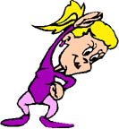
- AEROBIC DANCE
- FITNESS (CHOREOGRAPHY)

- MIME
- KATA (KARATE)

- JUDO
- OTHER

TECHNICAL/ARTISTIC ACTIVITIES
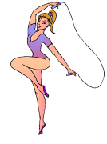
- RHYTHMIC GYMNASTICS
- ARTISTIC GYMNASTICS


SKILL ACTIVITIES

- JUGGLING
- PRECISION THROWING
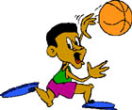
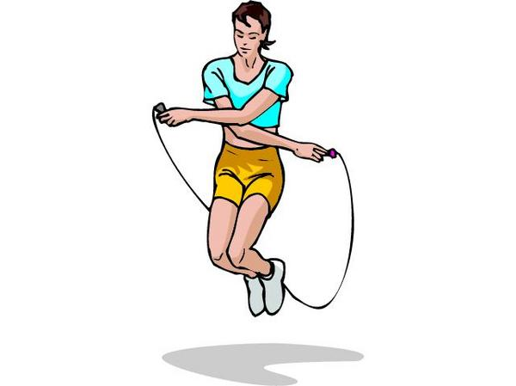
- OTHER

APPENDIX 4

EVALUATION RUBRIC FOR THE TEACHER

++  SUCCEEDS EASILY  (without help) | +  SUCCEEDS  (with occasional help) | ±  SOMETIMES SUCCEEDS  (with constant help) | -  DOES NOT SUCCEED  (despite constant help)

Observable aspects  My Movement Skills  Class:  Date: | Plans the sequence, taking into account the goal pursued, the constraints of the physical environment and his/her abilities. | Justifies his/her choice of movement skills based on his/her abilities, the goal and the constraints. | Coordinates the performance of his/her movement skills. | Performs the sequence as planned (number and sequence of elements). | Applies safety rules. | Notes improvements to be made to his/her sequence. | Notes the strengths and weaknesses of his/her process. | Lists activities in which he/she could apply his/her learning. | Rating

APPENDIX 5

EVALUATION RUBRIC FOR THE TEACHER

++  SUCCEEDS EASILY  (without help) | +  SUCCEEDS  (with occasional help) | ±  SOMETIMES SUCCEEDS  (with constant help) | -  DOES NOT SUCCEED  (despite constant help)

Observable aspects  My Movement Skills  Class:  Date: | Plans the sequence, taking into account the goal pursued, the constraints of the physical environment and his/her abilities. | Justifies his/her choices based on his/her abilities, the goal and the constraints. | Coordinates the performance of his/her movement skills. | Performs the sequence as planned (number and sequence of elements). | Applies safety rules. | Notes improvements to be made to his/her sequence. | Notes the strengths and weaknesses to of his/her process. | Lists activities in which he/she could apply his/her learning. | Rating

