Document 5-B

A Question of Balance

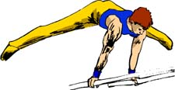


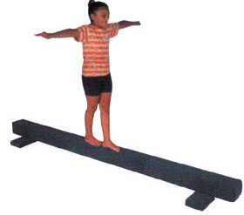

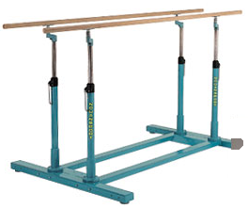

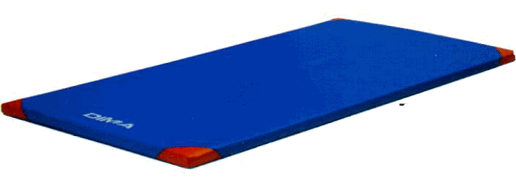

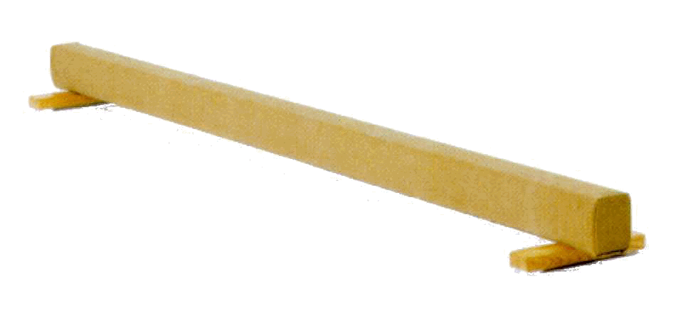

USING INFORMATION GATHERED ON THREE STUDENTS:

- interpret their results
- make a judgment on their level of competency development

EVALUATION RUBRIC FOR THE TEACHER
Competency: To perform movement skills in different physical activity settings

A Question of Balance – Elementary Cycle Three
Legend for the observable aspects:
++  SUCCEEDS EASILY  (without help) | +  SUCCEEDS  (with occasional help) | ±  SOMETIMES SUCCEEDS  (With constant help) | -  DOES NOT SUCCEED  (despite constant help)

Observable aspects  Title: A Question of Balance  Class:  Date: December 2006 | Plans his/her sequence of movement skills taking into account his/her ability, the goal pursued and the constraints of the physical environment. |  | Justifies his/her choice of movement skills based on his/her skill level, the goal pursued and the constraints of the physical environment. |  | Coordinates the performance of his/her movement skills. | Performs the sequence as planned (number and sequence of elements). | Applies safety rules. | Notes improvements to be made to his/her sequence. | Notes the strengths and weaknesses of his/her process. | Lists activities in which he/she could apply his/her learning. | Rating¹⁻²
EDDY | + |  | + |  | + | + | ++ | - | ++ | ++
EDDY | Does not consider safety important. Likes doing things that are dangerous to himself or to others. His analysis is not getting much better. He still needs guidance. He observed his difficulties in his self-evaluation. Performs his movement skills as planned.
JULIE | ++ |  | + | ++ |  | ++ | ++ | ++ | ++ | ++
JULIE | Consistent in her autonomy in the planning and performance of the different tasks involved. Insists on performing movement skills that are too difficult for her. Does not have enough time to consolidate her movement skills and integrate them into her final sequence. I have discussed this with her.
FRANK | ++ | + |  | ++ |  | ++ | ++ | + | ++ | ++
FRANK | Adequate planning. His choice of movement skills is not adapted to his ability. His challenge is too difficult. He has trouble with safety rules. I have discussed this with him.
1. What could you do to help each student make progress
in a key feature of the competency? Don’t forget that this first
evaluation is “to support learning.”
A: The student succeeds easily.

B: The student succeeds with or without occasional help.

C: The student needs help to succeed.

D: The student has difficulty despite the help given.

NE: Not evaluated

2. After another learning and evaluation situation involving the same
evaluation criteria, a more global rating (A, B, C, D or NE) could be
assigned to establish the student’s progress in the development of the
competency. Ideally, it would be better to use three situations.

EVALUATION TOOL – Self-evaluation and peer evaluation

A Question of Balance

Name: Julie Student no.: 11

Identify the equipment you will use:
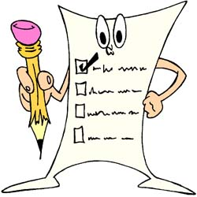

Short balance beam: ______ Balance beam: ___ √
Parallel bars: ______

Section 1. Plan your sequence of movement skills.

Description of the sequence (first draft)

- Indicate the sequence of your movement skills using the appropriate number.

E.g.: 3 5 1, etc.

1

EVALUATION TOOL – Self-evaluation and peer evaluation

A Question of Balance

Section 2. Peer evaluation

Name of evaluator: Audrey
Yes No
1. Performs movement skills in each category.  ____
2. Moves in at least two directions.  ____
3. Nonlocomotor skills maintained for three seconds.  ____
4. Regular rhythm, no stopping.  ____
5. The sequence includes an entrance and an exit.  ____

Section 3. Improvements

Note the improvements you will make to your sequence.
_____________________________________________________________________________________________________________________________________________________________________________________________________________________

Plan for the improved sequence

5
4
3
4
2

Section 4. Self-evaluation

Write A for achievement and D for difficulty.

- I tried different movement skills. A
- I practised my sequence several times A
- I selected movement skills based on my ability. D
- I planned my sequence of movement skills. A
- I followed the instructions. A
- I always applied the appropriate safety rules. A
- I coordinated and linked my movement skills. A
- I performed my sequence as planned. A
- I noted improvements to be made to my sequence. A

EVALUATION TOOL – Self-evaluation and peer evaluation
A Question of Balance

Name: _______________________________ Student no.: _______

Identify the equipment you will use:

Short balance beam: ______ Balance beam: ______
Parallel bars: ______

Section 1. Plan your sequence of movement skills.

Description of the sequence (first draft)

- Indicate the sequence of your movement skills, using the appropriate number.

E.g.: 3 5 1, etc.

EVALUATION TOOL – Self-evaluation and peer evaluation
A Question of Balance


Section 2. Peer evaluation

Name of evaluator: _______________________________

Yes No
1. Performs movement skills in each category. ____ ____
2. Moves in at least two directions. ____ ____
3. Nonlocomotor skills maintained for three seconds. ____ ____
4. Regular rhythm, no stopping. ____ ____
5. The sequence includes an entrance and an exit. ____ ____

Indicate the improvements you made to your sequence.
_____________________________________________________________________________________________________________________________________________________________________________________________________________________

Plan for the improved sequence

Section 4. Self-evaluation

Write A for achievement and D for difficulty.

- I tried different movement skills. ____
- I practised my sequence several times. ____
- I chose movement skills based on my ability. ____
- I planned my sequence of movement skills. ____
- I followed the instructions. ____
- I always applied the appropriate safety rules. ____
- I coordinated and linked my movement skills. ____
- I performed my sequence as planned. ____
- I noted improvements to be made to my sequence. ____

