Controlled Jumping
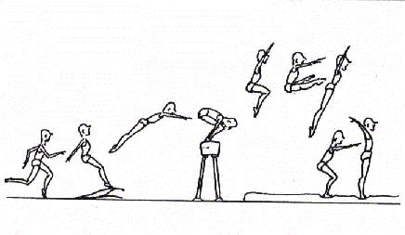

USING INFORMATION GATHERED ON THREE STUDENTS:

- interpret their results
- make a judgment on their level of competency development

SEPTEMBER 2006

EVALUATION RUBRIC FOR THE TEACHER

Competency: To perform movement skills in different physical activity settings
Controlled Jumping – Elementary Cycle Three

Legend for observable aspects
++  SUCCEEDS EASILY  (without help) | +  SUCCEEDS  (with occasional help) | ±  SOMETIMES SUCCEEDS  (with constant help) | -  DOES NOT SUCCEED  (despite constant help)

Observable aspects  Class:  Date: December 2005 | Plans his/her sequence of movement skills taking into account his/her ability, the goal pursued and the constraints of the physical environment. | Justifies his/her choice of movement skills based on his/her skill level, the goal pursued and the constraints of the physical environment. | Coordinates the performance of his/her movement skills. | Performs the sequence as planned (number and sequence of elements). | Applies safety rules. | Notes improvements to be made to his/her sequences. | Notes the strengths and weaknesses of his/her process. | Rating
EDDY | + | + | + | ++ | - | + | ++
EDDY | Has difficulty applying safety rules. His analysis is improving, but he still needs guidance to plan and choose movement skills based on his ability. He has a lot of difficulty expressing movement skills in words in his plan. Easily performs what he has planned.
JULIE | ++ | ++ | + | ++ | ++ | ++ | ++
JULIE | Is very autonomous (analysis, plan). In this situation, she has a little difficulty linking the approach and the takeoff on the trampoline and the beatboard. Execution is still not automatic.
FRANK | + | ++ | ++ | ++ | ++ | ++ | ++
FRANK | Needs help planning. Needs guidance to realize that his choice of movement skills will be difficult to perform. Adjusts his challenge accordingly.

Scale for mid-cycle report card

A: The student succeeds easily.

B: The student succeeds with or without occasional help.

C: The student needs help to succeed.

D: The student has difficulty despite the help given.

NE: Not evaluated

EVALUATION TOOL
Self-evaluation and peer evaluation
Controlled Jumping
Student’s name: Eddy Date: December 2, 2005
Class: 01

Identify the equipment you will use for your sequence.

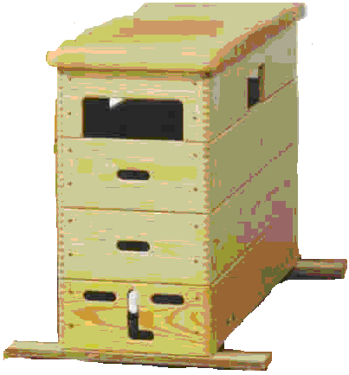

Trampoline

Beatboard
Vaulting box
Cylinder

Section 1. Plan your sequence of movement skills.
Describe your jumps. Use the posters and descriptions provided.

1. Square

2. 360⁰

3. Grab

4.

5.

Section 2. Peer evaluation
Ask a classmate to watch your performance.
Name of evaluator: Frank
(Check the box if you observe the aspect.)
 | Aspects observed | Jump no.
 | Aspects observed | 1 | 2 | 3
1. | Accelerated approach | √ | √ | √
2. | Synchronized approach →push-off→flight→landing sequence | √ | √ | √
3. | Takeoff using both feet
4. | Push-off using both feet | √ | √ | √
5. | Jump well executed | √ |  | √
6. | Stable landing on both feet | √ | √ | √
7. | Landing position maintained for three seconds

Section 3. Improvements
Note the improvements you will make to each jump.

1. I have difficulty with 360⁰ jumps.

2.

3.

4.

5.

Section 4. Self-evaluation
Write A for achievement and D for difficulty.

- I tried different movement skills. __D____
- I practised my sequence several times. __D____
- I chose movement skills adapted to my ability. __D____
- I planned my sequence of movement skills. __D____
- I followed the instructions. __A____
- I always applied the appropriate safety rules. __D____
- I coordinated and linked my movement skills. __D____
- I performed my sequence according to plan. __A____
- I noted improvements to be made to my sequence. __D____

EVALUATION TOOL
Self-evaluation and peer evaluation
Controlled Jumping

Student’s name: ___________________________ Date: ______________
Class: ____________________________________

Identify the equipment you will use for your sequence.

□ Trampoline

□ Beatboard
□ Vaulting box
□ Cylinder

Section 1. Plan your sequence of movement skills.
Describe your jumps. Use the posters and descriptions provided.

1.

2.

3.

4.

5.

Section 2. Peer evaluation
Ask a classmate to watch your performance.
Name of evaluator: ____________________________________
 | Aspects observed | Jump no.
 | Aspects observed | 1 | 2 | 3
1. | Accelerated approach
2. | Synchronized approach→push-off→flight→landing sequence
3. | Takeoff using both feet
4. | Push-off using both feet
5. | Jump well executed
6. | Stable landing on both feet
7. | Landing position maintained for three seconds
(Check the box if you observe the aspect.)

Section 3. Improvements

Note the improvements you will make to each jump.

1.

2.

3.

4.

5.

Section 4. Self-evaluation
Write A for achievement and D for difficulty.

- I tried different movement skills. ______
- I practised my sequence several times. ______
- I chose movement skills adapted to my ability. ______
- I planned my sequence of movement skills. ______
- I followed the instructions. ______
- I always applied the appropriate safety rules. ______
- I coordinated and linked my movement skills. ______
- I performed my sequence according to plan. ______
- I noted improvements to be made to my sequence. ______

