TEACHER’S DOCUMENT
ELEMENTARY CYCLE THREE
1st YEAR OF THE CYCLE

TO PERFORM
MOVEMENT SKILLS IN DIFFERENT PHYSICAL ACTIVITY SETTINGS

LEARNING AND EVALUATION SITUATION

Controlled Jumping

SEPTEMBER 2006
Elementary  Cycle Three  1st year of Cycle Three | Number of periods: 6 | Subject-specific competency:  To perform movement skills in different physical activity settings
Author:  Pierre Gagnon, physical education teacher |  | Cross-curricular competency:  Broad area of learning:
Title: Controlled Jumping

Summary of the learning and evaluation situation

Working alone, the students choose different ways they can jump in a sequence of movement skills, following your instructions and applying the appropriate safety rules. A student’s document is provided so that they can plan and modify the sequence as needed. Different sources of information (e.g. posters, expert classmates, video) are available to help them choose movement skills. The students must also evaluate another student’s sequence using the Student’s Process sheet (see Appendix 1), which will help him or her regulate his or her learning. After presenting their sequence, the students will make a judgment on their process.

Evaluation criteria | Observable aspects 
Justification of own choice of movement skills | Plans the sequence, taking into account:  - the goal pursued  - the constraints of the physical environment  - his/her abilities  Justifies the movement skills based on his/her abilities, the goal and the constraints.
Performance of sequence of movement skills  Performance of simultaneous movement skills | Coordinates the performance of his/her movement skills.  Performs the sequence as planned (number and sequence of elements).  Applies safety rules.
Identification of desirable improvements or elements that are worth keeping  Identification of possible opportunities for the transfer of learning | Notes improvements to be made to his/her sequence.  Notes the strengths and weaknesses of his/her process.

Essential knowledge
- Concept of space
- Concept of speed
- Linking of movements
- Flow in the performance of movement skills
- Single-skill activities

Period 1

Presentation of the challenge
Explain that the students must plan and perform a sequence of different jumps as follows: “You must try performing different jumps using different equipment. Then, you will plan your performance and choose the equipment you will use. The jumps must be adapted to your ability. You must apply the safety rules established by the group throughout the situation. You must perform at least three jumps, and they must be coordinated. You will have three periods to prepare and present your jumps to another student so that he or she can judge your performance and help you make improvements. Finally, you will present your jumps to me and evaluate your process.”

Indicate the observable aspects (see Appendix 1) you will be using to make a judgment on each student’s level of competency development.

Prior knowledge
Have the students safely observe the equipment in the gym and prepare to do jumping workshops. Ask them about their successful jumps.

- Do you know athletes who are famous for their jumps and landings?
- What did they do in order to succeed?
- What elements are essential for a successful jump?
- What safety rules should we follow in the gym?

Write the students’ answers on the board or on a sheet of cardboard for later application.

Presentation of the jumping workshops:
Workshop 1: mini trampoline
Workshop 2: beatboard
Workshop 3: vaulting box
Workshop 4: cylinder

- Explain the components of a jump using a poster (see Appendix 7).
- Have the students establish safety rules. Write them on the board.
- Once they have learned about the different workshops, have the students safely try different jumps.
- Walk around the gym and regulate the students’ learning (see Appendix 1).

Period 2

- Tell the students that they must choose the equipment they will use and the types of jumps they will perform.
- Have them perform different sequences of jumps, applying the appropriate safety rules.
- Have them refer to the posters and instructions posted on the gym walls.
- Walk around the gym for the purpose of individual and interactive regulation of the students’ learning.
- Note on the observation checklist (see Appendixes 8 and 9) whether the students are applying the appropriate safety rules.
- Gather the students for feedback on their application of the appropriate safety rules.
- Explain the content of the student’s document.
- Have the students work on their sequences of jumps and plan their sequence based on the different sections of the student’s document.

Period 3

- Have the students continue working on their sequence of jumps.
- Walk around the gym, recording your observations on the checklist. Inform the students that they have until Period 4 to plan their sequence.
- Provide feedback as needed.

Period 4

- The students who are ready to present their sequences may do so now. They should have their student’s document and have completed the first three sections.
- After presenting their sequence of jumps, have the students regulate their learning and hand in the completed document.
- Complete your observations using the checklist.

Period 5

- Have the students present their jumps or fill out the different sections of the student’s document.
- Those who have finished can help their classmates or work on jumps they would like to improve.

Period 6

- Have the students present their jumps or complete the different sections of the student’s document.
- Those who have finished can help their classmates or work on jumps they would like to improve.

APPENDIX 1

STUDENT’S PROCESS
(What you will be evaluated on)

ANALYZE (the situation based on the requirements of the context) AND CHOOSE (appropriate movement skills)

- I choose what I am going to do and in what order (first, second, third, etc.).
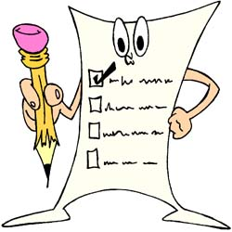

- I choose my movement skills based on the instructions posted in the gym.

- I choose my movement skills based on my abilities (not too hard, not too easy).

- I can say why I chose the movement skills in my sequence.

PERFORM (movement skills based on the requirements of the situation)
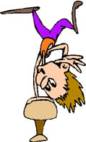

- I perform my movement skills without hesitation and without stopping.

- I perform all the movement skills chosen in the order indicated.

- I perform my movement skills in
accordance with the instructions.
See posters in the gym
- I apply safety rules.

EVALUATE (your process and results)
- I identify my achievements and my difficulties in the preparation and presentation of my sequence.

- I note improvements to be made to my sequence.

APPENDIX 2

PROCESSES

- I try and practise different jumps.

- I think about movement skills I could perform.

- I plan my sequence of movement skills on my work sheet.

- I have three periods to prepare.

- I present my sequence of movement skills to a classmate.

- Using the Student’s Process sheet, I observe a classmate to help him or her.

- I present my sequence of jumps to the teacher.

- I evaluate my process.

INSTRUCTIONS (production)

- I choose movement skills based on my abilities.

- My sequence includes three different jumps.

- I perform my jumps without hesitation and without stopping.

- I take jumping techniques into account.

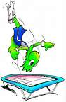

APPENDIX 3

JUMPING TECHNIQUES
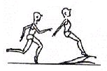

- Accelerated approach
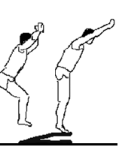
- Linking of components without hesitation

- Takeoff on one foot for all jumps

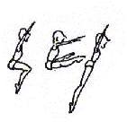
- Push-off using two feet on trampoline and beatboard
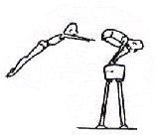
- Creation of a mental image of the jump before execution

- Aggressive push-off to maximize height
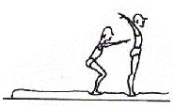
- Landing on two feet with flexed knees

- Entire bottom of both feet touching down at same time

- Gaze directed toward the horizon to maintain balance

APPENDIX 3

SAFETY RULES

Rules |  | My responsibility
1 | 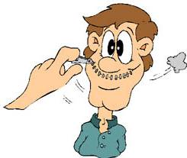  Respect for people and the atmosphere in the gym | - I do not do anything dangerous that could injure me or another student.  - I wait until the student in front of me has finished.  - I do not disturb another student during his or her performance.  - I walk calmly around the equipment.  - I reposition the mats after my jump.
2 | Student’s suggestions:

APPENDIX 5

JUMPS (TRAMPOLINE AND BEATBOARD)

Jump |  | Illustration | Jump |  | Illustration
1 | Straight jump | 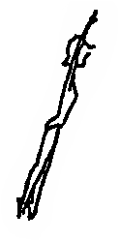 | 7 | Double full twist  (720⁰) | 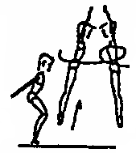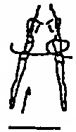  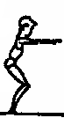
2 | Quarter twist (90º) | 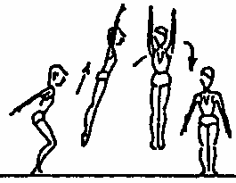 | 8 | Tuck | 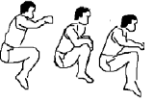
3 | Half twist (180º) | 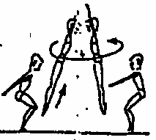 | 9 | Legs bent and arms raised (heels touching buttocks) | 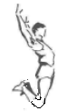
4 | Three-quarter twist (270º) | 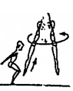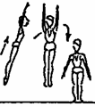 | 10 | Straddle
5 | Full twist (360º) | 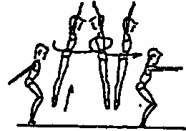 | 11 | Your choice
6 | One-and-a-half twist (540º) | 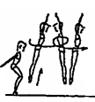  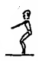

APPENDIX 6

VAULTS (VAULTING BOX OR CYLINDER)

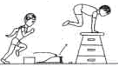

- Kneel vault

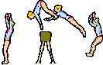
2. Squat vault

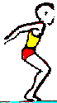
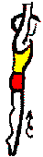

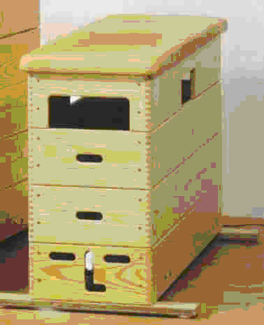
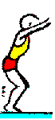
3. Straight jump

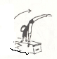

4. Side vault

APPENDIX 7

COMPONENTS OF A JUMP

1
2
3
4
5

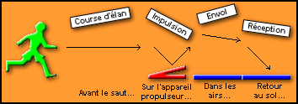
Appel

Illustration taken from Yves Potvin’s Web site: <http://www.bandesportive.com/franchi1.html>

[Approach, Takeoff, Push-off, Flight, Landing, Before the jump, On the beatboard, In the air, Back on the ground]

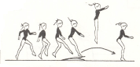

1
2
3
4
5

Takeoff
Last step before hitting the beatboard with both feet

APPENDIX 8

EVALUATION RUBRIC FOR THE TEACHER

++  SUCCEEDS EASILY  (without help) | +  SUCCEEDS  (with occasional help) | ±  SOMETIMES SUCCEEDS  (with constant help) | -  DOES NOT SUCCEED  (despite constant help)

Observable aspects  Controlled Jumping  Class:  Date: | Plans his/her sequence of movement skills taking into account his/her ability, the goal pursued and the constraints of the physical environment. | Justifies his/her choice of movement skills based on his/her skill level, the goal pursued and the constraints of the physical environment. | Coordinates the performance of his/her movement skills. | Performs the sequence as planned (number and sequence of elements). | Applies safety rules. | Notes improvements to be made to his/her sequence. | Notes the strengths and weaknesses of his/her process. | Rating

APPENDIX 9

EVALUATION RUBRIC FOR THE TEACHER

++  SUCCEEDS EASILY  (without help) | +  SUCCEEDS  (with occasional help) | ±  SOMETIMES SUCCEEDS  (with constant help) | -  DOES NOT SUCCEED  (despite constant help)

Observable aspects  Controlled Jumping  Class:  Date: | Plans his/her sequence of movement skills taking into account his/her ability, the goal pursued and the constraints of the physical environment. | Justifies his/her choice of movement skills based on his/her skill level, the goal pursued and the constraints of the physical environment. | Coordinates the performance of his/her movement skills. | Performs the sequence as planned (number and sequence of elements). | Applies safety rules. | Notes improvements to be made to his/her sequence. | Notes the strengths and weaknesses of his/her process. | Rating

