Document 3-A

TEACHER’S DOCUMENT

ELEMENTARY CYCLE THREE
1st YEAR OF THE CYCLE

TO PERFORM
MOVEMENT SKILLS IN DIFFERENT
PHYSICAL ACTIVITY SETTINGS

LEARNING AND EVALUATION SITUATION

Skills on Display

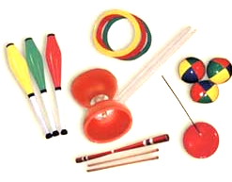
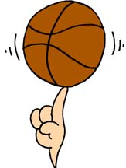
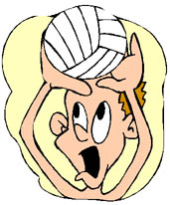

SEPTEMBER 2006

Elementary  Cycle Three  1st year of Cycle Three | Number of periods:  7 | Subject-specific competency:  To perform movement skills in different physical activity settings
Author:  Pierre Gagnon, physical education teacher |  | Cross-curricular competency:  Broad area of learning:
Title: Skills on Display
Summary of the learning and evaluation situation

The students must perform a sequence of object manipulation skills in a restricted space. A variety of equipment (e.g. juggling equipment, basketballs, mini volleyballs) is available to enable them to make a choice of movement skills adapted to their ability. They must reflect on and analyze the situation in order to perform a movement sequence in accordance with the proposed process. Different sources of information (e.g. posters, video) are available to stimulate their imagination and help them come up with ideas. The students must behave in a safe manner throughout the learning and evaluation activity. A student’s document is provided so they can plan the sequence and make improvements. They must present the sequence to you and evaluate their process. This situation is spread out over seven periods. An additional period could be added to accommodate students experiencing difficulty.

Evaluation criteria | Observable aspects 
Justification of own choice of movement skills | Plans the sequence, taking into account:  - the goal pursued  - the constraints of the physical environment  - his/her abilities  Justifies the movement skills based on his/her abilities, the goal and the constraints.
Performance of sequences of movement skills  Performance of simultaneous movement skills | Coordinates the performance of his/her movement skills.  Performs the sequence as planned (number and sequence of elements).  Applies safety rules.
Identification of desirable improvements or elements that are worth keeping  Identification of possible opportunities for the transfer of learning | Notes improvements to be made to his/her sequence.  Notes the strengths and weaknesses of his/her process.

Essential Knowledge
- Concept of space
- Concept of speed
- Linking of movements
- Flow in the performance of movement skills
- Manipulation skills
- Skill activity
- Rhythmic and expressive activity

Period 1

Presentation of the challenge

Explain the process as follows (see Appendix 2): “You must try performing different manipulation skills with different objects. Then, you will make a choice in order to perform manipulation skills adapted to your ability. You must plan your sequence to include five different manipulation skills, each one repeated three times in a row or at different points in your performance. The actions must be coordinated [make sure the students understand the word coordinated]. During every class, you will apply the safety rules established by the group. You will present your sequence to another student so that he or she can help you improve it, then present it to me so that you can be evaluated. You will also have to evaluate the process you used throughout the situation and discuss it with me.”

Indicate the observable aspects (see Appendix 1) you will be using to make a judgment on each student’s process.

Prior knowledge
- Ask the students whether they have ever seen acrobats perform.
- Ask them: “What did you like about their performance? What movement skills did the acrobats perform? Do you think they had to practise a lot to be able to give such a beautiful performance? What types of difficulties do you think they encountered?”
- Write the students’ answers on the board.
- Present a short video of circus acts to give the students an idea of what they could do.
- Present the equipment available to them.
- Divide the equipment into workshops (including posters and registration forms).

Formation of teams, creation of workshops and experimentation
- Present the workshops the students will be setting up in the gym. They have already done manipulation activities in the past. The workshops are: juggling (e.g. beanbags, balls, clubs, scarves), devil sticks, balls (e.g. basketballs, volleyballs, rhythm balls), hoops, balancing poles.
- Have the students form teams of five or six and set up the workshops (cooperation) according to a plan established by you. Have them experiment with the different workshops, performing manipulation skills they are familiar with. From one period to the next, the same teams will be responsible for setting up the same workshops. Hang posters (see Appendix 3) to help them.

Procedure

Period 2

Ask the class to name important safety rules. Write the answers on the board (see Appendix 3) and add more if necessary. Allow the students a few minutes to prepare their workshop, then have them present it.
- Explain that they can work in teams of two or three, and that each student will be presenting his or her sequence.
- Walk around the gym, helping students and regulating learning. Observe them and make notes on the observation checklist concerning how they apply the safety rules.

Period 3

- Have the students continue experimenting with the equipment. Observe them and record your observations as needed.
- Have the students refer to the instructions (see Appendix 2).
- Explain the student’s document. Have the students continue their work, referring to the instructions.

Period 4

- Have the students continue their work, referring to the instructions. Tell them that they should have completed section 2 of the student’s document by the end of the period.
- Observe the students and record your observations on the checklist. Then, walk around the gym to regulate learning.

Period 5

- Comment on the students’ level of achievement of the observable aspects that you have indicated on the checklist since the beginning of the situation. Share your observations about the process they have adopted since Period 3. Inform them that they can now present their sequence and that they must have completed all the sections of the student’s document.
- Have the students continue their work, referring to the instructions posted on the gym walls.
- Help students experiencing difficulties make corrections.

Period 6

- Have the students continue their preparatory work and presenting their sequences, making sure they have completed the first three sections of the student’s document.
- Before they present their sequence, have them discuss it with you in order to justify their choice of manipulation skills and equipment.
- After the presentation, have the students fill out section 4 of the student’s document on self-regulation. Then have them hand in the document and discuss their process with you. Complete your notes on the observation checklist.
- Once the students have finished, they may go to the section of the gym set up for free activities or practise manipulation skills in the workshops without disturbing those who have not yet finished. They can also help their classmates who have not yet finished. Develop examples of questions you can ask about the justification of the students’ choice of manipulation skills in accordance with their abilities, the goal pursued and the constraints of the physical environment.

Period 7

Same tasks as Period 6 to enable students to present their sequences.

APPENDIX 1

STUDENT’S PROCESS
(What you will be evaluated on)

ANALYZE (the situation based on the requirements of the context) AND CHOOSE (appropriate movement skills)

- I choose what I am going to do and in what order (first, second, third, etc.).
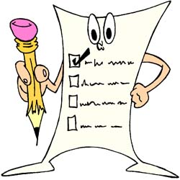

- I choose my movement skills based on the instructions posted in the gym.

- I choose my movement skills based on my abilities (not too hard, not too easy).

- I can say why I chose the movement skills in my sequence.

PERFORM (movement skills based on the requirements of the situation)
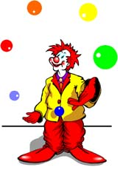
- I perform my movement skills without hesitation and without stopping.

- I perform all the movement skills chosen in the order indicated.

- I perform my movement skills in
accordance with the instructions.
See posters in the gym
- I apply safety rules.

EVALUATE (your process and results)

- I identify my achievements and my difficulties in the preparation and presentation of my sequence.

- I note improvements to be made to my sequence.

APPENDIX 2

PROCESSES

- I try and practise different manipulation exercises.

- I think about movement skills I could perform.

- I plan my sequence of movement skills using the student’s document.

- I have three periods to prepare.

- I present my sequence of movement skills to a classmate.

- Using the Student’s Process sheet, I observe a classmate to help him or her.

- I present my sequence of movement skills to the teacher.

- I evaluate my process.

INSTRUCTIONS (production)

- I choose movement skills based on my abilities.

- My sequence includes at least five different movement skills.

- Each movement skill is repeated at least three times in my sequence.

- I perform my movement skills without hesitation and without stopping.

- I perform my movement skills without losing control of the objects.

APPENDIX 3

SAFETY RULES

Rules |  | My responsibility
1 | Observance of workspace   | I define my workspace and take care to respect it.
2 | Respect for people and equipment  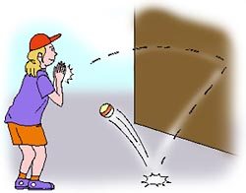 | I hand over the equipment that accidentally ends up in my workspace.  I do not do anything dangerous that could injure me or another student (e.g. throw a ball at another student).
3 | Calm attitude, conducive to working  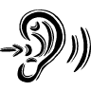 | I speak calmly and take care not to disturb the other students when I walk around.  

APPENDIX 4

WORKSHOP ON MANIPULATING BALLS (Example)

Description of movement skills:

- Dribble the ball at hip level.
- Dribble like a basketball player.
- Dribble in a circle around you.
- Dribble in a circle around your foot.
- Dribble in a figure-8 pattern around your feet.
- Spin the ball on your finger.
- Pass the ball between your legs, changing hands.
- Pass the ball between your legs while walking.
- Throw the ball up and catch it behind you.
- Roll the ball on your arms behind your head.

Illustrations:

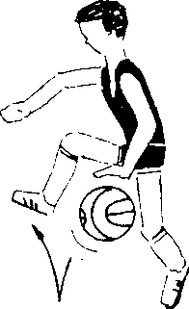

APPENDIX 5

EVALUATION RUBRIC FOR THE TEACHER

++  SUCCEEDS EASILY  (without help) | +  SUCCEEDS  (with occasional help) | ±  SOMETIMES SUCCEEDS  (with constant help) | -  DOES NOT SUCCEED  (despite constant help)

Observable aspects    Skills on Display  Class:  Date: | Plans his/her sequence of movement skills taking into account his/her ability, the goal pursued and the constraints of the physical environment. | Justifies his/her choice of movement skills based on his/her skill level, the goal pursued and the constraints of the physical environment. | Coordinates the performance of his/her movement skills. | Performs the sequence as planned (number and sequence of elements). | Applies safety rules. | Notes improvements to be made to his/her sequence. | Notes the strengths and weaknesses of his/her process. | Rating

APPENDIX 6

EVALUATION RUBRIC FOR THE TEACHER

++  SUCCEEDS EASILY  (without help) | +  SUCCEEDS  (with occasional help) | ±  SOMETIMES SUCCEEDS  (with constant help) | -  DOES NOT SUCCEED  (despite constant help)

Observable aspects   Skills on Display  Class:  Date: | Plans his/her sequence of movement skills taking into account his/her ability, the goal pursued and the constraints of the physical environment. | Justifies his/her choice of movement skills based on his/her skill level, the goal pursued and the constraints of the physical environment. | Coordinates the performance of his/her movement skills. | Performs the sequence as planned (number and sequence of elements). | Applies safety rules. | Notes improvements to be made to his/her sequence. | Notes the strengths and weakness of his/her process. | Rating

