English Montreal School Board
2009-2010
PHYSICAL EDUCATION AND HEALTH

SECONDARY CYCLE 2
Grade 10

Competency 2: Interacts with others in different physical activity settings
VOLLEYBALL
Class ____________
Team ________________________________________

Annex A
Volleyball
Offence

Aim for the open spaces.
Aim for the sidelines + endlines.
Aim between 2 players
Aim for an inattentive player
Set up to attack
Winning the point (spike transition)
Attack as a team
Strategies
For Grade 10

Synchronization

Use at least 2 contacts to return
the ball, but 3 is better
Follow the sequence of receiver,
passer, attacker
Set the ball up well for your partner
Be ready to send + receive the ball
Get under the ball to receive
Don’t just watch the ball, move to it.
In order to block at the net, time your jump with your opponent

Defence

Ready in defensive position
Team should get into ready position
to receive the serve.
Recover missed hits from partners
Defend the space on your own court
Defend against an attack
Defend as a team

Communication

Use short expressions to signal your intentions
Send misleading messages to your opponents
Take a neutral posture to mask your intentions

Sportsmanship

Be positive
Encourage your teammates
Respect your opponents

Annex B

Parking Lot
of knowledge
Goals we have | Strategies we like | Questions we have
Rules we are not clear on | Skills we have all mastered | Skills some of us need work on
Annex B
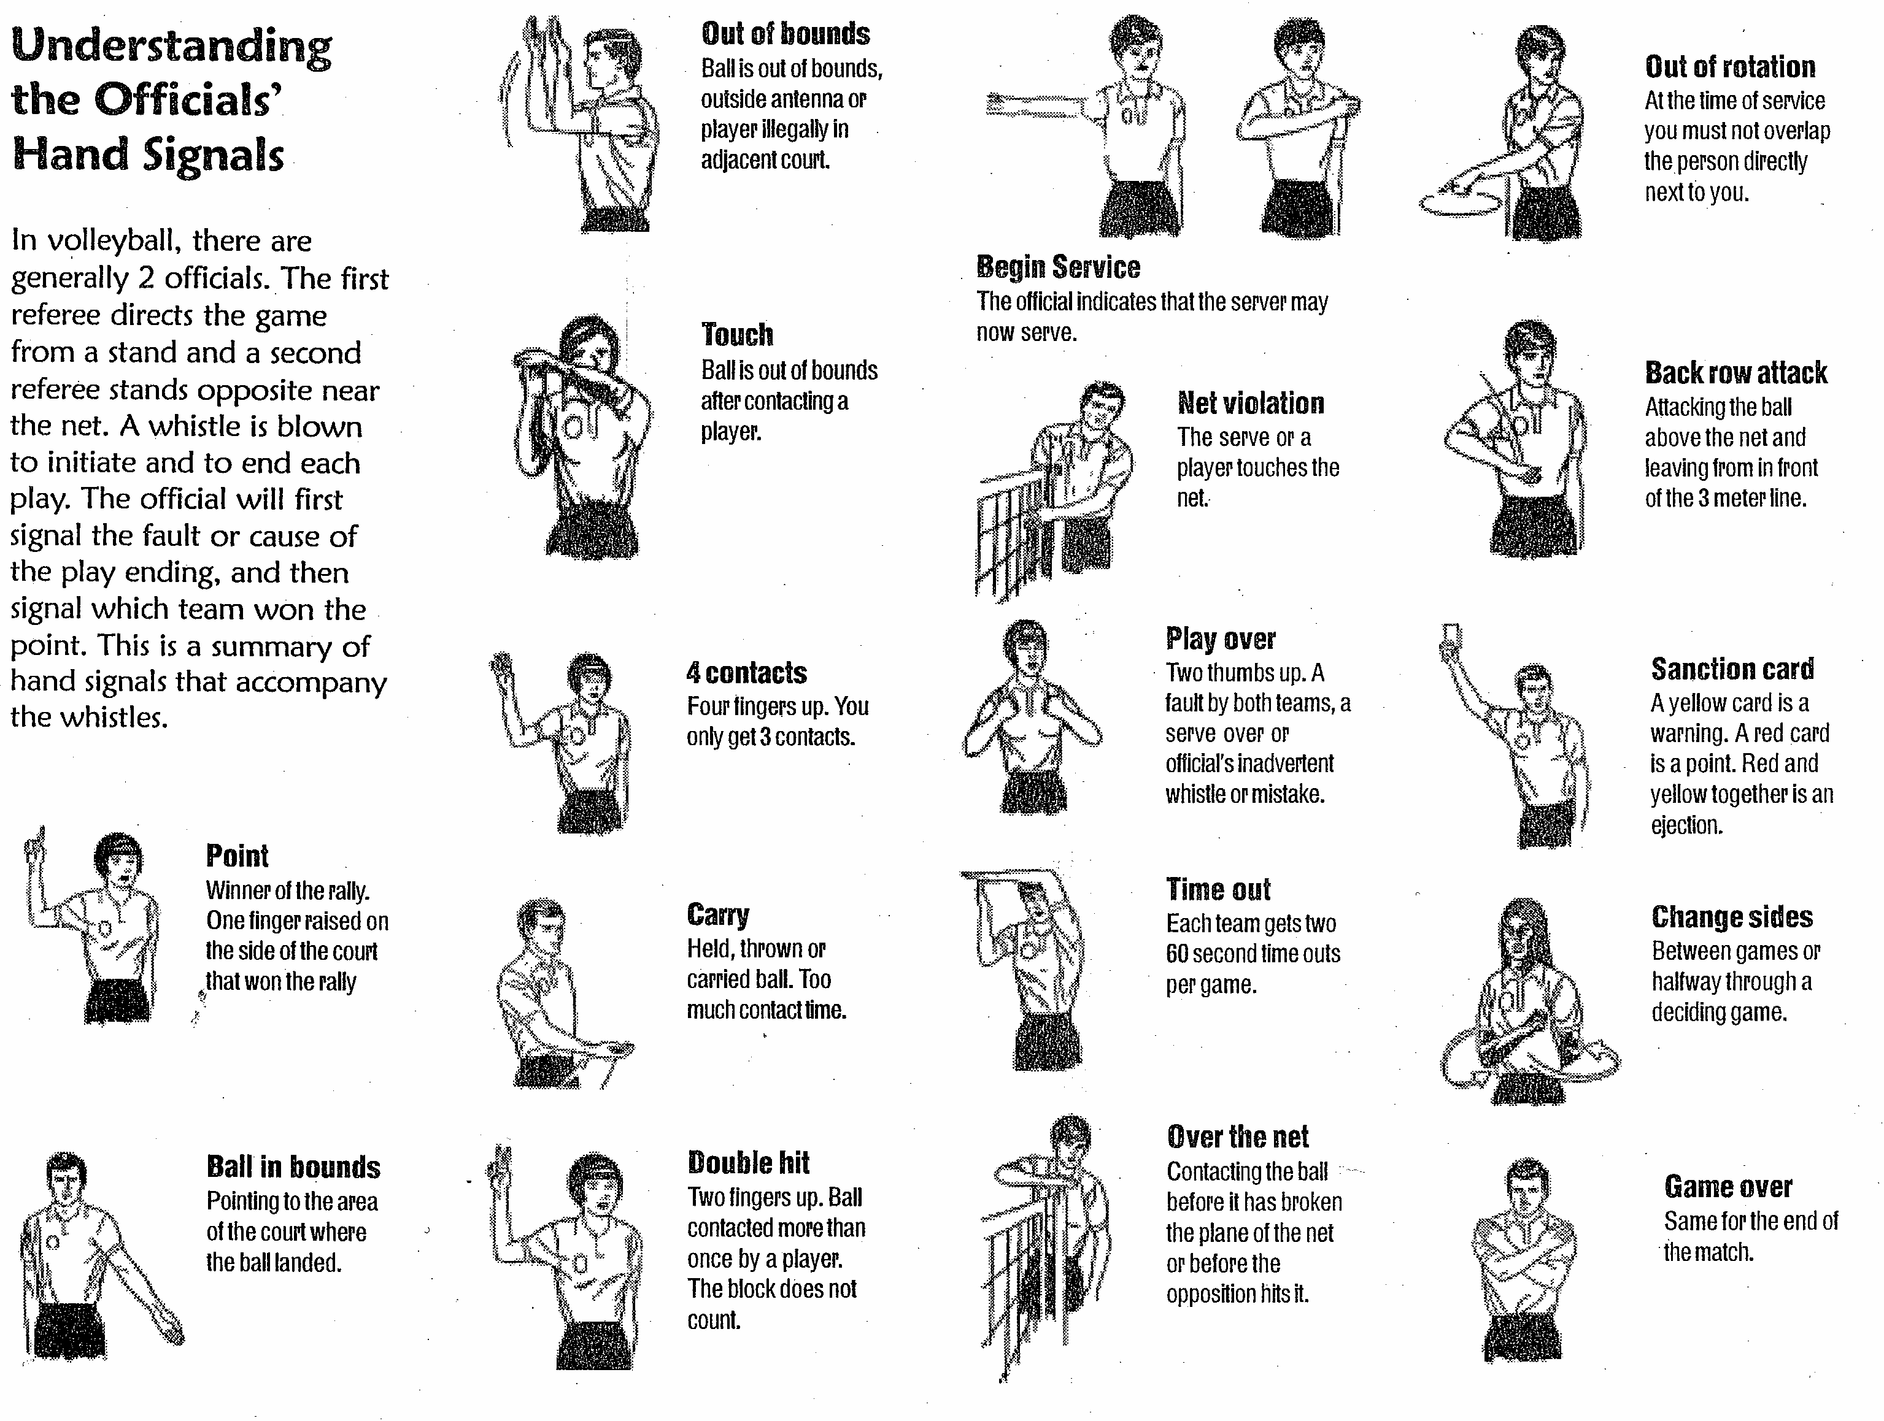
Annex D

Work as a team to use the following terms and match them to the appropriate signals:

- Back Row Attack
- Ball in bounds
- Begin Service
- Carry
- Change sides
- Double Hit
- Game over
- Net Violation
- Out of bounds
- Out of rotation
- Over the net
- Play Over
- Point
- Sanction Card
- Time Out
- Touch
- 4 contacts

In the Ref’s Shoes
Annex E
PLAN F ACTION

COMMUNICATION

After having played the SILENT VOLLEYBALL MATCH, you have probably realized how important communication is in Volleyball. Therefore, you must ensure that everyone on your team understands the verbal and non-verbal cues.

As a team, list all the verbal and non-verbal cues that can be used during a game. Do not forget that misleading messages to your opponents can also lead to points.

PLAN F ACTION
Annex F

WINNING CHOICES

Your team will be participating in a Volleyball tournament. You must prepare for different game situations that combine all the skills developed along with your team strategies.

Below, you will find different situations that take place during a game. As a team, select how you could react to each situation. Write your answers on each court.

Your team is serving. List your strategies.

2. You are close to the net and you make the 2nd contact.

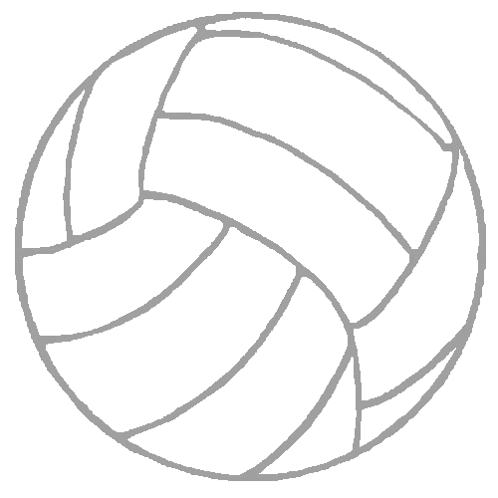

3. Your team is on serve reception. What do you do?

4. You make the 3rd contact.

PLAN F ACTION
Annex G
Class:

Our Volleyball Action Plans

Team Name: ______________________

Team members

1.
2.
3.
4.
5.
6.
7.

Plan of action 1
Diagram/Written Plan | Our achievements and our challenges
Diagram/Written Plan | Successful? Yes Non
Challenges: ___________________________________
___________________________________
___________________________________
___________________________________

Plan of action 2
Diagram/Written Plan | Our achievements and our challenges
Diagram/Written Plan | Successful? Yes Non
Challenges: ___________________________________
___________________________________
___________________________________
___________________________________
___________________________________

Plan of action 3
Diagram/Written Plan | Our achievements and our challenges
Diagram/Written Plan | Successful? Yes Non
Challenges: __________________________________
__________________________________
__________________________________
__________________________________
__________________________________

Annex I Evaluation

Competency 2: TO INTERACT WITH OTHERS IN DIFFERENT PHYSICAL SETTINGS

Evaluation Criteria | PP:Good | P: Acceptable | X Unacceptable
Cooperation in developing a plan of action | - Shows leadership in making a plan of action  - Encourages team to demonstrates effort | - Gives input in making a plan of action  - Demonstrates effort most of the time | - Does not give input in making a plan of action  - Does not demonstrates effort
Performs the movement skills necessary for a plan of action. | - Helps others to develop their skills | - Good skill development | - Poor attempts to develop skills
Demonstrates fair play and sportsmanship during all stages of the game.. | - Encourages team | - Shows respects to ref, other team and teammates s | - Unsportsmanlike behaviour (Rude to ref, other team or teammates)
Applies the safety rules. | - Intervenes in unsafe situations | - Applies safety rules in moving around the court and in handling the equipment | - Does not follow safety rules in moving around the court and in handling the equipment (kicks volleyball, poor handling of volleyball poles…)
Evaluates his/her performance and that of his/her team. | - Shows leadership in revising plan of action | - Gives input in revising plan of action | - Does not gives input in revising plan of action (uninterested, sabotages discussion…)

