TEACHER’S DOCUMENT

SECONDARY CYCLE TWO
Grade 10

INTERACTS WITH OTHERS IN DIFFERENT
PHYSICAL ACTIVITY SETTINGS

LEARNING AND EVALUATION SITUATION

Volleyball

March 2009

Secondary |  |  |  |  | Subject | Title | Number of periods
Cycle One |  | Cycle Two |  |  | Physical Education and Health | Volleyball | 8 seventy-five minute periods
1st | 2nd | 1st | 2nd | 3rd | Physical Education and Health | Volleyball | 8 seventy-five minute periods

Authors: Steven Carroll, Julia King, Jeff Kosow, Michael MacKenzie, Sandy Farr
School board: English Montreal School Board Date: Feb 16, 2009.

Subject-specific competency
Interacts with others in different physical activity settings
Achievement context
The students are called upon to play a specific role, determined by the team and based on the strengths and weaknesses of each player. Together, they develop an offence strategy based on their knowledge about volleyball. They apply the principles learned in team activities in a separate space, as well as the principles of communication.
Challenge
“With your teammates, you will determine your strengths and challenges in volleyball. Based on these strengths and in cooperation with your teammates, you will develop a strategy, implement it and evaluate its effectiveness. You will have four periods to finalize and implement your plan of action. You will draw a diagram of your strategy (Annex G: Our Action Plans). The diagram should contain your offensive and//or defensive moves that you will be playing on the strategy. In addition, you will evaluate your performance (Annex H: Individual Reflection). I will note your contribution to the team on an evaluation rubric (Annex I, J: Evaluation). Note that the focus is not only on your technical skills, but also on your ability to participate in the development, implementation and evaluation of the plan of action and to demonstrate good sportsmanship. For example, if for one reason or another the plan of action does not succeed, although the entire team applied the planned strategy, you will need to analyze the error and make an effort to correct it. The situation will end with a tournament in which you will implement your plan of action.”

Throughout the Volleyball LES you will use the PARKING LOT (Annex A) to store the following information:
- What are your goals as a team?
- What strategies does your team excel at?
- What questions do you have?
- What rules are you unclear on?
- Which skills has your team now mastered?
- What skills do some of you still have to work on?

Based on the evaluation criteria, determine the observable aspects selected for evaluation
- Suggests ideas for developing strategies.
- Listens to others’ ideas with a view to developing team strategies.
- Applies the strategies during games.
- Applies the rules of ethics.
- Communicates effectively during games.
- With his/her teammates, identifies the strengths and weaknesses of the plan.
- With his/her teammates, identifies ways of adjusting the plan.

Phase 1: Preparation

Objectives | - Present the problem  - Activate prior knowledge  - Draw out students’ representations and questions  - Establish a work plan  - Specify the expected productions and the target audience, if applicable

Period no. | Identification of tasks
Period 1 | 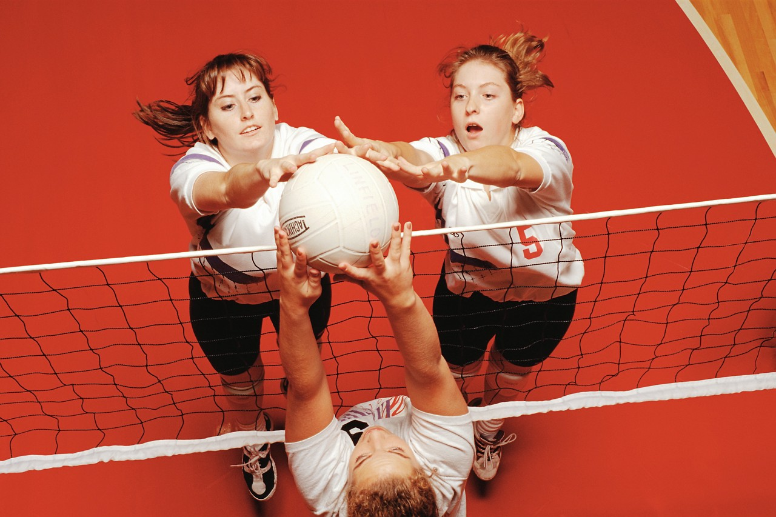  - Make the teams. Let students play in a match then question them after…What was your goal in playing (to avoid the ball, to protect yourself , to avoid letting the ball land in your space, to serve to make it hard for the opposition to return the ball, to pass the ball to a player who is in position?). Use answers to create a poster on strategies. Hand out team folders. Let students know they have a handout on strategy in their folders. (Annex A: Volleyball Strategies for Grade 10. Good reference text: Teaching Sport Concepts and Skills, A Tactical Games Approach by Linda L. Griffin et al.). You will use the PARKING LOT (Annex B) to store the following information  - Take note of the answers, these are your beginning strategies. You can also give students your observations about their game.  Optional  - Have students watch a video and discuss the strategies used.  (Annex A: Volleyball Strategies for Grade 10).  - Let students know that over the next few periods, you will increase the intensity of the game in 3 ways  - Varying the serves  - Using the advantage of the 3 touches  - How to help your team even without the ball (communication)
 | Phase 2: Performance
Objectives | - Guide the students in complex tasks  - Propose resource acquisition tasks, if applicable  - Set aside time for reflection and review
Period 2  Periods  3-4  Periods 5-6  Periods 7-8 | Inventory of Student Knowledge  - What volleyball rules and skills do you already know? Use answers to create a poster(s) on student knowledge. Good way to introduce the stations.  - Setup 6 stations that allow students to realize their strengths and challenges. (See below: Ideas for Manipulation. Suggest using Stations 1-6). Rotate through the stations as a team, then decide on which skills they want to improve. Suggestion: Sign-up sheets for the 2 skills that students want to work on next class.  - Mini match. What format will it take? How to make the teams? Which rules to use? Use a ref? Can discuss options with the class  Skill Development  - Students focus on the 2 skills they signed up for .Teacher sets up 4 stations based on class needs. Ideas for manipulation stations are listed below. Station work lasts about 30 minutes (2 x 15 minutes). Students can repeat same skills for 2 classes in a row or try 2 other stations.  - Volleyball mini matches follow the station work, allowing students to try out the skills in game situation and to reassess their development.  - Idea!!! Differentiate by varying the rules during this stage of learning (i.e. allowing for a shorter service line, modify court and/or equipment).  - During these matches, teachers take note of the strategies that are emerging during play.  Manipulation Stations  - HEY COACH: Partner up with someone from your team. Coach corrects your technique for the serve (underhand or overhand). (Annex C)  - HEY COACH: Coach corrects your technique for the forearm pass-bump. (Annex C)  - HEY COACH: Coach corrects your technique for the volley. (Annex C)  - Rules activity: Team activity (Annex D: In the Ref’s Shoes and D1: Answer Sheet)  - Try the smash (groups of 3) Start with a lower net. One team member holds or lobs the ball. You approach, jump and hit the ball onto the other side of the net. One team member retrieves the ball. Variation = smash from a pass from your partner.  - Highest # of touches. Volleyball pass with a partner to see how many in a row. Variation = the fewest hits possible in a given time.  - HEY COACH: Coach corrects your technique for the spike. (Annex C)  - Serving to targets. Serve to a line, a target on the wall, to a partner (positions 1-6) etc  - Serving farther and farther. Each serve that goes over, move 1 step further from the net. Partner returns the ball to you.  - Volley-Basket. Juggle the ball with 2 hands, final touch is a volley into the basketball net. Variation = receive a pass from a partner and volley it into the basket.  - Throw and Hit. Partner throws the ball to you low or high, you return with a bump or volley. Variation: Increase the distance between partners, move before returning the ball.  - Hit, move, hit. 1 thrower with the ball, varying direction and height of the ball. Receive the ball from each one by moving quickly into place. If your return goes over the shoulder of the receiver, student has to contact the ball better.  Focus on Strategy  - Teams continue working on ball control at the beginning of each class according to the needs of each team. However, the focus of these classes is on strategy development.  - Teachers discuss some of the strategies that emerged during play in previous lessons.  - Silent Volleyball Match (Annex E: Plan of Action-Communication and E1: Answer Sheet)  - Mini matches. (Annex F Plan of Action-Winning Choices and F1: Answer Sheet)  Tournament  - Students choose action rules and movement skills that will make up their plan of action  (Annex G: Our Action Plans).  - They participate in a volleyball tournament and implement their plan of action  - They effectively perform the movement skills included in the plan.  - Participate in the organization and smooth functioning of the tournament.

Phase 3: Integration

Objectives | - Lead a discussion summarizing the learning acquired  - Help the students identify situations to which they could transfer their learning  - Allow them to express their degree of satisfaction

Period no. | Identification of tasks
30 min. | After the tournament  At the end of the tournament, have the students fill out the worksheets (Annex H: Individual Reflection) and share their results. Reflection: Discuss the following questions: What strategies did your team use? What worked? What didn`t work? How effective was I in the game? How have I improved? Present any results and observations you recorded.  Finally, ask the students to identify different activities in which they could use the learning acquired in the past few periods. Ask them to make a connection between the spirit of fair play and the ability to cooperate, and everyday life.  NEXT: Grade 11 = Reception positions

Annex A

Volleyball
Offence

Aim for the open spaces.
Aim for the sidelines + endlines.
Aim between 2 players
Aim for an inattentive player
Set up to attack
Winning the point (spike transition)
Attack as a team
Strategies
For Grade 10

Synchronization

Use at least 2 contacts to return
the ball, but 3 is better
Follow the sequence of receiver,
passer, attacker
Set the ball up well for your partner
Be ready to send + receive the ball
Get under the ball to receive
Don’t just watch the ball, move to it.
In order to block at the net, time your jump with your opponent

Defence

Ready in defensive position
Team should get into ready position
to receive the serve.
Recover missed hits from partners
Defend the space on your own court
Defend against an attack
Defend as a team

Communication

Use short expressions to signal your intentions
Send misleading messages to your opponents
Take a neutral posture to mask your intentions

Sportsmanship

Be positive
Encourage your teammates
Respect your opponents

Parking Lot
of knowledge
Annex B
Goals we have | Strategies we like | Questions we have
Rules we are not clear on | Skills we have all mastered | Skills some of us need work on

In the space provided, write down your goals, strategies, questions you want answered, rules you are not sure of, skills that are mastered and skills to be developed. Answers can come from any team member.

Annex C

Hey Coach
Player’s Name _____________________________

Class: __________ Date: ___________

Observe Your Player |  |  | √ = well done  X = needs work
Choose 1 type of serve | Underhand | Contacts the ball in front of hitting arm
Choose 1 type of serve | Underhand | Follow through in direction of target
Choose 1 type of serve | Underhand | Transfer of weight from back to front
Choose 1 type of serve | Underhand | Contacts the ball on the heel of the hand
Choose 1 type of serve | Overhand | Stand so that feet, shoulders, and hips face the direction you want to serve, feet are staggered
Choose 1 type of serve | Overhand | Hold the ball in non-serving hand in front of body on serving arm side
Choose 1 type of serve | Overhand | Toss or lift ball in front of serving shoulder
Choose 1 type of serve | Overhand | Step or shift weight forward onto front foot
Choose 1 type of serve | Overhand | Contact ball with heel of hand at full extension of arm
Choose 1 type of serve | Overhand | Make solid contact in the middle of the ball with follow-through
Choose 1 type of serve | Overhand | Contact the ball on the palm of the hand
The forearm pass /bump
 |  | Keep wrists parallel and thumbs pointed toward the floor
 |  | Arms are parallel to your thighs, below shoulders
 |  | Arms should be even when contacting the ball
 |  | Move through the ball to the target
 |  | Keep knees flexed when you step to the target and transfer your body weight forward
The volley/set/ overhead pass
 |  | Thumbs are towards the eyes
 |  | Make contact with all ten fingertips, not with the palms
 |  | Move under the ball
 |  | Your arms are fully extended then follow through with your entire body
The spike

 |  | For right-handed attack, begin approach (right, left, right-left)
 |  | Approach begins from outside the court
 |  | Use both arms to generate force for jump
 |  | Keep ball in front of the hitting shoulder
 |  | Make contact with heel of hand on top of the ball with arm at full extension
 |  | Snap wrist and finish with fingers over the top of the ball facing the floor
 |  | Land in a balanced position on both feet

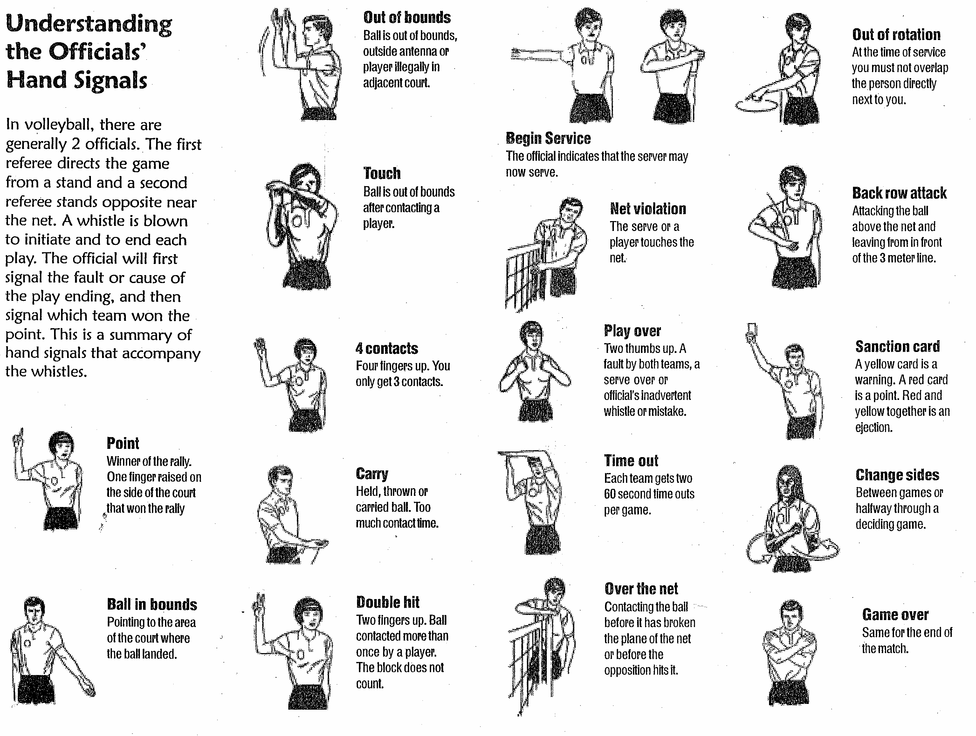
Annex D

Work as a team to use the following terms and match them to the appropriate signals:

- Back Row Attack
- Ball in bounds
- Begin Service
- Carry
- Change sides
- Double Hit
- Game over
- Net Violation
- Out of bounds
- Out of rotation
- Over the net
- Play Over
- Point
- Sanction Card
- Time Out
- Touch
- 4 contacts

In the Ref’s Shoes

Annex D1 Answer sheet
In the Ref’s Shoes

Annex E
PLAN F ACTION

COMMUNICATION

After having played the SILENT VOLLEYBALL MATCH, you have probably realized how important communication is in Volleyball. Therefore, you must ensure that everyone on your team understands the verbal and non-verbal cues.

As a team, list all the verbal and non-verbal cues that can be used during a game. Do not forget that misleading messages to your opponents can also lead to points.

Annex E1 Answer sheet
PLAN F ACTION

COMMUNICATION

After having played the SILENT VOLLEYBALL MATCH, you have probably realized how important communication is in Volleyball. Therefore, you must ensure that everyone on your team understands the verbal and non-verbal cues.

As a team, list all the verbal and non-verbal cues that can be used during a game. Do not forget that misleading messages to your opponents can also lead to points

Verbal
“Out”Yes!! (on the point)
“Tight” Go Team
“I got it”
“At the net”
“Second hit”

Non-verbal
Hand Signals
Group huddle
Clapping on the point
Team spirit!!!!

Front row player can fake a smash but then gently tips the ball over.
Second hit player can fake an attack
Intentionally leave an open space to entice an attack

PLAN F ACTION
Annex F

WINNING CHOICES

Your team will be participating in a Volleyball tournament. You must prepare for different game situations that combine all the skills developed along with your team strategies.

Below, you will find different situations that take place during a game. As a team, select how you could react to each situation. Write your answers on each court.

You are serving. List your strategies.

2. You are close to the net and you make the 2nd contact.

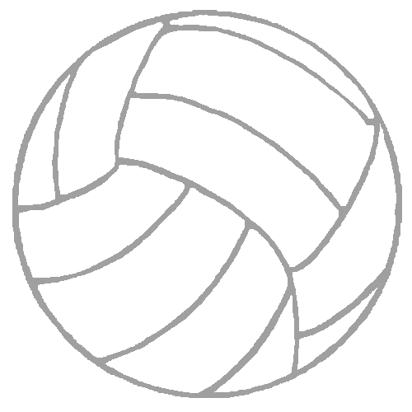

3. Your team is on serve reception, what do you do?

4. You make the 3rd contact.

Annex F1 Answer sheet
PLAN F ACTION

WINNING CHOICES

Your team will be participating in a Volleyball tournament. You must prepare for different game situations that combine all the skills and strategies developed.

Below, you will find different situations that take place during a game. As a team, select how you could react to each situation. Write your answers on each court.

Your team is serving. List your team strategies?

Vary the speed of your serve
Vary the distance of your serve
Aim for the lines
Aim for the open spaces

2. You are close to the net and you make the 2nd contact.

Set up the ball for the spike
Pretend to pass and attack
Pretend to attack and pass
Tip it over
Vary the type of attack
Vary the attack off the 2nd contact or 3rd.

3. Your team is on serve reception. What does your team do?

Adjust your position depending on the server
Adjust your position depending your offensive strategy
Cover all open spaces

4. You make the 3rd contact.

Spike, tip etc (vary your attack)
Aim for a spot that will end the exchange
Be ready for the block

PLAN F ACTION
Annex G
Class:

Our Volleyball Action Plans

Team Name: ______________________

Team members

1.
2.
3.
4.
5.
6.
7.

Plan of action 1
Diagram/Written Plan | Our achievements and our challenges
Diagram/Written Plan | Successful? Yes No Non
Challenges: ____________________________
_______________________________________
_______________________________________
_______________________________________
______________________________

Plan of action 2
Diagram/Written Plan | Our achievements and our challenges
Diagram/Written Plan | Successful? Yes No Non
Challenges: ____________________________
_______________________________________
_______________________________________
_______________________________________
_______________________________________

Plan of action 3
Diagram/Written Plan | Our achievements and our challenges
Diagram/Written Plan | Successful? Yes No Non
Challenges: ____________________________
_______________________________________
_______________________________________
_______________________________________
_______________________________________
_______________________________________

Annex H
Individual

Name: Team Name:

- Identify 5 strategies your team used during the tournament.
- Place a √ beside the strategies that worked and an Χ beside those that did not.

- How effective was I in the tournament?

- How have I improved?

Annex I Evaluation

Competency 2: TO INTERACT WITH OTHERS IN DIFFERENT PHYSICAL SETTINGS

Observable Indicators | PP: SUCCEEDS EASILY  (without help) | P: SUCCEEDS  (with occasional help) | X: DOES NOT SUCCEED  (despite constant help)
Evaluation Criteria | PP: SUCCEEDS EASILY  (without help) | P: SUCCEEDS  (with occasional help) | X: DOES NOT SUCCEED  (despite constant help)
Selection of individual or team strategy (a plan of action) | - Shows leadership in making a plan of action  - Participates in filling out team sheets | - Gives input in making a plan of action  - Participates in filling out team sheets | - Does not give input in making a plan of action  - Does not participate in filling out team sheets
Performs the appropriate individual movements to achieve the goal (plan of action.) | - Helps others to develop their skills  - Participates in skill development  - Hands in Hey Coach | - Good skill development  - Participates in skill development  - Hands in Hey Coach | - Poor attempts to develop skills  - Poor participation in skill development  - Does not hand in Hey Coach
Demonstrates fair play and sportsmanship during different stages of the game or activity.  Applies the safety rules. | - Encourages team  - Intervenes in unsafe situations | - Shows respects to ref, other team and teammates  - Applies safety rules in moving around the court and in handling the equipment | - Unsportsmanlike behaviour (Rude to ref, other team or teammates)  - Does not follow safety rules in moving around the court and in handling the equipment (kicks volleyball, poor handling of volleyball poles…)
Evaluates his/her performance and that of his/her team in order to improve cooperation, performance or plan of action. | - Shows leadership in revising plan of action  - Hands in Individual Reflection | - Gives input in revising plan of action  - Hands in Individual Reflection | - Does not give input in revising plan of action (uninterested, sabotages discussion…)  - Does not hand in Individual Reflection

Annex J Evaluation

Competency 2: Interacts with others in different physical activity settings

Volleyball Tournament – Secondary Cycle Two

(During the Cycle Evaluation)

Class:____________ Means of Action: Volleyball
Teacher: ________________________ Date: __________

Legend for the observable aspects:
PP: SUCCEEDS EASILY  (without help) | P: SUCCEEDS  (with occasional help) | X: DOES NOT SUCCEED  (despite constant help)
Circle the P if students needed help to perform the task

Observable aspects  Student Names |  | Cooperates in the development of the plan of action.  (ie. Participation in Team Sheets: Annex E,F & G) | Performs the movement skills c\necessary for a plan of action. (ie. Hey Coach: Annex C, Teacher observation) | Demonstrates fair play and sportsmanship during all stages of the game. Applies the safety rules (Teacher observation) | Evaluates his/her performance and that of his/her team (ie Reflection: Annex H)
- JAKE |  |  | P | PP

% | DESCRIPTION
88-100  74-87  60-73  42-59  24-41  NE | Excellent performance in all tasks
88-100  74-87  60-73  42-59  24-41  NE | All tasks performed correctly
88-100  74-87  60-73  42-59  24-41  NE | Essential tasks performed correctly
88-100  74-87  60-73  42-59  24-41  NE | Tasks performed with difficulty
88-100  74-87  60-73  42-59  24-41  NE | Tasks performed only with help
88-100  74-87  60-73  42-59  24-41  NE | Not evaluated

Annex J Evaluation

Competency 2: Interacts with others in different physical activity settings

Volleyball Tournament – Secondary Cycle Two

(End of Cycle Evaluation)

Class:____________ Means of Action: Volleyball
Team: ________________________ Date: __________

Legend for the observable aspects:
PP: SUCCEEDS EASILY  (without help) | P: SUCCEEDS  (with occasional help) | X: DOES NOT SUCCEED  (despite constant help)
Circle the P if students needed help to perform the task

Observable aspects  Student Names | Cooperates in the development of the plan of action.  (Participation in Team Sheets: Annex E,F & G) | Performs the movement skills c\necessary for a plan of action. (Hands in Hey Coach: Annex C, Teacher observation) | Demonstrates fair play and sportsmanship during all stages of the game. Applies the safety rules  (Teacher observation) | Evaluates his/her performance and that of his/her team (Reflection: Annex H)
- JAKE | P | P | PP | P

Rating* |  | DESCRIPTION
88-100 | 5 | Advanced : Competency development is above the requirements.
74-87 | 4 | Thorough : Competency development clearly meets the requirements
60-73 | 3 | Acceptable : Competency development meets the requirements to a limited extent
42-59 | 2 | Partial : Competency development is below the requirements
24-41 | 1 | Minimal : Competency development is well below the requirements
 | NE | Not evaluated

*Refer to the Scales of Competency for End of Cycle evaluation

