Document 4S-B

Cross-country Skiing
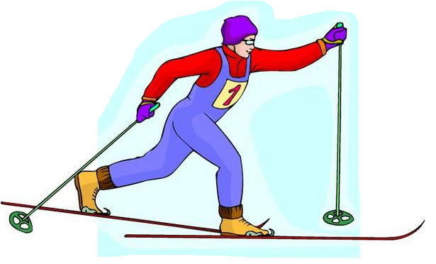

USING INFORMATION GATHERED ON THREE STUDENTS:

- interpret their results
- make a judgment based on a suggested scale

April 2006

EVALUATION RUBRIC FOR THE TEACHER
Competency: Performs movement skills in different physical activity settings
Cross-country skiing

Legend for the observable aspects
 : Good |  : Needs improvement | - : Has difficulty

Observable aspects  Class:  Date: | Makes an effort to take up a reasonable challenge. | Applies the principles of coordination and balance. | Determines improvements to be made during the learning process. | Demonstrates control when skiing the trail. | Applies safety rules and the rules of ethics. | At the end, can explain the improvements made and the difficulties overcome. | Recognizes the elements that could be used in other contexts. | Rating
CAROLINE |  |  |  |  |  |  | 
CAROLINE | Ended up with friends who are slightly stronger than her. The intermediate challenge allowed her to excel. Was sometimes discouraged, but enjoyed the activity. Seems to want to do this new activity with friends outside school.
MAX |  |  |  |  |  |  | -
MAX | Wanted to ski the trail but wasn’t interested in practising to improve his results. Does not like observing his teammates, even over a short period of time. Always wants to try new skis, even if another student has already chosen them. Has very little difficulty and would rather skate-ski.
STEPHANIE |  | - | - | - |  | - | -
STEPHANIE | Was absent for the first observation. Showed little interest in the activity. Needs constant support and motivation. Tries the solutions I suggest. Is rarely able to identify solutions or desired improvements on her own.

Scale used to make a judgment concerning the degree of
competency development during a cycle or year
RATING | DESCRIPTION
A | The student exceeds the requirements of the tasks.
B | The student meets most of the requirements of the tasks.
C | The student meets a few of the requirements of the tasks.
D | The student meets no requirements of the tasks.
NE | Not evaluated
Self-evaluation and peer evaluation

Cross-country skiing
Student’s name: CAROLINE Group: _________
Select two elements you would like to improve for each skill.
Techniques | ELEMENTS I can improve | Peer evaluation
Techniques | ELEMENTS I can improve | 1st observation | 2nd observation
Diagonal stride | - Same rhythm as walking  - Bear down on snow  - Synchronize arms and legs  - Slide on one ski |  | 
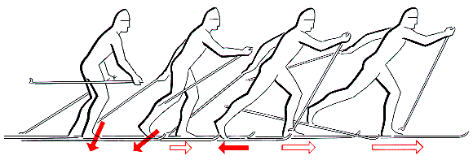 |  |  | 
Tuck position | - Skis slightly apart  - Arms slightly bent and away from body  - Knees and hips slightly flexed |    | 
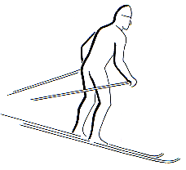 |  |    | 
Snowplow | - Knees and feet slightly flexed  - Heels out, knees in  - Body leans back slightly |    |   
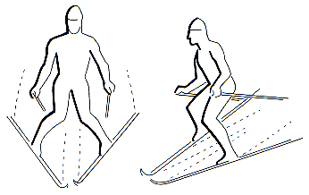 |  |    |   
Sidestep | - Skis parallel with the slope  - Body weight toward the top ski  - Body leans toward top of slope |    |   
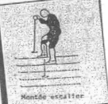 |  |    |   
Herringbone step | - Body leans toward top of slope  - Heels in, knees out  - Push on pole and foot on same side |    |   
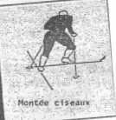 |  |    |   

Legend: | P : Good | ä : Needs improvement | - : Has difficulty

How did you take your peers’ observations into account?

Now I practise the techniques on easier surfaces.
Self-evaluation
Cross-country skiing

Student’s name: CAROLINE Group: _________

COURSE:  Your choice | Why did you choose this trail? | What did you enjoy the most? | What did you find most difficult?
Beginner’s ( )
Intermediate (X) | It was a challenge for me | Skiing with my friends and trying to improve my technique | Skiing the trail, trying to apply what I had practised beforehand
Expert ( )

What have you learned since the beginning of the course?
Cross-country skiing is more fun if the slopes aren’t too hard.

What learning could you apply in other contexts?
I could ski on other trails with friends outside school.

Self-evaluation and peer evaluation
Cross-country skiing

Student’s name: MAX Group: _________

Select two elements you would like to improve for each skill.

Techniques | ELEMENTS I can improve | Peer evaluation
Techniques | ELEMENTS I can improve | 1st observation | 2nd observation
Diagonal stride | - Same rhythm as walking  - Bear down on snow  - Synchronize arms and legs  - Slide on one ski |    |   
Tuck position | - Arms slightly apart  - Arms slightly bent and away from body  - Knees and hips slightly flexed |    |   
Snowplow | - Knees and feet slightly flexed  - Heels out, knees in  - Body leans back slightly |    |   
Sidestep | - Skis parallel with the slope  - Body weight toward the top ski  - Body leans toward top of slope |    |   
Herringbone step | - Body leans toward top of slope  - Heels in, knees out  - Push on pole and foot on same side |    |   

Legend: | P : Good | ä : Needs improvement | - : Has difficulty

How did you take your peers’ observations into account?

I was able to do almost everything my observer told me.

Self-evaluation
Cross-country skiing

Student’s name: MAX Group: _________

TRAIL:  Your choice | Why did you choose this trail? | What did you enjoy the most? | What did you find most difficult?
Beginner’s ( )
Intermediate ( )
Expert (X) | The other two trails were too easy for me | Speeding up going downhill and comparing my results with those of others | Observing others and telling them what they were doing right or wrong

What have you learned since the beginning of the course?

Not much. I was able to do just about everything. I would rather skate-ski.

What learning could you use in other contexts?

I don’t intend to do much cross-country skiing outside the course.
Self-evaluation and peer evaluation
Cross-country skiing

Student’s name: STEPHANIE Group: _________

Select two elements you would like to improve for each skill.

Techniques | ELEMENTS I can improve | Peer evaluation
Techniques | ELEMENTS I can improve | 1st observation | 2nd observation
Diagonal stride | - Same rhythm as walking  - Bear down on snow  - Synchronize arms and legs  - Slide on one ski | Absent
Tuck position | - Skis slightly apart  - Arms slightly bent and away from body  - Knees and hips slightly flexed | Absent | 
Snowplow | - Knees and feet slightly flexed  - Heels out, knees in  - Body leans back slightly | Absent | -  
Sidestep | - Skis parallel with the slope  - Body weight toward the top ski  - Body leans toward top of slope | Absent
Herringbone step | - Body leans toward top of slope  - Heels in, knees out  - Push on pole and foot on same side | Absent | Didn’t want to do it

Legend: | P : Good | ä : Needs improvement | - : Has difficulty
How did you take your peers’ observations into account?

I have trouble understanding what they are trying to explain. I don’t know how to do it. Maybe I could change partners.

Self-evaluation
Cross-country skiing

Student’s name: STEPHANIE Group: _________

TRAIL:  Your choice | Why did you choose this trail? | What did you enjoy the most? | What did you find most difficult?
Beginner’s (X) | I had no choice, the other trails were too difficult for me | Being on an easy trail, going uphill and downhill
Intermediate ( )
Expert ( )

What have you learned since the beginning of the course?

I should dress warmly because I was cold on two occasions. I enjoyed myself a little more the last time, because it was nice out and I had more time to ski the trail twice.
What learning could you apply in other contexts?

I don’t know.

