s
Document 4S-A

TEACHER’S DOCUMENT

SECONDARY CYCLE ONE
1st YEAR OF THE CYCLE

PERFORMS
MOVEMENT SKILLS IN DIFFERENT
PHYSICAL ACTIVITY SETTINGS

LEARNING AND EVALUATION SITUATION

Cross-country Skiing
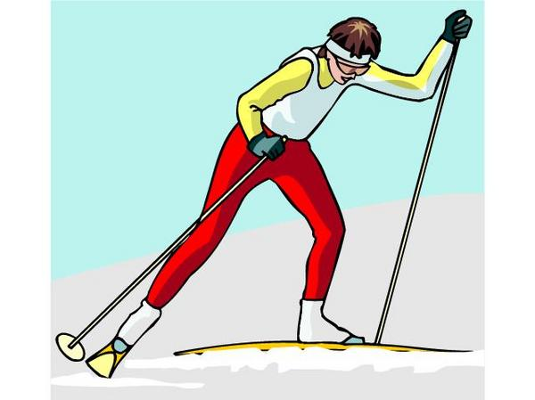
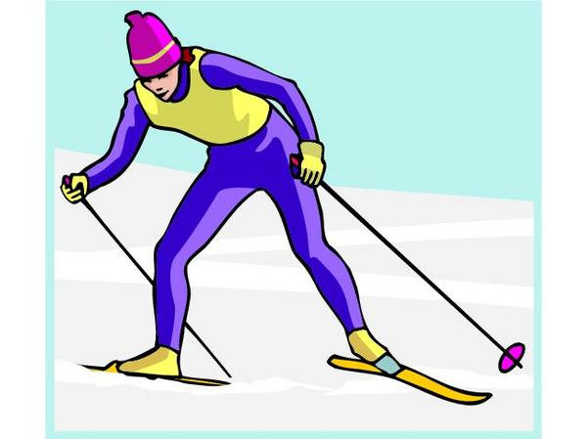
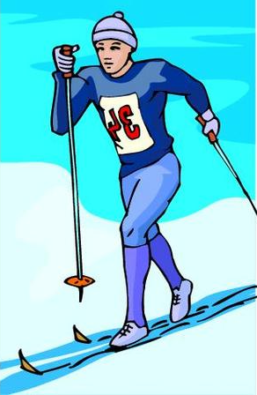

APRIL 2006
LEARNING AND EVALUATION SITUATION
Secondary |  |  |  |  | Subject | Title | Number of periods
Cycle One |  | Cycle Two |  |  | Physical Education and Health | Cross-country Skiing | 7 seventy-five minute periods
1st | 2nd | 1st | 2nd | 3rd | Physical Education and Health | Cross-country Skiing | 7 seventy-five minute periods

Author: Yvon Lachance
School board: School: Date:

Subject-specific competency
Performs movement skills in different physical activity settings
Achievement context
The students work in small teams and practise the following technical skills: diagonal stride, sidestep, herringbone step, tuck position and snowplow. After choosing their equipment, they agree with the teacher on a method of getting the equipment quickly at the beginning of the period. They apply the principles of coordination and balance relevant to each technique and receive feedback from their peers. They develop motor skills, taking into account their strengths and weaknesses, the difficulties of different cross-country trails and safety aspects. They explain to a peer the improvements they need to make to their repertoire of technical skills, as well as the skills they could apply in another context within their process.

Challenge
The students ski one of three cross-country trails, each of which has a different level of difficulty. They select the one that poses a challenge, demonstrate efficiency and apply safety measures. At the end, they explain the learning process used and the movement skills they could apply in other contexts.
Based on the evaluation criteria, determine the observable aspects selected for evaluation
- Makes an effort to take up a reasonable challenge.
- Applies the principles of coordination and balance in the performance of his/her technical skills.
- Determines improvements to be made during the learning process.
- Demonstrates control when skiing the trail.
- Applies safety rules and the rules of ethics.
- At the end, can explain the improvements made and the difficulties overcome.
- Recognizes the elements that could be used in other contexts.

