s
Document 3S-B


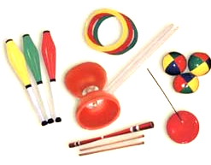
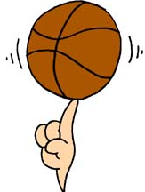
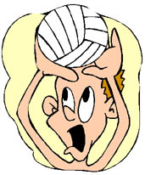

Manipulation 101

USING INFORMATION GATHERED ON THREE STUDENTS:

- interpret their results
- make a judgment based on a suggested scale

April 2006
EVALUATION RUBRIC FOR THE TEACHER
Competency: Performs movement skills in different physical activity settings
Manipulation 101

Legend for the observable aspects
P : Good | ä : Needs improvement | - : Has difficulty

Observable aspects  Class:  Date: | Plans his/her sequence using the student’s document. | Selects movement skills based on his/her ability. | Justifies his/her choice of movement skills based on his/her ability. | Coordinates the performance of his/her movement skills. | Performs the sequence as planned. | Applies safety rules. | Notes improvements to be made to his/her sequence. | Identifies achievements and difficulties in his/her process. | Rating
CAROLINE |  |  |  |  |  |  |  | 
CAROLINE | Has difficulty planning and choosing movement skills and justifying her choices (her plan and choices are somewhat unclear). Needs help and a lot of guidance. Has low self-esteem. Underestimates her abilities. Correct report.
MAX |  |  |  |  |  | - |  | 
MAX | Has a lot of difficulty applying safety rules and I must intervene on a regular basis. Demonstrates autonomy in carrying out the process. Performs as planned. Incomplete report.
STEPHANIE |  |  |  |  |  |  |  |  | NE
STEPHANIE | Sprained wrist – medical exemption for the greater part of the activity.

Scale used to make a judgment concerning the degree of
competency development during a cycle or year
RATING | DESCRIPTION
A | The student exceeds the requirements of the tasks.
B | The student meets most of the requirements of the tasks.
C | The student meets a few of the requirements of the tasks.
D | The student meets no requirements of the tasks.
NE | Not evaluated

EVALUATION TOOL
Self-evaluation and peer evaluation

Manipulation 101

Section 1

Student’s name: ______________________ Date: _________ Group:_____

Identify which objects you will use.
□ Basketball Other: ___________________________
□ Volleyball ___________________________
□ Juggling clubs ___________________________
□ Juggling balls ___________________________
Section 1. Plan your sequence of movement skills.
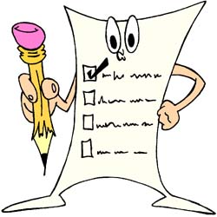
Indicate the movement skills you will use in your sequence. Use the descriptions on the posters.

Example: I will spin a ball on my finger.

1. | 2.

3. | 4.

5. | 6.

7. | 8.

9. | 10.

11. | 12.

13. | 14.

EVALUATION TOOL
Self-evaluation and peer evaluation

Juggling

Section 2

Section 2. Peer evaluation
Ask a classmate to watch your performance.
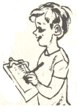
Student’s name: ________________________________ Group:______

Name of evaluator: ____________________________ Date:________

Aspects to observe (check the box if you observe the aspect)
- Controls objects without dropping them. 
- Performs the movement skills without hesitation
(links the movements). 
- Uses different movement skills. 
- Makes it look easy. 
- Synchronizes the movement skills. 
 Section 3. Improvements
Note the improvements you will make to your juggling sequence.
Example: In juggling, I will cross using two objects instead of three.

1.

2.

3.

4.

Section 4. Self-evaluation
Write A for achievement and D for difficulty.
- I tried different movement skills. _____
- I practised my sequence several times. _____
- I chose movement skills adapted to my ability. _____
- I planned my sequence of movement skills. _____
- I followed the instructions. _____
- I always applied the appropriate safety rules. _____
- I coordinated and linked my movement skills. _____
- I performed my sequence according to plan. _____

I noted improvements to be made to my sequence. _____

