s
Document 3-A.S.

[
TEACHER’S DOCUMENT

SECONDARY CYCLE ONE
1st YEAR OF THE CYCLE

PERFORMS
MOVEMENT SKILLS IN DIFFERENT
PHYSICAL ACTIVITY SETTINGS

LEARNING AND EVALUATION SITUATION


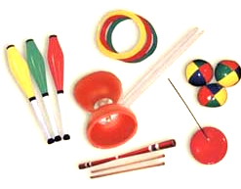
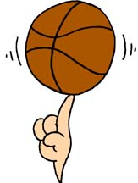


Manipulation 101

APRIL 2006

LEARNING AND EVALUATION SITUATION
Secondary |  |  |  |  | Subject | Title | Number of periods
Cycle One |  | Cycle Two |  |  | Physical Education and Health | Manipulation 101 | 7 seventy-five minute periods
1st | 2nd | 1st | 2nd | 3rd | Physical Education and Health | Manipulation 101 | 7 seventy-five minute periods

Author: Pierre Gagnon Adaptation: André Rousseau
School board: School: Date:

Subject-specific competency

Performs movement skills in different physical activity settings

Achievement context
This situation is spread out over seven periods. An additional period could be added to accommodate students experiencing difficulty. The students must perform a sequence of object manipulation skills in a restricted space. A variety of equipment (e.g. juggling equipment, basketballs, mini volleyballs) is available to enable them to make a choice of movement skills adapted to their ability. They must reflect on and analyze the situation in order to perform a movement sequence in accordance with the proposed process. Different sources of information (e.g. posters, video) are available to stimulate their imagination and help them come up with ideas. The students must behave in a safe manner throughout the learning and evaluation activity. A student’s document is provided so they can plan the sequence and make improvements. They must present the sequence to you and evaluate the process (analyze, choose, perform, evaluate).

Challenge
Based on the evaluation criteria, determine the observable aspects selected for evaluation

- Plans his/her sequence.
- Selects movement skills based on his/her ability.
- Justifies his/her choice of movement skills based on his/her ability.
- Coordinates the performance of his/her movement skills.
- Performs the sequence as planned.
- Applies safety rules.
- Notes improvements to be made to his/her sequence.
- Notes the strengths and weaknesses of his/her process.

Phase 1: Preparation
Materials: | Duration

Objectives | - Present the problem  - Activate prior knowledge  - Draw out students’ representations and questions  - Establish a work plan  - Specify the expected productions and the target audience, if applicable

Period no. | Identification of tasks
Period 1 | Presentation of the challenge  - Indicate the observable aspects (see Appendix 1) you will be using to make a judgment on each student’s process.  - Prior knowledge  - Verify the students’ prior knowledge by asking, for example: Have you ever juggled?

Phase 2: Performance

Materials: See first point ➢ below, Period 1 (cont.) | Duration

Objectives | - Guide the students in complex tasks  - Propose resource acquisition tasks, if applicable  - Set aside time for reflection and review

Period no. | Identification of tasks
Period 1 (cont.)  Period 2  Period 3  Period 4  Period 5 | - Present the workshops set up in the gym: juggling (e.g. beanbags, balls, clubs, scarves), devil sticks, balls (e.g. basketballs, volleyballs, rhythm balls), hoops, balancing poles.  - Have the students form teams of five or six and experiment with the different workshops, performing manipulation skills they are familiar with. Hang posters to help them.  - Walk around the gym, helping students and making sure everything is going well. After a time, signal the teams to change workshops.  - Randomly assign a workshop to each team. Have the students explain the different techniques involved and identify the safety rules to follow during the activity.  - Have the students prepare their presentation, which should last three to four minutes.  - Walk around the gym, helping the teams prepare.  - Ask the students to identify the safety rules they deem important. Write their answers on the board and add any they have missed (see Appendix 3).  - Explain that they can work in teams of two or three, and that each student will be presenting his or her sequence.  - Walk around the gym, helping students and regulating learning. Observe them and make notes on the observation checklist concerning how they apply the safety rules.  - Have the students continue experimenting with the equipment. Observe them and record your observations as needed.  - Have the students refer to the instructions and processes (see Appendix 2).  - Explain the student’s document. Have the students continue their work, referring to the instructions.  - Have the students continue their work, referring to the instructions. Tell them that they should have completed section 2 of the student’s document by the end of the period.  - Observe the students and record your observations on the checklist. Then, walk around the gym to regulate learning.  - Comment on the students’ level of achievement of the observable aspects that you have indicated on the checklist since the beginning of the situation. Share your observations about the process they have adopted since Period 3. Inform them that they can now present their sequence and that they must have completed the first three sections of the student’s document.  - Have the students continue their work, referring to the instructions posted on the gym walls.  - Help students experiencing difficulties make corrections.  - Have the students continue doing their preparatory work and presenting their sequences, making sure they have completed the first three sections of the student’s document.  - Before they present their sequence, have them discuss it with you in order to justify their choice of manipulation skills and equipment.

Phase 3: Integration
Materials: | Duration
Objectives | - Lead a discussion summarizing the learning acquired  - Help the students identify situations to which they could transfer their learning  - Allow them to express their degree of satisfaction
Period no. | Identification of tasks
Period 6  Period 7 | - After the presentation, have the students fill out section 4 of the student’s document on self-regulation. Then have them hand in the document and discuss their process with you. Complete your notes on the observation checklist.  - Once the students have finished, they may go to the section of the gym set up for free activities or practise manipulation skills in the workshops without disturbing those who have not yet finished. They can also help their classmates who have not yet finished.  - Same tasks as Period 6 to enable students to present their sequences.

APPENDIX 1

STUDENT’S PROCESS
(What you will be evaluated on)

ANALYZE (the situation based on the requirements of the context)

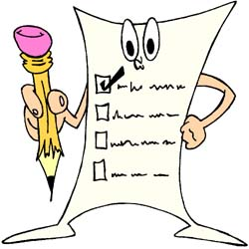
- I plan my sequence using the student’s document.

- I choose my movement skills based on the instructions posted in the gym.

- I choose my movement skills based on my abilities (not too hard, not too easy).

- I can say why I chose the movement skills in my sequence.

PERFORM (movement skills based on the different constraints of the physical environment)
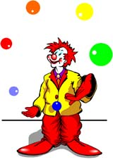
- I coordinate my sequence.

- I perform all the movement skills chosen in the order indicated.

- I perform my movement skills in
accordance with the instructions.
See posters in the gym
- I apply safety rules.

EVALUATE (your motor efficiency and your process based on the goal pursued)

- I identify my achievements and my difficulties in the preparation and presentation of my sequence.

- I note improvements to be made to my sequence.

APPENDIX 2

PROCESSES
- I try and practise different manipulation exercises.

- I think about movement skills I could perform.

- I plan my sequence of movement skills using the student’s document.

- I have three periods to prepare.

- I present my sequence of movement skills to a classmate.

- Using the Student’s Process sheet, I observe a classmate to help him or her.

- I present my sequence of movement skills to the teacher.

- I evaluate my process.

INSTRUCTIONS (production)
- I choose movement skills based on my abilities.

- I take into account the technical elements of my performance.

- My sequence includes at least five different manipulation skills.

- Each movement skill is repeated at least three times in my sequence.

- I perform my movement skills without hesitation and without stopping.

- I perform my movement skills without losing control of the objects.

APPENDIX 3

SAFETY RULES

Rules |  | My responsibility
1 | Observance of workspace   | I define my workspace and take care to respect it.
2 | Respect for people and equipment  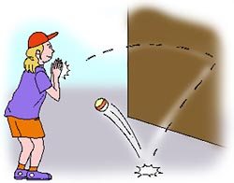 | I hand over the equipment that accidentally ends up in my workspace.  I do not do anything dangerous that could injure me or another student (e.g. throw a ball at another student).
3 | Calm attitude, conducive to working  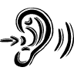 | I speak calmly and take care not to disturb the other students when I walk around.  
BE CAREFUL!
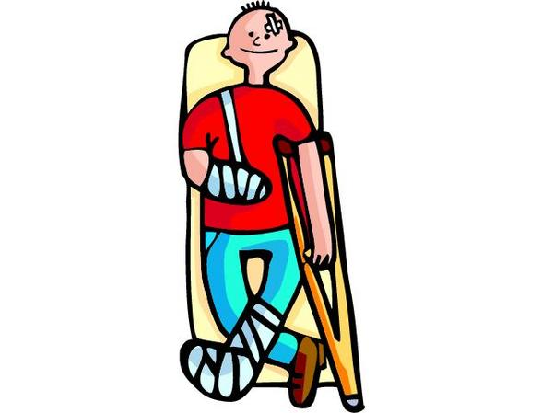

APPENDIX 4

WORKSHOP ON MANIPULATING BALLS

Description of movement skills:

- Dribble the ball at hip level.
- Dribble like a basketball player.
- Dribble in a circle around you.
- Dribble in a circle around your foot.
- Dribble in a figure-8 pattern around your feet.
- Spin the ball on your finger.
- Pass the ball between your legs, changing hands.
- Pass the ball between your legs while walking.
- Throw the ball up and catch it behind you.
- Roll the ball on your arms behind your head.

Illustrations:

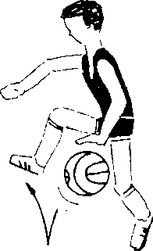

EVALUATION RUBRIC FOR THE TEACHER
Competency: Performs movement skills in different physical activity settings

Manipulation 101 – Secondary Cycle One, first year
Legend for observable aspects:

P : Good | ä : Needs improvement | - : Has difficulty
COTE | DESCRIPTION
A | .
B
C
D
NE
Observable aspects    Title:  Manipulation 101  Class:  Date: | Plans his/her sequence using the student’s document. |  | Selects movement skills based on the instructions posted in the gym. | Justifies his/her choice of movement skills based on his/her ability. | Coordinates the performance of his/her movement skills. |  | Performs the sequence as planned. | Applies safety rules. | Notes improvements to be made to his/her sequence. |  | Identifies achievements and difficulties in his/her process. | Rating
1.
2.
3.
4.
5.
6.
7.
8.
9.
10.
11.
12.
13.

Scale used to make a judgment concerning the degree of
competency development during a cycle or year
RATING | DESCRIPTION
A | The student exceeds the requirements of the tasks.
B | The student meets most of the requirements of the tasks.
C | The student meets a few of the requirements of the tasks.
D | The student meets no requirements of the tasks.
NE | Not evaluated

