Acrogym
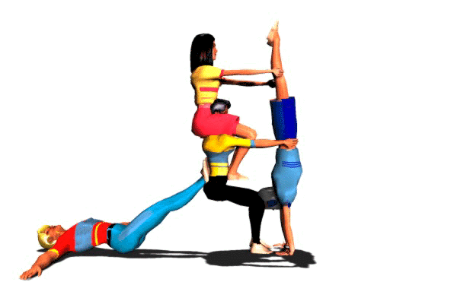

USING INFORMATION GATHERED ON THREE STUDENTS:

- interpret their results
- make a judgment based on a suggested scale

April 2006

EVALUATION RUBRIC FOR THE TEACHER
Competency: Interacts with others in different physical activity settings

Acrogym – Secondary Cycle One, 1st Year of the Cycle

Legend for the observable aspects:
P : Good | ä : Needs improvement | - : Has difficulty

Observable aspects  Class:  Date: May 2007 | Suggests ideas during the development of the routine. | Listens to others’ ideas during the development of the routine. | Performs as planned. | Applies the rules of ethics. | Communicates effectively during rehearsals and the presentation. | With his/her teammates, identifies the strengths and weaknesses of the plan. | With his/her teammates, identifies ways of adjusting the plan. | Rating
CAROLINE | - | P | P | P | P | P | P
CAROLINE | Allows the others to make the decisions and accepts the role they assign her. Plays her role correctly during rehearsals and the presentation. Records the team’s results. Accurate self-evaluation.
MAX | P | - | P | - | P | - | -
MAX | Insisted that there be eight people on his team (the instructions say a maximum of six). Took over the leadership of the team. Had difficulty working: little perseverance and effort. I had to constantly help him refocus on the task at hand. I often had to remind him to secure the mats and remove his jewellery and shoes. Minimal presentation. The team had difficulty completing the report. Inadequate self-evaluation.
STEPHANIE | P | - | P | P | - | - | -
STEPHANIE | Participated a little more than usual in this activity. Played a “backstage” role (assistant almost all the time), while she has the physique of a flyer. Correct presentation. Incomplete evaluation.

Scale used to make a judgment concerning the level of
competency development attained during a cycle or year
RATING | DESCRIPTION
A | The student exceeds the requirements of the tasks.
B | The student meets most of the requirements of the tasks.
C | The student meets a few of the requirements of the tasks.
D | The student meets no requirements of the tasks.
NE | Not evaluated
SELF-EVALUATION
Individual evaluation of teamwork

Student’s name: | Caroline | Criteria:
 |  | A:  B:  C:  D: | Progresses easily  Progresses adequately  Progresses with help  Progresses with difficulty despite the help given

 | A | B | C | D
I suggest my ideas to my teammates. |  |  | ✓
I listen to my teammates’ ideas. |  | ✓
I adjust my actions to those of my teammates. |  | ✓
I agree to play different roles. |  | ✓
I apply the appropriate rules. |  | ✓

SELF-EVALUATION
Individual evaluation of teamwork

Student’s name: | Max | Criteria:
 |  | A:  B:  C:  D: | Progresses easily  Progresses adequately  Progresses with help  Progresses with difficulty despite the help given

 | A | B | C | D
I suggest my ideas to my teammates. | ✓
I listen to my teammates’ ideas. | ✓
I adjust my actions to those of my teammates. | ✓
I agree to play different roles. | ✓
I apply the appropriate rules. |  | ✓

SELF-EVALUATION
Individual evaluation of teamwork

Student’s name: | Stephanie | Criteria:
 |  | A:  B:  C:  D: | Progresses easily  Progresses adequately  Progresses with help  Progresses with difficulty despite the help given

 | A | B | C | D
I suggest my ideas to my teammates. |  | ✓
I listen to my teammates’ ideas.
I adjust my actions to those of my teammates.
I agree to play different roles.
I apply the appropriate rules.

EVALUATION RUBRIC
Plan of action for the routine

NAME OF TEAM:

Level | 1 | 2 | 3 |  |  |  |  | Level | 1 | 2 | 3
OPENING |  |  |  | TRANSITION 1 |  |  |  | PYRAMID 1
 |  |  |  | Level | 1 | 2 | 3
TRANSITION 2 |  |  |  | PYRAMID 2 |  |  |  | TRANSITION 3
Level | 1 | 2 | 3 |  |  |  |  | Level | 1 | 2 | 3
PYRAMID 3 |  |  |  | TRANSITION 4 |  |  |  | PYRAMID 4
 |  |  |  | Level | 1 | 2 | 3
TRANSITION 5 |  |  |  | PYRAMID 5 |  |  |  | TRANSITION 6
Level | 1 | 2 | 3 | Names of team members ⇒
CLOSING

