TEACHER’S DOCUMENT

SECONDARY CYCLE ONE
2nd YEAR OF THE CYCLE

INTERACTS
WITH OTHERS IN DIFFERENT
PHYSICAL ACTIVITY SETTINGS

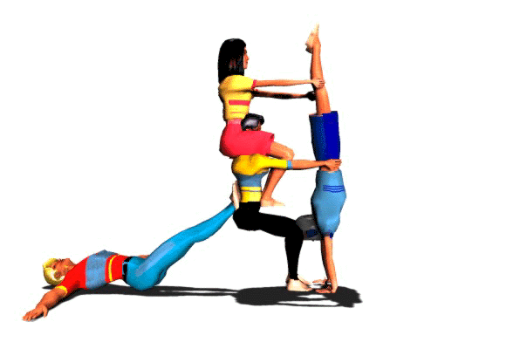
LEARNING AND EVALUATION SITUATION

Acrogym!

AVRIL 2006

April 2006

LEARNING AND EVALUATION SITUATION
Secondary |  |  |  |  | Subject | Title | Number of periods
Cycle One |  | Cycle Two |  |  | Physical Education and Health | Acrogym | 7 seventy-five minute periods
1st | 2nd | 1st | 2nd | 3rd | Physical Education and Health | Acrogym | 7 seventy-five minute periods

Development: François Légaré, École secondaire Roger-Comtois
Adaptation 1: Cindy Boucher, student teacher
Adaptation 2: André Rousseau
School board: des Navigateurs (Jacques Corriveau)
School: Date:

Subject-specific competency

Interacts with others in different physical activity settings
Achievement context
Over the course of five periods, the students form teams of six and select their teammates based on their strengths and weaknesses. The students take into account the different roles in the formation of an acrogym team: base, flyer, leader and assistant. Of a list of pyramids in pairs, trios and fours, the students try forming pyramids and choose five of them to use in a routine. They must respect safety rules.
Web sites:

<http://members.aol.com/_ht_a/didrichaud/article.html>
(bank of pyramids in pairs, trios and fours)
<http://www.ac-dijon.fr/pedago/eps/acrospor/>

Challenge
“You will form a team of six, taking into account the different roles in an acrogym team. You will present a two-minute routine to the class. The routine must include: an opening move, five pyramids of your choice (from the list of pyramids in pairs, trios and fours that I will be handing out) and a closing move. In addition, you will include transition movements before and after each pyramid. You can present your routine to the music of your choice. You will be asked to evaluate your work and produce a report at the end of the activity.
Based on the evaluation criteria, determine the observable aspects selected for evaluation
- Suggests ideas during the development of the routine.
- Listens to others’ ideas during the development of the routine.
- Performs as planned.
- Applies the rules of ethics.
- Communicates effectively during rehearsals and the presentation.
- With his/her teammates, identifies the strengths and weaknesses of the plan.
- With his/her teammates, identifies ways of adjusting the plan.

Phase 1 – Preparation

Materials: | Duration

Objectives | - Present the problem  - Activate prior knowledge  - Draw out students’ representations and questions  - Establish a work plan  - Specify the expected productions and the target audience, if applicable

Period no. | Identification of tasks
Period 1 | - Presentation of acrogym (see Appendix 1)  - Presentation of evaluation  - Presentation of the roles, taking personal competencies into account  - Presentation of external resources: pyramids in pairs, trios and fours  - Formation of teams  - Performance of pyramids (fill out Appendix 2)  - Teacher’s evaluation of teamwork out of 5

Phase 2 – Performance

Materials: | Duration

Objectives | - Guide the students in complex tasks  - Propose resource acquisition tasks, if applicable  - Set aside time for reflection and review

Period no. | Identification of tasks
Period 2 | - Presentation of transitions  - Review of final plan (5 pyramids, 1 opening move, 1 closing move, transitions)  - Possibility of finding a theme (easier)  - Performance of pyramids  - Choice of pyramids  - Practice  - Preliminary development of routine: sequence and transitions  - Preliminary drafting of routine  - Teacher’s evaluation of teamwork out of 5
Period 3 | - Consolidation of learning and adjustments  - Development of routine  - Drafting of routine  - Practice  - Teacher’s evaluation of teamwork out of 5
Period 4 | - Polishing and rehearsal  - Teacher’s evaluation of teamwork out of 5  - Planning of order of presentation for the next period
Period 5 | - Last rehearsal  - Presentation before the class

Phase 3 – Integration
Materials: | Duration
Period no. | Identification of tasks
Period 5 (cont.) | - Oral evaluation of the presentation by the teacher  - Teacher’s overall evaluation of the activity out of 5

Objectives | - Lead a discussion summarizing the learning acquired  - Help the students identify situations to which they could transfer their learning  - Allow them to express their degree of satisfaction
APPENDIX 1
INTRODUCTION TO ACROGYM

PARAMETERS

- Cooperation
- Balance
- Creativity
- Flexibility
- Aesthetism (body expression)
- Muscle strength and endurance

Group activity in which each member of the team can put his or her competencies to good use:

Base: - Occupies the position at the base of the pyramid and supports all or part of the weight of the person on top.

Flyer: - Occupies the top position of the pyramid.
- Climbs onto base and assistants.
- Maintains a stable, solid posture in different configurations.

Leader: - Gives the rhythm in order to synchronize the team’s actions.
- Ensures that all team members cooperate.

Assistant: - Manually helps the flyers get to the top.

SAFETY:

Hold wrists
Remove shoes
Align supports: pelvis, shoulders, knees, back straight
Maintain a stable position
Offer the largest support area possible
At the joints (shoulders, pelvis, never the middle of the back)
If he or she loses his or her balance, the flyer must jump immediately unless the pyramid is very high
Create a pyramid from the base to the top and from the centre out
A flared pyramid can be as impressive as a high pyramid

APPENDIX 2

ACROGYM

ACROGYM Secondary I Group: _______

INSTRUCTIONS

FORM A TEAM OF UP TO SIX PEOPLE.

- UNDERSTAND EACH ROLE AND CHOOSE ONE: BASE, FLYER, LEADER, ASSISTANT.

- PREPARE A TWO-MINUTE CHOREOGRAPHY INCLUDING:
- AN OPENING POSITION
- FIVE PYRAMIDS (FROM THE LISTS PROPOSED)
- TRANSITION MOVEMENTS BETWEEN THE PYRAMIDS
- A FINAL POSITION
- MUSIC (OPTIONAL)

TEAM: NAME:______________________

LEADER: __________________

MEMBERS: _________________ ____________________

____________________ ____________________ _________________

PERIOD 1: PYRAMIDS ATTEMPTED (CIRCLE THEM IF YOU SUCCEEDED):

P: ___________________________________________________

T: ___________________________________________________

F: ___________________________________________________

