

Evaluation of Learning in Elementary Social Sciences
(To be used as of 2011-2012)
Evaluation Criteria 1 & 2
1. Proficiency of subject-specific knowledge  targeted in the Progression of Learning.  http://www.mels.gouv.qc.ca/progression/geoHistoire/index_en.asp | 2. Appropriate use of knowledge
“The arrow indicates that the evaluation of learning involves a process of going back and forth between
the acquisition of subject-specific knowledge and the understanding, application and use of this knowledge.
Evaluation must thus take place throughout the learning process to ensure proficient knowledge.”
Clarifying the Criterion:
“APPROPRIATE USE OF KNOWLEDGE”
Note: This criterion evaluates learning associated with the 3 competencies. It is a criterion that evaluates the student’s ability to perform intellectual operations that draw on geographic and historical knowledge and knowledge related to citizenship education.
- Situate in time and space
- Establish facts
- Characterize a territory
- Make comparisons
- Determine changes
- Establish connections between facts
- Establish causal connections

Intellectual operations overview:
I.O. | WHAT THE INTELLECTUAL OPERATION INVOLVES | COMPETENCY CONNECTIONS
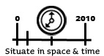 | The student’s ability to place facts in chronological order  OR  The student’s ability to place a fact or a set of facts on a timeline  OR  The student’s ability to establish the precedence or posteriority of facts  OR  The student’s ability to situate territories in time  OR  The student’s ability to situate geographic elements or facts or territories in a space at a given point in time. | 1  2  3
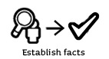 | The student’s ability to identify relevant and accurate facts | 1  2  3

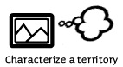 | The student’s ability to identify characteristics | 1  (DEMOGRAPHIC & ECONOMIC)
 | The student’s ability to identify similarities and differences | 3
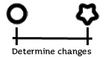 | The student’s ability to indicate a change occurring over time | 2
 | The student’s ability to interrelate facts  OR  The student’s ability to illustrate a statement by citing relevant and accurate facts | 1  2  3
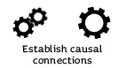 | The student’s ability to establish a logical connection between explanatory factors and consequences | 1  2  3

