Tensions and Conflict:
The Rwandan Genocide through graphic novels and interviews

Contemporary World
& Ethics and Religious Culture

Learning and Evaluation Situation
STUDENT BOOKLET
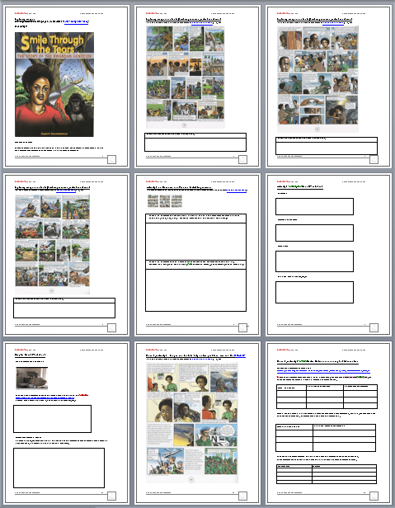
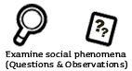
Phase 1: Activity 1 on Genocide:
Prior Knowledge, Initial Impressions, Identifying actors, power relations.

E K W Q
Experience | Knowledge | Wonder | Question
What do I already know about this
I have seen…  I have been to…  I have lived…  E | What I know about the issue, the event, the people who are involved…  K
I wonder…  W | Questions I have about  this society and territory:  Q
Phase 1: Activity 1 on Genocide:
Prior Knowledge, Initial Impressions, Identifying actors, power relations.
Consider the following picture:  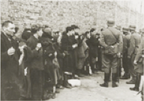  Larger version: http://fcit.usf.edu/Holocaust/GALL31R/26538.htm | Consider definitions of genocide:  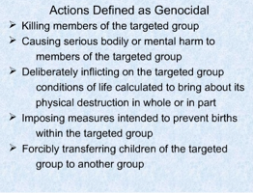  Larger version at Genocide Framework slide 8
Initial impressions, information, etc.
Define genocide in your own words:
Identify some elements of society and/or actors involved in typical genocides.
(People, gov't, military). Discuss in terms of some familiar examples in history, cinema, games, etc.
Alternate images sources to which you could respond:
http://www.authorstream.com/Presentation/Sushil-297-the-holocaust-world-ii-jews-hitler-nazi-germany-PowerPoint/
http://www.shamash.org/holocaust/photos/
http://fcit.usf.edu/Holocaust/resource/gallery/G1941WGU.HTM
Exploring images
from Rupert Bazambanza's graphic novel entitled "Smile Through the Tears."
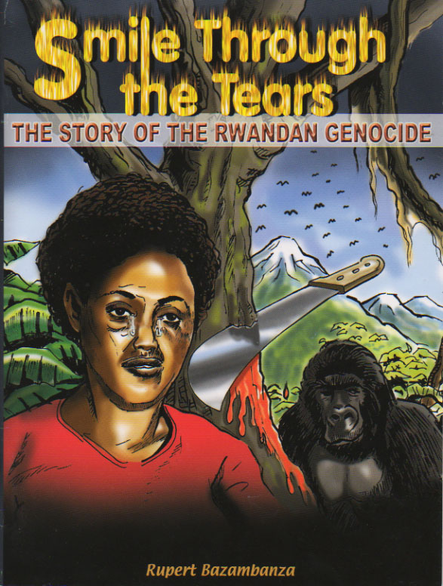
Questions to discuss:
What do you think is going on here?
What part of the world is this?
It is a positive or negative title for a story?
How could this have anything to do with local or world Conflicts and Tensions?
Exploring images and texts (First impressions, initial questions)
from Rupert Bazambanza's graphic novel entitled "Smile Through the Tears." (p. 49)
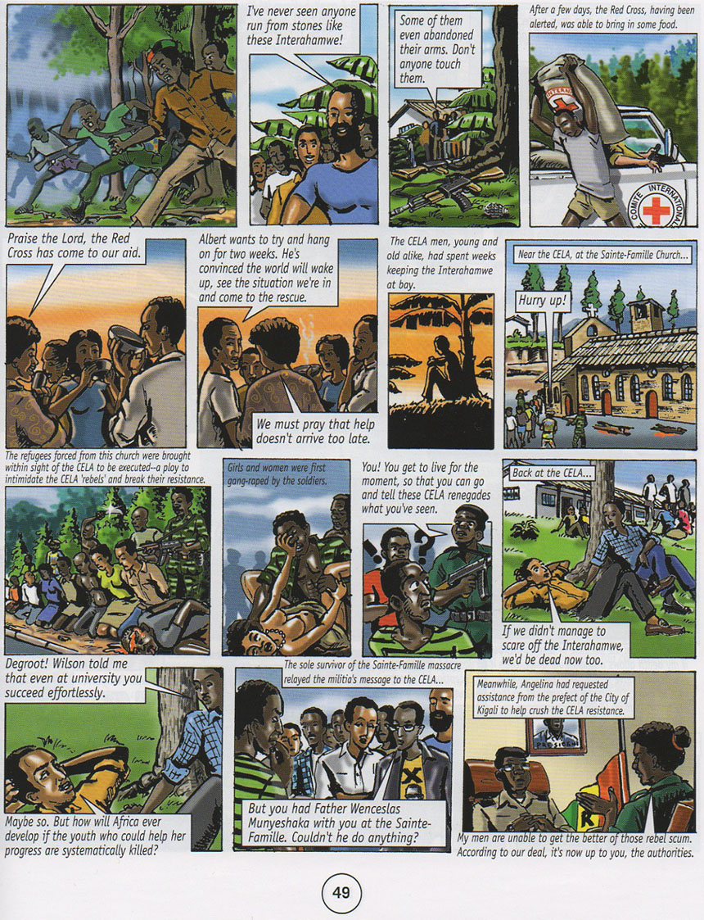
Jot down any questions and share them with the class.
Exploring images and texts (First impressions, initial questions)
from Rupert Bazambanza's graphic novel entitled "Smile Through the Tears." (p. 52)
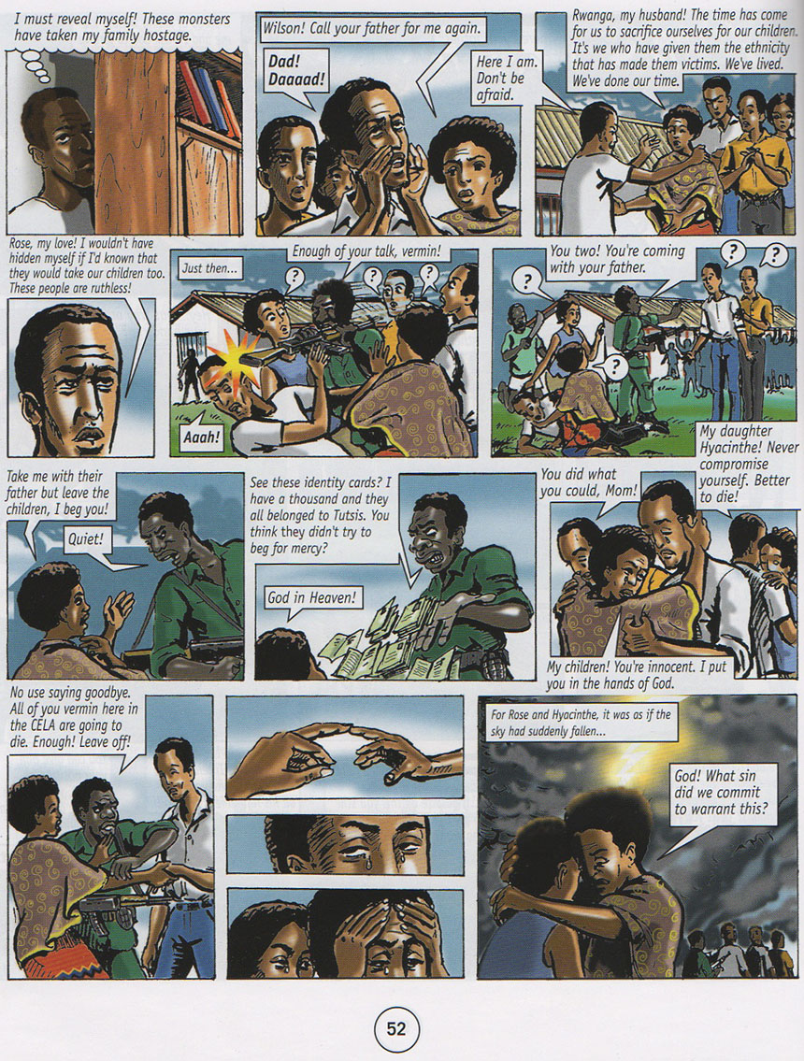
Jot down any questions and share them with the class.
Exploring images and texts (First impressions, initial questions)
from Rupert Bazambanza's graphic novel entitled "Smile Through the Tears." (p. 54)
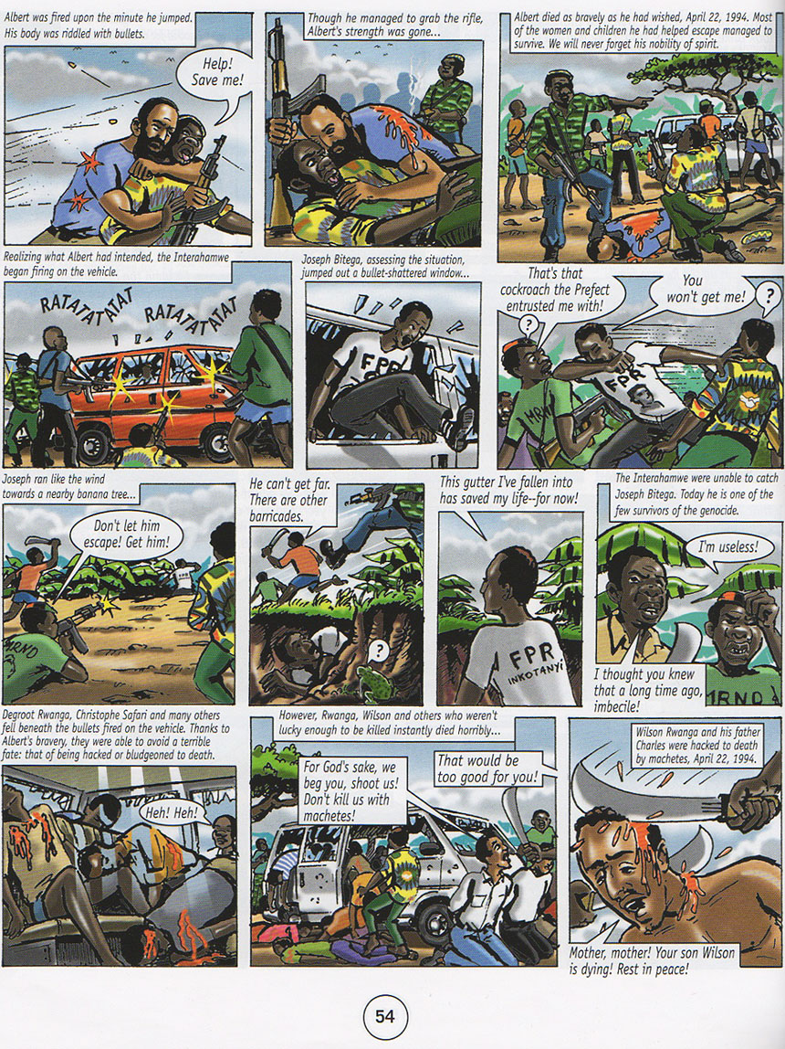
Jot down any questions and share them with the class.

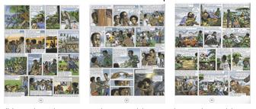
Activity 2 on Genocide and Rwanda Initial Impressions:
Make observations and formulate questions after reading through selected pages of Rupert Bazambanza's graphic novel "Smile Through the Tears."

Write a few observations and questions related to historical “contexts” in Rwanda
(Use where, when, who, what. Consider individual frames of novel.)

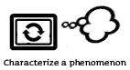
Write observations and questions about morally questionable scenes and any issues that come to mind.
(Consider tolerance, cultural differences, un-controlled emotions... Ask questions, to understand why.)
Activity 3: Graphic Novel Worksheet 1
Definition:
Well-known examples of graphic novels:
Techniques:
Different effects (emotional, etc.):

Activity 3: Graphic Novel Worksheet 2

Quotes from Jessica Silva, MA Major paper entitled
Graphic Content: Interpretations of the Rwandan Genocide through the Graphic Novel.

"Creative aesthetic techniques employed by the artist specifically to promote reader participation can be achieved through various artistic techniques. Panels that portray views from above in which the reader is looking down create a sense of detachment in the reader as they become an observer rather than a participant. Whereas panels featuring a view from below endorse a sense of smallness and stimulate fear in the reader, creating a sense of viewer participation in the scene." p. 11

"The graphic novel’s unique ability to capture and involve the reader through a creative interplay of images and words is especially critical when dealing with the subject of genocide. Images of genocide alone have the potential to repel viewers rather than engage them due to the content of such photos, whereas the combination of images and words create an approachable medium that can trigger emotion as well as interpretation." p. 11
Activity 3: Graphic Novel Worksheet 3
Rupert Bazambanza interview on
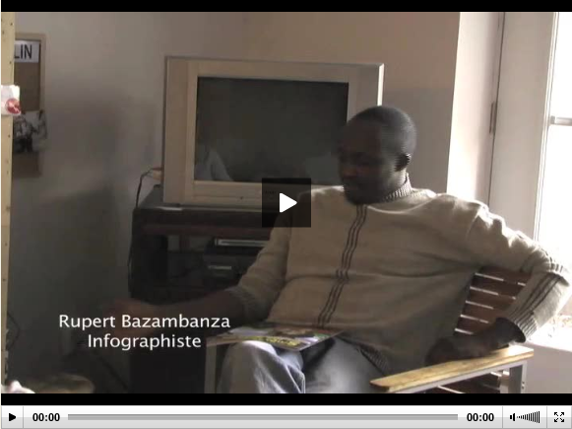
Write some key points said during Rupert Bazambanza interview on Parole Citoyenne:
http://citoyen.onf.ca/entrevue-avec-rupert-bazambanza?term_tid=53
(Consider Bazambanza’s own history, why he used a graphic novel, etc.)
Explain Bazambanza’s reasons
In a space provided, students could now write a short paragraph explaining Bazambanza’s personal reasons for writing the story, the choice of media used and its effectiveness.
Phase 2, Activity 1: Images and texts to help define problem: Aid and the UNAMIR
from Rupert Bazambanza's graphic novel entitled "Smile Through the Tears." (p. 34)
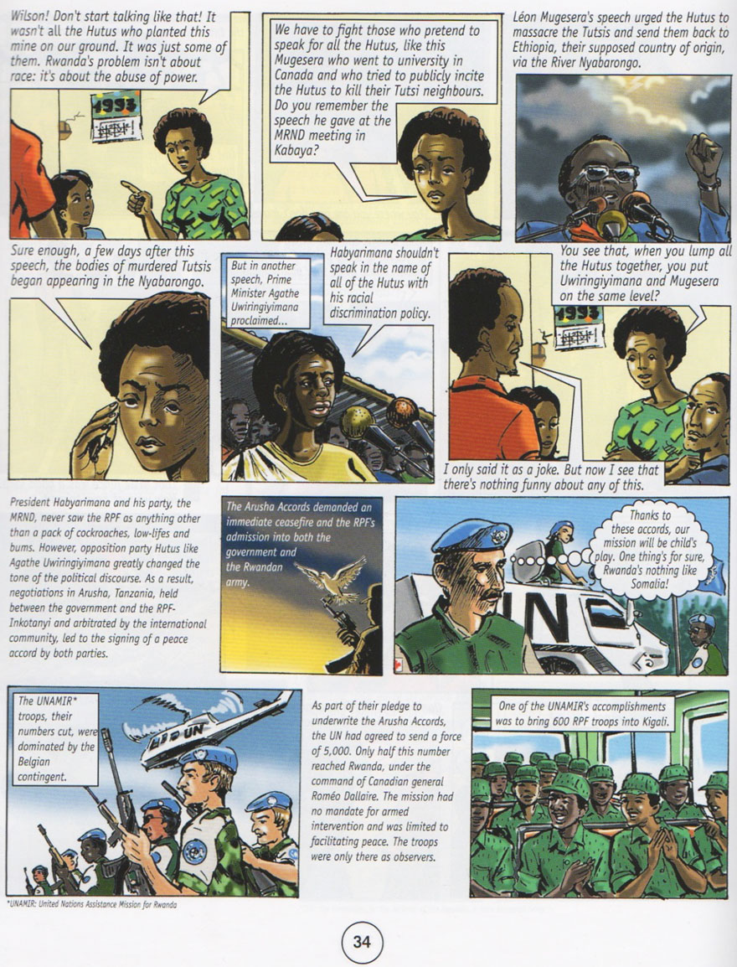

Phase 2, Activity 1: The United Nations and concept of Intervention
Use supplied original scans available here
http://www.learnquebec.ca/en/content/curriculum/social_sciences/sec_contworld/les_rwanda_genocide/smiletears_scans.zip
Slides from page 34: | Information evident in slide | Info still needed (Questions)
i) Respond to individual slides in section of larger graphic novel. The task is to identify aspects of new actor, and maybe top identify contexts for which intervention may still be needed.
ii) Explore the UN sites for more specific information about the international situation, role of UN, the potential of the UN to act as a peacekeeper. Canadians actors could also be identified here.
iii) Define new concepts in light of new information about UN involvement in Rwandan genocide.
Students discuss and target information needed in order to take a position on guiding question.
Section of UN site I viewed | Information related to peacekeeping
Key concepts: | Definition

Notes on complexity of Peacekeeping
Use the following pace for student notes during discussion of complexities of Peacekeeping, Role of UN, How they could have helped, Issues associated with sovereignty and intervention.
Formulate additional questions
Write more specific questions if needed. (Questions that you will answer by reading and researching later.)

Phase 2 Activity 2: Specific actors in novel: Identify and Interpret
Include in these summaries questions or areas in need of further research.
Name the “Actors”  (i.e. characters or organizations) | Describe their experience or involvement in the conflict | Describe any Moral questions or Ethical Issues associated with the experiences of those actors. | List any specific historical contexts  (ethnic groups, country of origin, politics, historical phenomena, etc.)

Phase 2 Activity 3: Group Work: Historical Records Compared
Instructions: Each group starts with a different actor to research.
Task is to identify their timeframe (dates), what you know of their values/interests, restate their role as you now see it given this new historical information.
Actor (Historical, Political, Economic, Etc.) | Timeframe (Dates) | Values and/or Interests of Actor | Role in Genocide
German and Belgium colonialists
Colonial Rwanda http://www.ambarwanda.ch/spip.php?article115

False History, Real Genocide: The Use and Abuse of Identity in Rwanda
http://genocide.change.org/blog
/view/false_history_real_genocide_the_use_and_abuse_of_identity_in_rwanda

Catholic priests.
Killings create a rift among Catholics
http://www.maykuth.com/Projects/rwan3.htm

Rwandan Hutu government.
See same article from above
False History, Real Genocide..
Post independence History. Peace agreements, etc.
http://www.rwandagateway.org/article.php3?id_article=116

Interahamwe: Hutu extremists, militias, etc.
Who were these people? What was their motivation?
Interahamwe - Wikipedia http://en.wikipedia.org/wiki/Interahamwe

Phase 2 Activity 3: Group Work: Historical Records Compared …..(Cont’d)
Instructions: Each group starts with a different actor to research.
Task is to identify their timeframe (dates), what you know of their values/interests, restate their role as you now see it given this new historical information.
U.S. and other governments' interests Lying About Rwanda's Genocide
http://www.thenation.com/blog/156079/lying-about-rwandas-genocide
The U.S. and the Genocide in Rwanda 1994: Information, Intelligence and the U.S. Response http://www.gwu.edu/~nsarchiv/NSAEBB/NSAEBB117/

U.S. and other governments' interests
Lying About Rwanda's Genocide http://www.thenation.com/blogs/capitalgames/1353
The U.S. and the Genocide in Rwanda 1994: Information, Intelligence and the U.S. Response http://www.gwu.edu/~nsarchiv/NSAEBB/NSAEBB117/
RPF rebel tutsi forces
http://www.independent.co.uk/news/world/millions-flee
-rwanda-as-rpf-claims-victory-1414819.html
U.N. and policies on intervention in general.
Issue of sovereign territory. “The Organization is based on the principle of the sovereign equality of all its Members.” Source http://www.un.org/en/documents/charter/chapter1.shtml
Dallaire, UNAMIR
Just Last Man 2 of 4 no longer available in Canada. Outside Canada at
http://www.dailymotion.com/video/x2xz21_rwanda-genocide-last-just-man-2-of_news
Alternative: Excerpts from PBS Frontline “Ghosts of Rwanda” at
http://www.pbs.org/wgbh/pages/frontline/shows/ghosts/video/
Article: “Millions flee Rwanda as RPF claims victory”
http://www.independent.co.uk/news/world/millions-flee-rwanda-as-rpf-claims-victory-1414819.html

Phase 3 Activity 2: Listening Grid for viewing Rupert Bazambanza Interview in sections:
Instructions: After listening Bazambanza describes his life just before the genocide as a class (around 00:35 minutes to 1:00 hour minute point.)
Students are to note down information gathered from the listening segment. Questions and focus points are provided, but only as guides. Share your group’s findings.
 | Suggested focus points and questions to consider: | What we learned from our interview section:
Group 1 Section on  Introductions/Family/Novel/Arrival  (Section time: 0:00- 0:15+ minutes) | Consider…when, where, why, memories (17 years old, and his childhood)  What about his family, their escape, their experience? Consider who, when he/they arrived in Canada, his age, any problems.  What does he say experiences of genocide? Mass graves, identification of victims, reburial?
Group 2 Section on  Bazambanza’s experience before genocide.  (Section time: 00:23-00:35 minutes) | Politics and war details. Geography.  Racism (terms and actions)  Memories negative and positive  UN and West - contact and reactions
Group 3 Section on  First Days of Genocide  (Section time: 1:00 - 1:08 minutes) | Priests left? Lack of shelter and help?  Excuses the Militias ("miliciens") had for attacking Bazambanza’s group? And how they called in the army to help them..!
Group 4 Section on  Montreal and the Graphic Novel  (Section time: 1:08 - 1:22 minutes) | How long in Montreal? When book created? Time to make?  How writing helped him? His family and reactions?  It is about whom? What were their reactions to the novel?  Why them?  What does Bazambanza say about prior events? 1959? UN roles before?
Group 5 Section on  Ethnicity  (Section time: 1:22- 1:32 minutes) | Belgium and race policies painted contrived image of race differences. So, why did Bazambanza also paint characters with similar features?  What does he say about ethnicity!?  Describe some of the history of ethic differentiation in Rwanda?

Resource collections
Note: Some links that are embedded above, or in your teacher’s guide, may not be available here.
Also visit resources on LEARN Cont. World section at http://www.learnquebec.ca/en/content/curriculum/social_sciences/sec_contworld/ and the links collection on Genocide Education at LEARN at http://www.learnquebec.ca/en/content/curriculum/social_sciences/sec_contworld/les_rwanda_genocide/cit_culturepeace_genocide.html
General genocide histories of Rwanda
http://www.un.org/preventgenocide/rwanda/infokit.shtml (includes historical summary)
http://www.pbs.org/wgbh/pages/frontline/shows/ghosts/
http://www.pbs.org/wgbh/pages/frontline/shows/evil/
http://www.hrw.org/en/video/2009/02/13/confronting-evil-genocide-rwanda-featuring-alison-des-forges
http://www.globalpolicy.org/security-council/index-of-countries-on-the-security-council-agenda/rwanda.html
http://teacherweb.ftl.pinecrest.edu/SNYDERD/APHG/projects/Hotel%20Rwanda/chronology.htm
http://en.wikipedia.org/wiki/Rwandan_Genocide (also their list of links at bottom of page!)
http://www.unitar.org/ny/sites/unitar.org.ny/files/Preventing%20Genocide%20by%20Greg%20Stanton%2C%20Genocide%20Watch%281%29.pdf

Resources for different actors and their point of view:
Rwandan survivors themselves:
http://www.un.org/preventgenocide/rwanda/testimonies.shtml
http://survivors-fund.org.uk/
http://www.romeodallaire.com/shake-hands-with-the-devil/rwandan-survivors.html
Hutu people and state of government and peace at time of genocide
Hutu - Wikipedia, the free encyclopedia (outlines conflicting origin theories)
http://en.wikipedia.org/wiki/Hutu and also http://en.wikipedia.org/wiki/Origins_of_Tutsi_and_Hutu
Online NewsHour: The Heart of the Conflict (notes disagreements with migration theory, only economic differences)
http://www.pbs.org/newshour/bb/africa/jan-june99/hutus_tutsis.html
Hutu - Introduction from Countries and Cultures. (no mention of genocide. about people and customs)
http://www.everyculture.com/wc/Rwanda-to-Syria/Hutu.html
False History, Real Genocide: The Use and Abuse of Identity in Rwanda
http://genocide.change.org/blog/view/false_history_real_genocide_the_use_and_abuse_of_identity_in_rwanda
Post independence History. Peace agreements, etc.
http://www.rwandagateway.org/article.php3?id_article=116
UN Intro for kids
http://cyberschoolbus.un.org/unintro/unintro.asp
UN vs Unamir
http://www.imdb.com/title/tt0355680/usercomments
Dallaire, etc
Just Last Man 2 of 4 no longer available in Canada. Outside Canada at
http://www.dailymotion.com/video/x2xz21_rwanda-genocide-last-just-man-2-of_news
Alternative: Excerpts from PBS Frontline “Ghosts of Rwanda” at
http://www.pbs.org/wgbh/pages/frontline/shows/ghosts/video/
Article: “Millions flee Rwanda as RPF claims victory”
http://www.independent.co.uk/news/world/millions-flee-rwanda-as-rpf-claims-victory-1414819.html

UN Charter http://www.un.org/aboutun/charter/
UN respect for non-inteference
http://www.unhcr.org/cgi-bin/texis/vtx/refworld/rwmain?page=search&amp;docid=3b00f031b&amp;skip=0&amp;query=non-interference
Catholic Priests
http://www.maykuth.com/Projects/rwan3.htm
Germans and Belgians in colonial times
German and Belgium colonialists
Colonial Rwanda in Rwanda - Rwanda DG
http://www.rwandagateway.org/article.php3?id_article=115
False History, Real Genocide: The Use and Abuse of Identity in Rwanda
http://genocide.change.org/blog
/view/false_history_real_genocide_the_use_and_abuse_of_identity_in_rwanda
Asian Times article: " World panel outlines guidelines for military intervention"
http://www.atimes.com/front/CL21Aa02.html
Humanitarian Intervention: The Case for Legitimacy
http://www.ndu.edu/inss/strforum/SF166/forum166.html
Pervasion of Sovereignty article
http://www.isn.ethz.ch/isn/Current-Affairs/Security-Watch/Detail/?ots591=4888CAA0-B3DB-1461-98B9-E20E7B9C13D4&lng=en&id=97239
United Nations Assistance Mission in Rwanda
http://www.canadiansoldiers.com/history/peacekeeping/unamir.htm
UN and peacekeeping (some on non-interference) http://www.unac.org/peacecp/factsheet/role.html
http://edition.cnn.com/2008/WORLD/africa/11/13/sbm.dallaire.profile/
http://www.globalpolicy.org/security/issues/rwanda/1999inquiry.pdf

U.S. Interests and lack of response:
http://www.pbs.org/wgbh/pages/frontline/shows/ghosts/themes/response.html
http://www.pbs.org/wgbh/pages/frontline/shows/ghosts/etc/cronflash.html
http://www.fas.org/irp/offdocs/pdd25.htm source mentioned from http://en.wikipedia.org/wiki/PDD_25
Lying About Rwanda's Genocide http://www.thenation.com/blog/156079/lying-about-rwandas-genocide
The U.S. and the Genocide in Rwanda 1994: Information, Intelligence and the U.S. Response http://www.gwu.edu/~nsarchiv/NSAEBB/NSAEBB117/

French
http://www.smh.com.au/news/world/france-played-major-role-in-rwanda-genocide/2008/08/06/1217702077638.html
http://www.theglobeandmail.com/news/politics/ottawa-handed-genocide-intervention-plan/article1297118/

Media involvement
Various texts and articles exist as references and could be used for further reading including the online edition of The media and the Rwanda genocide at http://web.idrc.ca/openebooks/338-0/ Here are few shorter articles on the subject for student use:
Foreign media share blame for Rwanda genocide: new book
http://www.allanthompson.ca/news/14012007-book.html
Examining the media’s role in the Rwanda genocide
http://blog.smu.edu/studentadventures/2009/laura-in-rwanda/examining-the-medias-role-in-the-rwanda-genocide/

