Tensions and Conflict:
The Rwandan Genocide through graphic novels and interviews
TEACHER GUIDE
(Note: Student Booklet and organizers now available separately at http://tinyurl.com/28ejgly)

Contemporary World
& Ethics and Religious Culture

Learning and Evaluation Situation
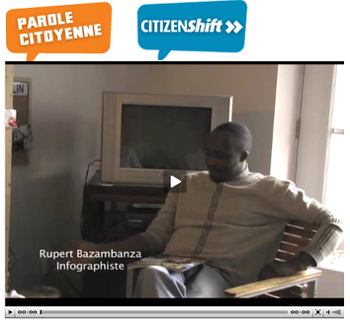
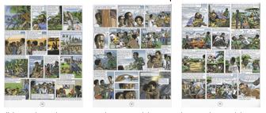
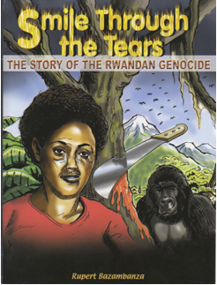

NOTE
This learning and evaluation situation (LES) is a working document, which is therefore subject to change. It may be adapted as needed depending on the student’s social environment, the planning of teaching and learning activities, the integration of the Contemporary World and Ethics and Religious Culture program and the Québec Education Program, etc.
This Learning and Evaluation Situation (LES) was prepared by LEARN http://www.learnquebec.ca in collaboration with the CURA Life Stories in Education Working Group. http://www.lifestoriesmontreal.ca/
Written by Paul Rombough in collaboration with Emmanuelle Sontag and others. Updated November 2011…

Table of Contents

Section 1: Presentation of the Learning and Evaluation Situation

Section 2: Suggested Procedures
- Phase 1: Preparation Phase
- Phase 2: Interpretation of facts (C1 beginning of C2)
- Phase 3: Taking a Position (C2) / Integration Phase
- Phase 4: Production Phase: Taking a Position (C2)

Section 3: Teacher Annexes
Student Book located in separate document at
http://www.learnquebec.ca/en/content/curriculum/social_sciences/sec_contworld/les_rwanda_genocide/LES_5_TensionsRwanda_student.doc
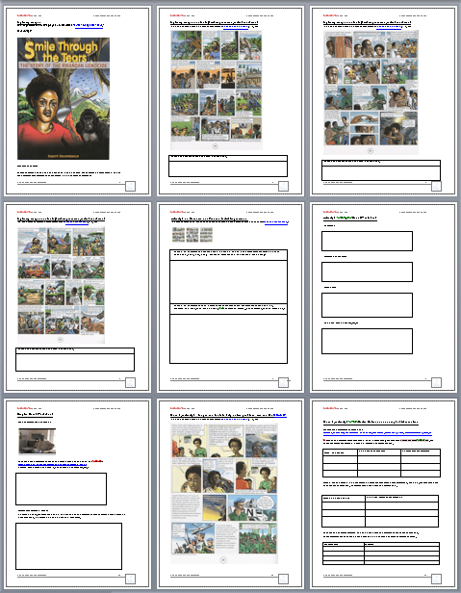
Section 1: Presentation of the Learning and Evaluation Situation
Contemporary World program connections:
Program section: Tensions and Conflicts
Designated focus: External intervention into a sovereign territory
Topic for interpretation (C1): the legitimacy of external intervention in areas of tension & conflict.
Position to be taken on (C2): the application of the principle of humanitarian assistance.
Ethics and Religious Culture program connections:
Themes: Freedom, Tolerance, Justice, Human ambivalence
Reflects on ethical questions (C1): analyzes situations, examines references, evaluates options for action
Engages in dialogue (C3): organizes thinking, interacts with others, develops point of view
Main Guiding Question:
Is military intervention a justified form of humanitarian intervention?
Broad Areas of Learning:
Citizenship and Community Life 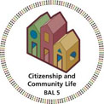 Media Literacy 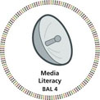
Learning Situation Overview
Crimes against humanity have been committed on unbelievably vast scales, as is evident not only from official reports and media records, but also from the stories told by those who survived. Human suffering has been undeniable, yet intervention from international organizations to help prevent or limit atrocities has not always been forthcoming. This Learning and Evaluation situation asks students to examine and interpret the events surrounding the Rwandan genocide of the 1990s. It then asks them to act on their interpretation (i.e. to take a position) by entering into and extending the dialogue began by those witnesses who lived to tell the tale.
Students will first consider their own knowledge of genocide. They will then explore imagery and shorter narratives that describe personal experiences of the Rwandan genocide. They will be put into the “situation” of continuing the story line of Rupert Bazambanza's graphic novel entitled "Smile Through the Tears." And to prepare for this task students will acquire background knowledge, interpret historical facts and opinions, identify actors, and recognition of facts related to the political, social and ethical issues that came into play during the genocide, in particular those portrayed in the graphic novel. By the end of the Learning situation, students are expected to be able to effectively take a position on the political and moral issue of “humanitarian assistance” (in this case military intervention!) into areas where extreme human rights violations are occurring.
Throughout the LES the students will also consider the role of the media, as a means to enflame emotions and to encourage acts of genocide within Rwanda, and also as a tool that could have been used to encourage international aid but for political and other reasons did not. Students will consider media-types such as Television, Internet videos, longer personal testimonies (Life Stories), and especially the graphic novel, as sources of information and options for taking social action. \
Students will also develop competencies associated with the new Ethics and Religious Culture program, including an ability to engage in dialogue, and how to reflect on the ethical issues.

Activity 1: Use familiar historical images to introduce difficult concept of genocide. Develop definitions. Pose ethical Questions
Key features of Contemporary World Comp. 1 Interprets a problem:
Defines the problem: • Identifies forms the problem takes in different parts of the world • Identifies actors • Establishes facts • Defines the context
Analyzes the problem: • Examines some of the interests at stake • Recognizes power relations • Establishes consequences
Key features of Ethics Comp. 1 Reflect on Ethical Questions
Analyzes a situation from an ethical point of view: ● Describes a situation and puts it into context ● Formulates a related ethical question

Concepts: • Power • Ideology • Human Rights
Essential Knowledge: • Questions related to cultural identity (ethnicity, religion)
Teacher Process | Student Process:
Present word "Genocide" on board and review for prior knowledge.  Compare with other words (Homicide, Genes).  Discuss well-known examples throughout history.  View more precise definitions of genocide, search the Internet for definitions of genocide, or refer to slides on Genocide Framework sites.  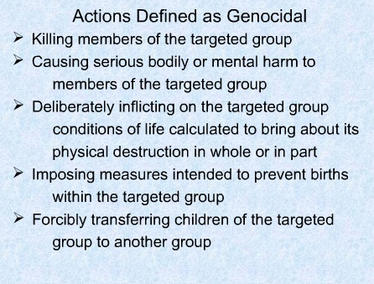  See online slideshow Genocide Framework slide 8 at http://tinyurl.com/cwx2qj  Analyze a representative single image of a familiar genocide scene.  Use example in documents entitled  “Prior Knowledge, Initial Impressions, Identifying actors, power relations.”  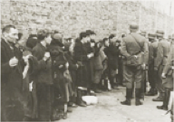  Source and larger version: http://fcit.usf.edu/Holocaust/GALL31R/26538.htm  Teacher could discuss differences between the sort of persecution based on race or culture and others based on individual persecution, political persecution, military abuse, etc.  As a class or individually, consider some basic moral questions:  What for you makes genocide morally apprehensible? In terms of the individuals concerned? In terms of the types of actions? In terms of the treatment of different groups by other groups? | 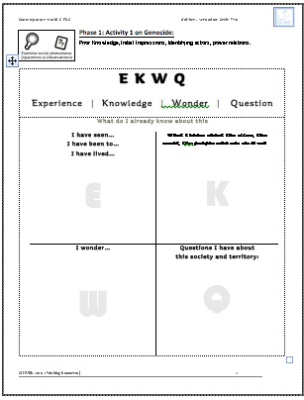  Students articulate their prior knowledge about genocide, and ask questions.  They then interpret the problem (C1) by identifying the forms the problem of genocide has taken in the past, and in different areas of the world. They begin to define the term and understand the contexts for mass atrocities.  Students analyze images associate with organized cultural persecution and known examples of genocide (holocaust).  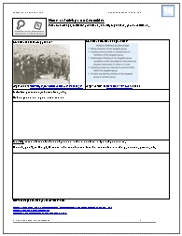  Through this process students identify aspects of society (people, gov't, military) and power relations associated with known genocides. Students also reflect on differences between this kind of persecution and others kinds.  Students consider ethically difficult issues and events in historical and personal contexts
Required materials:
PowerPoint and/or photos with holocaust images:
Teacher use: http://www.authorstream.com:80/Presentation/Waldarrama-34989-GENOCIDE-FRAMEWORK-forTeaching-aboutGenocide-Outline-Workshop-Goals-Personal-View-Rationale-as-Entertainment-ppt-powerpoint/
Student use: http://fcit.usf.edu/Holocaust/GALL31R/26538.htm
http://www.authorstream.com/Presentation/Sushil-297-the-holocaust-world-ii-jews-hitler-nazi-germany-PowerPoint/
http://www.shamash.org/holocaust/photos/
http://fcit.usf.edu/Holocaust/resource/gallery/G1941WGU.HTM
Worksheets for Phase 1 entitled “Prior Knowledge, Initial Impressions, Identifying actors, power relations.”
Section 2: Suggested Procedure
Phase 1: PREPARATION

Engage Activity 2: Remembering the Rwandan tragedy through a creative work (30 minutes):
Explore images of Rwandan genocide from a creative work, to present students with the less familiar situation of 1994 Genocide in Rwanda. Permit students to form initial historical and ethical questions.
The teacher: | The students:
Present several isolated scans of pages taken from Rupert Bazambanza's graphic novel entitled "Smile Through the Tears." (Some scanned pages are reprinted in the annexes with the author and publisher’ permission, but to work effectively with this novel in-class purchased copies could be purchased at http://tinyurl.com/7qyco6k)  Alternatively: Use Bazambanza’s graphic novel entitled “Tugire Ubumwe – Let’s Unite!” and alter the approach accordingly http://www.un.org/preventgenocide/rwanda/education.shtml  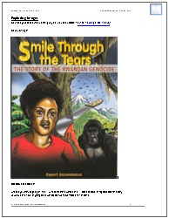  Show the book’s cover image. Help class to analyze the image with simple questions like: What do you think is going on here? How could this have anything to do with local or world Conflicts?  Ask students to create questions in response to the selected scenes. For example use pages 49, 52 and 54. Choose scenes which by themselves still show something of the severity and the scale of human suffering during the Rwandan Genocide of 1994.  Guide class discussion in an effort to ask ethical questions like, What is obviously morally wrong in these pictures? What actions or thoughts on the part of characters are obviously or potentially problematic? Emphasize that to Analyze a situation from an Ethical point of view. (ERC C1) and to Define the problem more fully (CW C1) we will need more detailed information about the historical contexts.  Teacher could use these first impression responses and formulated questions to track or just give feedback on competency development.  Use Quick Judgment tracker: Initial Impressions and Formulating Questions s document provided in teacher annexes | Students examine Bazambanza’s book cover and note impressions and previous knowledge of related geography, history, of Africa, etc. They begin to define general contexts for the problem... the particular situation in Rwanda. (CW-SC1)  Later students examine key images and scenes from the novel in order to begin considering moral issues. They could list things they see in the picture which are obviously not correct, and explain their first impressions of the situation in Rwanda in their own terms.  To help for later contextualization, students brainstorm questions they need to ask about the historical context and the moral complexities (tolerance, cultural differences, etc.)  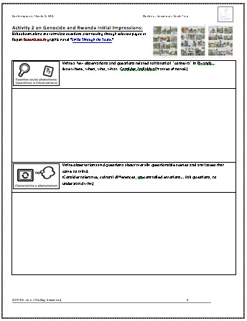  Use document entitled Activity 2 on Genocide and Rwanda Initial Impressions: In student workbook files
Required materials:
1) Scans of images and cover available at: http://www.learnquebec.ca/en/content/curriculum/social_sciences/sec_contworld/les_rwanda_genocide/smiletears_scans.zip
or http://tinyurl.com/44ak45v
2) Exploring images sections of student logbook if available.

Record keeping: Quick Judgment tracker: Initial Impressions and Formulating Questions

Activity 3: The graphic novel and the novelist's story. (Optional)
Consider the "graphic" novel as form of expression. Consider different choices of media used to tell a personal story.
Key features of Contemporary World Comp 2 Take a position:
Considers the media treatment of the issue: • Recognizes the choices made by some media in their treatment of the issue • Establishes the influence of the media on his/her opinion
The teacher: | The students:
Graphic Novel initial definitions and impressions  Present definition of a graphic novel:  "A graphic novel is a narrative work in which the story is conveyed to the reader using the comics form." Graphic novel - Wikipedia, the free encyclopedia  See also: http://www.firstsecondbooks.com/pdf/onesheets.pdf  Discuss with class the particularities of graphic novels in general. Share any other graphic novels students know of or have read? Differences? Similarities?  Graphic Novel as effective choice  Read and discuss the following quotes from Jessica Silva’x, paper entitled “Graphic Content: Interpretations of the Rwandan Genocide through the Graphic Novel.” (See attached document in Annexes)  a) "Creative aesthetic techniques …." p. 11  b) "The graphic novel’s unique ability to capture …." p. 11  Graphic Novel as personal choice  Present short Rupert Bazambanza interview segments on Parole Citoyenne site to discover why and how he created the graphic novel in the first place, his own personal reasons, etc.  http://citoyen.onf.ca/entrevue-avec-rupert-bazambanza?term_tid=53  Discuss the limitations and accessibility of the graphic novel format, here but especially in Rwanda itself. Ask, who is the audience for such a book? | 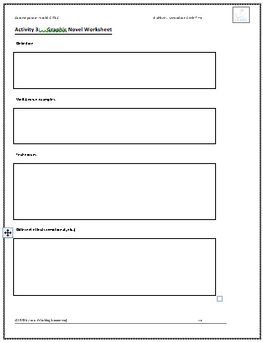  Students use provided Graphic Novel Worksheet to take notes and state opinions. They formulate and discuss a definition of a graphic novel and share well known examples.  Students consider the medium used by the author by explaining quotes from Jessica Silva’s paper in their own words. Focus on  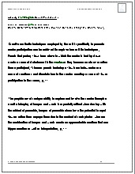  Students consider the graphic novel as a "choice" of media made by the author. They write a short paragraph explaining Bazambanza's personal reasons for writing the story, the choice of media used and its effectiveness.  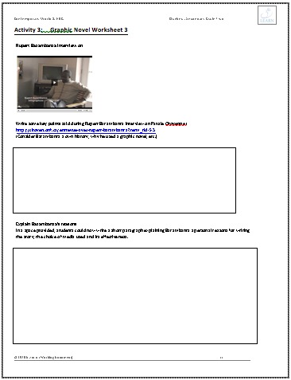
Required materials:
Graphic novel definitions
Rupert Bazambanza interview on Parole Citoyenne site at http://citoyen.onf.ca/entrevue-avec-rupert-bazambanza?term_tid=53
Graphic Novel Worksheets (in Student workbook)

Phase 2: Exploration & Interpretation of Facts
Activity 1 : The problem, in general terms. Overview of international contexts and the United Nations.
Key features of Contemporary World Comp. 1 Interprets a problem:
Defines the problem: • Identifies actors • Defines the context • Identifies different points of view
• Examines some of the interests at stake • Recognizes power relations
Concepts: • Globalization • Human Rights • Interference
Essential Knowledge: • Peacekeeping missions •International alliances •International institutions
The teacher: | The students:
Introduce the UN role.  Present new sections of Rupert Bazambanza's graphic novel that demonstrate the presence of the UNAMIR forces. Show images that indicate a desperate need for aid, intervention, or any other form of "help". Focus on all or some of the frames on page 34 (available scans below, or use Student Workbook document)  With the class, briefly define the United Nations and refer to quote on Canadian Encyclopedia: "It was designed to promote international co-operation among sovereign states in which each would give up some of its sovereignty in the common interest of all nations to promote peace, security, economic development, social justice and fundamental human rights and freedoms."  Have students explore the UN website for information on the UN and Peacekeeping, especially the Cyberschoolbus section. http://www.un.org/Pubs/CyberSchoolBus/  Direct students to find aspects of the site they feel apply to this situation. Definitions of peacekeeping and other concepts can be outlined here. Emphasize that Canadians were involved. Suggest they browse sections UN intro ; Peace Education ; and Human Rights. Share information and discuss how the UN role as peacekeepers could impact on the lives of the characters in Rupert's story.  Consider Intervention. Define concept of Intervention. Differentiate from invasion. Name a situation where intervention could be bad, or problematic, or a threat to a local people's sovereignty and rights. Define Humanitarian and Military Aid. Ask class questions like: Given previously viewed images and initial impressions of genocide, what would you expect of the UN if faced with a situation of genocide? Discuss practical complexities of Peacekeeping efforts and other obvious obstacles. Give students chance to jot down their thoughts on what UN’s role should be.  Introduce the guiding question Is military intervention a justified form of humanitarian intervention? Emphasize importance of taking an informed position on the question.  Teacher and peers could use Quick Judgment tracker: Identify new actor (UN) | Students respond to individual slides in section of larger graphic novel. Their task is to identify a new actor, and to identify and clarify further contexts for which intervention may have been needed.  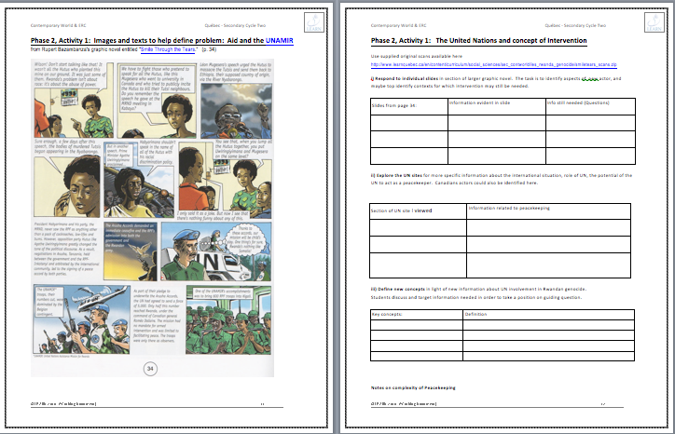  Students explore the UN websites for more specific information about the international situation, role of UN, and the potential of the UN to act as a peacekeeper. In the process they define new concepts in the light of specific information about the UN involvement in the Rwandan genocide.  In this way they discuss and target information needed in order to take a position on the guiding question.
Required materials:
- The United Nations and Intervention.” Document in Student Booklet.
- Scanned images at http://tinyurl.com/44ak45v

Record keeping: Quick Judgment tracker entitled Identify new actor (UN)

Activity 2: Interpreting the problem in light of different sources.
Guided reading of first sections of the Bazambanza's graphic novel. (Possibly over several classes.)
Key features of Contemporary World Comp. 1 Interprets a problem:
Defines the problem: • Identifies actors • Establishes facts • Defines the context
Analyzes the problem: • Interrelates various aspects of society • Determines causes • Establishes consequences • Identifies different points of view • Examines some of the interests at stake • Recognizes power relations

The teacher: | The students:
Before assigning reading of full novel, emphasize two-tiered goal of this Learning Situation: to develop an ethical perspective on now-distant events in Rwanda (ERC program connections) & to take a position on whether military intervention is a justified form of humanitarian assistance into another sovereign territory. Remind students to consider new actors, new historical details, new points of view.  Assign reading session(s), either as a class or silently as individuals. Explain use of “Specific actors in novel: Identify and Interpret”  A suggested place to stop might be to page 63, to summarize together any answers to previous questions and new information.  Discuss any specific new moral questions or issues. Discuss any historical connections that need to be explored further or clarified. Emphasize scale of tragedy.  Teacher could decide to now continue to Activity 3 Researching the historical record and finish reading novel later, or read completely then research to help clarify facts before final complex task. | Students review designated focus of this LES and of the respective subject areas (ERC and Contemporary World).  Students discuss or write other questions to help guide their reading. They consider actors, historical information needed, new perspectives.  Students use the organizer “Specific actors in novel: Identify and Interpret”. They list and describe actors and any new information, morally questionable situations, ethical issues and historical connections noticed so far. They include, in their notes and summaries, additional questions or areas in need of further research.
Required materials:
Rupert Bazambanza's graphic novel entitled "Smile Through the Tears."
http://migs.concordia.ca/BiographyofRupertBazambanza.htm
http://tinyurl.com/2adb8ne to buy. Contact also Concordia University http://histoiresdeviemontreal.ca/ to borrow copies for use in this LES
Organizer in student book entitled “Specific actors in novel: Identify and Interpret.”

Activity 3 Researching the historical record.
An examination of events and actors in more detail. Re-interpreting the problem in light of different sources. Reflecting on personal narrative vs. these "established" histories. Comparing forms of media.
Key features of Contemporary World Comp. 1 Interprets a problem:
Defines the problem: Establishes facts • Defines the context
Analyzes the problem: • Interrelates various aspects of society • Determines causes • Establishes consequences • Identifies different points of view • Examines some of the interests at stake • Recognizes power relations

Key features of Contemporary World Comp Take a position
Considering media treatment: • Recognizes the choices made by some media in their treatment of the issue

The teacher: | The students:
Examine historical background in greater detail by assigning groups to research and report back on some of the specific historical actors and their involvement (even indirectly) in the genocide (or in events leading up to the genocide). Use “Phase 2 Activity 3: Group Work: Historical Records Compared” document  Groups can report back in order. After groups report on Rwandan Hutu government, guide discussion on Concept of “Diplomacy”. (Was it ever possible to solve internally? How were international organizations involved then?) Compare each group’s finding to Bazambanza's novel's first pages. With last group on Dallaire discuss the guiding question again, Is military intervention a justified form of humanitarian intervention?  Examine historical background as presented in mass media. Present the “Edge of Horror” from the CBC Archives web site, originally broadcast in 1997.  http://archives.cbc.ca/war_conflict/peacekeeping/clips/11595/  Arrange class in small groups to review film and have them search for then compare other reports available from the CBC archives. How did media respond to genocide at that time then shortly after in 1997? Did the media’s role influence the way Canada and other countries responded?  Various texts and articles exist as references and could be used for further reading including the online edition of The media and the Rwanda genocide at http://web.idrc.ca/openebooks/338-0/ Here are few shorter articles on the subject for student use:  Foreign media share blame for Rwanda genocide: new book  http://www.allanthompson.ca/news/14012007-book.html  Examining the media’s role in the Rwanda genocide  http://blog.smu.edu/studentadventures/2009/laura-in-rwanda/examining-the-medias-role-in-the-rwanda-genocide/  Comparing media representations  Finish graphical novel, possibly over several days. Stop occasionally to compare portrayals in the graphic novel and the different media records.  Refer to elements from the historical records that are emphasized differently in the different forms of media. | In groups students research a selected group or actor that was involved in the conflict. Students use an organizer entitled “Phase 2 Activity 3: Group Work: Historical Records Compared” to identify timeframe, values and interests, and role. Students share their information to other groups using the organizer. Ideally organizer could be uploaded into collaborative space like Google Docs, and shared as class.  Students view “Edge of Horror “together as a class and discuss new information, ethical issues. In small groups or individually for homework, students view and compare other reports in CBC archives. Students could look for differences in ideology, interests, biases, etc.  Students silently read to end of the graphic novel, to finish it over one or two days. In class discussions compare portrayals in the graphic novel with ways things/people/groups were portrayed in the films viewed in class.
Required materials:
-Student booklet section: “Phase 2 Activity 3: Group Work: Historical Records Compared“ with included links to website resources

-“Edge of Horror” from the CBC Archives web site. http://archives.cbc.ca/war_conflict/peacekeeping/clips/11595/
Phase 3: Developing a Position (CW - C2)
Activity 1: Considering the novel itself:
as a form of social action... as forum for discussion of ethical issues…
as a way to educate the public and prevent future occurrences of genocide.
Key features of Contemporary World Comp. 2 – Taking a position:
Considers opportunities for social action: ● Recognizes types of action he/she might take ● Identifies contexts or institutions that could provide the framework for his/her actions

The teacher: | The students:
After reading at least beyond page 63, class could begin discussions as to how to solve this kind of problem for future generations.  Teachers may want to refer to recommendations made by the W2I project at http://migs.concordia.ca/W2I/W2I_Project.html and read their report at http://migs.concordia.ca/W2I/the_report.htm An essential recommendation is that civic institutions instil “knowledge” of past genocides, so that future generations might better pressure governments to prevent re-occurrences and to act when needed. See also http://tinyurl.com/23jd29y for related video panel discussion.  Guide students in the process of articulating a position on what could have prevented genocide, and on what they believe were the causes of the genocide.  -Discuss internal diplomatic solutions suggested in the graphic novel.  -Discuss call for tolerance suggested in the graphic novel..  -Discuss again references to military or otherwise intervention and other possibilities for action from external forces.  Debate whether the graphic novel itself takes a position on the issues and on what could or should have been done, and if the novel we read successfully educated the readers.  Preview students' complex task which will be respond to the guiding question by illustrating a continuation of the book, possibly with new characters, and using 1 to 5 images and dialogue/text boxes. They will be required to articulate their “informed position” on the issue of international intervention. For example, a character could state it, or they as writer could illustrate it in less obvious ways. | In groups or as a class, students engage in discussions around possible solutions, causes, ways to solve the problem and to prevent it in the future. etc.  Students recognize types of actions available to those at the times (the West, the UN forces, Rwandan government, the people, etc.)  Students discuss the book as a way to take a position and if it is a good way to educate the public, and consider how they could use this platform to state a position on the guiding question.
Required materials:
http://migs.concordia.ca/W2I/W2I_Project.html and their report here http://migs.concordia.ca/W2I/the_report.htm
Record keeping:

Activity 2 Considering Oral histories of witnesses
as a form of social action.
as a way to educate the public and prevent future occurrences of genocide. As a way of establishing real personal contexts
as a more direct means of establishing facts (than the novel, then media reports)
Key features of Contemporary World Comp. 2 – Taking a position:
Examines some points of view on the issue ●Identifies the values and interests that underlie various points of view ●Notes the solutions proposed by the stakeholders
Debates the issue ●Develops arguments defending his/her position● Demonstrates an open mind towards opinions differing from his/her own

The teacher: | The students:
Reflect on oral histories themselves. Introduce the interview process and the Histoires de vie Montreal | Montreal Life Stories project at http://www.lifestoriesmontreal.ca/ . Explain challenges involved in creating and then interpreting these more complete types of interviews: Length, language and accents of interviewees, non-linear responses, distance in time from actual events, selecting sections vs. viewing whole, etc.  Start by presenting only the 25 minute interview segment of the Bazambanza Interview where he describes his earlier life and the first nights of the genocide, just after the President's plane was shot down and where his father was killed. From around 00:35 minutes to the 1:00 hour minute point. Discuss his personal suffering, emotions, his reaction now and probably what his reaction was then. Discuss type of media (video interview recording the oral history of a witness). Discuss details not previously brought to light in research above.  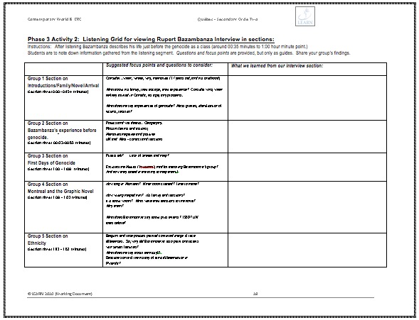  Group work: Listening to the interview entirely. Divide the class into listening groups for key sections. Distribute “Listening Grid for viewing Rupert Bazambanza Interview in sections. Assign a certain section of grid (10 minute time segments) to each group. Allow at least 15-20 minutes to each group for listening and for discussion and notes/responses.  Encourage groups to share their thoughts about what Bazambanza said in the video clips. Then as a class encourage each group to identify:  --New information not in previous sources.  --How intervention by external forces could have helped or not?  --Ethical questions to consider?  --Rupert role, experience, etc.  --Characters involved.  For homework continue listening to unfinished sections 1:32-2:00, and return to share thoughts the next day. | Students discuss challenges involved in recording and then listening to oral histories, in the case of the Life Stories project interviews, but also in general.  Students listen to sample section. As a class we practice getting both personal, ethical and historical information from the interview.  Students move into listening groups in order to examine key sections of the interview. Use your group’s section of “Listening Grid for viewing Rupert Bazambanza Interview in sections”  (See student booklet)  Groups then share their thoughts and identify various important points, such as: New information not in previous sources.  How intervention by external forces could have helped or not?  Ethical questions to consider?  Rupert role, experience, etc.  Characters involved.  Students listen to other sections for homework. Note their thoughts on their own terms and with less guidelines.  1:32-2:00 the end
Required materials:
--DVD or M4V Uploaded version of Bazambanza interviews. (M4V zipped and uploaded at http://tinyurl.com/3c5lr64)
- “Listening Grid for viewing Rupert Bazambanza Interview in sections” (See Student Booklet)
Phase 4: Production Phase:
integrating knowledge & Taking a Position (CW - C2)
Students final complex task is to write and illustrate an extension to the graphic novel:
A final page containing from 1 to 5 images.
Key feature of Contemporary World C2 Takes position on contemporary world issue
Debates the issue: ● Bases his/her opinion on facts ● Develops arguments defending his/her position ● Demonstrates an open mind toward opinions differing from his/her own
The teacher: | The students:
Students final complex task is to write and illustrate an extra page to the graphic novel entitled “ Smile Through the Tears” This final page can contain from 1 to 5 images or “frames”.  This “continuation of the novel” should take a position on the general principles of humanitarian intervention, and in the case of Rwanda it should consider military intervention. (i.e. Is this a case for a just war?)  The continuation of the novel should specifically:  - Include characters from the book (though the character could be Rupert Bazambanza himself!).  - At least one character must state their point of view and position with regard to the guiding question  - It should also articulate a position on ethical issues in general terms that could apply universally to any country or regime. | Students should plan out their short continuation of the graphic novel. A storyboard grid could be used to jot down characters, action, images for each of the 1 to 5 scenes to be portrayed. The grid should leave a place for notes about how the scenes will meet the task requirements.  Students could use pencil crayons, or the equivalent electronic drawing tools to alter old or add new characters. Free editors such as The Gimp and the online Aviary Image Editor could be used.  To create scenes students could use one of many free comic book templates available online, or insert their characters into a comic book software such as Comic Life or use free sites like http://www.bitstrips.com/. Another display option would be import scenes into Voicethread to display them, so others can comment!  Aloud during a sharing session, or from within the new scenes themselves (as narrative thought bubbles or as footnotes), students should identify and explain a at least three elements which are established facts. They should also identify and explain which elements are opinions or point of view. (i.e. show critical distance). The facts explained must be relevant to the guiding question and focus of this Learning and Evaluation Situation.  Finally, in the storyline or visuals used, one or more of the characters should articulate an informed position on the issue of international intervention. The student could elaborate on this position after or during the presentation.
Required materials:
Record keeping:

Annexes for teachers

(Worksheets, evaluation tools, resources, etc. unless embedded above)

Complex Task Rubric for CW
(under construction)
Criteria | Observable  Elements…. | A | B | C | D
Appropriate use of knowledge | Student identifies and explains established facts | The student(s) clearly identifies 3 or more facts relevant to the guiding question. For each fact they justify the accuracy with a source or argument. | The student(s) clearly identifies 2 to 3 facts that are relevant to the guiding question. For each fact they justify the accuracy with a source or argument. | The student(s) clearly identifies 2 to 3 facts that are relevant to the guiding question. However they inadequately justify facts with arguments and references to sources.  OR  The student justifies only 1 fact adequately. | The student does not identify and justify any facts adequately.
Critical distance &  Rigour of reasoning | Student identifies and explains opinions and points of view in the novel and in the history of the Rwandan Genocide.  Note: Opinions on either events OR the issues posed by the guiding question. | The student(s) identifies and explains at least 2 opinions or points of view | The student(s) identifies 2 opinions. However the opinions are not sufficiently explained.  OR  The student identifies and explains only 1 opinion. | The student identifies opinions but does not sufficiently explain them. | The student does not identify opinions.
Expression of a well-founded opinion | Student articulates an informed position on the issue of intervention during extreme humanitarian crises like genocide. | The student expresses their own opinion on the guiding question, taking into account both facts and opinions of others. | The student expresses their own opinion on the guiding question, by taking into account both facts but not the opinions of others…  or by taking into account opinions but not sufficiently dealing with facts. | The student expresses thoughts on the issue of intervention, but doesn’t really formulate an opinion. The expressed thoughts are not well informed. | The student is unable to articulate an informated position on the issue of intervention

Quick Judgment tracker: Initial Impressions and Formulating Questions
For Phase 1 Activity 2
Observable Tasks -- > | Summarizing initial impressions and Info on Genocide |  | Formulating Questions about Rwanda and moral complexity
Competency Key Features → | Defines the problem  • Identifies forms the problem takes in different parts of the world  • Identifies actors |  | Defines the problem  • Identifies actors • Establishes facts • Defines the context  Analyzes the problem  • Examines some of the interests at stake • Recognizes power relations  • Establishes consequences
Student Names/Groups | Quick Judgment  3-Good for where we are at  2-Sufficient for where we are at  1-Needs work, focus, effort | Comments  Based on evaluation criteria: “Clear overview:” | Quick Judgment  3-Good for where we are at  2-Sufficient for where we are at  1-Needs work, focus, effort | Comments  Based on evaluation criteria: “Clear overview:”
1.
2.
3.
4.
5.
6.
7.

Observable Tasks: |  | Identify new actor and define concepts |  |  |  | Discusses complexities
Competency Key Feature targeted. |  | Defines the problem C1  • Identifies actors • Establishes facts • Defines the context |  |  |  | Analyzes the problem C1  • Examines some of the interests at stake  • Recognizes power relations
Student Names | Quick Judgment  3-Good for where we are at  2-Sufficient for where we are at  1-Needs work, focus, effort |  | Comments  Based on evaluation criteria: “Clear overview:” |  | Quick Judgment  3-Good for where we are at  2-Sufficient for where we are at  1-Needs work, focus, effort |  | Comments  Based on evaluation criteria: “Rigorous reasoning”
1.
2.
3.
4.
5.
6.
7.
8.
Quick Judgment tracker: Identify new actor (UN)
For Phase 2 Activity 1

