Wealth: Distribution of Wealth and Emerging Economies
Balancing social justice with economic development
Updated May 20, 2010

Contemporary World
Secondary 5

Learning and Evaluation Situation
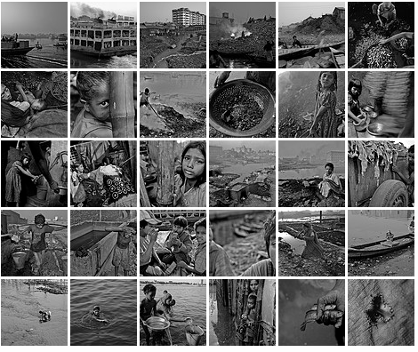
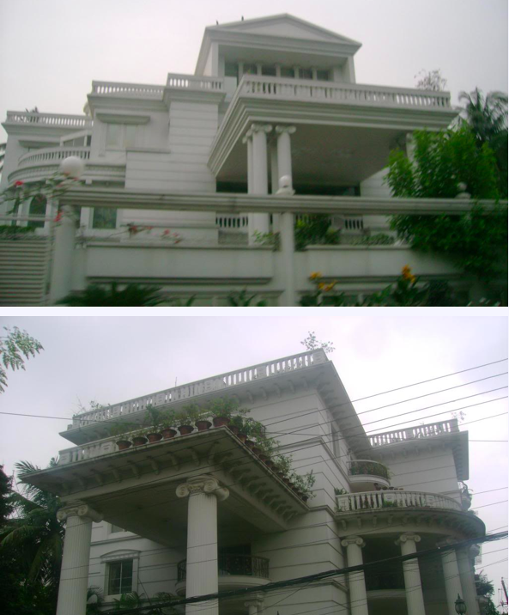

River Bleeds Black set by Shehzad Noorani on Flickr hostos by mirzazeehan. User at Skyscraper city.
(Photos linked to from preparation activities.)

NOTE
This learning and evaluation situation is a working document, which is therefore subject to change. It may be adapted as needed depending on the student’s social environment, the planning of teaching and learning activities, the integration of the Contemporary World program and the rest of the Québec Education Program.
Concept: Paul Rombough, Mordechai Antal
Author: Paul Rombough
Editor:
Pedagogical Review: Matt Russell
Piloted by:

Table of Contents

Section 1: Presentation of the Learning and Evaluation Situation

→ Guiding Question

→ Overview

→ QEP connections

Section 2: Suggested Procedure

Phase 1: Preparation to Engage students
→ Introductory activities that hook students, but also make connections with their own lives and those in different countries.

Phase 2: Performance: Competency 1 Interpretations
→ Activities that define the problem in local and global terms,

Phase 3: Performance: Competency 1 Interpretations
→ Activities that analyze the problem in terms of power, wealth, economic theory, etc.

Phase 4: Performance: Competency 2 Developing and taking a position
→ Activities on emerging economies, taking into account media influences, considering new actors and their interests.

Complex Task --> Public Service Announcement (PSA) in response to guiding question. Evaluation, reflection.
Section 4: Annex of Tools and Resources (unless embedded in LES)
Section 1: Presentation of the Learning and Evaluation Situation
Guiding Question
How can emerging economies generate wealth in a socially just way?
Learning Situation Overview
Students will consider whether wealth can be generated in countries with emerging economies, in a way that is socially just? Students will also consider our own actions as consumers of products from emerging economies. In the process, students will understand and apply select concepts/knowledge, consider multiple perspectives, and then form an opinion on a world issue in line with the guiding question.
Students first "interpret the contemporary world problem" (Competency 1) by examining different ways Disparity exists world-wide. A route to "analyzing" the problem is then suggested, whereby students interpret the basic features of Capitalism itself, the way that Industry drives Economies, and how the very generation of Wealth itself can create Social Gaps.
Students then begin to "take a position" (Competency 2) by first understanding emerging economies. Students consider the way media here is used to sell us the products they produce. Students "establish critical distance" by considering both the perspective of those who gain wealth here (shareholders in companies) and the perspective of those who live in countries where certain items are produced. (shareholders there, but also workers, local populations, etc).
A final complex tasks asks students to bring together the above competencies, knowledge and concepts in order to take and support a position, to situate themselves in a real world outcome. Students must create a balanced public service announcement (PSA) for the UN that responds to the guiding question.
Some of the sub-questions which are explored or implied throughout:

What is the definition of wealth?
How is wealth distributed at all? By whom?
Who decides what is fair?
What is meant by social justice?
Why does poverty exist?
What is a middle class?
Does the existence of a middle class justify extremes in poverty?
Why has the mainstream media been hesitant to expose disparity in emerging countries?

Quebec Education Program Connections:
Contemporary World Program section: Wealth
Designated focus: Distribution of Wealth
Topic for interpretation (C1): The disparity in the distribution of wealth
Position to be taken on (C2): Balancing social justice and economic development
Broad Area of Learning (BAL):

Citizenship and Community Life
Promotion of the rules of social conduct and democratic institutions: knowledge of the main actors in political and social life and respect for their roles.
Adoption of a culture of peace: understanding of mechanisms that contribute to poverty and illiteracy

Alternative BAL... Media Literacy
Awareness of the place and influence of the different media in his/her daily life and in society:
• reflection on the functions of the media
• awareness of the influence of media messages on his/her world-view and everyday environment

Cross Curricular Competencies (Not evaluated):
Uses information
Uses information and communications technologies
Exercises critical judgment
Section 2: Suggested Procedure
Preparation Phase
Activity: Consideration of extreme poverty.
Introduction of "situation" and how complex task of creating a PSA will give students a chance to take a position on the guiding question. (2 classes)
Key features of Contemporary World (Interprets a Problem, Competency 1) :
Considers the problem as a whole: Demonstrates the global nature of the problem.
Concepts: Disparity Knowledge: Social gaps
Teacher roles | Student tasks
i) Consider extreme poverty and starvation.  View pictures and short texts that show and describe the effects of disparity. Focus on agricultural communities affected by droughts, famines, war.  Ask students to guess where these pictures were taken, which parts of the world, etc.  ii) View and discuss: Use QEP suggestion: Present the video and song "We are the World Video in 1985, about starvation in Ethiopia.  Use resources about song and the Ethiopian famine to guide discussion. And have class note which lyrics emphasize the "global nature" of the problem.  Tasks: Discuss as a class the relevance of this sort of song and calls to end poverty today. Refer to articles such as the 2002 BBC article “Massive famine stalks Ethiopia” http://news.bbc.co.uk/2/hi/africa/2440093.stm Consider impact of Ethiopia’s Gibe III dam construction on water levels below it.  Arrange class in groups to discuss poverty and Canadian connections.  iii) Interpretation: Reasons vs. emotional responses Read a short article offering an explanation  Ex. Growing cash crops on BBC  Then show PSA on famine done by students.  Example: African Famine PSA by South Asheboro Middle School on TeacherTube. Discuss with class what is good about this PSA, the message, the way they did it, etc. Discuss what facts or issues are left out.  Discuss who can access this message? Is Youtube the future of how messages will be received in an age of mobile devices?  Introduce complex task "situation":  The United Nations would like you to create a Public Service Announcement about Poverty and Wealth creation in emerging countries, but is concerned about sensational, one-sided portrayals of the problem. They want a balanced PSA that informs people of the situation both here and in poorer countries. They want a PSA that takes an informed position on disparity in general, on "economic inequality", and on a socially just generation of wealth. The thing is… they also want something that could be shared and downloaded into a handheld device like an iPod or phone! | i) Students view and respond to images of extreme poverty: Show CBC Ethiopia Famine Gallery 1984-1985  Students share initial emotional reactions to images of extreme poverty. Students share their own assumptions about when and where these pictures were taken.  ii) Students view and discuss "We are the World" its history and the context of for the song and video production.  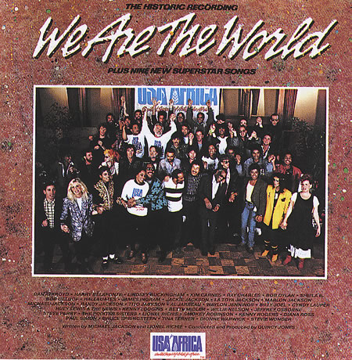  Students access prior knowledge to respond to questions like the following, and share their thoughts.  - Should we see starvation and famine as a global problem? Why?  - Why are we not starving here? What is different about their situation?  In group discussions students discuss:  - Are Canadians connected?  - How we are linked?  - Hwe are affected.  iii) Interpretation of global problem:  Students recognize the necessity and complexity of effectively interpreting the problem of poverty, as well as the complexity involved in taking a position on the issue.  Students consider the medium through which future messages must travel… i.e. handhelds and media on the go!

Activity: Consider different forms of poverty, within an industrialized world.
Awareness of disparity within countries (here) and in emerging economies. (Elsewhere)
Initial consideration of the implications of the very existence of a middle class.
Key features of Contemporary World:
Considers the problem as a whole: Compares manifestations of the problem
Teacher roles | Student tasks
i) Disparity within industrial societies.  The teacher again activates students’ prior knowledge through a visual task. New examples of poverty and economic inequality are considered.  View images of poor labourers in industrial areas of emerging countries. Ex. River Bleeds Black set on Flickr Explore questions like, When and in what contexts have you seen or heard about such situations of economic disparity?  Contrast those images with images of the wealthy individuals somehow profiting from situations in poorer countries. Ex. Luxury Houses and Mansions in Gulshan, Dhaka.  http://www.skyscrapercity.com/showthread.php?t=241806&page=11  Activate students' prior knowledge and form hypotheses: Isn't this an image you would associate with a neighbourhood in Canada? Where? What are possible explanations for 1) wealthy people existing in our country, but also for 2) wealthy people thriving in even the poorest countries.  ii) Reading Tasks:  In different groups, students could read short introductory texts on problems associated with cheap labour, poor factory conditions, child workers, etc., but also on the real generation of wealth alongside great disparity that exists in poorer but emerging countries.  iii) Introduce notion of Middle Class  Ask students to try to define Middle Class.  Note the seeming absence of a middle class in the contrasting photo collections chosen above. Introduce the surprising presence of a middle class even in countries such as Bangladesh.  Read "Bangladesh's growing middle class" and discuss reasons for such middle income earners even there.  [New: Unverified site that might work here:  http://www.classesmoyennes-afrique.org/en/ ]  Show class selected definitions of Middle Class.  Show graphs and read through summary articles indicating ways to determine middle-class. Ex. "How Class Works" from the New York Times  Note that to be able to take a position on poverty and disparity students may at one point need to decide whether the existence of a middle class justifies extremes in poverty? | i) Students view and respond to images of disparity: workers in factories in emerging countries, then rich in same countries.  Students activate prior knowledge and hypothesize as to how and why wealth is generated even in poor countries.  ii) Students read and respond to short texts and videos about rich and poor within emerging and already industrialized societies, overseas and in Canada. Example texts:  - "Working Conditions" section of Salvation Army website article entitle We are one world:  http://salvationist.ca/2010/02/we-are-one-world/  - Spotlight on Indonesian 'sweat shops' http://news.bbc.co.uk/2/hi/asia-pacific/1860217.stm  - Bangladesh: A Country Thrives on Extortion http://www.americanchronicle.com/articles/view/14127  Students share information gathered and compares various manifestations of the problem of poverty. They should be able to compare poverty or questionable working conditions in cities more well known reasons for famine discussed previously.  iii) Middle class?  Students define middle class, but are then confronted with the complex nature of a middle class, and the way poverty can still exist in countries with a middle class. In effect, the global nature of the problem is more complex in that it exists even as wealth is generated.  In this way students recognize there are other facts to consider when taking a more informed and balanced position on the problem of poverty and disparity.

Phase 2: Competency 1 Performance Phase
Competency 1 Interpreting Global Disparity
Activity : Read and interpret indicators of disparity around the world and over time.
Key features of Contemporary World Comp. 1 Interprets a contemporary world problem
K.F. - Define problem: Defines context, Establishes facts
K.F. - Considers the problem as a whole: Considers the problem on different scales
Evaluation Criteria of Contemporary World: Clear overview
Teacher roles | Student tasks
Disparity indicators around the world.  Present to class available maps that indicate disparity in wealth worldwide.  Ex. http://www.mint.com/blog/trends/mint-map-global-wealth-distribution/  Refer students to various statements from the QEP section on Wealth: "Wealth is the result of the economic activity of a community—of the processes involved in the production, distribution and consumption of goods and services" of "employment and remuneration" and of "gaps between living conditions in the city and the country". Students and teachers may also want to find different articles on "poverty indicators" where sites like this one suggest some other indicators to consider when monitoring changes.  Demonstrate use of Gapminder, and statistics to make conclusions  Create graph that indicates specific gaps or examples of disparity worldwide. Makes suggestions as to how to go about interpreting the graphs and what to watch for. Use Canada and United States compared to other representative countries. (Angola, Sudan, Ethiopia plus China, Mexico, Brazil) http://www.gapminder.org/  Divide students into groups to compare representative first-world (high-income) countries and representative third world countries (low-income but also emerging middle-income?).  Use the suggested graphs and prepare focus questions .  Sharing: Ask students to share their groups graphs and questions.  Task: Assign students a short response assignment, focusing on two countries on each of these graphs.  Track and/or encourage self-evaluation of competency development with tool entitled Competency 1 Development Tracker Sheet (Quick “overview description”) (see Annexes) | Discussion: First students discuss possible reasons for disparity in wealth between different countries, in terms of history, resources, politics, etc. while referring to available maps that indicate disparity in wealth world-wide.  Task: Establish facts, define contexts, consider problem on different scales. In groups, interpret 1 of 4 suggested graphs, by reading them and responding to questions. Use gapminder and global statistics. Suggestion here is to always use the "adjusted in terms of purchasing power GDP" statistic (Gross domestic product) on the bottom (i.e. to show wealth), as compared to various other indicators.  Suggested graphs (follow embedded links)  - GDP differences alongside Life Expectancy  - GDP differences alongside Education (eg. Primary School Completion for Girls)  - -GDP differences alongside consumption (ex 1. Sugar per person per day! ex 2. Electricity consumption)  - GDP differences alongside income share held by lowest 20 percent.  For all graphs, each group considers these same questions:  (A organizer could be created with space for notes for each question.)  - Name and describe details about two familiar countries that have changed significantly over time? (Facts)  - Name four generally rich countries, and four generally poor countries. Can you make conclusions as to where in the world the rich tend to be? Anything you know about their history, economy, geography? (Facts, Context)  - What in general happens on your left axis statistic as countries become richer (higher GDP)? Try to point out and explain any exceptions. (Contexts, Scale)  - Make a general conclusion about disparity between countries that you noticed from this graph.  - Did any of these graphs (or ones you could create) indicate disparity within a single country?  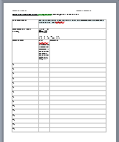  Sharing: After group work on one graph, each group presents their findings and graphs to the other groups.  Task: Writing a quick overview of the problem of disparity between countries.  (Consider competency development being tracked.)  - Choose two (or more countries) that demonstrate the problem of "disparity between regions" and explain your choice.  - Write a clear overview of the problem.  - Consider the different scales involved.  - Refer to at least two graphs from sites like Gapminder.

Activity: Define Problem: The so-called "north-south divide"
Key features of Contemporary World Comp. 1 Interprets a contemporary world problem
K.F. - Analyzes the problem: Determines causes, Recognizing power relations.
K.F. - Considers problem as a whole: Demonstrates global nature of the problem
Evaluation Criteria of Contemporary World:
Reasons rigorously and develops clear overview
Teacher roles | Student tasks
i) Provide package of article excerpts and website suggesting possible historical causes for economic disparity.  Begin by clarifying terms (knowledge related to the theme)  - North-South relations (see also North-South Divide)  - The influence of colonization, decolonization and neo-colonialism on so-called “southern” countries  - International organizations  - The power of multinational firms  With class read articles and review previous history course content and textbooks for information on colonization of key regions in question. Consider also Wikipedia on  - First European colonization wave (15th century–19th century)  - New Imperialism - Wikipedia  Task: Students use excerpts from articles and websites on North-South.  Instruct students to search of explanations for global economic disparity. Sample articles from which excerpts could be drawn:  Wikipedia entry and image.  http://en.wikipedia.org/wiki/North-South_divide  Possibly find excerpts in article like this:  Poverty Throughout History  Simpler student work on Brandt Line could be used:  http://jordan081.glogster.com/The-Brandt-Line/  Global Maps: The North-South Divide: summary & maps:  http://www.geography-revision.co.uk/global_maps.php  Human Development Index as alternative way of visualizing divide between rich and poor nations.  Map on Worldmapper  http://www.worldmapper.org/display.php?selected=173  Inequalities in Development summary page for HDI and Brandt considered here: http://school.edturtle.co.uk/inequality.htm  Guide discussion as groups share their findings and describe any connections they found between historical phenomena and global economic divisions . Where possible, display selected areas on Google Maps/Google Earth.  ii) Report using mapping tools:  Provide more detailed information on specific industries in Canada that use cheap raw materials from elsewhere to make profits and generate wealth.  Assign task: Research further and report using maps  Each group could read articles and research one particular industrial location (factory or mine). They could report back to class using Google Maps features.  Suggestion 1: Focus on one company. Ex. Alcan!  Articles students could read:  - Countrycurrents: DARK SECRETS BEHIND ALUMINIUM  - IRC- Globalization - Sterlite Brings Darkness to India's Indigenous Peoples  - Saving Iceland » Behind the Shining: Aluminum’s Dark Side  Alcan uses cheap Bauxite from many countries. Mining in Guinea, Mozambique and Ghana and other countries mentioned in articles above could be investigated.  Suggestion 2: Have students research terms such as "cheap labour", "raw materials" and see which corporation, factory or mine locations they can identify.  Suggestion 3: One group could search for examples of "cheap labour" or "cheap raw materials" from within Canada. (Example: Cheap labour in Beauce!)  Students might also consider factories which establish here but are owned elsewhere!  Evaluation opportunity:  Track Student Competency development using “Identifies and explains relationships Competency 1 Development Tracker Sheet” (see annexes)  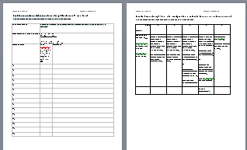  OR evaluate students' competency 1 development using an appropriate rubric such as “Sample Competency 1 Rubric for Analyzes the problem & Considers problem as a whole (Relationships between multinational and first and third world countries)” (See annexes) | i) Read to determine reasons for economic disparity:  Students learn to «analyze the problem» by first determining causes related to power structures, location, and historical events.  Task: In groups or individually student read suggested articles on historical causes for disparity of wealth & on economic theories that describe a North-South divide.  In groups students and share their views regarding connections between historical knowledge and economic disparity worldwide.  ii) Reporting using mapping tools and descriptions. Students "analyze the problem" in order to recognize power relations. According to teacher instructions, students consider competency development being tracked. OR rubric's evaluation criteria.  After research task, students present information gathered using maps and descriptions (Google Maps or Google Earth) to indicate relationships between multinationals and first and third world countries:  - Indicate location of head office of one company based in a first-world country but which benefits from a north-south-type difference labour or resource costs.  - Indicate location of (at least) one industry (mine, factory, etc.) owned by that company situated in a developing country, set up there to profit from cheap labour or raw materials.  - In map-bubbles indicate and explain  - relationship between head-office and foreign industry/factories. (power, control)  - any historical connections (i.e. what about the colonial or neocolonial connections)  - reasons for developing industry in this location (economic, political, etc.)

Phase 3: Competency 1 Performance Phase continued...
Interpreting Poverty, Power, Wealth and Capitalism. Developing a position.
Activity: Understand how wealth is generated and how capitalist practices involve and affect our contemporary world.
Key features of Contemporary World:  Competency 1 K.F. - Analyze problem  Determines causes  Recognizes power relations | Competency 2 K.F. - Examines some points of view on the issue  Identifies various points of view  Establishes points of convergence and divergence among these points of view
Teacher roles |  | Student tasks
I) Provide overview of basics of Capitalism  (Emphasis on Capitalists and how they make profit)  Adam Smith:  -Definition of wealth, and understanding how it is created  -Explained difference between money and wealth  -Shows how wealth is best created in a society  Some essential arguments he put forth include  -labor itself produces value  -Individuals would naturally, without specific state intervention, "direct... industry in such a manner as its produce may be of the greatest value." This tendency essentially enables the whole economy to become more productive, and it (everyone?) naturally becomes wealthier.  Karl Marx says or implies  - Profit relies on cheap labour to add value, for which workers do not receive full market value of product  - Capitalism/ists essentially search out cheap enough labour and raw materials to ensure profit.  - Marx questions the morality and sustainabilitiy of Capitalism  Suggested Youtube videos to use:  Ethics 10 Adam Smith and the Free Market  Justifying free market capitalism, in terms of utility but also in ways it frees up individuals, even workers. But also notes problems.  Marx's Theory of Economic Crisis  Interesting rapid distillation of Marx theory of surplus value and source of profit. Also theory of crisis! Points at end to temporary solutions capitalists find including globalization.  ii) Present definitions for essential knowledge:  - International trade  - Wealth creation  - The assets and liabilities of states  - Social gaps  - Emerging economies  Ask students to make connections between the different theories of wealth generation and the essential knowledge. (Mind map format) |  | i) Students analyze by recognizing causes for generation of wealth: Students view or read media/articles on how wealth is generated and how capitalism works. They then share their overviews and interpretations as to how this might (or might not) apply to the countries and industries viewed in the previous activity.  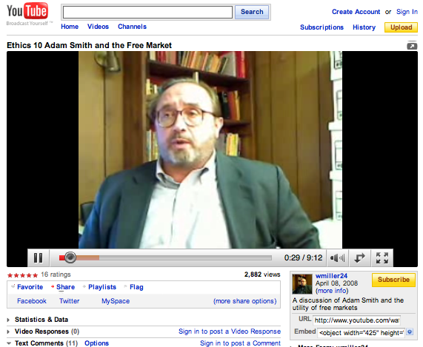  Ethics 10 Adam Smith and the Free Market  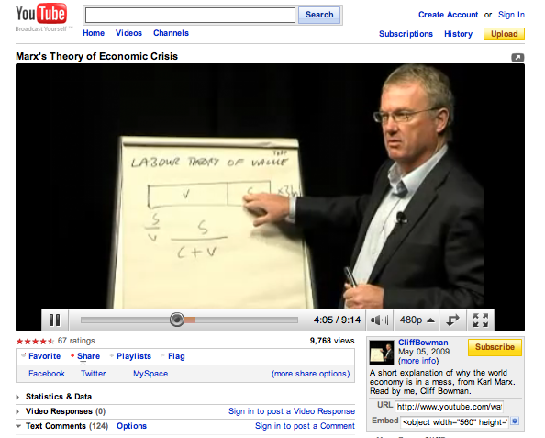  Marx's Theory of Economic Crisis  ii) Students analyze problem by  • Interrelates various aspects of society • Determines causes • Establishes consequences • Identifies different points of view • Examines some of the interests at stake • Recognizes power relations.  Task suggestion:  Create a mind map of sorts that connects some of the theories of wealth, value and labour to elements of essential knowledge from QEP program.  Below mind map analyze problem by focussing on at least two key feature manifestations listed above.

Activity: Identifying the pros and cons of Economic Development in general
Key features of Contemporary World:  K.F. - Analyze problem: Interrelates various aspects of society, Identifies points of view , Examines some interests at stake |  | K.F. - Considers the problem as a whole  Compares manifestations of the problem  Considers the problem on different scales
Evaluated criteria for Competency 1 Interprets a Contemporary World Problem.
Clear overview: Interrelate elements of the problem
Rigour of reasoning: Use facts and concepts... to establish connections.
Teacher roles | Student tasks
i) Provide overview of potential of industry-driven economic development  a) Show and discuss examples where private companies, foreign investment and even state-supported industry help create "growth" in terms of tax revenues, develop infrastructure, increase social services, encourage other local businesses, increase the value of currency used to purchase imports, etc.  Review and apply definitions of wealth:  Explain how individuals in poor nations benefit from our investment into their countries (hiring of workers, factories, jobs, technological transfer, skill and educational transfer of information, etc.  Demonstrate positive argument: i.e. a growth in overall standards Refer to Gapminder video How world changed in 200 years, or other statistical sources. Demonstrate how overall standard of living in both the developing countries and developed ones has increased over time?  b) Assign additional reading from selected articles (see Student tasks), and share findings.  c) Consider an example reason by viewing segments of a video  ii) Wealth Creation vs other problems or issues  Ask, questions from Cont. World Quebec Education Program p 17:  -Why, despite overall growth in standards, is "The gap between rich and poor is growing wider in many countries."  -How does "the disparity continue to grow"?  Comment on Gapminder video above in terms of other issues, and introduce other documents. For example, consider the moral, social and economic effects when use of child labor becomes common: Children pay high price for cheap labour  Consider various other problems associated with multi-nationals. View and consider web site entitled: Beyond McDonald's  Consider the long-term consequences of the use of cheap labour! Read or refer to excerpts from: Cheap Labour on a One Trick Pony : StevenClark.com.au  Assign Task Create a Geographic sketch,  and present evaluation rubric:  Sample Competency 1 Rubric for Analyzes the problem & Considers problem as a whole (Wealth Creation vs other problems or issues.) | i) Analyze and consider problem as a whole.  a) Listen carefully and participate in teacher presentation on industry-driven economic development.  b) Read articles on various aspects of economic growth and consider possible arguments presented within. Teacher may need to paraphrase:  In Praise of Cheap Labor - By Paul Krugman - Slate Magazine  Exploiting Cheap Labor Decreases Poverty - Opinion | NowPublic  c) View video: Consider the example region: Africa: A New Emerging Market, by viewing segments of video presented with this article: Emerging Markets « How to Make Meaning  Task: Share findings in articles with the class.  ii) Interpret problem: Wealth Creation vs other problems or issues.  Task for evaluation of Competency 1:  Create a Geographic sketch and present resulting sketches with explanations to the class  Process (Completed in small groups or individually.)  a) Use a word-processing or drawing software to create at least two Geographic sketches. (Google Maps could also be used)  On the sketches include the following:  - Evidence of economic expansion in developing countries (Location of industries from previous activities. Infrastructure indicated by symbols.)  - Evidence of wealth and economic growth (Icons to show different types of economic expansion: $, products, etc.)  - Evidence of problems (images and textboxes overlayed to indicate wealthy vs. poor, capitalist vs worker; multinationals and absentee ownership, child labour)  b) Combine the sketches above into a slide-show format, and give an accompanying oral presentation explaining each slide and some reasons why disparity occurs.

Phase 4: Competency 2 Performance Phase
To build towards taking a position on economic development in emerging countries.

Activity Emerging Countries:
Key features of Contemporary World Competency 1:
Defines the problem: Identifies forms the problem takes in different parts of the world, Defines the context, Identifies actors
Teacher roles | Student tasks
i) Guide class discussion  Teacher leads discussion of notions of Emerging Economies (producers) and of Emerging Markets (Consumers).  Show video and quotes from articles on the specific notion of emerging economies.  Example quote: "Emerging Economies are those regions of the world that are experiencing rapid informationalization under conditions of limited or partial industrialization. " Source: Emerging Economy Report. Other more precise definition here: What Is An Emerging Market Economy?  Example videos to use:  - Generation Lost – Chapt. 21 Emerging Economies  by Boyan S. Benev  - India to surpass US economy  Use simple focus questions to review, define contexts and actors, and to access previous knowledge:  - What are emerging economies then?  - What does that imply for them? For us? For companies here and there?  - Name 5 examples of countries you consider emerging economies, whose products you know are sold in Canada.  Teacher then may need to clarify to eliminate countries, such as certain OECD countries, which already have high standards and have already "emerged". This Wikipedia list of Emerging Markets includes some of the same countries, but mostly indicates fairly countries still emerging. Another list to consider, the G20 countries which also contains emerging economies. See Economic snapshot of G20 on BBC. Finally here is another good list: The CEPII list of emerging countries . Oops, here is another BRIC - Wikipedia, the free encyclopedia) | i) Students consider emerging countries  Students consider different contexts for wealth generation by discussing notions of emerging economies and emerging markets. They identify new actors in that they recognize individuals here and there as producers and consumers in economic environments that are “emerging” onto the world stage.  Students view videos:  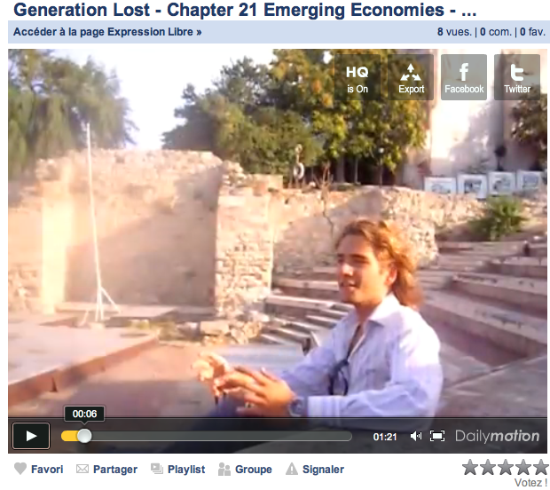  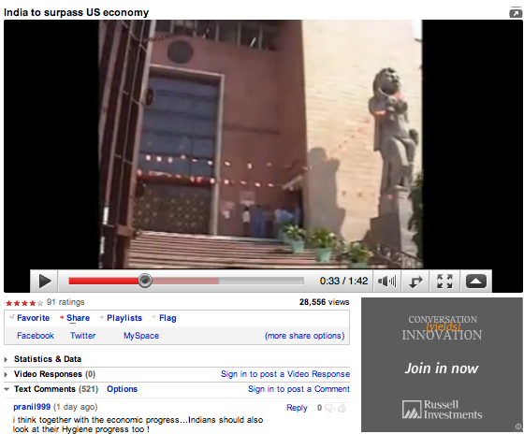  Students define for themselves the notion of emerging economies.  Students search prior knowledge for countries they consider emerging.  Students then clarify which countries can still be considered emerging.

Activity: Take into account how our perspective on certain products/countries is influenced by media
Key features of Contemporary World:
KF 2: "Considering media treatment" of products from emerging countries.
Teacher roles | Student tasks
Teacher provides example of photos and videos of advertisements for different products from countries with emerging markets or developing countries in which factories have been located.  Teacher demonstrates example of video podcast style or slideshow using those products. (images, with texts and oral interpretations)  Teacher outlines a strategy for finding products from such countries:  Choose products you already believe are produced, in whole or in part, in emerging countries and that export goods. (ex. Russia)  Search for terms of common products (ex. "Russian-produced cars", "Cars from Russian" or just "Russian exports") to get ideas.  If chosen country does not export to Canada, you are not likely to find product here for which you can take an action picture, so choose other countries.  Search for mention of advertisement using search terms like "Russian ad campaign"  Example search result: Stallone in Russian vodka ad! But... can you find a photo of that product in action?  Restart search process using alternate search strategy!  Try instead starting with available products at home, on the streets. Keep list of emerging countries handy.  Try as well searching for phrase "Made in Russia" or "Made in Taiwan" to find products produced by multinationals located in the West (see Activity iii below.)  Try searching phrases like "Canadian product" along with "produced elsewhere" | Task: Identify 5 products  Identify 5 products that are advertised and used in Quebec, possibly created by local and wealthy multinational companies, but that are produced in whole or in part in emerging countries of your choice. (If possible, use only one country to focus your search.)  - In advertisements: Collect pictures or audio for how products are portrayed in advertising, in streets, tv, internet.  - For internet media: access online videos either through URL or downloading copyright-free media directly or using tool such as http://keepvid.com/.  - For street advertising: use cell phone cameras to capture products viewed using Google street view. Send to someplace like drop.io for storage.  - For television ads: access same on Internet or use cameras or VCR to record the video segment.  Extension task: As a homework assignment, ask students to take pictures of the same products as they occur in the streets or in the home. Use cell phone cameras as above. Collect online at drop.io for storage and access. Use regular digital cameras if available. Record the use of that product in action if possible.  Organize the collected information or actual media in 5 rows in a table using Google Docs or equivalent. i.e. photo of product in real life, beside advertisement that encourages you to buy it, as in chart below. Leave space for notes and commentary.  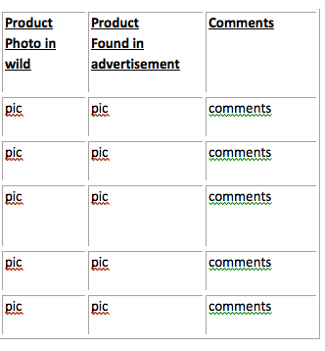  Task: Expressing well-founded opinions.  Create a short podcast or visual slideshow that displays the above pairs of images, along with explanation as to:  - How and by whom the product is used here.  - Why the ad makes the choices it does.  - How the media (an actor) influences peoples opinion of the product.  - Statement on whether ad makes connection between place or method/situation of actual production.  Alternative class strategy (or one advance group's task): The sections above and below could possibly be adjusted to consider the CELL phones themselves!  -The cell phone is being used how?  -The cell phone is made where?  -The cell phone is empowering people or not?  -The cell phone is actually breaking down media influence. How?  Task: Establishing critical distance. Consider the position of shareholders in company involved in making or selling products from an emerging economy. For each picture (see activity above) determine:  - the company and its mission, mandate, goal, reputation, etc.  - location of company head office and country's wealth (GDP) on world stage  - location of factory which produces  - examples of raw materials needed to produce that product  - location of raw materials.  Create a brochure for the company, including its various successes. The brochure is for potential shareholders, investors, etc. Include in the portrait of the company its positive influence on the development of their local and emerging economy, and what that might mean from all points of view.

Activity: Establishing connections between actors and their interests and values, by interviewing youth in emerging countries.
Key features of Contemporary World Comp. 2 Takes a position
Debates the issue: Bases opinion on facts.
Examining points of view
Evaluation Criteria of Contemporary World:
Clear overview...
Teacher roles | Student tasks
i) Direct students to use Taking It Global to find youth in target countries where companies are based.  As a class tour some profiles of youth from countries that might be considered as representative countries with emerging economies.  Introduce goal: Through interviews and email contacts, develop portraits of youth who agree and who disagree with companies from North entering their countries.  2) Help students to prepare interview questions to ask targeted same or other similar youth in target countries.  Help students to conduct interviews by email or via chatting/skype.  3) As a class, attempt to understand and explain their their perspective. | Task - Establishing critical distance.  Considering the position of actors from an emerging country.  Compile results of interview and position of interviewee with regards to Social Justice vs. Economic development, including:  - Portrait of interviewee  - Interviewee's responses and comments  - Newly informed perspective of student. (i.e. our students may not agree with opinion of interviewee)

Integration

Competency 2 Section: Complex task
Activity Create an informed Public Service Announcement that takes a position on the issues and responds to the guiding question.
Key features of Contemporary World:
Evaluation Criteria of Contemporary World:
Clear overview...
Teacher roles | Student tasks
Re-introduce complex task, to create a PSA that uses concepts and knowledge from above, and opinions developed through previous Competency 1 and 2 tasks.  The United Nations would like you to create a Public Service Announcement about Poverty and Wealth creation in emerging countries, but is concerned about sensational, one-sided portrayals of the problem. They want a balanced PSA that informs people of the situation both here and in poorer countries. They want a PSA that takes an informed position on disparity in general, on "economic inequality", and on a socially just generation of wealth. The thing is… they also want something that could be shared and downloaded into a handheld device like an iPod or phone!  As a student of the Contemporary World course though, you are also expected to take a position, and to respond to the following question in your PSA:  How can emerging economies generate wealth in a socially just way? | Students prepare first as a class and then in groups to prepare a PSA.  Possible steps:  Outline which information will be useful in order to best announce and consider the issues, and to respond to the guiding question.  If working in groups, decide on a general tone or response to the question. Discuss whether it is possible and how wealth might be generated justly.  If working in groups, divide up tasks.  Work together or individually to create a Public Service Announcement to be broadcasted or podcasted to your fellow students!

Annexes

(Worksheets, evaluation tools, etc….. unless still embedded above)

Competency 1 Development Tracker Sheet
(Quick “overview description”)
Observable Tasks: |  | Overview Description of disparity in two or three representative countries using more than one graph from Gapminder
Competency Key Features developed: |  | K.F. - Define problem:  Defines context: Establishes facts  K.F. - Considers the problem as a whole:  Considers the problem on different scales
Evaluation Criteria considered: |  | Clear overview
 | Student Names | Quick Judgement  1-Really good for where we are at  2-Sufficient for where we are at  3-Needs work, focus, effort | Comments on competency development  (or reflections by students during conference)
1.
2.
3.
4.
5.
6.
7.
8.
9.
10.
11.
12.
13.
14.
15.

Identifies and explains relationships Competency 1 Development Tracker Sheet
(Relationships between multinational and first and third world countries)
Observable Tasks: |  | Identify and explain relationships between multinational and first and third world countries
Competency Key Feature targeted. |  | K.F. - Analyzes the problem  Determines causes  Recognizing power relations.  K.F. - Considers problem as a whole  Demonstrates global nature of the problem
 | Student Names | Quick Judgement  (on expected level of development)  1-Really good for where we are at  2-Sufficient for where we are at  3-Needs work, focus, effort | Comments
1.
2.
3.
4.
5.
6.
7.
8.
9.
10.
11.
12.
13.
14.
15.

Sample Competency 1 Rubric for Analyzes the problem & Considers problem as a whole
(Relationships between multinational and first and third world countries)
Grade  CRITERIA | A | B | C | D | E
Develops clear overview by....  –interrelating elements of the problem  –identifying global trends | Correctly indicates location of multinational head-office AND location of industry or other economic operation within third-world country or emerging economy, and through exceptional iconography or description is able to indicate reasons for a profitable relationship. | Correctly indicates location of multinational head-office AND location of industry or other economic operation within third-world country or emerging economy. | Correctly indicates location of multinational head-office AND location of industry or other economic operation within third-world country or emerging economy. | Indicates the location of multinational head-office OR the location of industry or other economic operation within third-world country or emerging economy, but not clearly both. | Student does not identify location of either element.
Demonstrates rigour of his/her reasoning | The student explains at least two reasons why this profitable relationship exists. | AND student explains at least two reasons why this profitable relationship exists. | AND student partially explains why this profitable relationship exists. | Student only partially explains why this profitable relationship exists. | Student does not explain interrelated elements correctly
Judgement/grade average for
Competency 1:

Sample Competency 1 Rubric for Analyzes the problem & Considers problem as a whole
(Wealth Creation vs other problems or issues.)
Grade  CRITERIA | Observable Elements | A | B | C | D | E
Reasons rigorously and develops clear overview by...  --Using facts and concepts... to establish connections in his/her explanation (reasoning)  --Interrelating elements of the problem (overview) | Student’s analysis of wealth generation and its positive and negative aspects.  Production of geographical sketches.  Presentation and explanation of sketches as slideshows. | Correctly identifies industrial (or agricultural) expansion in a developing country,  AND illustrates the way both economic development and disparity can occur as a result  AND uses facts and concepts to establish connections while explaining specific cases of development and disparity | Correctly identifies industrial (or agricultural) expansion in a developing country,  AND illustrates the way either economic development and disparity can occur as a result  AND uses facts and concepts to establish connections while explaining specific cases of development or disparity | Partially identifies industrial (or agricultural) expansion in a developing country,  AND illustrates the way either economic development and disparity can occur.  AND uses facts and concepts to partially establish connections while explaining specific cases of development and disparity | Partially identifies industrial (or agricultural) expansion in a developing country,  OR illustrates the way both economic development and disparity can occur.  Does not use facts and concepts, or uses them incorrectly | Is not capable of correctly identifying and illustrating industrial (or agricultural) expansion in a developing country,
Judgement/grade average for
Competency 1:

☺

