(School Board Information) (School logo)

Preschool Education
1st Communication and Report Cards

Name: ______________________________________

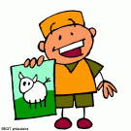
Second Language Acquisition
With regards to your child’s French English second language acquisition, your child:
Term 1: | Is progressing with direct support | Is progressing with guided support | Is progressing with minimal support | Is progressing without support
Demonstrates an interest in the second language
Demonstrates understanding of the second language
Communicates in the second language
Overall Comments:

Term 2: | Is progressing with direct support | Is progressing with guided support | Is progressing with minimal support | Is progressing without support
Demonstrates an interest in the second language
Demonstrates understanding of the second language
Communicates in the second language
Overall Comments:

Term 3: | Has partially attained the end of kindergarten outcomes | Has attained the end of kindergarten outcomes | Has exceeded the end of kindergarten outcomes
Demonstrates an interest in the second language
Demonstrates understanding of the second language
Communicates in the second language
Overall Comments: | 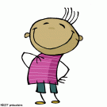

Please sign and return your child’s progress folder after each reporting period.
1st Written Communication:
Parent(s) comments:

____________ ____________________ ______________
Date of remittance Parent’s signature Date

Term 1: Report Card
Parent(s) comments:

___________ __________________ ______________
Date of remittance Parent’s signature Date

Term 2: Report Card
Parent(s) comments:

____________ ____________________ ______________
Date of remittance Parent’s signature Date
A summary of the 6 competencies found in the report card and the Preschool Education Program
Illustration of the competency | Wording in Report Card | Link to the global areas of child development | Explanation with reference to the Preschool Education Program
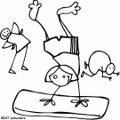 | Develops sensorimotor skills | Psychomotor Development | To perform sensorimotor actions effectively in different contexts.  In everyday classroom physical activities, your child moves, explores his/her learning environment and manipulates objects, tools and materials with more precision. He is able to adapt his actions to his environment and becomes aware of the importance of taking care of his body and interacting within his learning environment safely and soundly
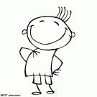 | Develops his/her personality | Emotional Development | To affirm his/her personality.  Your child expresses his tastes, needs, interests, feelings and emotions. He makes personal choices, takes initiatives and assumes responsibility. He is able to recognise his strengths and is beginning to become aware of his limits.
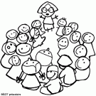 | Relates well with others | Social Development | To interact harmoniously with others.  Your child is beginning to reconcile his interests and needs with others. He is learning how to resolve social conflict in the spirit of mutual respect and justice. He shares his toys and ideas with those around him. He adopts and respects the classroom rules established by his peers.
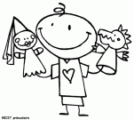 | Communicates orally | Language Development | To communicate using the resources of language.  Your child demonstrates an interest in communicating with those around him. He understands what is said and is able to produce a message using a variety of means to express his ideas. For example, tells a story, uses proper words to convey a message, uses a pictogram to convey a message.
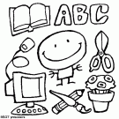 | Becomes familiar with his/her environment | Cognitive Development | To construct his/her understanding of the world.  Your child observes, explores, asks questions, makes associations and links to the arts, history, geography, mathematics, science and technology. He expresses what he knows and is able to explain the process and strategies he used to complete a given task.
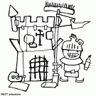 | Completes projects or activities | Methodological  Development | To complete an activity or project.  Your child engages in, uses his creative thought processes and demonstrates his perseverance throughout the completion of a project and/or activity. He is able to express his satisfaction and is able to explain the steps he took to complete the task at hand.

Evaluation as a means of following your child’s development
In order for you to follow your child’s progress and provide him with the support that he/she needs, the school uses different means to track and inform you on your child’s progression of learning.
Evaluation is an integrated part of the teaching/learning process and is used for pedagogical interventions. In preschool, evaluation is an ongoing process and occurs during the everyday daily routine and activities of classroom life. Observation is the favoured means for evaluation and focuses on your child’s attitudes, behaviours, processes, strategies and productions. Your child learns to take part in self evaluation practices which enable him/her to begin to recognise his/her strengths, limits, challenges and accomplishments.
In order to inform you on your child’s competency development, the school will periodically provide you with different forms of communication. You will receive one written communication and three report cards. You may receive one other form of communication, like a student portfolio for example, which documents your child’s strengths, challenges and accomplishments over time.
It is important to note that evaluation does not merely serve to situate where your child is in relationship to the programs’ expected outcomes. It is more importantly used to better support your child in his/her overall development.
Here is a reminder of the official communications you can expect to receive this year.
This Year’s Official Communications

1st Written Communication | You will receive your first communication regarding your child’s transition and adaptation to kindergarten, before October 15.
1st Report Card | The first report card will be issued no later than November 20.
2nd Report Card | The second report card will be issued no later than March 15.
3rd Report Card | The last report card will be issued on the last day of school.

