Mapping space
Schematic maps represent a significant learning experience when students create them themselves. These maps should also be used within the context of a complex task that is meaningful to students such as a situational problem or project. For an example of a methodological framework in Social Sciences that integrates technology tools, visit: www.recitus.qc.ca/methode/
- What is a schematic map?
  - The term “schematic map,” as used here, refers to a simplified representation of reality (i.e., it is an example of a simple map as defined in the QEP on page 288).
  - It attempts to represent the essential elements of a territory, phenomenon, movement, etc.
  - It can be used to communicate the observations noted by students in their geographical sketches.
  - It should be backed up with texts and statistics to confirm observations.
  - Its purpose is to communicate. Its title should introduce a situational problem related to the type of territory under study.
  - Schematic maps are therefore a synthesis approach involving observation and research.
Technique for making a schematic (or simple) map:
  - Define the purpose of the map.
  - Consult several sources of information: maps, tables, documents, etc.
  - Establish an outline of the argument.
  - Depending on the purpose of the map, identify the essential elements.
  - Envision the phenomena and spaces to be mapped.
  - Draw a schematic map:
  - Give it a title.
  - Indicate the scale.
  - Represent the essential elements using signs and symbols.
  - Create a legend.
To make it easier and faster to represent a given area, you can simplify its contours. Use a vector graphics editor to create a rough schematic representation of the area you want to map.

Example of a schematic representation of the world:
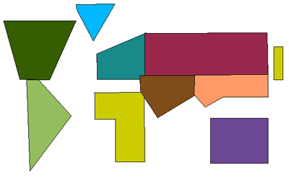
Example of a schematic representation of Montréal:
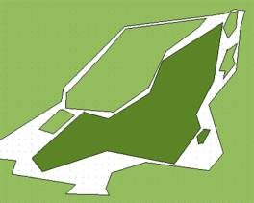
Add symbols to the map: objects, shapes, arrows, etc.
Examples of symbols that could be used (available in Word):
Symbol | Possible meanings
 | Movement, travel
 | Centre, periphery
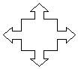 | Meeting place, exodus
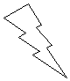 | Energy, electricity
Colours, patterns or graduated shading can be used to identify zones, movement, etc.
 |  |  |  |  | 
Example of a schematic map:
Traffic movement in a metropolis
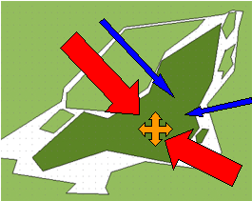 | Montréal: A city and a metropolis  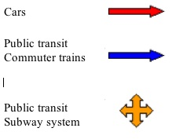
Another example (French only):
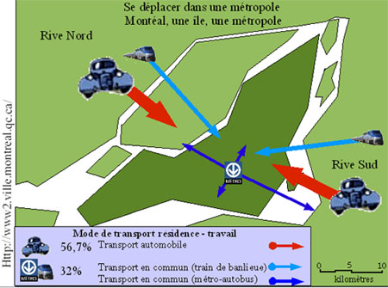
More about schematic maps (in French only):
www.protic.net/profs/menardl/2002-geo/techniques/carte-schematique.html#technique

