Interpreting a Picture
Develop upon First Impressions

Date: _________________

Name: __________________________________

Insert an image (Delete any sample images here)

Give source link:

How DIRECT is this representation?
◄◄◄
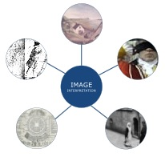
What’s the
MEDIUM used?
◄◄◄

How direct is this representation? From what I know, is this an image taken or made at the time it is representing? Is it likely to have been taken or made by people directly involved in the event?

What medium is this? Painting, photo, other? How do I know? What does the apparent medium indicate about how direct this representation of reality is?

Inferences I can make on first look:
What seems to be going on? Who seems to be portrayed? What seems important?

What’s SEEMS to be
to be going on? Who, what, where?
◄◄◄

