
GOAL Symposium,
The GOAL: Mapping out the future for our learners, Making Learning Relevant with GOAL
When? Wednesday, February 17th, 2010 Where? Hôtel Sheraton Laval
For Whom? Teachers, Professionals, Administrators, Consultants, Directors and School Teams
A variety of workshop will meet your needs. Topics include how to build a GOAL based learning situation, POP, best practices for GOAL, Bill 88, how to integrate GOAL into the school's success plan and much more. New Approaches, New Solutions (NANS) and the School Administrators' Support Team (SAST) will be partnering with us. The program will be available in early December and registration will be available online through LEARN in early January 2010. Looking forward to meeting you there!
For more information and a preliminary glance at the program, please consult the GOAL Web site: www.learnquebec.ca/en/content/mels/goal.
Professional Development Innovation Grant (PDIG)
LES development in POP and Explo
Keep an eye for more resources coming your way this spring thanks to a group of educators working on various LESs in POP and Explo. The teams have met on several occasions both face-to-face and virtually to develop practical classroom resources which will support the development of competencies in these programs.
POP Tool Kits
The delivery of the fourth and last phase of tool kits is scheduled for Fall 2010. Twelve new tool kits will be sent to the schools and will be available on the POP Index Web site. Expect tool kits about aeronautics, agriculture, computers, flooring, graphic design, industrial design, medicine, military, office administration, police, politics and professional sports. The tool kits vary in complexity to accurately represent the tasks to which the workers of the various trades and professions are exposed daily. They offer flexibility and opportunities for active learning. Keep in mind that it is up to you (and your students, if you wish) as to how the tool kits are used in your classroom. Watch for more news in the fall of 2010.

Graphic Organizer (GO) Project
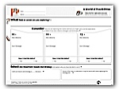
The GO project is field-testing a series of graphic organizers that are available for use by students and teachers in POP and EXPLO classrooms across Québec. Graphic Organizers provide a simple visual structure for guiding students in their learning process. This project gives teachers the opportunity to observe and learn more about how the organizers can be used to support student competency development and evaluation in the POP and EXPLO classroom. Completed GO will be reviewed and summarized and results shared on www.learnquebc.ca/content/curriculum/career_dev. For more information about this project contact your POP/EXPLO consultant.
Online Training Web sites for POP and Explo
POP teachers now have a new professional development tool available at their fingertips anytime, anywhere. The POP Online Training site is an interactive, self-directed training tool that allows teachers to work at their own pace and at their own convenience. The site presents situations typically encountered in the POP classroom and offers teachers learning activities, reference documents, and some best practices to deal with them. Teachers who field tested the program share their experiences and insights. The site is especially helpful to teachers new to POP, and its purpose is to complement, not replace, the professional development teachers receive from MELS or school board-based training sessions. The POP site can be found at http://poptraining.qc.ca/. The Explo site will be launched in the near future.
Mentoring: Communities of Practice

POP teachers from across the Anglophone community are presently participating in a MELS-subsidized pilot project that involves experienced POP teachers mentoring teachers new to the POP classroom. Two wonderful days were held in November where teachers met, set goals and exchanged ideas. An online community has been created to support communication and the sharing of resources. Members of the community also include school board consultants and MELS consultants. If you are interested in more information and want to participate, please contact your school board POP consultant.

Using Sakai to Build Learning Communities
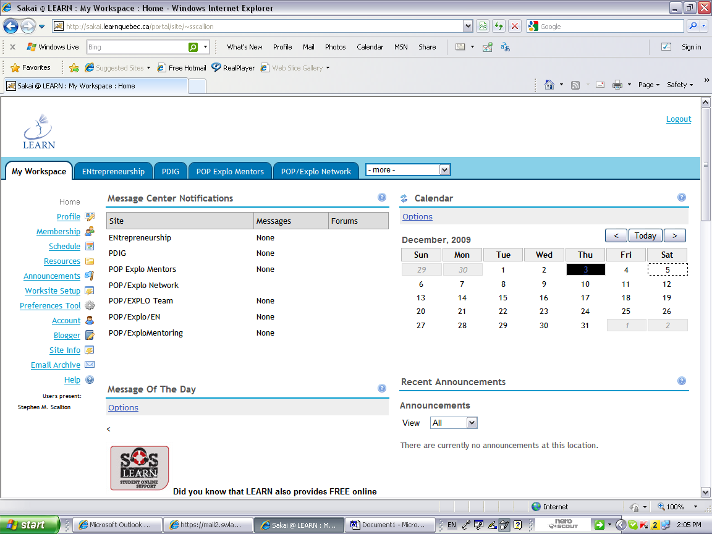
The provincial Career Development Network is a group of professionals dedicated to developing a learning community. To enhance the communication process we have begun to implement learning communities on the Sakai portal, which can be accessed through the LEARN Web site. These communities are open to all users of LEARN who work in the areas of POP, EXPLO, and ENTREPRENEURSHIP. They make it possible for teachers to share their subject-specific struggles and successes with each other, for school board level consultants to offer assistance from a distance and for MELS to provide new information between workshops. We look forward to developing these communities into a resource for all educators across the Anglophone Sector. To access these learning communities you must first register with Nancy Kerec at nkerec@learnquebec.ca providing her with your full name and school board or school if from the private sector and which of the three subject area communities you wish to participate in (POP, Explo or Entrepreneurship).
http://sakai.learnquebec.ca/portal

Building your Vocational Intelligence

Need too learn about vocational training realities, trends, QEP links with the generic competencies sought by employers, list of centres? Download a copy of the Building your Vocational Intelligence resource, a production of the GOAL Vocational Resource Committee. Printed copies will be distributed to all the elementary schools, high schools, adult education and vocational training centres in early December.

For more information, please consult the GOAL Web site: www.learnquebec.ca/en/content/mels/goal.

New POP Index

The new POP Index will be online early in the New Year 2010. You will be able to navigate on a completely updated site where the search functions have been improved. The search by keywords will be more precise and will therefore provide more relevant results. Furthermore, you will also be able to search not only by field of interest but also by vocational training sector. New tools will be added, such as a forum, an RSS reader, etc. and will be progressively accessible once you register yourself. More information concerning the features and use of the new site will be available when it is up and running.

Future CEO Stars …
an inspirational magazine that spotlights the creative innovations of young entrepreneurs in North America. Each issue features student testimonials that highlight a variety of entrepreneurial endeavors, offers ideas for classroom lesson plans, and provides information about conferences and contests related to entrepreneurship. A great tool to use in your classroom to engage students in the discussion and exploration of entrepreneurship!
To access current and past issues of the magazine, as well as a library of video diaries of budding young entrepreneurs, visit: http://www.fcsmag.com/node/1.
Be Your Own Boss: Is Self-Employment for Me?
This pedagogical resource contains a simple lesson plan focusing on the skills and characteristics associated with being an entrepreneur. In addition, it encourages students to identify and assess needs in their community in order to develop potential business plans. Could you use it as an activity or resource in your classroom? Check it out at http://www.careerprep.ab.ca/pickupkits.htm.

The Quebec Entrepreneurial Contest 2009-2010
Do you and your students have a great Entrepreneurial project or a significant innovation that adds value to last year’s project? It is time to get your projects on the move because the 12th edition of the Entrepreneurial Contest is in full swing for the 2009-2010 school year. There are $500,000 in prizes up for grabs and a wealth of Entrepreneurial skills to develop with your students. Change your destiny and apply today. Funds are available if you and your students have a business idea. Let's make it happen!
Consult http://www.concours-entrepreneur.org/en/entrepreneuriat/admissibilite.asp for contest rules and information
Please contact your board’s career development consultant for help in your endeavors.

Career Development Resources
Here are a few great Web sites for Career Development:

- http://www.khake.com/page95.html (This site is chalked full of career development information, quizzes, tests, worksheets, organizers – Mainly looks at POP’s Competency One – can be seen as Learning Activities to supplement your Career Explorations)
- http://www.best-job-interview.com/index.html (Great for everything about interviews)
- http://www.liensppo.qc.ca/poplinks.htm (Links to Web sites that accompany the POP tool kits)
- http://www.servicecanada.gc.ca/eng/sc/sin/index.shtml (Get your SIN now!!!!)
- http://vector.cfee.org/english/index.php?section_id=1&language=english (Excellent 5 minute video/documentaries on a thousand different careers


WINTER 2010 ISSUE
WINTER 2010 ISSUE

