
FIRST DAYS OF POP
Want a good project to begin the year with? Ask the students to fill out a Career Family Tree. Instead of just writing names and birthdates, the students will also fill in the career(s) of their parents, siblings, grandparents, aunts and uncles, etc. This is a great way to introduce them into the world of careers by having them talk to different family members about theirs. They can learn about different jobs, even ask their family about likes and dislikes, or get advice on the workforce. Best of all, is opens the line of communication between students and their family and it is a good way for their family to learn all about this new and exciting course! A sample Career Family Tree can be found at: http://www.breitlinks.com/careers/career_pdfs/familytreews.pdf
Myself: Joanna Albert; Tutor
Mom: Ally Norman; Cashier, Librarian Assistant, Nurse, Physiotherapist.

Dad: Jon Albert; Delivering Newspaper, Summer Landscaper, Civil Engineer

Grandma: Vicky Smith; housewife and teacher’s aid

Granddad: Al Albert; Ran a landscaping business

Grandma: Sue Levine; housewife, helped on the farm.
Granddad: Ted Norman; farmer
Aunt Jane: waitress, secretary, newspaper columnist, novelist.

ePEARL

This is an online, Web-based portfolio which allows students to document the traces of their career explorations. You can write directly in ePEARL using a simple text editor, attach URLs or other files or record brief reflections. From a teacher perspective you can quickly take a glance at the students' portfolios from anywhere where you have an Internet connection. In addition, feedback you provide in ePEARL can be summarized in one layout and used as part of your evaluation process. Contact your local POP or RECIT consultants for more information on how to get started.

Career Cruising Webinar Recordings Available
Do you want to learn more about the site your students use often in your classroom? Career Cruising (www.careercruising.com) is offering access to a new set of recorded training webinars to help you get the most out of Career Cruising. To access the Career Cruising webinar recordings, go to:
https://www2.gotomeeting.com/register/197126146
Take Our Kids to Work™: November 4, 2009
The date is set for this year’s Take Our Kids to Work™ day: Wednesday, November 4, 2009. Take Our Kids™ to Work is a national initiative sponsored by The Learning Partnership, a coalition of public and private groups organized to strengthen and support Public Education in Canada. Take Our Kids to Work™ is a safe and fun way to encourage your students to step outside of the classroom and explore the real world of work, as lived everyday by their parents, or other trusted relative/friend. The Take Our Kids to Work™ website will provide you with all of the details, including resources for Teachers, Parents and Employers. The Teacher’s Guide includes pre-and post work site classroom activities and a permission form. To participate speak with your POP Consultant and go to http://www.takeourkidstowork.ca/
Jacynthe Dallaire is our Quebec Learning Partnership Representative, she would also be happy to answer your questions and help you order materials. Her e-mail address is: jdallaire@thelearningpartnership.ca

Creative Career Exploration “Products”: Thinking Outside the Poster Board or PowerPoint Boxes
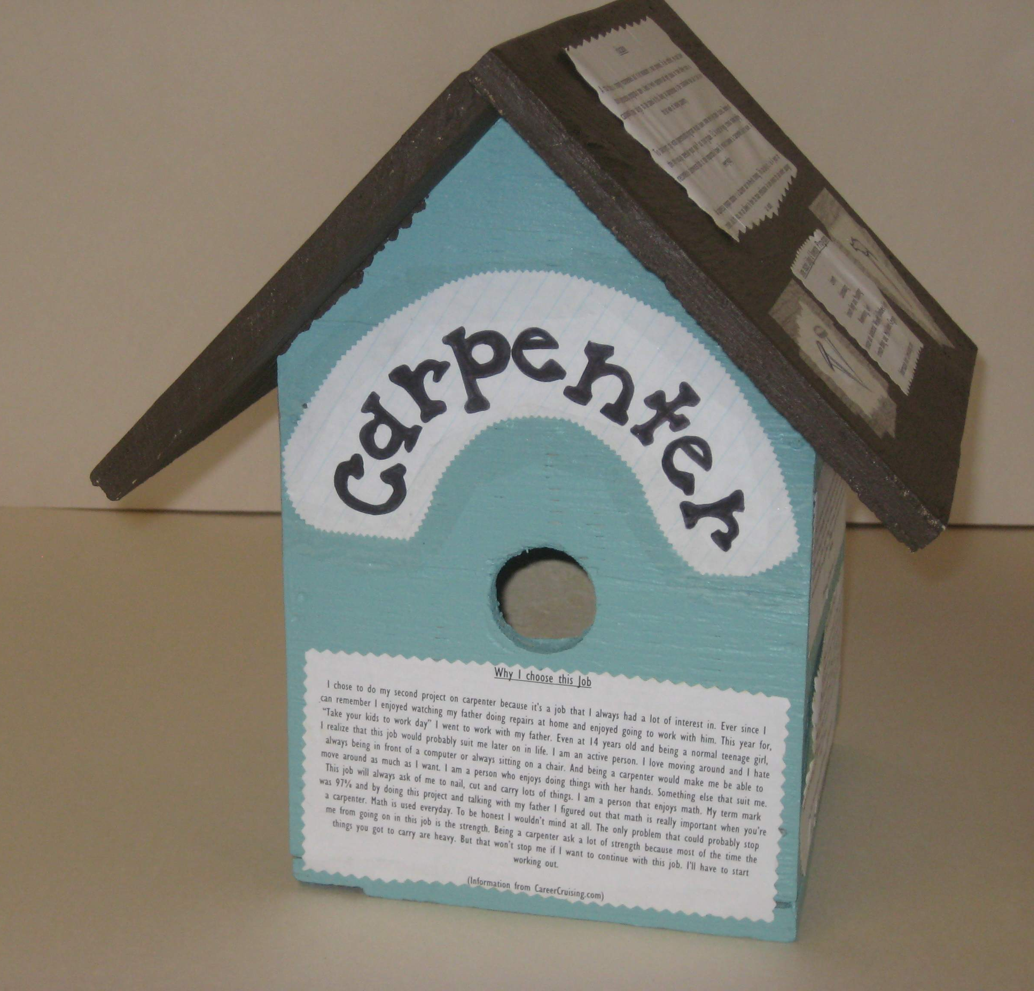
Career Explorations can take many forms. The QEP tells us that students are free to select the means of their exploration and set out the steps of the process themselves. Over time, students should vary their means of exploration to include trying out actual work functions, visiting workplaces and educational institutions, researching, and meeting with key people. Exactly HOW students share their experiences, reflections and discoveries with you and their classmates can vary as much as the career choices themselves. Students enjoy pouring their creativity into this part of the process, and often choose to showcase their work in a manner which demonstrates related work tasks or skills. Check out the following link to see how students in Steve Scallion’s POP classroom at Rosemere High School represented some of their Career Explorations:
http://micromedia.vaniercollege.qc.ca/swlsb/2008/pop/index.htm


FALL 2009 ISSUE

