2014-01-07
Type name here
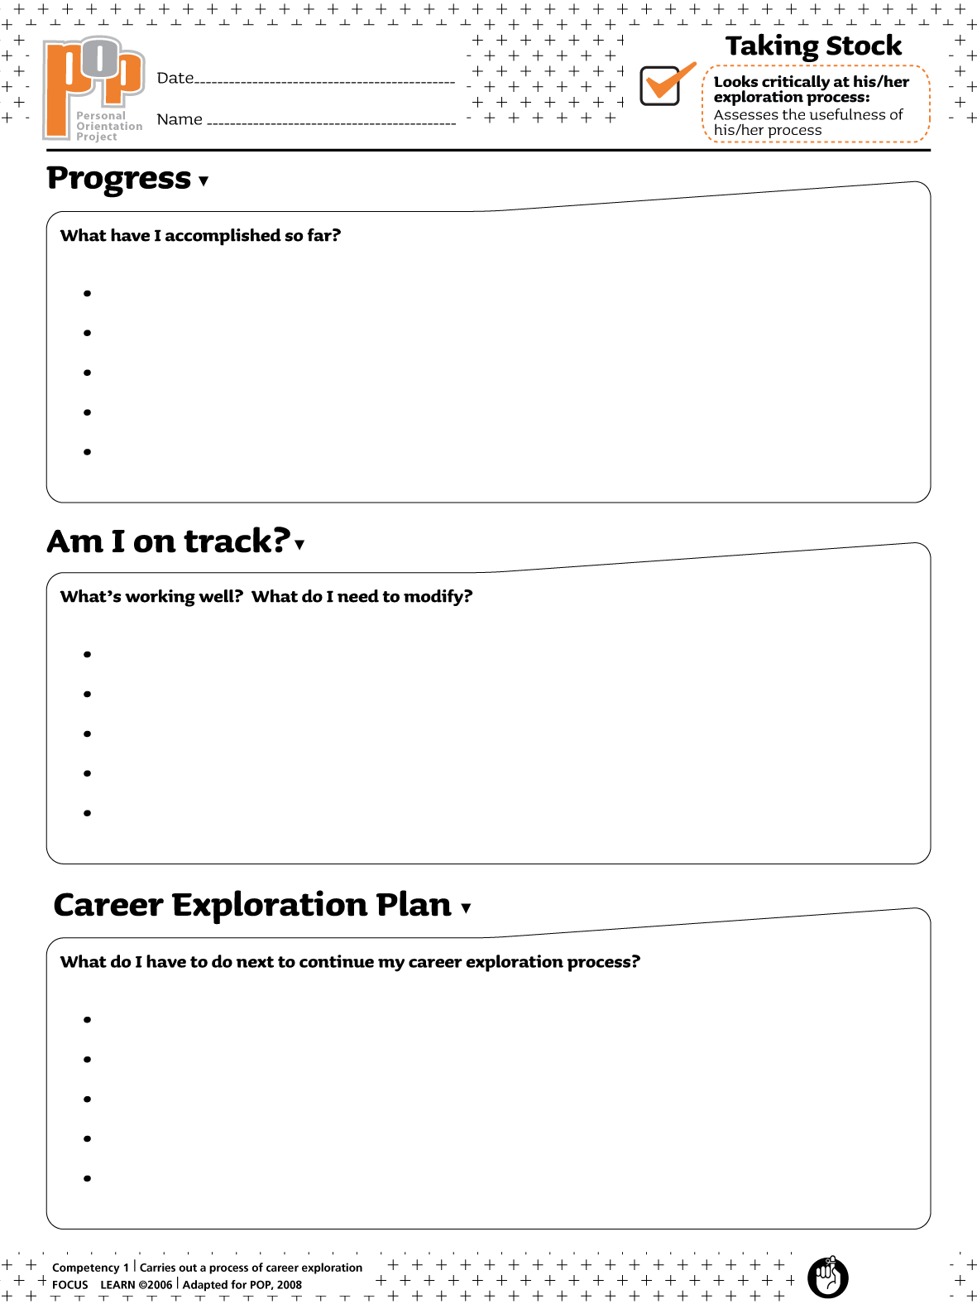Type here
Type here
Type here

