2013-12-20
Type name here
Type questions here
Type here
Type here
Type here
Type here
Type here

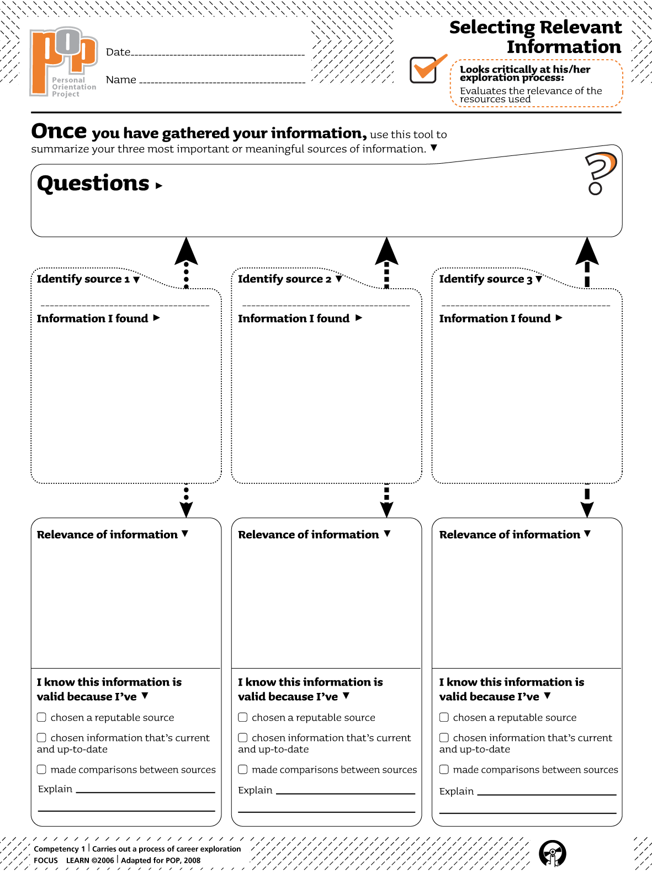

Type here
Type here
Type here

Type here

