Type here
Type here
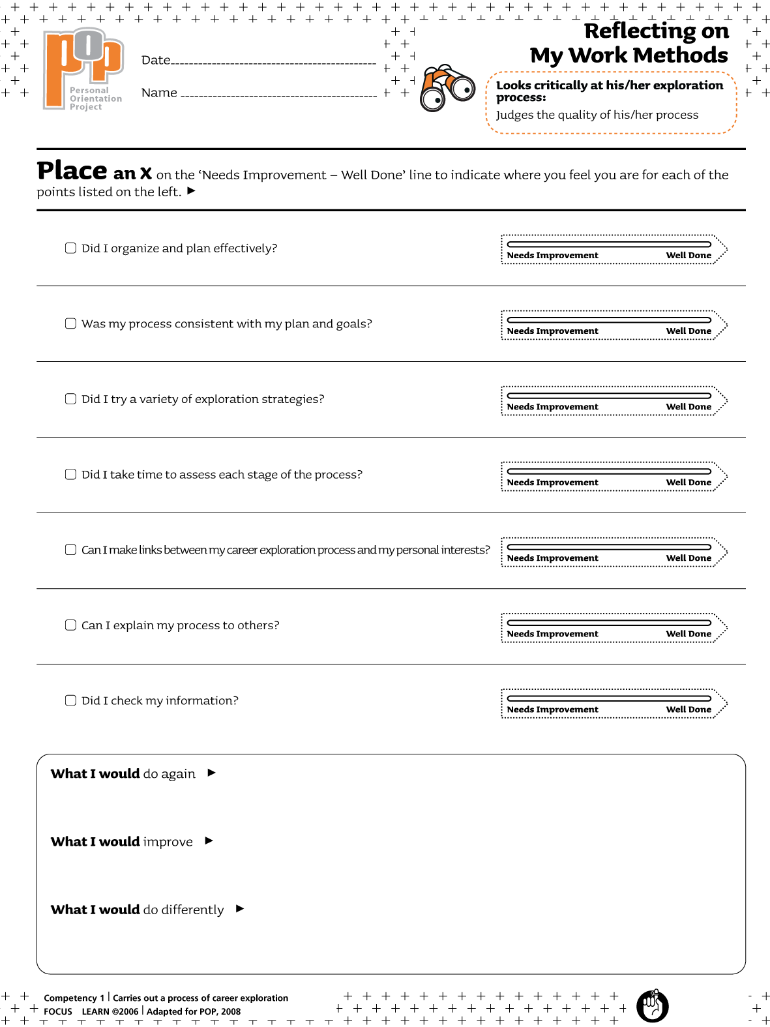Type here

2013-12-16
Type name here

