2013-12-16
Type name here
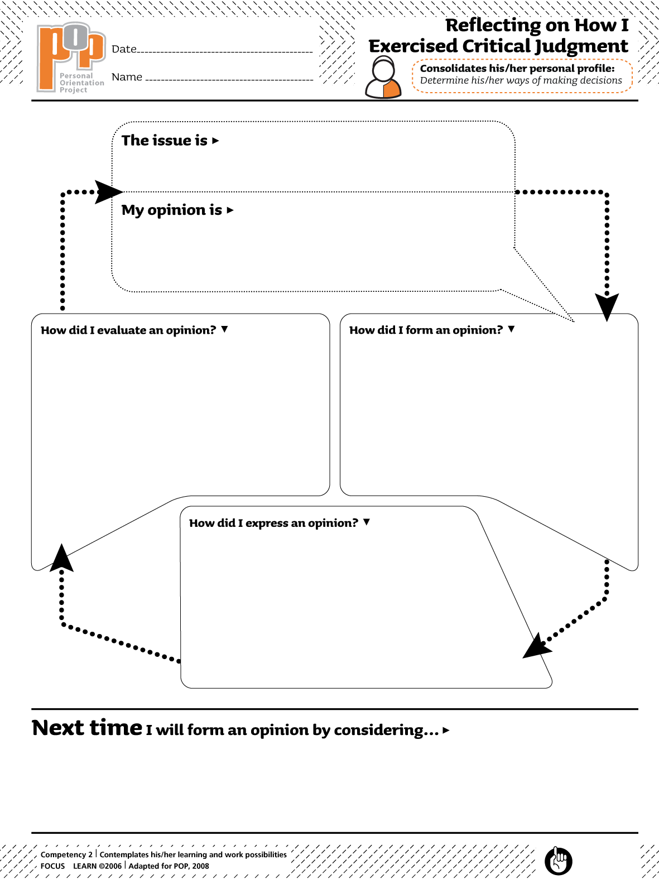Type issue here
Type opinion here
Type here
Type here
Type here
Type here

