2013-12-16
Type name here
Type issue here
Type here
Type here
Type here
Type here
Type here
Type here
Type here
Type here
Type here
Type here
Type here
Type here
Type here
Type here
Type here
Type here
Type here
Type here
Type here
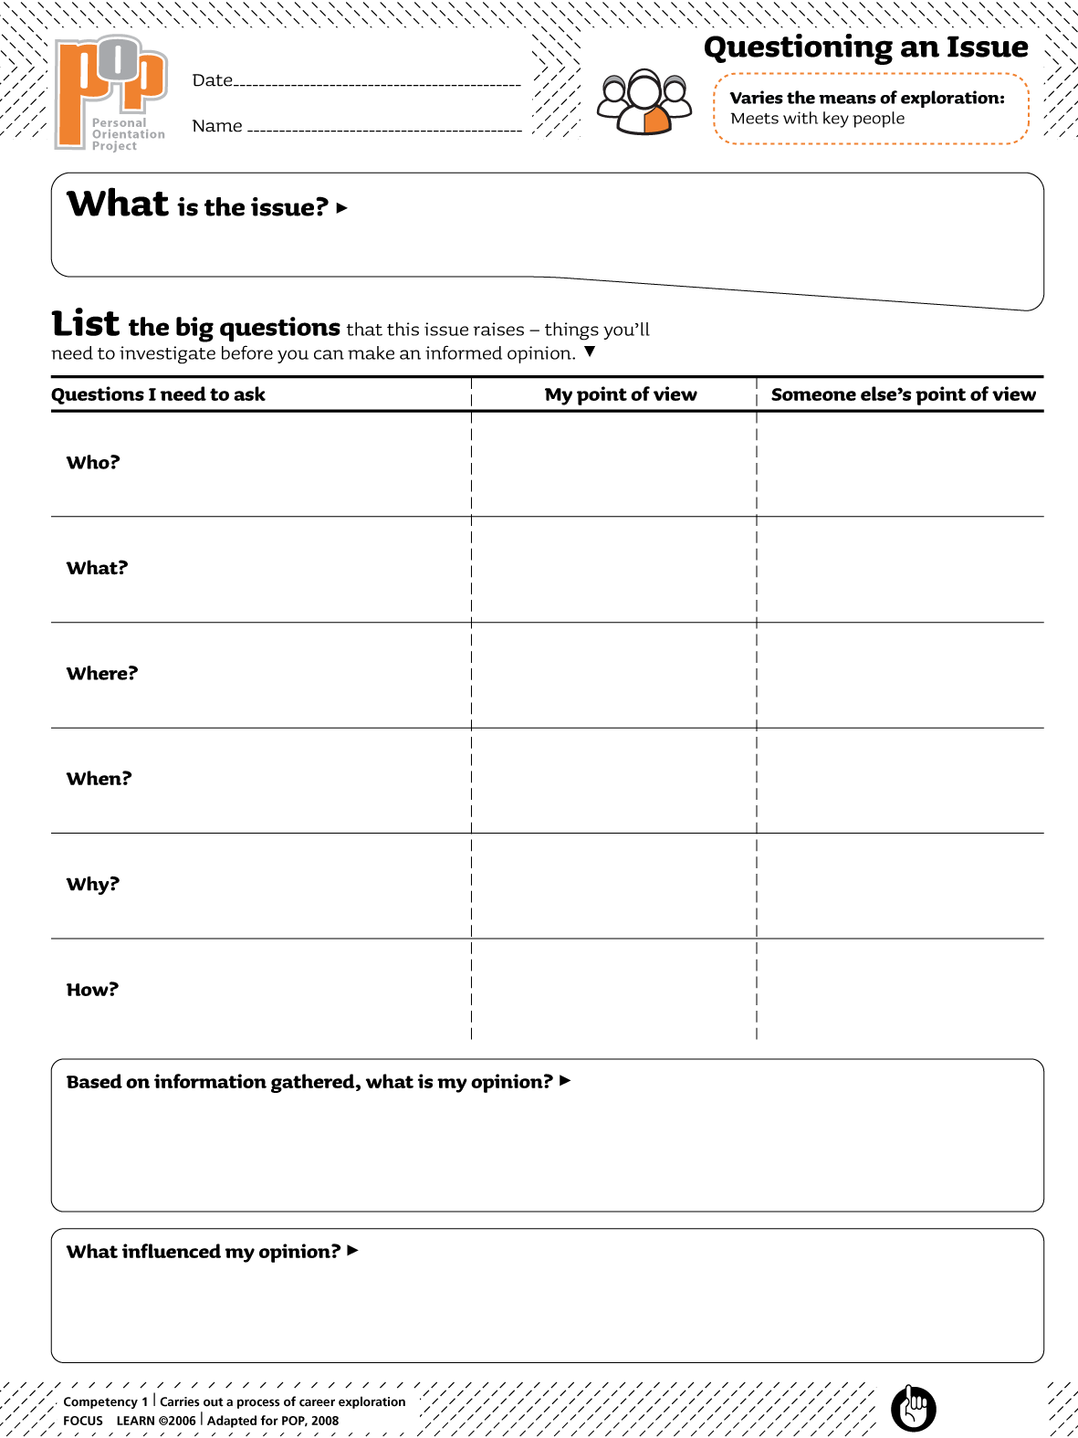Type here

