Type here
Type issue 1
Type issue 2
Type issue 3
Type here
Type here
Type here
Type here
Type here
Type here
Type here
2013-12-16
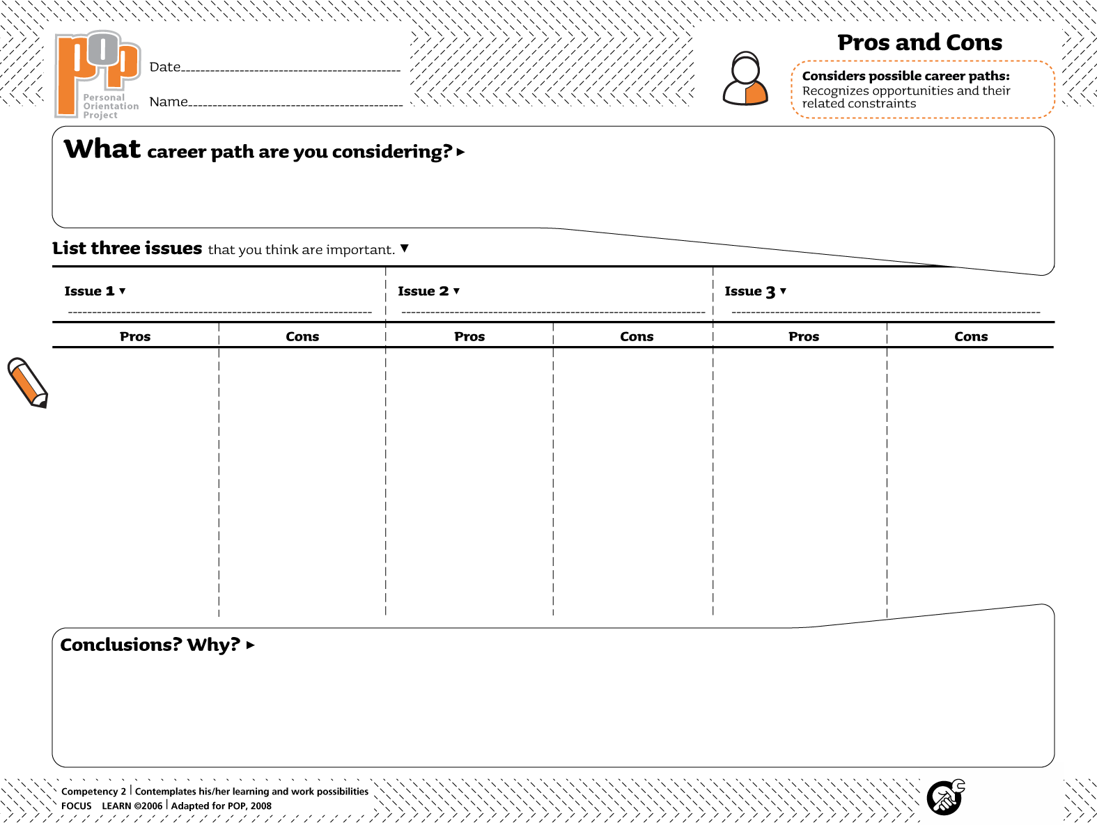Type name here

