2013-12-06
Type name here
Type here
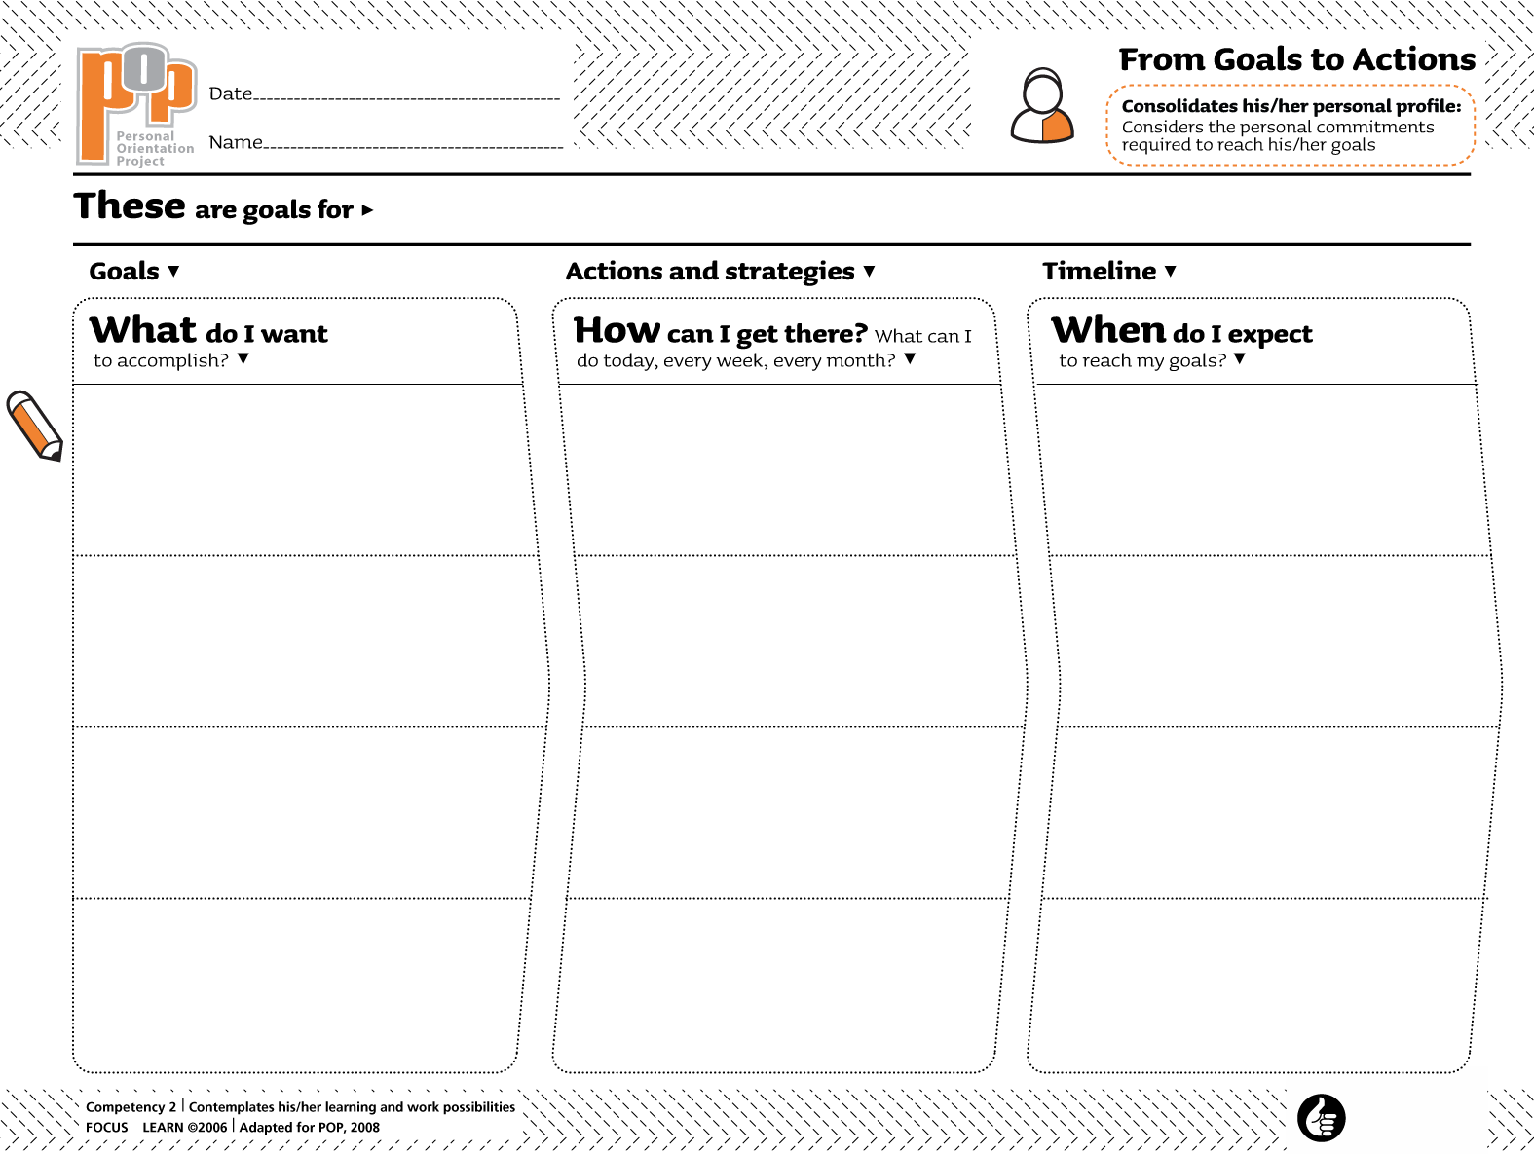Type here
Type here
Type here
Type here
Type here
Type here
Type here
Type here
Type here
Type here
Type here
Type here

