2013-12-05
Type here
Type here
Type here
Type here
Type here
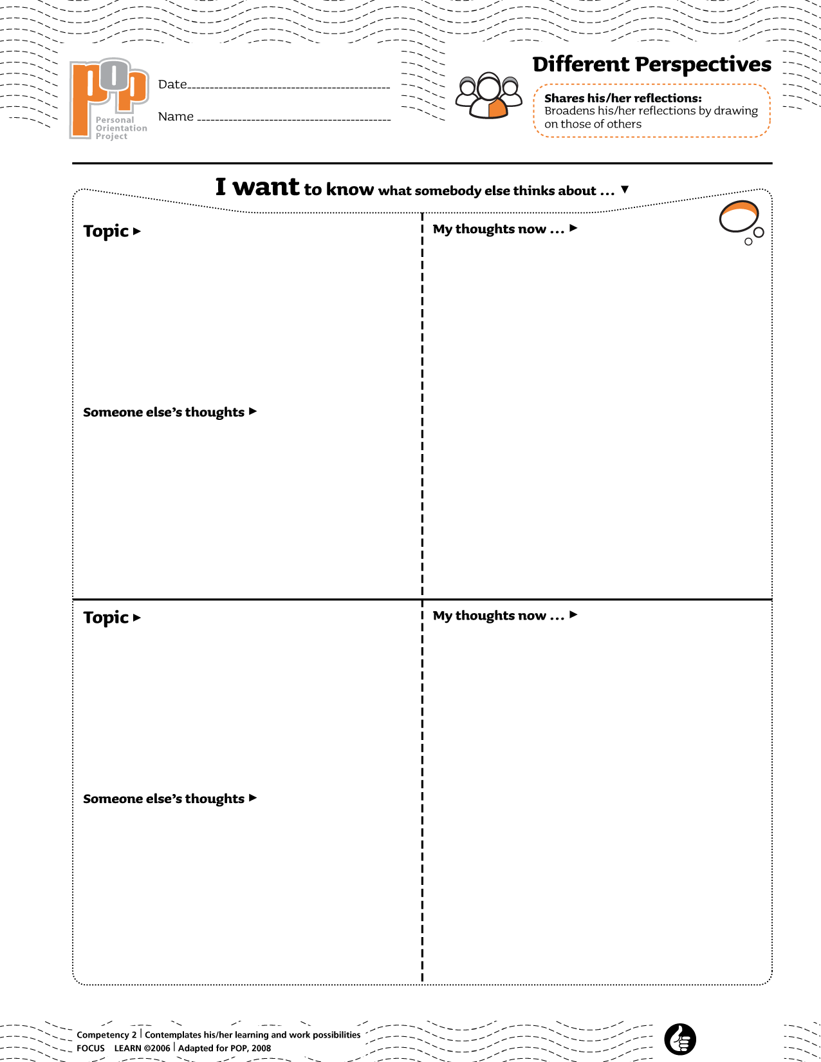Type here
Type name here

