2013-12-04
Type name here
Type here
Type here
Type here
Type here
Type here
Type here
Type here
Type here
Type here
Type here
Type here
Type here
Type here
Type here
Type here
Type here
Type here
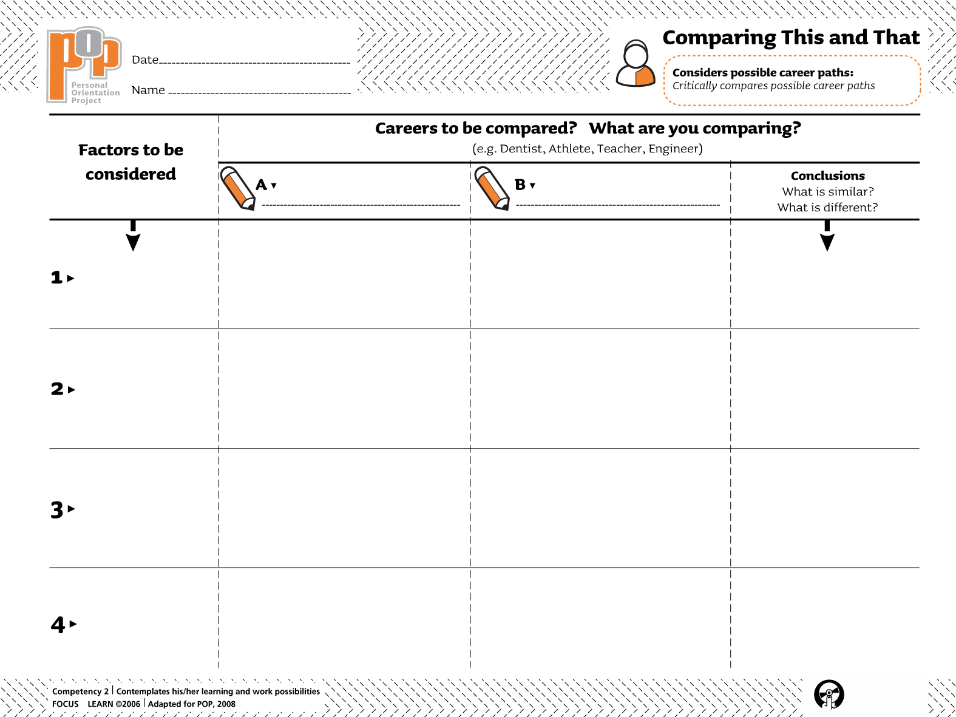Type here

