Type Name here
Type assignment here

type here
type here

type here
type here

type field

type here
Type here
Type here

type here
type here

type here

type here
Type here
Type here
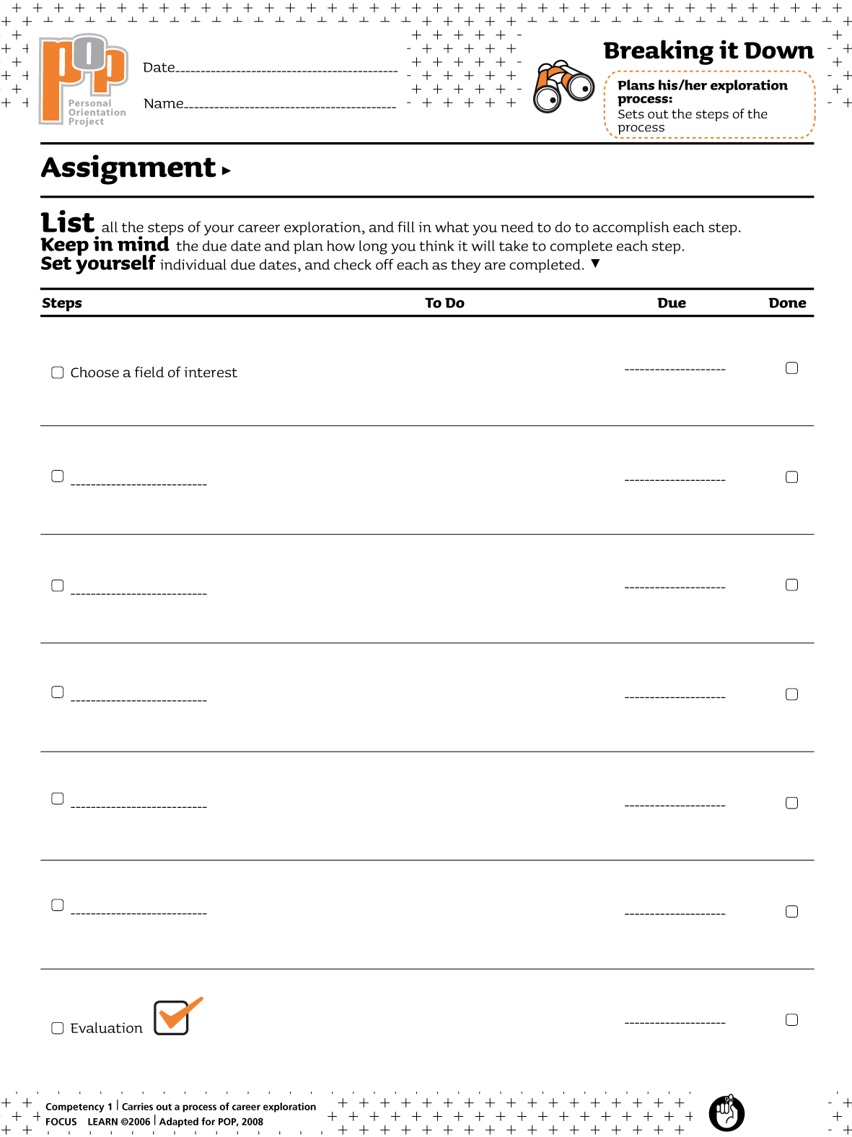 Type here
2013-12-04

