 | 5 | 4 | 3 | 2 | 1
A | Raises relevant questions about lifestyle habits and their consequences on health and well-being. Sets objectives beyond established norms for his/her age group with respect to regular physical activity and his/her lifestyle habits. | Drawing on a variety of relevant sources of information, develops a clear and structured plan designed to improve or maintain his/her lifestyle habits. | Sets realistic objectives, develops a plan for improving or maintaining his/her lifestyle habits, and explains what is required to implement it. | With the help of the teacher, sets an objective designed to improve or maintain a lifestyle habit apart from his/her regular physical activities. | Takes a few steps toward improving or maintaining a lifestyle habit.
B | Demonstrates that he/she has incorporated healthy behaviour and regular physical activity into his/her daily routine. Is at a fitness level way beyond the recognized standards for his/her age group. | Demonstrates that his/her results on the physical fitness tests are in keeping with the recognized standards for his/her age group. | Demonstrates that he/she has improved in some components of health related fitness in accordance with the recognized standards for his/her age group. | Demonstrates that he/she has improved or maintained results in a component of health-related fitness, in accordance with the recognized standards for his/her age group. | Partially performs the tasks in the action plan with constant help from the teacher.
C | Analyzes the effects of integrating healthy lifestyle habits on his/her health, well-being and fitness level. | Evaluates his/her results, the effectiveness of his/her process and identifies elements that could be carried over to activities related to the other two competencies of the Physical Education and Health Program. | Evaluates the extent to which he/she has improved lifestyle habits and attained objectives, based on records kept and results obtained. | With the help of the teacher, identifies his/her successes and difficulties. | Is not able to associate his/her habits to possible health risks.
D | Keeps detailed records to demonstrate habits are improving, using a variety of tools and resources to compile information. Gives help and advice to teammates on ways they can improve healthy lifestyle habits. | Keeps records to show that these habits are being improved and maintained, using a tool for compiling information. | Puts together a list of physical activities that could be performed in school, at home or in the community. | Incorporates into his/her plan a number of actions designed to improve or maintain his/her lifestyle habits. | Does not record information and has not demonstrated any improvement in maintaining a healthy lifestyle.
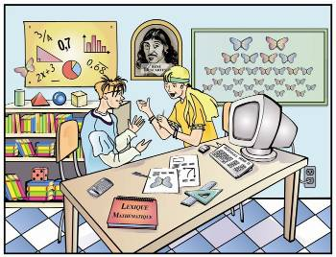
* For the purpose of this training and to make the Scales of Competency more teacher friendly the fonts above in italics have been added to the original profiles written.

