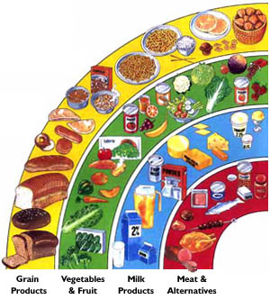
What am I eating?

Look at your 24 hour food log and answer the following questions:

- How many calories did I eat?

- How many servings of grain products did I have?

- How many servings of vegetables and fruits did I have?

- How many servings of milk products did I have?

- How many servings of meat and alternatives did I have?

- How many times a day did I eat?

- Was the majority of the food I ate processed?

- What ways can I make my eating habits healthier?

Your task is to design a meal and exercise plan that fits within the Canada’s food guide for one week. You must include recipes for any meal that you are making. For example, you must include a recipe for a lasagne, or stir fry.

Your assignment needs:
- A cover page
- Meal plans per day
- Calories per meal
- Nutrition guide per meal (including food guide servings)
- BMR and calories out per day
- Grocery list with pricing

