What is
the

WOTP?

The Work-Oriented Training Path provides students opportunities for personal growth and career exploration. The WOTP offers targeted work skills training through internship experience.

Contact
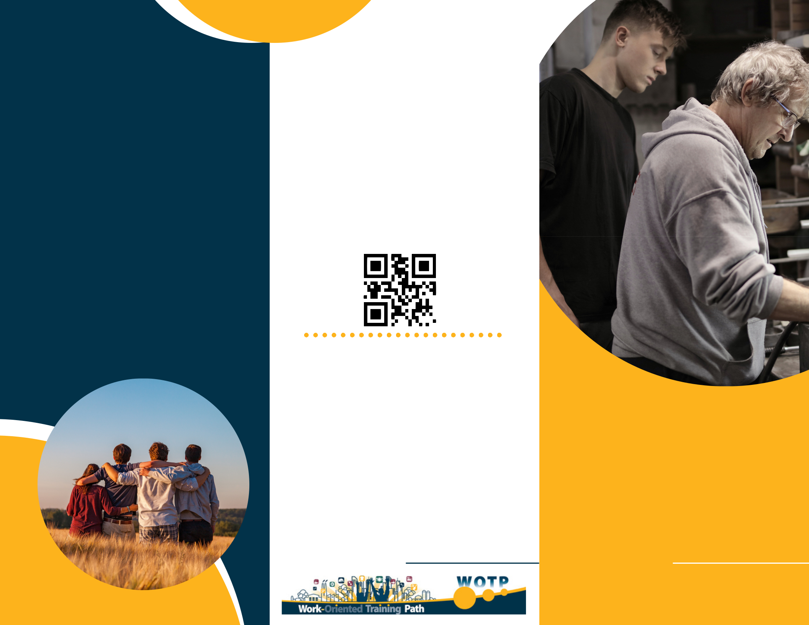
Us

Don't miss out on on opportunity to give back to your community and train future employees!

Scan to find out more:

For more information about our WOTP program, contact:

 123-456-7890

 hello@reallygreatsite.com  www.reallygreatsite.com

Work-Oriented Training Path

Role of the
Employer

Help the student develop workplace competencies:

provide guidance adapted to

students' needs

demonstrate tasks and provide

explanations, supervision and

correction as needed

welcome student, help them

understand workplace culture,

facilitate their integration

Why partner with us?

CNESST is covered by the

school board

Potential tax credit

Training future employees

Giving back to the community
Role of the

Student

The WOTP uses the work-study approach to give students the opportunity to develop their employability skills.

During the practicum students are
expected to develop specific
competencies (from the Directory of Semiskilled Trades) and adopt attitudes and behaviours required in the workplace.

Role of the
School

Provide students constant support throughout their experience in the workplace: accompany students as

needed and provide on-the - job resources

hold frequent meetings with students to address any concerns

Provide employers with:

constant support while working with students

clear and consistent communication

